CITY OF TITUSVILLE
COMMUNITY REDEVELOPMENT AGENCY
S
COMMERCIAL INTERIOR BUILDING RENOVATION
INCENTIVE GRANT PROGRAM
POLICIES AND PROCEDURES

November 2024
Page ! of !!

UUSection 1
Program Purpose and Benefits
The purpose of the Commercial Interior Building Renovation Grant Program is threefold: (1) To provide an incentive for the build-out of a commercial and mixed-use space that is vacant; (2) To assist existing businesses to renovate and to relocate to commercial space within the Community Redevelopment Agency (CRA) district; and (3) To upgrade the existing historic building stock within the CRA district. The goal of these activities is to increase commercial occupancy rates and property values within the CRA thus facilitating redevelopment through long-term stability. The renovation of older and historic downtown buildings many times is deterred by the expense required to bring older buildings up to today’s Americans with Disabilities Act (ADA), Florida Fire Protection Code and the Florida Building Code. To accomplish this objective, the Program assists eligible property owners and tenants to restore or renovate the interiors of their structures, thereby improving the area’s physical characteristics and enhancing the utilization of existing structures. Therefore, the Program will serve as an additional incentive to utilize vacant and or older commercial and mixed-use space, which will lead to increased investment and economic vitality within the CRA district. This grant program is consistent with the intent of Section 163.350, Florida Statutes, specifically “encouraging voluntary rehabilitation” of vacant and/or underutilized commercial and mixed-use properties within the CRA district.
Eligible applicants may receive grant funding up to $50,000 for the following:
- Expanding and improving older and underused buildings to increase commercial and residential intensity or renovating a historic structure;
- Bring existing buildings into compliance with the Americans with Disability Act (ADA), Florida Building Code (FBC), and the Florida Fire Protection Code;
- Assisting the small business community grow and prosper;
- Promote job creation in the CRA District;
- Promote pedestrian and transit use in the CRA District;
- Increase the customer base or customer opportunity in the CRA District.
Up to an additional $50,000 of grant funding may be received for mixed-use projects including non-residential uses and residential living units. Examples of non-residential uses include, but are not limited to, commercial offices, retail uses, restaurants, or personal services. Common amenities such as pools, clubhouses, or leasing offices related to residential uses shall not be used to meet the mixed-use requirement to allow these additional grant monies.
All interior Simprovements must be consistent with the City of Titusville’s Community Redevelopment Plan, Downtown Master Plan, the Land Development Regulations and the Adopted Standards Code set forth in the City of Titusville’s Code of Ordinances.
Program Objectives
- Eliminate blighting influences and prevent further deterioration of commercial and residential properties within the CRA boundaries.
- Stimulate renewed interest and investment within the District and preserve the traditional retail district as a location for convenient pedestrian/visitor commercial activities over extended hours of operation that are compatible with the CRA Master Plan.
November 2024
Page 2 of !!

- Encourage the development of multiple business activities to enhance new business growth, development and job opportunities.
- Encourage the utilization of existing business stock within the CRA District.
- Bring customers to commercial areas within the CRA to patronize nearby businesses.
- Increase the occupancy rate of eligible buildings in the CRA.
Eligibility Requirements:
- The incentive is available to buildings constructed prior to the adoption of the Florida Building Code, adopted on March 1, 2002.
- All commercial and mixed use properties within the Titusville Community Redevelopment Area are eligible except as noted.
- Drive through facilities and convenience stores with or without gas pumps are NOT eligible types of businesses under this program.
- Buildings with residential uses located on the first floor are NOT eligible.
- Ad valorem property tax exempt properties are NOT eligible.
- Interior renovation grants are intended for rehabilitation and restoration of existing properties only. New construction is ineligible.
The CRA will review and consider each application as measured by the goals, priorities, and objectives of the CRA Master Plan Update, and Florida Statutes Chapter 163.
CRA staff will review applications for completeness and determine if funding is to be recommended. The CRA Executive Director or designee may approve grant applications for Commercial Interior Building Renovation grants of $10,000 or less; applications in excess of $10,000 will be forwarded to the Community Redevelopment Agency for review
of funding approval. Grant funds will be distributed only upon completion of improvements; the submittal of all receipts, invoices and required documentation to CRA staff; and the occupancy of the building at the following milestones: 75% of the grant award at completion of the development, and 25% of the grant award at the first year of building occupancy. Applicants for Commercial Interior Building Renovation grant funds must be willing to maintain the renovations and improvements for at least five years.
The Grantee shall not be liable to the CRA for repayment of the grant funds provided the Grantee complies with all conditions set forth in the Grant Agreement. The Grantee will however be required to repay the grant funds if within five (5) years from receiving the grant funds the building in which the improvements are made is either destroyed by more than 50% of its value and is not rebuilt within two (2) years or if the building is demolished.
Grant funding is awarded on a first-come, first-served basis. Based on the amount of funding requested, applications must be approved by the appropriate entity (CRA, CRA Executive Director or designee) before work can begin on any improvements. Grants will not be awarded for work previously completed or that is in the process of being completed.
November 2024
Page 3 of !!

Section 2
Community Redevelopment Area Boundaries
The Downtown Titusville Community Redevelopment Area boundaries can be described as follows: Grace Street to the South, Buffalo Road to the North, the Indian River Lagoon to the East and the FEC Railroad tracks to the West. See the following map:
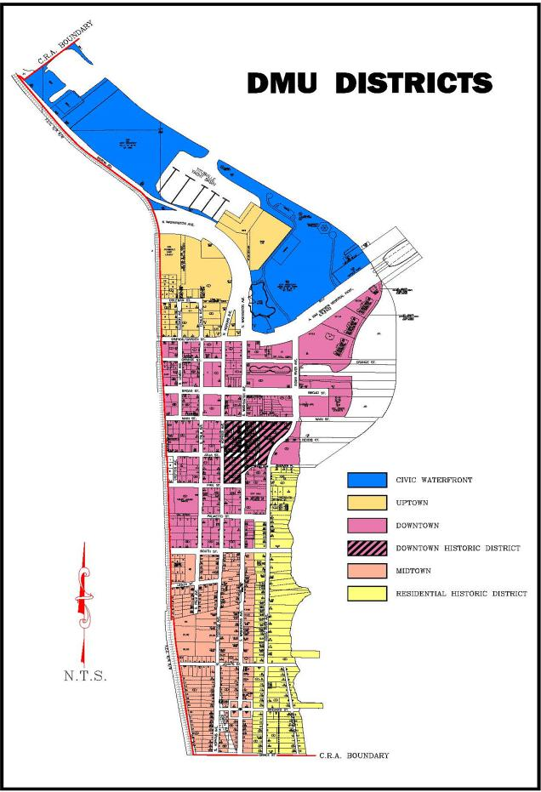
November 2024
Page 4 of !!

UUSection 3
Eligible Expenses
A.A. The Commercial Interior Building Renovation Program offers financial assistance in the form of a reimbursable, matching (50%) grant to the property owner or business owner for eligible expenses associated with the renovation or rehabilitation of the interior elements of the commercial and mixed use operating space. Items eligible for funding under the program are limited to the following permanent improvements:
- ADA Requirements
- Florida Fire Protection Code Requirements
- Florida Building Code Requirements including:
- Interior plumbing to meet code (including internal grease traps and external grease interceptors)
- Interior electrical system including lighting to meet code
- HVAC system to meet code
- All permanent improvements shall require written permission of the property owner, which shall be submitted as part of the grant application, if the applicant is not the property owner. In all cases, the property owner shall be a co-signer to the grant award agreement.
- The Commercial Interior Building Renovation grant funding may be budgeted annually by the CRA Board and awarded on a first-come, first-serve basis. All applications are subject to approval by the CRA Executive Director and/or CRA Board. Making application to the program is NOT a guarantee of funding.
- All buildings improved with Program grant funds must maintain or receive a certificate of occupancy or a certificate of completion upon the completion of the proposed improvements and must comply with all local building codes and Land Development Regulations.
- No building owner, lessor, lessee, tenant, occupant, employee, or immediate relative of the same, either personally or in a corporate capacity, shall be paid or compensated in any manner to serve as a contractor, subcontractor, laborer or material man in connection with any rehabilitative work or labor to said building pursuant to the Program.
UUSection 4
Ineligible Expenses
- Painting.
- Permitting fees.
- Any service performed by a non-licensed contractor or which is inconsistent with the City’s adopted codes.
- Improvements constructed prior to execution of final agreement with the CRA.
November 2024
Page 5 of !!

- Routine maintenance activities that are part of normal property ownership.
- Repairs performed to correct Code violations unrelated to the eligible grant items listed in these guidelines.
- Improvements to a property, that has any judgment liens; is not current on all mortgage and tax obligations; and has any Code violations unrelated to the eligible grant items listed in these guidelines.
- New construction.
- Improvements to properties that are exclusively residential.
- Improvements to properties that “expand” non-conforming uses.
- Relocation expenses or loss of business expenses during relocation period.
- Physical or visual removal of architecturally important features.
- Refinancing existing debt.
- Sweat equity payments, i.e., reimbursement for applicant’s own labor and performance of renovation work.
UUSection 5
Program Criteria
- The structure to be improved must be within the boundaries of the Downtown Titusville Community Redevelopment Area (Grace Street to the South, Buffalo Road to the North, the Indian River Lagoon to the East and the FEC Railroad tracks to the West).
- The applicant can be an owner or tenant of the building. A tenant may qualify upon receipt of written consent of the owner of the building. In all cases, the property owner shall be a co-signer to the grant award agreement.
- Applicants must demonstrate that all necessary financing required to complete the project has been secured and that the applicant is providing matching funds that are at least one-half (¹/₂) of the amount of the grant amount being requested. Matching funds will be only for expenses for the listed eligible items noted in Section 3 of this document. Such improvements cannot be removed from the premises.
- Applicants must have received the requisite CRA, CRA Executive Director or designee approval prior to commencement of improvements.
- All necessary permits and approvals must be obtained from the City of Titusville before work is commenced. All work is to be performed to the satisfaction of City
November 2024
Page 6 of !!

of Titusville officials pursuant to the City’s adopted codes and Land Development Regulations.
- A licensed contractor must perform the work; proof of licensure and insurance is required.
- Applicants must agree to maintain the improvements for at least five years. The Community Redevelopment Agency, CRA Executive Director or designee, as applicable, may approve any changes proposed to the improvements that are $10,000 and less in value. Proposed changes greater than $10,000 in value must be approved by the Titusville CRA.
- The property must be free from any judgement liens, and all mortgage and tax obligations must be current. The applicant will be required to provide a Title Search showing that the property is free from any judgement liens, and all mortgage and tax obligations are current.
- The total amount of grant funds available for any one property under this Program is $50,000, except for projects meeting the requirements of a mixed-use project described in Section 1, which may be eligible for up to an additional $50,000, for a total of $100,000. Any subsequent applications for the same property in future years will be treated cumulatively for purposes of determining funding eligibility.
UUSection 6
Evaluation Criteria
Grant funds are limited and will be awarded on a first-come, first-served basis. Because one of the primary objectives of the Commercial Interior Building Renovation Program is to eliminate blighted conditions and improve the visual impact of the redevelopment area, applications will be evaluated using the following criteria:
- Consistency with the goals, principles and objectives of the City of Titusville Community Redevelopment Plan, the Downtown Master Plan and the Urban Design Manual.
- The amount of funds that the applicant pledged to match leveraged against CRA funds.
- The extent to which the project brings the building interior to current building, fire and ADA standards thus providing a safe, secure and convenient environment for patrons and employees.
- Return on investment of CRA funds. Return on investment shall include total cost of eligible permanent interior improvements as well as estimated economic impact based upon strength of business plan presented.
- Number of new jobs to be created within the CRA district boundaries.
November 2024
Page 7 of !!

- Potential that proposed business will enhance economic vitality of businesses within the CRA district, or attract additional businesses within the CRA district boundaries.
- The proposed improvements are to a building listed in the City of Titusville Community Redevelopment Area Historic Property Survey dated July, 2012 prepared by Janus Research.
UUSection 7
Application Procedures
A property owner or tenant that is interested in participating in the Commercial Interior Building Renovation Incentive Program must submit a completed and signed application, along with supporting documentation, to:
The City of Titusville Community Redevelopment Agency
555 South Washington Avenue
P.O. Box 2806
Titusville, FL 32781-2806
In addition to other supporting documents, applicants are required to submit quotes from two licensed contractors with the application, if applicable. Quotes shall include a detailed listing of materials and labor costs. All quotes shall include a non-collusion affidavit signed by the contractor or sub-contractor, as applicable. The affidavit is available from the CRA staff.
The City may request an audit of invoices related to the approved project be conducted at the expense of the applicant. In the event an audit of records shows the applicant or applicant’s agent or employees has, in the sole opinion of the CRA, utilized grant money in any manner contrary to the intent of the grant, the grant shall be considered null and void and all funds disbursed shall be returned to the CRA within thirty (30) days. These remedies are in addition to those provided by law.
CRA staff will review applications for completeness and for compliance with Program criteria. Incomplete applications may be returned for additional information. Projects that do not comply with Program criteria will not be considered for funding.
Awards of funding will be based on the lowest qualified bid. The applicant may elect to choose a contractor other than the one with lowest qualified bid but shall be responsible for all costs exceeding the lowest qualified bid. Under all circumstances, the contractor performing the work must be licensed, insured and have worker’s compensation insurance.
It is recommended that applicants retain the services of a registered architect, or similarly qualified design professional to prepare plans, drawings, renderings and construction specifications for their projects. Ten (10) percent of the fees for services provided by a registered architect or similarly qualified design professional may be counted towards the applicant’s Program match.
November 2024
Page 8 of !!

The CRA will not be responsible in any manner for the selection of a contractor. An applicant should pursue all activities necessary to determine contractor qualifications, quality of workmanship, and reputation. The applicant will bear full responsibility for reviewing the competence and abilities of prospective contractors and secure proof of licensing and insurance coverage.
Commercial Interior Building Renovation Program grant applications can be obtained from the City of Titusville Community Redevelopment Agency, Second P ^{P}Floor, City Hall, 555 South Washington Avenue, or from the City’s website at www.titusville.com.
Application Approval
The CRA Executive Director or designee will approve or deny grant applications of $10,000 and less for Commercial Interior Building Renovation funds. Projects of greater than $10,000 will be forwarded to the Community Redevelopment Agency with a recommendation from CRA staff for funding approval or denial. All applicants will receive written notification regarding approval or denial of their application. If an applicant’s proposal is approved by the CRA Executive Director/designee or the CRA, as applicable, the applicant will receive written notification of the approval, which will include a funding agreement listing the amount of grant funds that are approved and the construction start time.
Documentation of Applicant’s Funding Source
The applicant will be required to document the type and source of the project funds on the application submitted to the CRA. Verification of the funding sources will be required before final approval of the grant application.
Construction Start
After the funding agreement has been executed, the applicant may award the construction contract and secure all necessary construction permits. The owner/tenant must issue a “Notice to Proceed” to the contractor and apply for a building permit within 60 days of executing the funding agreement. Construction must begin within 90 days of the funding agreement and be completed within 12 months of the agreement. Extensions may be granted at the discretion of the CRA Executive Director or designee, contingent upon the applicant demonstrating just cause for such an extension. Failure to meet the construction start time may result in the forfeiture of the grant award.
Disbursements
Generally, approved projects will receive reimbursement funding upon completion of the project; and submission of all required receipts, invoices and documentation; and the occupancy of the building at the following milestones: 75% of the grant award at development completion, and 25% of the grant award at the first year of building occupancy. Grant funds cannot be used to reimburse the applicant for any work done on the building prior to the date of a fully executed Grant Agreement between the applicant and the Community Redevelopment Agency.
Funds will be disbursed by a check payable to the applicant (1) upon certification of completion or occupancy by the City Building official, or as agreed to with the CRA Executive Director; (2) CRA staff verification that the work was completed as proposed in a satisfactory and professional manner; (3) submission of all receipts and required
November 2024
Page 9 of !!

documentation, including contractor invoicing, and evidence of payment of funds for reimbursement and match, to CRA staff and (4) at the following milestones: 75% of the grant award at development completion, and 25% of the grant award at the first year of building occupancy. Funds will not be disbursed on projects that are not in accordance with the approved plans.
The City’s Community Development Department will make the final determination as to whether the project is complete. Applicants must provide verification, satisfactory to the CRA, of all project costs, including contractor invoicing, and evidence of payment of funds for reimbursement and match, before grant funds can be disbursed.
Application Process Summary
- Applicant submits a complete application to the CRA office.
- CRA staff reviews application for completeness, accuracy and eligibility.
- CRA staff presents recommendation to the CRA Executive Director and/or CRA, as appropriate.
- Upon approval, the applicant will be notified in writing of the amount of the grant awarded and the documentation that must be provided before funds are released.
UUSection 8
Nondiscrimination
The Grant shall be available to anyone meeting the eligibility requirements, and no one shall be denied the benefits of said program because of race, color, national origin or gender.
Section 9
Disclosures
The Community Redevelopment Agency expressly reserves the right to reject any or all applications or to request additional information from any or all applicants. The CRA retains the right to amend the program guidelines and application procedures without notice. The CRA also retains the right to display and advertise properties that receive grant funding.
Section 10
Contact Information
Questions related to the application or viability of a proposed project should be directed
to CRA staff at (321) 567-3860.
November 2024
Page 10 of 11

NON-COLLUSION STATEMENT

This is to affirm under the threat of perjury, that the undersigned, or representative, agent, member, or officer of the contracting party, has not, nor has any other member, employee, representative, agent or officer of the firm, company, corporation or partnership represented by him/her, directly or indirectly, entered into or offered to enter into any combination, collusion or agreement to receive or pay, and that he/she has not received or paid any sum of money or other consideration for the execution of the execution of the attached bid and/or contract other than that which appears upon the face of the bid and/or contract.
Signature
Printed Name
Title
Company
Date

November 2024

Page !! of !!

