City of Titusville

Community Redevelopment Agency

Permit & Impact Fee

Incentive Grant Program

Policies and Procedures

Section 1

Program Purpose and Benefits

The Titusville Community Redevelopment Agency (CRA) has found that development permit fees

and impact fees can often be a significant cost of new or expanding business or new multifamily
development. These upfront costs often prevent a business or development from expanding or opening its doors. The purpose of the Permit and Impact Fee Grant Program is: (1) To provide an incentive to expand an existing building and/or to put vacant land in the Community Redevelopment Agency (CRA) district into productive use; (2) To build community assets; and (3) To leverage public and private funds that will increase economic activity, building occupancy, job creation and property values to further revitalize downtown Titusville. The goal of the program is to help create an atmosphere of change and growth within the CRA thus facilitating redevelopment through long-term stability. To accomplish this objective, the Program assists eligible property owners and developers to build or expand commercial and certain multifamily development in the CRA, thereby improving the area’s physical characteristics, which will lead to increased investment and economic vitality within the CRA district. This grant program is consistent with the intent of Section 163.350, Florida Statutes, specifically “encouraging voluntary rehabilitation” of vacant and/or underutilized properties within the CRA district. The grant program is also consistent with the City of Titusville 2015 Supplemental Redevelopment Plan regarding Economic Incentives in the Downtown specifically the following wording: “By their nature, redevelopment activities can result in economic development opportunities within the redevelopment area. Therefore, CRA activities that may be considered in conjunction with private and public economic development activities include, but are not limited to, the following:

Assistance with site plan ad building permit fees.

All new construction applying for permit and impact grants must be consistent with the City of Titusville’s Community Redevelopment Plan, Downtown Master Plan, the Land Development Regulations and the Adopted Standards Code set forth in the City of Titusville’s Code of Ordinances.

Program Objectives

Eliminate and prevent the spread of blight and the deterioration of properties within the CRA

boundaries.

Stimulate renewed interest and investment by the private sector within the District by helping

to eliminate impediments to development and redevelopment.

Encourage the development of multiple business activities to enhance new business growth,

development and job opportunities in the CRA where there is existing infrastructure available

for new construction.

Encourage the development of multifamily residential buildings with more than three dwellings

per property within the CRA District, which will bring residents to commercial areas within the

CRA to patronize nearby businesses.

The CRA will review and consider each application as measured by the goals, priorities, and

objectives of the CRA Master Plan Update and Florida Statutes Chapter 163.
CRA staff will review applications for completeness and determine if funding is to be recommended. The CRA Executive Director or designee may approve grant applications for Permit & Impact Fee grants of $10,000 or less; applications in excess of $10,000 will be forwarded to the Community Redevelopment Agency for review of funding approval. Grant funds will be distributed for reimbursement only after completion of the project and approval of the work when a Certificate of Occupancy (C.O.) or Letter of Completion is obtained for the development; the submittal of all receipts, invoices and required documentation has been reviewed by CRA staff; and the occupancy of the new or expanded building at the following milestones: 75% of the grant award at completion of the development, and 25% of the grant award with building occupancy one (1) year from C.O. Applicants for Permit & Impact Fee grant funds must be willing to maintain the property at the structure’s condition at the time of C.O. or Letter of Completion for at least five years from the date of receipt of the grant funds.
The Grantee shall not be liable to the CRA for repayment of the grant funds provided the Grantee complies with all conditions set forth in the Grant Agreement. The Grantee will however be required to repay the grant funds if within five (5) years from receiving the grant funds, the structure is either destroyed by more than 50% of its assessed value on the date of damage as determined and maintained by the Brevard County Property Appraiser’s Office and is not rebuilt within two (2) years or if the building is demolished.
Grant funding is awarded on a first-come, first-served basis depending on availability of funds. Applications must be approved by the appropriate entity (CRA, CRA Executive Director or designee) before any construction takes place. Grants will not be awarded for work previously completed or that is in the process of being completed prior to obtaining the necessary approval of the grant.

Section 2

Community Redevelopment Area Boundaries
The Downtown Titusville Community Redevelopment Area boundaries can be described as follows: Grace Street to the South, Buffalo Road to the North, the Indian River Lagoon to the East and the FEC Railroad tracks to the West. See the following map.

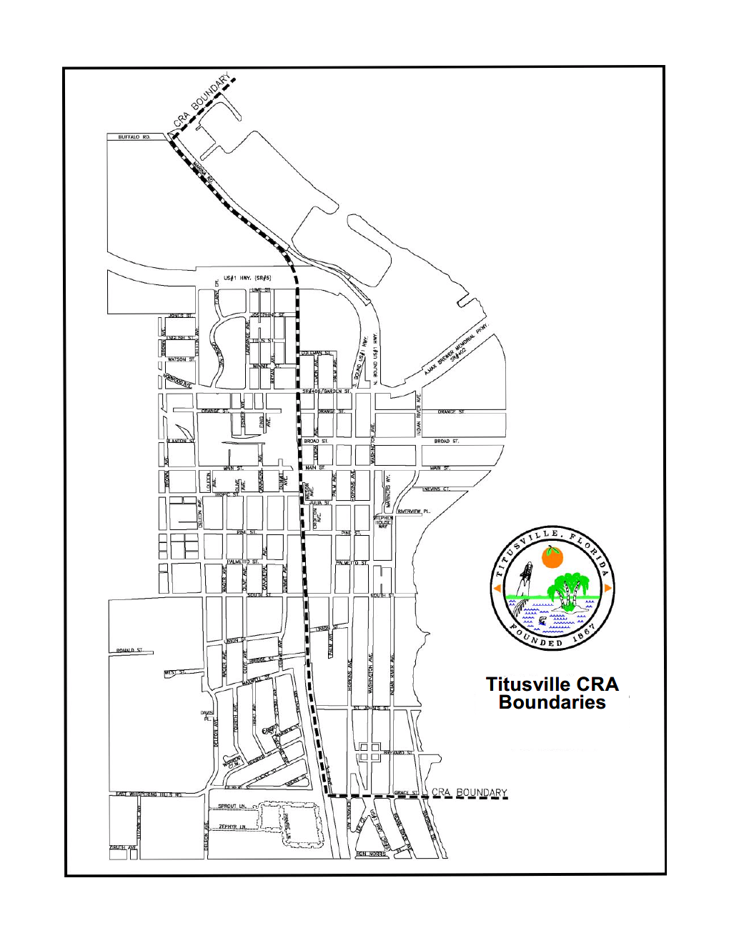

Section 3

Eligible Projects and Expenses
A. The Permit and Impact Fee Grant Program offers financial assistance in the form of a reimbursable, matching (50%) grant to the property owner/developer for eligible expenses associated with the construction of new commercial, mixed-use, and multifamily residential principle structures; the expansion of existing commercial, mixed-use, and multifamily principle structures; and the redevelopment and change of a use of a building that requires an impact fee in the CRA district. Items eligible for funding under the program are limited to the following development permits and impact fees:

Building Permit fee;

Building Inspection fee;

Fire Review and Inspection fees;

Community Development Site Review fees;

Utilities (Water and Sewer) Impact fee;

Utilities (Water and Sewer) Connection fees;

City of Titusville Impact fee, which includes Transportation, Police, Fire, City Hall and

Public Works; and

Brevard County Impact fee, which includes Corrections and Emergency Services (EMS)
B. Applications shall require written permission of the property owner, which shall be submitted as part of the grant application, if the applicant is not the property owner. In all cases, the property owner shall be a co-signer to the grant award agreement.
C. The Permit and Impact Fee Program grant funding is subject to being budgeted annually by the CRA Board and awarded on a first-come, first-serve basis. All applications are subject to approval by the CRA Executive Director and/or CRA Board. Making application to the program is NOT a guarantee of funding.
D. All buildings constructed with Program grant funds must receive a Certificate of Occupancy or a Letter of Completion upon the completion of the proposed improvements and must comply with all local building codes and Land Development Regulations.

Section 4

Ineligible Projects and Expenses
Permit fees and impact fees for Single Family homes; Duplexes; Drive through facilities; Convenience Stores with or without gas pumps; Warehouses; Self- Storage/Mini-Warehouse facilities; Used Car businesses; Automobile & Vehicle Repair establishments; Vehicle for Hire establishments; Private Clubs; Pawn Shops; Soup Kitchens; Bars, Night Clubs, Lounges or establishments that primarily serve alcohol; projects that will contain sexually oriented businesses, as defined in Section 11-82 of the Titusville Code of Ordinances; and Accessory Structures are NOT eligible types of businesses/developments under this program.

Developments that will be ad valorem property tax exempt are NOT eligible.

Section 5

Program Criteria
1. The proposed development must be within the boundaries of the Downtown Titusville Community Redevelopment Area (Grace Street to the South, Buffalo Road to the North, the Indian River Lagoon to the East and the FEC Railroad tracks to the West).

2. The applicant can be a property owner or a developer. A developer may qualify upon receipt of written consent of the owner of the property. In all cases, the property owner shall be a co-signer to the grant award agreement.

3. Applicants must demonstrate that all necessary financing required to complete the project has been secured and that the applicant is providing matching funds that are at least one-half (½) of the amount of the grant amount being requested. Matching funds will be only for expenses for the listed eligible items noted in Section 3 of this document.

4. Applicants must have received the requisite CRA, CRA Executive Director or designee approval prior to commencement of improvements.

5. All necessary permits and approvals must be obtained from the City of Titusville before work is commenced. All work is to be performed to the satisfaction of City of Titusville officials pursuant to the City’s adopted codes and Land Development Regulations.

6. Applicants must agree to maintain the property for at least five years. The Community Redevelopment Agency, CRA Executive Director or designee, as applicable, may approve any changes proposed to the improvements that are $10,000 and less in value. Proposed changes greater than $10,000 in value must be approved by the Titusville CRA.

7. The property must be free from any judgment liens, and all mortgage and tax obligations must be current. The applicant must provide a title search showing that the property is free from any judgement liens, and all mortgage and tax obligations are current and that the lending institutions will provide updated information upon request by the Community Redevelopment Agency.

8. There may be no more than one approval for project funding every two years. SA “project” is defined as a single or set of enhancement/renovation activities for an eligible property.

9. The total amount of grant funds available for any one property under this Program is $50,000. Any subsequent applications for the same property in future years will be treated cumulatively for purposes of determining funding eligibility.

Section 6

Evaluation Criteria
Grant funds are limited and will be awarded on a first-come, first-served basis. Because one of the primary objectives of the Permit & Impact Fee Grant Program is to eliminate blighted conditions and improve the visual impact of the redevelopment area, applications will be evaluated using the following criteria:
1. Consistency with the goals, principles and objectives of the City of Titusville Community Redevelopment Plan, the Downtown Master Plan and the Urban Design Manual.\

2. The proportional value of funds that the applicant pledged to match over and above the 50% minimum match leveraged against CRA funds.

3. Return on investment of CRA funds. Return on investment shall include total cost of eligible permanent interior improvements as well as estimated economic impact based upon strength of business plan presented.

4. Number of new jobs and or permanent residences to be created within the CRA district boundaries.

5. Potential that proposed business/development will enhance economic vitality of businesses within the CRA district, or attract additional businesses within the CRA district boundaries.

6. Mixed use commercial – residential developments that have the greatest potential to reduce traffic impacts within the CRA.

Section 7

Application Procedures
A property owner or developer that is interested in participating in the Permit & Impact Fee Program must submit a completed and signed application, along with supporting documentation, to:

The City of Titusville Community Redevelopment Agency

555 South Washington Avenue

P.O. Box 2806

Titusville, FL 32781-2806

The City may request an audit of invoices related to the approved project be conducted at the expense of the applicant. In the event an audit of records shows the applicant or applicant’s agent or employees has, in the sole opinion of the CRA, utilized grant money in any manner contrary to the intent of the grant, the grant shall be considered null and void and all funds disbursed shall be returned to the CRA within thirty (30) days from the date of notice by the CRA. These remedies are in addition to those provided by law.

CRA staff will review applications for completeness and for compliance with Program criteria. Incomplete applications may be returned for additional information. Projects that do not comply with Program criteria will not be considered for funding.

Under all circumstances, the contractor performing the work must be licensed in the State of Florida, insured and have worker’s compensation insurance.

Applicants shall retain the services of and identify the qualified contractor and or design professional to prepare plans, drawings, renderings and construction specifications for their projects.

The CRA will not be responsible in any manner for the selection of a contractor. An applicant should pursue all activities necessary to determine contractor qualifications, quality of workmanship, and reputation. The applicant will bear full responsibility for reviewing the competence and abilities of prospective contractors and secure proof of licensing and insurance coverage.

Pre-Application Meeting
A pre-application meeting to review the applicant’s conceptual plans in an informal setting, including discussion of eligibility criteria, program requirements, costs, funding, proposed project scheduling, and consistency of the proposal with the intent of the Permit & Impact Fee Program. Staff will provide the applicant with a general determination as to whether the proposed project is likely to qualify to receive program grant funds and whether the applicant is sufficiently prepared to move on to the application stage.

Permit & Impact Fee Grant Program applications can be obtained from the City of Titusville Community Redevelopment Agency, Second Floor, City Hall, 555 South Washington Avenue, or from the City’s website at www.titusville.com.

Submittal Requirements

1. A completed application form;

2. A project schedule and projected construction budget;

3. Document of estimated permit fees and impact fees as calculated by the City of Titusville

Building Division;

4. Photographs of the existing site or existing buildings, depending on the situation;

5. A proposed site plan with elevations of the proposed project/development;

6. All non-property owners must have a letter signed and notarized by the property owner

giving permission to apply for the grant;

7. Proposed building tenants;

8. All other information as required by the Permit & Impact Fee Grant application.

The application and exhibits shall be submitted in paper and digital format. The application package shall be saved to a PDF format on a compact disk, digital video disk or a thumb drive. In addition to the digital application, one (1) hard copy of the application and exhibits shall be submitted.

Application Approval
The CRA Executive Director or designee will approve or deny grant applications of $10,000 and less for Permit & Impact Fee grant funds. Projects of greater than $10,000 will be forwarded to the Community Redevelopment Agency with a recommendation from CRA staff for funding approval or denial. All applicants will receive written notification regarding approval or denial of their application. If an applicant’s proposal is approved by the CRA Executive Director/designee or the CRA, as applicable, the applicant will receive written notification of the approval, which will include a grant funding agreement listing the amount of grant funds that are approved and the construction start time.

Documentation of Applicant’s Funding Source
The applicant will be required to document the type and source of the project funds on the application submitted to the CRA. Verification of the funding sources will be required before final approval of the grant application.

Construction Start
After the funding agreement has been executed, the applicant may award the construction contract and secure all necessary construction permits. The owner/developer must issue a “Notice to Proceed” to the contractor and apply for a building permit within 60 days of executing the funding agreement. Construction must begin within 180 days of the funding agreement and be completed within 24 months of the agreement. Extensions may be granted at the discretion of the CRA Executive Director or designee, contingent upon the applicant demonstrating just cause for such an extension. Failure to meet the construction start time may result in the forfeiture of the grant award.

Disbursements
Approved projects will receive reimbursement funding in stages upon completion of the project and the occupancy of the building at the following milestones: 75% of the grant award at completion of the development, and 25% of the grant award with building occupancy one (1) year from the C.O. Completion of the project requires receipt of a Certificate of Occupancy or Letter of Completion from the City of Titusville Building Division and submission of all required receipts, invoices and documentation. The final incentive amount and milestone payout amounts will be a reimbursement calculated from the actual costs incurred as confirmed by invoices and other documentation needed to confirm payment of expenses associated with eligible development fees. Grant funds cannot be used to reimburse the applicant for any work done on the building prior to the date of a fully executed Grant Agreement between the applicant and the Community Redevelopment Agency.

Funds will be disbursed by a check payable to the applicant (1) upon certification of completion or occupancy by the City Building official; (2) CRA staff verification that the work was completed as proposed in a satisfactory and professional manner; and (3) submission of all receipts and required documentation, and evidence of payment of funds for reimbursement and match, to CRA staff; (4) and inspection by staff to confirm occupancy of the development. Funds will not be disbursed on projects that are not in accordance with the approved plans.

The City’s Community Development Department will make the final determination as to whether the project is complete. Applicants must provide verification, satisfactory to the CRA, of all project costs, including contractor invoicing, and evidence of payment of funds for reimbursement and match, before grant funds can be disbursed. All eligible requests for reimbursement shall be submitted within thirty (30) days of project completion.

Application Process Summary

1. Applicant submits a complete application to the CRA office.

2. CRA staff reviews application for completeness, accuracy and eligibility.

3. CRA staff presents recommendation to the CRA Executive Director and/or CRA, as

appropriate.

4. Upon approval, the applicant will be notified in writing of the approval of the application.

Staff will prepare a Redevelopment Grant Agreement for execution by the applicant and the

City.

5. Owner/Developer received building permit approval.

6. Development is constructed and receives Certificate of Occupancy (CO) or Letter of

Completion.

7. Documentation confirmed by receipts and paid invoices for eligible development fees and

charges must be provided to staff and confirmation of development occupancy before grant

funds are released.

Section 8

Nondiscrimination
The Grant shall be available to anyone meeting the eligibility requirements, and no one shall be denied the benefits of said program because of race, color, national origin or gender.

Section 9

Disclosures
The Community Redevelopment Agency expressly reserves the right to reject any or all applications or to request additional information from any or all applicants. The CRA retains the right to amend the program guidelines and application procedures without notice. The CRA also retains the right to display and advertise properties that receive grant funding.

Section 10

Contact Information
Questions related to the application or viability of a proposed project should be directed to CRA staff at (321) 567-3860.

Non-Collusion Statement
This is to affirm under the threat of perjury, that the undersigned, or representative, agent, member, or officer of the contracting party, has not, nor has any other member, employee, representative, agent or officer of the firm, company, corporation or partnership represented by him/her, directly or indirectly, entered into or offered to enter into any combination, collusion or agreement to receive or pay, and that he/she has not received or paid any sum of money or other consideration for the execution of the execution of the attached bid and/or contract other than that which appears upon the face of the bid and/or contract.

Signature

Printed Name

Title

Company

Date

