

“Gateway to Nature and Space”

DESIGN GUIDELINES & BEST PRACTICES
for historic residential and commercial buildings

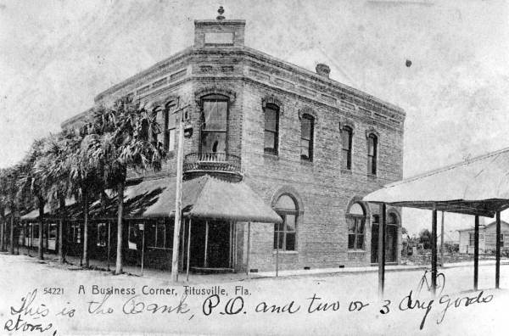



DESIGN GUIDELINES & BEST PRACTICES
for historic residential and commercial buildings

Grant Funding Statement

This document is sponsored in part by funds made available by the Division of Historical Resources, Department of State, State of Florida. The contents and opinions herein do not necessarily reflect the views or policies of these agencies, nor does the mention of trade names or commercial products constitute endorsement or recommendation by this agency.
2023
Table of Contents

Chapter 1. Introduction to Preservation 1
Purpose of Design Guidelines 1
The Secretary of the Interior's Standards for the Treatment of Historic Properties 3
What Are Design Guidelines? 4
Who Uses This Document? 4
When Does This Document Apply? 4
How Is This Document Used? 5
Benefits of Historic Preservation 6
Chapter 2: Historic Preservation in Titusville 11
Historic Properties 11
Individually Listed National Register Resources 17
Locally Designated Historic Resources 19
Historic Preservation Code 22
Historic Preservation Board 23
Florida Master Site File Forms 24
Chapter 3: Procedures 28
Nominations to the National Register of Historic Places 28
Local Designation 31
Certificates of Appropriateness (COA) 34
Determining Whether a COA Is Required 34
Procedural Steps: Obtaining a COA 35
Chapter 4: Design Principals 43
Alignment 43
Detail 43
Height 43
Massing 43
Orientation 44
Proportion 44
Rhythm 44
Scale 45
Setback 45
Style 45
Symmetry 45
Unity 45
Chapter 5: Architectural Style Guide 46
Introduction 46
Architectural Styles 47
Chapter 6: Design Guidelines 82
6.1 Secretary of The Interior’s Standards for Rehabilitation 82
6.2 General Guidelines 83
6.3 Maintenance 87
6.4 Universal Guidelines for Exterior Walls including Siding 88
6.5 Universal Guidelines for Exterior Materials including Siding 92
6.6 Universal Guidelines for Site Design 96
6.7 Universal Guidelines for Garages, Outbuildings, other Accessory Structures 100
6.8 Universal Guidelines for Additions 101
6.9 Universal Guidelines for New Construction 105
6.10 Universal Guidelines for Relocation 111
6.11 Universal Guidelines for Demolition 113
6.12 Additional Guidelines for Residential Properties 115
6.13 Additional Guidelines for Commercial Properties 137
Appendix A: Glossary 152
Appendix B: Substitute Material 165
Appendix C: Additional Resources 173
Appendix D: Selected Bibliography 195
Appendix E: Historic Preservation Code 199

Chapter 1. Introduction to Preservation

Purpose of Design Guidelines and Best Practices
The purpose of design guidelines and best practices for historic residential and commercial buildings is to promote the preservation of the historic character of the built environment while ensuring that new construction and additions are compatible with their historic surroundings.
These guidelines and best practices are intended to help property owners make appropriate decisions regarding changes to historic buildings, regardless of whether they are officially listed in the Local or National Register of Historic Places or not. For properties and districts that are listed in the national or local register, the guidelines and recommended treatments in this document are consistent with the Secretary of Interior’s standards for the treatment of historic resources, and therefore will help inform the regulatory decisions by the Historic Preservation Board (HPB) in design review and permitting actions.
For properties that are not listed but are historic, these can be considered “best practices” that property owners are encouraged but not mandated to follow. By voluntarily following the design guidelines and best practices detailed in this document, Titusville residents and business owners can help ensure their decisions do not negatively impact surrounding properties or the overall character of the neighborhood and City. This supports the HPB’s role in education, promotion, and advocacy for historic preservation.
These guidelines are intended to support the city’s preservation ordinances. The purpose of the City of Titusville’s Historic Preservation Ordinance is to:

- Preserve and protect properties of historic, cultural, archaeological, aesthetic, and architectural merit;
- Strengthen the economy of the City by stabilizing and improving property values in historic areas by combating urban decay through rehabilitation and revitalization and by encouraging new construction and developments that are harmonious with neighboring historic structures;
- Assist the City and property owners in qualifying for federal tax incentives, federal and state grant funds, and other potential property tax abatement programs for the purpose of furthering historic preservation activities, including, but not limited to, Section 193.502, Florida Statutes or subsequent statutes and the National Register of Historic Places Program; and to
- Foster civic pride in the accomplishments of the past, protect and to enhance the City’s attraction to visitors, and promote the use of individual sites and districts for the education, pleasure, and welfare of the people of the city.

The City’s Code of Ordinances also established the HPB. The HPB has been delegated regulatory authority by the City Council to review and approve alterations to listed historic resources, new additions, demolitions, and new construction on sites in defined and officially listed historic districts. The HPB is also responsible for preparing, updating, and maintaining a plan for the protection of the city’s historic districts and sites. The HPB is tasked with administering the historic district regulations as outlined in the City’s Historic Preservation Ordinance. The intent of the regulations is the protection of historic districts and sites and the buildings which they contain by ensuring that new construction and rehabilitation projects are compatible with the character of each individual property as well as the overall character of the district in which it is located. To this end, the HPB reviews all applications for Certificates of Appropriateness (COA) for all exterior changes to existing sites and structures and new construction within designated districts (see definition of ’districts’ in glossary).
This document provides guidance and recommendations on maintaining, repairing, and, when necessary, replacing historic features on properties within the City of Titusville. These guidelines and best practices are based on the Secretary of the Interior's Standards for the Treatment of Historic Properties (36 CFR Part 68, referred to hereafter as “the Standards”), a set of guidelines on the treatment of historic properties which was established and is administered by the National Park Service. The Standards include guidance on the preservation, restoration, rehabilitation, and reconstruction of historic properties.
“Rehabilitation is defined as the act or process of making possible a compatible use for a property through repair, alterations, and additions while preserving those portions or features which convey its historical, cultural, or architectural values. The Rehabilitation Standards acknowledge the need to alter or add to a historic building to meet continuing or new uses while retaining the building’s historic character.”
(36 CFR Part 67, 1990)
Source: Florida Memory

The Secretary of the Interior's Standards for the Treatment of Historic Properties

- A property will be used as it was historically or be given a new use that requires minimal change to its distinctive materials, features, spaces and spatial relationships.
- The historic character of a property will be retained and preserved. The removal of distinctive materials or alteration of features, spaces and spatial relationships that characterize a property will be avoided.
- Each property will be recognized as a physical record of its time, place and use. Changes that create a false sense of historical development, such as adding conjectural features or elements from other historic properties, will not be undertaken.
- Changes to a property that have acquired historic significance in their own right will be retained and preserved.
- Distinctive materials, features, finishes, and construction techniques or examples of craftsmanship that characterize a property will be preserved.
- Deteriorated historic features will be repaired rather than replaced. Where the severity of deterioration requires replacement of a distinctive feature, the new feature will match the old in design, color, texture and, where possible, materials. Replacement of missing features will be substantiated by documentary and physical evidence.
- Chemical or physical treatments, if appropriate, will be undertaken using the gentlest means possible. Treatments that cause damage to historic materials will not be used.
- Archeological resources will be protected and preserved in place. If such resources must be disturbed, mitigation measures will be undertaken.
- New additions, exterior alterations, or related new construction will not destroy historic materials, features, and spatial relationships that characterize the property. The new work will be differentiated from the old and will be compatible with the historic materials, features, size, scale and proportion, and massing to protect the integrity of the property and its environment.
- New additions and adjacent or related new construction will be undertaken in such a manner that, if removed in the future, the essential form and integrity of the historic property and its environment would be unimpaired.

What Are Design Guidelines?
Titusville’s Land Development Ordinance requires that anyone proposing changes to a designated historic resource must obtain a Certificate of Appropriateness before starting work. Such changes include alterations, restoration, rehabilitation, renovation, relocation, and demolition of existing buildings, as well as excavations, additions, and new construction within designated areas.
Titusville’s HPB is tasked with evaluating the historical appropriateness of proposed alterations and related work to determine whether the work meets the requirements of the City’s Historic Preservation Ordinance and if a COA can be issued.
Design guidelines are recommendations for best practices in making alterations to the exterior of historic properties based on the Secretary of the Interior’s Standards for Historic Preservation. It may be considered a handbook for both the HPB and applicants for determining the appropriateness of proposed changes to historic buildings and sites in Titusville.

Who Uses This Document?
This document serves as a guide for anyone planning to make exterior changes to a property within the City who consciously wish to preserve the unique character of Titusville’s built environment.
The HPB and City staff will reference these guidelines to help make decisions on COA applications, and to advise property owners on appropriate courses of action. COA applicants who consult this document and seek guidance from the staff at the Planning Department during the planning stages of their projects may be more assured that their proposals will comply with Titusville’s preservation ordinance and will likely be approved by the HPB.

When Does This Document Apply to the COA Process?
It is important to remember that these are guidelines only and are intended to have flexibility, as no two projects are alike. What may work for one project may not work for another, based on the building, site, or project requirements. Boards and staff need to “know where the community is” on the preservation spectrum while still considering the integrity of a district.
Titusville’s Historic Preservation Plan
This document applies to all properties located within the Titusville Downtown Historic Commercial District, as well as historic resources and sites as determined by the City of Titusville. Should the City establish additional historic districts, this document will serve as guidance for buildings within the districts.
The City’s guidelines for COA review adhere to the Secretary of the Interior’s Standards for Rehabilitation, pursuant to Section 29-119(i) of the City’s Land Development Regulations as set forth in the City’s Code of Ordinances. These guidelines will apply to any proposed work which requires a COA as issued by the HPB.

How Is This Document Used?
This document should be used as a guide to evaluate the appropriateness of proposed work on the exterior of any property designated as a historic resource or site, listed in the NRHP, and any contributing building in the Titusville Historic Downtown Commercial District and any future district(s). Additionally, these guidelines will apply to interior work for structures where interior designation has been given pursuant to Section 29-117(c) of the City’s Code of Ordinances. Further, this document should serve as a manual of best practices that can be used by owners of historic properties as they plan and implement repairs, renovations, or new construction projects.
The remainder of Chapter 1 describes the benefits of historic preservation in the city.
Chapter 2 describes Titusville’s historic preservation tradition, the Historic Preservation Board, and related topics.
Chapter 3 provides information on the National Register of Historic Places and Titusville’s Certificate of Appropriateness
Chapter 4 presents architectural design principles which will aid in understanding the design guidelines.
Chapter 5 presents an Architectural Style Guide specific to the building types and styles found within the Titusville. This chapter should be used to determine the building type, architectural style, and associated features of a historic property.
Chapter 6 contains all design guidelines for planning a successful project within Titusville.
Appendix A is a glossary of standard architectural and preservation terms.
Appendix B includes additional guidance on choosing substitute materials to replace original materials when necessary.
Appendix C provides information on additional resources.
Appendix D contains a selected bibliography.
Appendix E contains the full text of Titusville’s Historic Preservation Code.

Benefits of Historic Preservation
The preservation of historic buildings provides benefits for the communities in which they are located. Besides preserving the outward historical appearance, historic preservation provides a number of social, economic, and environmental benefits.
Social and Economic
“The good news is historic preservation is good for the economy. In the last 15 years dozens of studies have been conducted throughout the United States, by different analysts, using different methodologies. But the results of those studies are remarkably consistent—historic preservation is good for the local economy. From this large and growing body of research, the positive impact of historic preservation on the economy has been documented in six broad areas: 1) jobs 2) property values 3) heritage tourism 4) environmental impact 5) social impact and 6) downtown revitalization.”

(Cheong, Caroline, and Donovan Rypkema. “Measuring the Economics of Preservation: Recent Findings,” Advisory Council on Historic Preservation June 2011)

Historic resources are existing buildings, sites, and landscapes which are connected to the City’s existing infrastructure. They were constructed with workmanship and materials which are often superior to new construction, including old growth lumber and forgotten construction techniques. As such, they typically have a longer lifespan (100 years +) when compared to new construction (30-40 years on average). Existing historic buildings are tied into existing infrastructure and utilize existing public investments including roads and sewers thereby reducing impact costs which apply to new construction. The rehabilitation of existing structures often compares very favorably to new construction for this reason.
Historic preservation is closely linked to development investment and tourism. Well preserved historic buildings and districts set Titusville apart from communities filled with new construction, which tend to lack “personality” or individual distinction. Heritage tourism attracts engaged visitors who seek local businesses for their travel needs and entertainment purposes. “Nearly all expenditures of tourists fall into five categories: lodging; food and beverage; local transportation; retail purchases; and entertainment/admissions/amusements”0F which are often directly linked to the small businesses of a town or city. Heritage tourism therefore stimulates the economy by encouraging localized spending.
Historic preservation can also help to stimulate the local economy by providing jobs. Rehabilitation projects provide more local jobs as compared to new construction, as a larger percentage of the project cost is for labor. The same cannot typically be said of new construction due to the widespread and common use of prefabrication, which effectively outsources work from beyond the local economy. Additionally, historic districts tend to attract more retail businesses and restaurants due to their unique atmospheres and walkability. Attracting businesses to commercial districts results in increase in employment opportunities at a local level.1F
Studies have consistently shown that communities with preserved or revitalized historic neighborhoods have higher property values which prove more stable over time. Such neighborhoods improve the local municipal tax base and are indicators of a healthy community which can attract relocating existing businesses and new startups to the area.
For more information on Preservation & Economics visit: https://forum.savingplaces.org/learn/fundamentals/economics
Environmental
Historic preservation is inherently sustainable as it makes use of existing buildings and infrastructure to the greatest extent possible. Waste materials from demolition and construction projects comprise approximately 25% of the waste in American landfills. Historic buildings contain embodied energy, which is the energy associated with extracting, processing, manufacturing, transporting, and assembling building materials. Demolishing a historic building that could otherwise be utilized for a productive purpose wastes a significant amount of energy which had been in use for decades, while replacing it with new construction, often utilizing inferior materials, wastes even more.
“Building reuse almost always yields fewer environmental impacts than new construction when comparing buildings of similar size and functionality.”

(https://living-future.org/wp-content/uploads/2016/11/The_Greenest_Building.pdf pg.61)

Not only is the demolition of usable structures wasteful, but many historic resources feature unique regional energy saving features which can contribute to overall sustainability. Inherent energy efficient features in historic buildings can include operable windows, clerestories, skylights, interior courtyards, rooftop ventilators, cupolas, thick masonry walls, and other features that can provide natural light and ventilation and reduce the need for energy consumption using mechanical systems and electric lighting. In Florida, large operable windows-especially double hung sash, central hall plans, tall ceilings, and landscape features such as large shade trees were used to provide methods of cooling and reduce solar thermal gain. When necessary, existing historic buildings can also be retrofitted to increase energy efficiency.
The Research & Policy Lab of the National Trust for Historic Preservation conducted a study which demonstrated that when compared a historic building and a newly constructed “green gizmo” structure vary greatly in their environmental impact. One significant finding was that it takes 10-80 years of operating savings of a “green gizmo building to recoup the negative climate change impacts of the [building’s] construction. Almost every building typology in every region of the country demonstrated a better environmental outcome through adaptive reuse than with demolition and new construction.”2F

For more information on Sustainability and Historic Preservation visit:
http://www.wbdg.org/design-objectives/historic-preservation/sustainable-historic-preservation
Other Benefits
In addition to social, economic, and environmental benefits, historic preservation helps a community to maintain a distinct sense of place. The preservation of historic buildings and districts helps to maintain a physical connection to community heritage and promote heritage tourism, attracting visitors and recreational activities to the area. Urban revitalization is also linked to the retention of historic buildings in downtown areas as these rehabilitated spaces attract more businesses and restaurants resulting in increased foot-traffic.
Preservation of the historic character of a neighborhood or district promotes beauty and can improve the overall quality of life for its inhabitants. Local historic districts encourage better quality design for new buildings, additions, and renovations. Living and/or working in an attractive environment can provide psychological benefits to residents.

Affordable Housing and Preservation
Affordable housing has long been considered a social issue centered around low-income families and individuals, often highlighting the unemployed or other people on the fringes of society. The issue is widespread with many paying at least 50% of their income for housing and transportation. Affordable housing issues are also seen in the increasing numbers of adult children (aged 25-34) that are choosing to reside with their parents due to high costs of living.3F Affordable housing has therefore become “an issue of urban policy, of environmental protection, of community development and particularly an issue of economic development”.4F
While new construction will aid in alleviating the housing crisis, it often leads to urban sprawl and can intensify other issues, such as environmental impacts, related to new development. This means that single and multi-family historic housing will be crucial to relieving the demand for affordable housing.
Federal programs such as the Low-Income Housing Tax Credit (LIHTC) also provide relief to investors, developers, and owners who provide affordable housing to the public. Under Section 106 of the National Historic Preservation Act (NHPA), LIHTC projects are required to undergo a review process which assesses potential effects to historic properties.
The NHPA also requires federal agencies including the U.S. Department of Housing and Urban Development (HUD) and the U.S. Department of Agriculture’s (USDA’s) Rural Development agency to undergo a Section 106 review when demolishing, altering, or rehabilitating affordable housing. The Section 106 process required for USDA, HUD, and LIHTC projects encourages affordable housing and historic preservation initiatives to work together creating affordable housing and maintaining historic character.
Although federal programs and incentives have alleviated some issues related to affordable housing, the issue still effects many American families. Today, historic districts are commonly found to contain affordable housing in many cities throughout the county. “Keeping older housing maintained and occupied, both in historic districts and elsewhere, needs to be a central strategy for housing affordability”.5F
A 2002 study from PlaceEconomics noted that historic neighborhoods and older housing were located within five miles of the resident’s workplace, over two thirds of the neighborhoods had an elementary school within one mile, over 60% of older houses had shopping within a mile of the neighborhood, and over 70% of the housing was under $150,000 compared to about half of new units meeting this price point. This data demonstrates that not only are historic houses often more affordable, but also more closely connected to the community. Historic housing is typically in locations which are walkable or bikeable distances from destinations commonly used by the residents. Walkability or bike-ability reduce costs of transportation (private or public), reduce carbon emissions, and provide for healthier and happier residents.

Incentives for Preservation
Historic Preservation has many incentives including economic development, diversification, affordable housing stability, and environmentally friendly practices. Exercising preservation in accordance with the Standards may have additional fiscal incentives including providing eligibility for historic tax credits. The federal historic tax credit program is administered by the National Park Service (NPS) and the State Historic Preservation Offices (SHPOs) and provides a 20% tax credit for income producing properties which are determined to be a “certified historic structure” (a property that is listed in the NRHP, eligible for listing and subsequently listed in the NRHP, or contributing to a listed district as determined by the NPS). The tax credit process requires that all work be conducted in compliance with the Standards and inspected by the SHPO.
The State of Florida enacted legislation in 1997 which allows counties and municipalities to adopt ordinances which create property tax exemptions. The statute allows local governments to provide an exemption for up to 100% of the increase in assessed improvements. The tax exemption may remain in effect for up to 10 years. The exemption only applies to the portion of the property tax levied by the government who is granting the exemption. For example, if the City of Titusville offered a tax exemption, only the taxes due to the City will be exempt. The County and any Federal taxes would remain unaffected.
A rehabilitation or restoration project which may be eligible for the local tax exemption will result from an approved rehabilitation of a qualified historic property. Like the federal tax incentive program, approved rehabilitations must adhere to the Standards. A qualifying historic property is a commercial or residential property which is:
- Listed in the NRHP,
- A contributing building in a NRHP listed district,
- A locally designated historic resource.
Applications for local property tax exemptions are reviewed either by the local preservation office if the local government is a Certified Local Government (CLG). The Florida Division of Historic Resources reviews projects in counties and municipalities that are not CLGs.
Additionally, to qualify for an exemption, the owner must place a covenant on the property for the term of the exemption. A covenant places restrictions on the alteration of a building to prevent loss or changes to work adhering to the Standards. The State of Florida does not offer any additional fiscal preservation incentives.
Other programs which provide fiscal incentives include the Main Street America program which is administered by Florida Main Street. The Florida Main Street is a program to encourage revitalization of downtown areas. The program supports certified Florida Main Street communities through the Main Street Historic Tourism and Revitalization Act (Florida House Bill 499 and Senate Bill 288) which provide a 20% rehabilitation tax credit for certified historic structures and a 30% tax credit for a certified historic structure within the official district boundaries of an active Florida Main Street community. Like the federal tax incentives, the rehabilitation must meet the Standards and be a certified historic structure. Titusville is not currently a recognized Florida Main Street community, but should the city pursue Florida Main Street status, these tax incentives will be available to the community and will likely result in additional development investments.

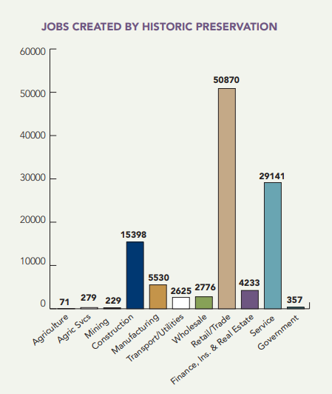
Economic Impacts of Historic Preservation in Florida https://files.floridados.gov/media/32433/economic_impact_summary-of-benefits_pdf.pdf

Historic preservation activities in Florida, including the rehabilitation of historic buildings, heritage tourism, the operation of history museums and activities generated by Florida Main Street programs contribute some $6.3 billion annually to the state. These impacts include the creation of jobs, income to Florida residents, an increase in the gross state product, increased state and local taxes, and increased in-state wealth.

Chapter 2: Historic Preservation in Titusville

Background History for the City of Titusville
The following historical context is intended to help identify and understand existing historic resources in Titusville. It is meant to help establish their historical significance to the city or community. This context is not intended to be a comprehensive history of the city, county, or area.
Civil War and Reconstruction Period (1861-1877)
Titusville was founded in 1867 by Colonel Henry T. Titus, who had served as a blockade runner for the Confederate Army during the Civil War. Titus had attempted several failed business ventures before he decided to establish a town on land overlooking the Indian River, which was owned by his wife, Mary Hopkins Titus. Before the arrival of the Titus’s, the area was known as Sand Point. The small settlement had a U.S. Post Office as early as 1859.
Colonel Titus and Mary established a hotel overlooking the river, called “The Titus House.” They donated land for the first courthouse, four churches, and laid out many of the town’s streets. Titus constructed a stagecoach line and river port by the early 1870s, and in 1873 the town’s name was officially changed from Sand Point to Titusville in honor of its founders (City of Titusville, 2023; Powell, 2018; Schene, 1976; Weaver, 1987).
Post Reconstruction Period (1877-1898)
The town was surveyed by C.B. McGruder in 1876, recorded in 1878, and platted in 1880. J. Francis LeBaron was responsible for platting the town. He established a northern boundary at Garden Street, a southern boundary at South Street, a western boundary at DeSoto Street, and the Indian River provided the eastern boundary. LeBaron was a civil engineer and former Army Corps of Engineers chief and was responsible for the layout of much of the town and early neighborhoods (Powell, 2018; Schene 1976; Weaver, 1987).
By the mid-1880s, railroads including the Atlantic Coast, St. Johns & Indian River Railway Jacksonville & Key West Railroad. A railroad wharf was built on the Indian River in 1885 and served as a transfer point for passengers and freight. The arrival of the railroads resulted in a boom in population and tourism in the area. Rail transportation also provided a means by which products such as fish and fruit could be easily shipped to distant markets. Due to its status as a significant shipping and transportation hub, Titusville was named the Brevard County seat in 1879 (Powell, 2018; Schene, 1976; Weaver, 1987).
Titusville was incorporated as a city in 1887 and the population continued to increase over the following years. When the town was incorporated it had five stores, express and telegraph offices, two hotels, two public schools, and a steam powered sawmill. Two schools were established in the late nineteenth century. Both were located on Washington Avenue and were racially segregated. The Black school was moved to Dummitt Avenue and South Street in 1886 (Foster, 2005; Powell, 2018).
The first subdivision in the town limits of Titusville was platted by LeBaron in 1887. The neighborhood was called Joynerville, named for J.W. Joyner. The newly formed neighborhood included several residences, J.W. Joyner’s Liquor Saloon, J.J. Seymour’s Grocery Stores, Wager’s Grocery Store, and LeBaron’s offices. In the same year two churches, the Presbyterian Church and St. Gabriel’s Episcopal, were constructed. The First Methodist Church and St. Teresa Roman Catholic were constructed in 1889, the same year the First Baptist Church was organized (Powell, 2018; Weaver, 1987).
The Nevins Fruit Company was established in Titusville in the late 1880s by Thomas Nevins. It was later sold to the Parrish family who have operated the business since. The Nevins Fruit Company is one of the oldest continuously operated citrus fruit businesses in the Indian River growing area. Indian River citrus fruit has long been considered among the finest produced in the state and Titusville proved a convenient shipping point for the fruit (Powell, 2018).
The booming fruit industry created a demand for additional services in Brevard County. This included banking services, and thus Captain James Pritchard organized the first bank in Titusville in 1888. It was incorporated as the Indian River State Bank in 1889. Pritchard sold the bank in 1925 and it closed in 1928 due to the Great Depression (Powell, 2018; “The Historic 1891 Pritchard House”, 2012).
The end of the nineteenth century brought new technology to Titusville including electric power. The Edison lighting system was officially adopted by the town council in 1890 and it was installed in April 1891. Captain Pritchard was responsible for the construction of the first electric generating plant in Titusville, it stood on Nevis Court and was later sold to Southern Utilities (later known as Florida Power and Light Company). Electrification allowed for the creation of the town’s first commercial ice plant, owned by the Crystal Ice Company. The plant was established by W.T. Whetmore and allowed for products including fish, fruit, and vegetables to be preserved and transported over greater distances than previously possible (Powell, 2018).
The Jacksonville, St. Augustine & Indian River Railway was extended to Titusville in 1893 and provided additional rail services to the area. The owner of the railroad, Henry Flagler, changed the railroad’s name to the Florida East Coast Railway (FECR) in 1895. The new railway quickly surpassed the steamboat as the primary means of transportation (Graham, 1978; Pettengil, 1952; Powell, 2018).
In the winter of 1894 a sudden freeze effectively destroyed the citrus industry in North Florida. Temperatures dropped to the lowest recorded temperatures in what was termed the “Great Freeze”. All unharvested fruit was lost, and railroads and steamboats were left unused, resulting in widespread unemployment. In February of 1895 a second freeze destroyed what small amounts of citrus had survived. The freezes of 1894 and 1895 impacted the entire state and forced many to seek new occupations (Bradford County Telegraph, 1954; Divine, 1952; Powell, 2018).
In December of 1895, a fire destroyed a large portion of Titusville’s central business area along Washington Avenue between Broad and Julia Streets. Buildings were rebuilt in the following years and the new structures were made of fire-resistant brick rather than timber framing (Bradford County Telegraph, 1954; Divine, 1952; Powell, 2018). Several of the buildings reconstructed in the wake of the fire survive today in varying degrees of preservation and alteration.
Turn of the Century Period/World War I (1898-1918)
Construction to replace buildings destroyed in the 1895 fire was still underway in 1900, although the town continued to serve as a major railroad shipping point, primarily exporting agricultural products. Many of the town’s significant buildings were constructed in the first two decades of the twentieth century. These include the 1912 courthouse, the Spell Building, and the Duren Building. Titusville Elementary and High School was completed in 1916.
The start of the twentieth century brought about several infrastructure improvements in Titusville. The Board of Trade (now the Chamber of Commerce) constructed schools, roads, and a bridge across the Indian River. Additionally, a water system was installed, the first streets were paved, stormwater drainage systems were installed, and a second bank was founded (Bradford County Telegraph, 1954; Divine, 1952; The City of Titusville, n.d.; Powell, 2018).
In 1915 the Black school located on Dummitt Avenue was closed. A new school was located between DeLeon and Wager Streets south of South Street. The new school, the Titusville Negro School, was comprised of two buildings which had were relocated from a White school in town. The school burned down in 1931 but was rebuilt and dubbed the “Old Barn”. It was closed and demolished in 1956 (Bradford County Telegraph, 1954; Divine, 1952; The Negro School in Titusville, n.d.; Powell, 2018).
Florida Boom Period (1919-1929)
During the Florida Boom period Titusville underwent a dramatic change which included the construction of the Dixie Highway. Like most 1920s American towns and cities, especially those in Florida, domestic automobile-based tourism grew in Titusville. Simultaneously, Americans discovered the natural beauty and warm climate of the state, especially the beaches along both coasts. The construction of the Dixie Highway and other roads in the Titusville area attracted tourism and long-term residents as roads were constructed throughout the 1910s and 1920s (Bradford County Telegraph, 1954; Divine, 1952; Powell, 2018; Tebeau, 1971).
Rapid growth trends in Titusville following World War I were similar to those of other communities throughout the state and residential development followed trends set out in South Florida. Towns such as Palm Beach and Coral Gables were the inspiration for several subdivisions platted outside the historic town center during the 1920s (Bradford County Telegraph, 1954; Divine, 1952; Powell, 2018; Tebeau, 1971).
In 1926 the statewide boom collapsed and significant development in Titusville ceased. It was the first significant economic decline since the 1870s. Despite a lack of population growth in the following years, the town persisted due to the presence of the county government (Powell, 2018; Weaver, 1987).
In 1927 the Arthur Dunn Airpark was established in Titusville as a county airport. It originally served as an emergency landing field for the airmail service and was the first airport established between Jacksonville and Miami. The Central Brevard Airport (later named the Merritt Island Airport) was established in the early 1940s, and the Space coast Regional Airport was created in 1943. Together these have served the city and county for decades (The City of Titusville, n.d.; Titusville-Cocoa Airport Authority, 2023).
Depression and New Deal Period (1929-1940)
Titusville experienced little development from the late 1920s until World War II. In 1939 the Banana River Air Force Base was constructed approximately 30 miles from Titusville. This military installation is the only impactful development which occurred during the Depression and New Deal Period and its impacts were not felt until the World War II Period. There are no recorded Works Progress Administration funded projects in Titusville (Air Force Space Museum, 2023; Powell, 2018; Stone, 1988).
World War II Period (1940-1945)
The Banana River Air Force Base was in operation from 1940-1947. It served to support war efforts including housing seaplane patrol operation, a blimp squadron, search and rescue, seaplane pilot training program, and an advanced navigation school. Additionally, the Space Coast Regional Airport was founded as a Navy airfield in 1943. During the war there were several enemy ships sunk off beaches near Titusville. Although the city did not see significant action, a local boat construction company was used to build hundreds of landing crafts at an existing plant at the yacht basin (Air Force Space Museum, 2023; Powell, 2018; Stone, 1988; the City of Titusville, n.d.).
Post-war Period/Atomic Age (1945-1975)
In 1948 the Banana River Air Force Base was transferred to the U.S. Air Force. It was renamed the Patrick Air Force Base in 1950. In 1949 the Long Range Proving Ground at Cape Canaveral was established, further attracting military and space exploration professionals and tourists to the area. The National Aeronautics and Space Administration (NASA) began operations at Cape Canaveral in 1958 (Stone, 1988; Tebeau, 1971; Powell, 2018).
As the NASA center attracted scientists, technicians, engineers, and reporters to Brevard County, Titusville was faced with the need to modernize and provide services to the growing population. Titusville’s easy access, via existing highways and roadways, made it more desirable as a commuter town than nearby Cocoa which had less infrastructure in place. This increase in population resulted in the creation of the Gibson School, which replaced the Titusville Negro School upon its closure in 1956. The school operated as a Black elementary school until 1968 (The Negro School in Titusville, n.d.; Powell, 2018).
The U.S. Fish and Wildlife Service (USFWS) and NASA signed an agreement in 1963 which resulted in the protection of the natural habitat and wildlife on Merritt Island adjacent to Cape Canaveral. The USFWS managed land not occupied by the Kennedy Space Center which was also established that year. The refuge which was created attracted additional tourists to Titusville and provided recreation space for residents (Fish & Wildlife Service 2023; Powell, 2018).
The 1960s also saw the consolidation of Titusville. The cities of North Brevard, Indian River City, Whispering Hills, and Titusville were combined under legislation presented by Senator John Parrish. The newly formed city was dubbed the City of Titusville. The Space Boom of the 1950s and 1960s attracted businesses and recreational facilities to Titusville including motels, apartment buildings, golf courses, and shopping centers where were built in the newly consolidated city (the City of Titusville, n.d.).
In 1963 the Titusville Cocoa Airport District was created. Governed by the Titusville-Cocoa Airport Authority, the district includes the Arthur Dunn Airpark, Merritt Island Airport, and Space Coast Regional Airport. The authority is responsible for maintaining the operations and facilities of these three locations as well as the new Spaceport. The airport authority continues to serve the community and has evolved to include the budding private space travel industry (the City of Titusville, n.d.; Titusville-Cocoa Airport Authority, 2023).
The population boom which resulted from the establishment of the NASA space program near Titusville resulted in several infrastructure improvements. By the mid-1970s Titusville had its first hospital, a new courthouse, two shopping centers, a new post office, Astronaut High School, seven new elementary schools, a new city pier, new library, two country clubs, three radio stations, and 42 churches. The space program also attracted several foreign-born residents including Canadians, Germans, British, Ukrainians, Irish, Polish, Cuban, Swedes, and other Eastern Europeans resulting in a rich blending of cultures (Faherty, 2002; Powell, 2018; Stone, 1988).

Florida in the Modern Era (1975-Present)
Following the successful moon landing in 1969, the space program based at Cape Canaveral diminished. In the decades which followed, the program experienced significant layoffs which resulted in an economic decline in the City of Titusville. Following the end of the Space Shuttle Program, launches have begun to rebound in the last decades with United Launch Alliance and SpaceX providing services for the U.S. Air Force and NASA payload launches as well as privately funded ventures. Titusville continues to attract visitors and residents to the area due to the Kennedy Space Center, Cape Canaveral Seashore, and Merritt Island National Wildlife Refuge. Today, like many coastal communities in Florida, Titusville is called the redfish capital and draws sport fishers and beach goers every year. The City of Titusville remains a vacation destination and boasts a diverse community with a historic downtown undergoing revitalization (Powell, 2018; Walters 2003).

Historic Properties
The City of Titusville currently has one National Register Historic District, the Titusville Historic Downtown Commercial District, six buildings and two sites listed individually in the National Register of Historic Places, and 12 locally designated historic resources. All of these resources are provided for in the City’s Code of Ordinances and are subject to the City’s Historic Preservation Code.
A historic district is a group of buildings, structures, and sites within an established district boundary which are considered significant for their architecture, history, or association with a significant person. The Titusville Historic Downtown Commercial District is composed of several adjacent buildings used historically for commercial activities.
The National Register of Historic Places (NRHP) is the United States Federal Government’s official list of districts, sites, buildings, structures, and objects that are considered worth preserving due to their architectural or historical significance. The NRHP, established by the National Historic Preservation Act of 1966, is administered by the National Park Service (NPS) under the U.S. Department of the Interior.
Locally designated buildings, sites, and districts are recognized as worthy of preservation similarly to resources included in the NRHP. The City’s Historic Preservation Board (HPB) is responsible for recommending proposed Local Register and National Register buildings or districts to the City Council. Locally designated resources meet similar criteria for significance and integrity as those listed in the NRHP but are not necessarily listed in the NRHP. These resources are significant on a more localized level compared to the NRHP listed resources although some buildings are listed on the NRHP and are locally designated.

Before (ca. 1900) and after of the Pritchard House
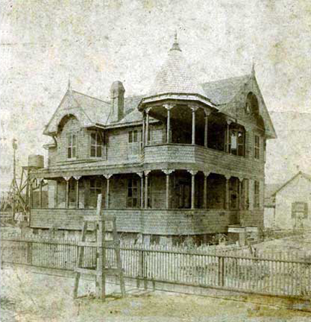  Source: Pritchard House Website | 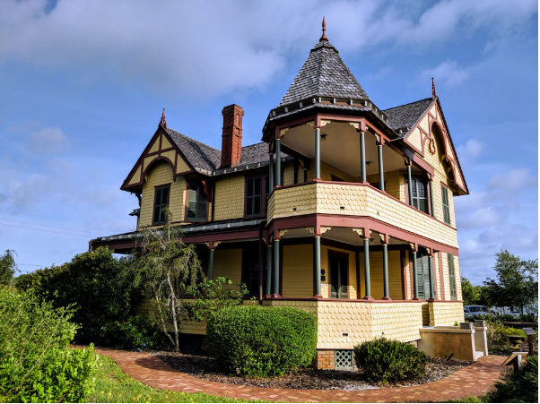

Individually Listed National Register Resources
The following resources are individually listed on the National Register of Historic Places.

The Pritchard House  424 Washington Avenue | The Wager House  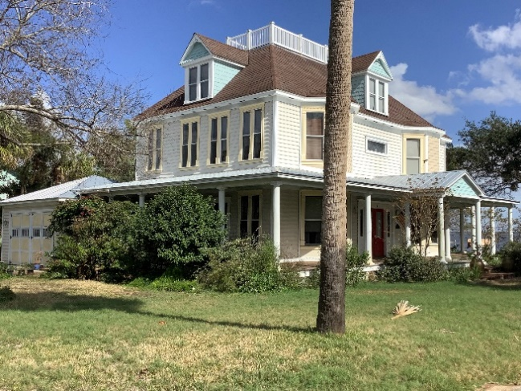  621 Indian River Avenue
Judge Robbins House  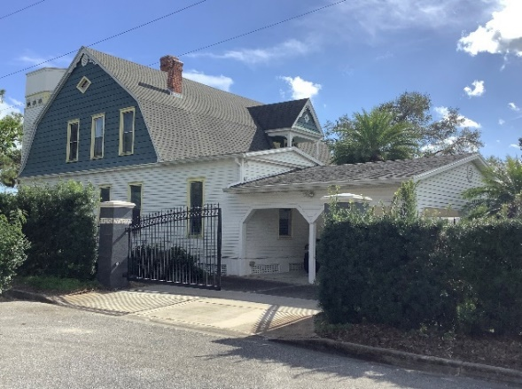  703 Indian River Avenue | The Spell House  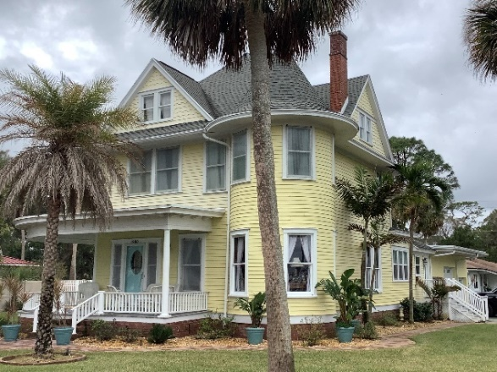  1200 Riverside Drive

St. Gabriel’s Episcopal Church  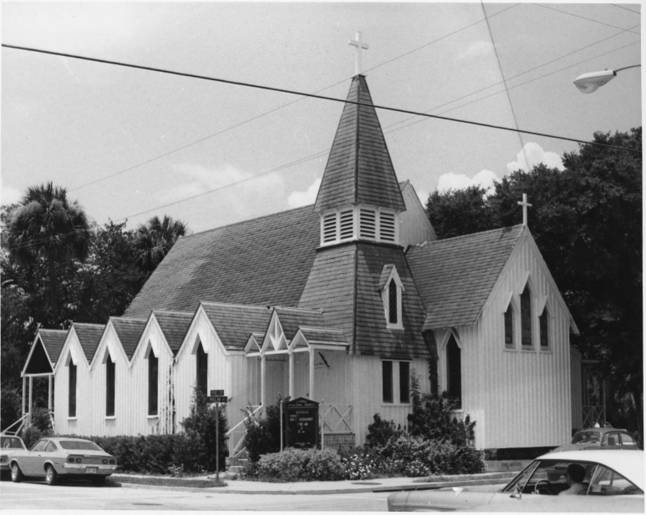  414 S Palm Avenue  (Photograph courtesy of the National Archives) | La Grange Church and Cemetery  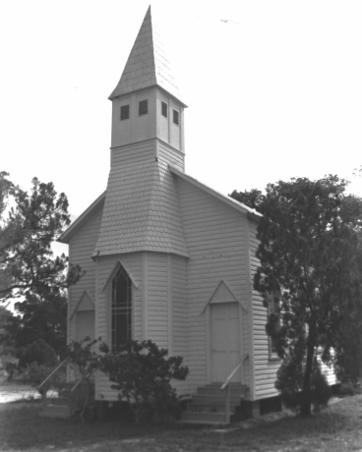  1575 Old Dixie Highway  (Photograph courtesy of the Florida Master Site File)

Locally Designated Historic Resources
The following resources have been designated Historic Resources by the City of Titusville.
The Carter House  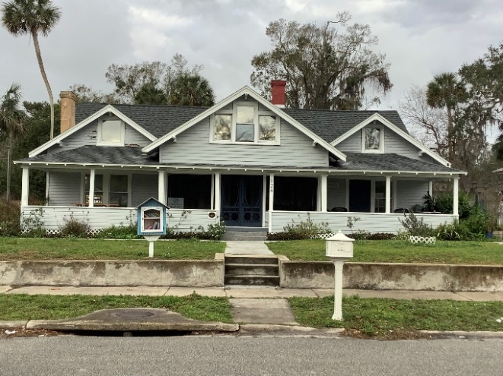  126 Grannis Avenue | The Norwoods House  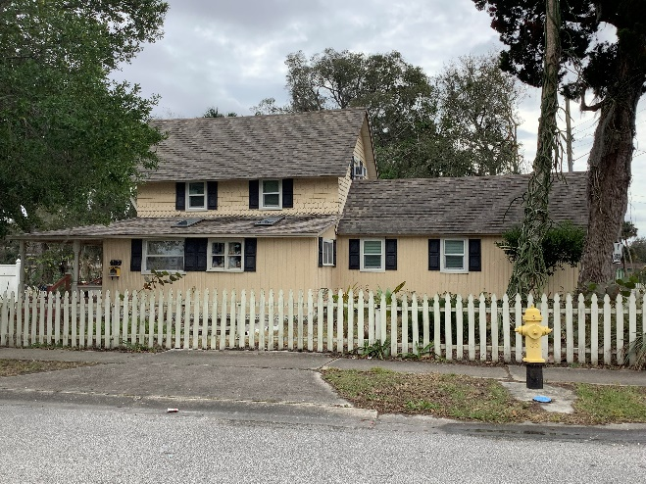  715 Tropic Street
Liberty House  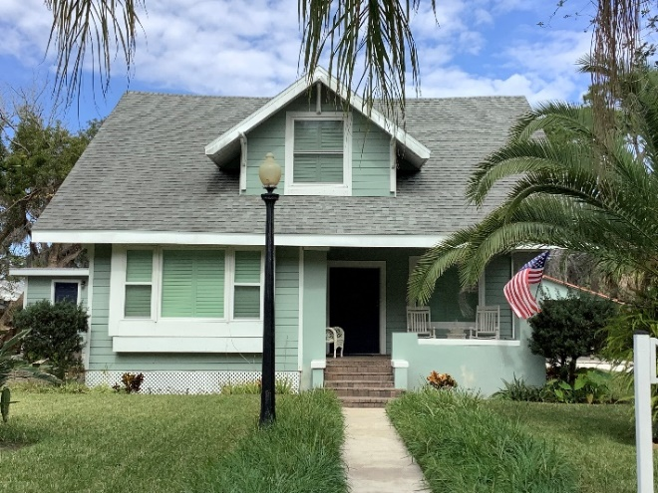  4050 Coquina Avenue | Hill Hotel Apartments  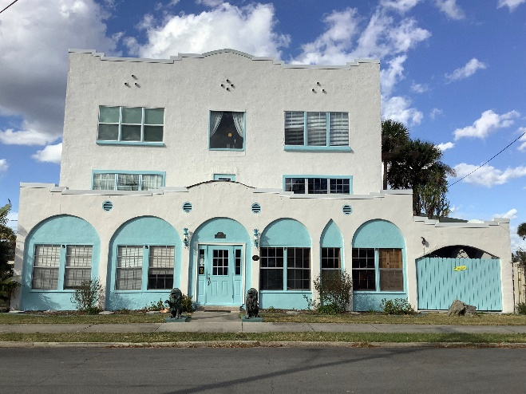  422 Julia Street

The Duren Building  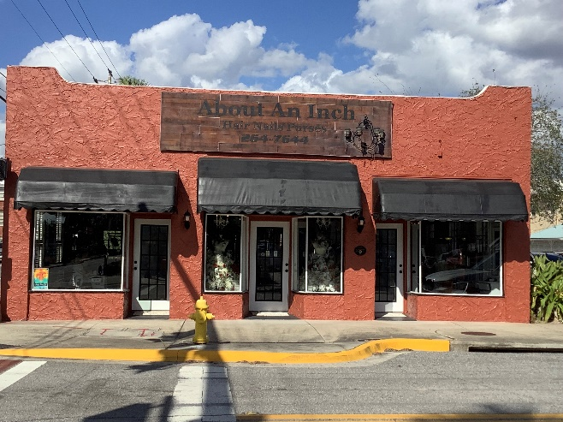  214 Julia Street | The Pritchard House  424 Washington Avenue
The Brady House  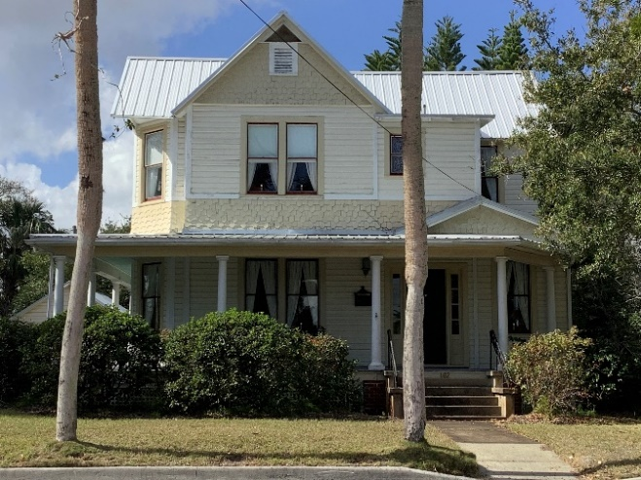  602 Indian River Avenue | The Judge Carlton House  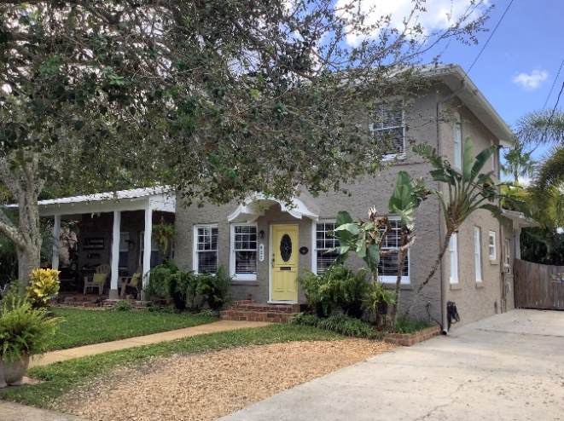  820 Indian River Avenue

The Dobson House  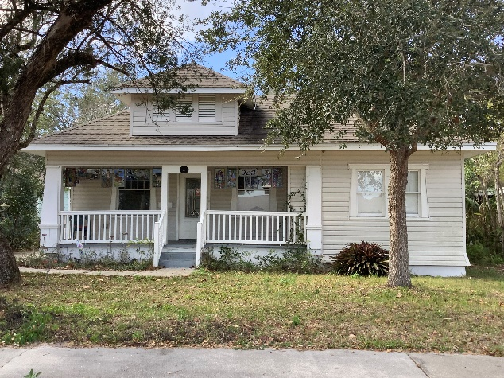  902 Indian River Avenue | The Conkling House  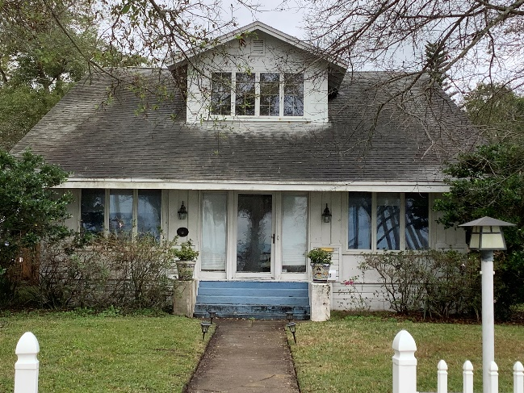  1120 Riverside Drive
St. Gabriel’s Episcopal Church  414 S Palm Avenue  (Photograph courtesy of the National Archives) | Hill’s Grocery and Lunch Store  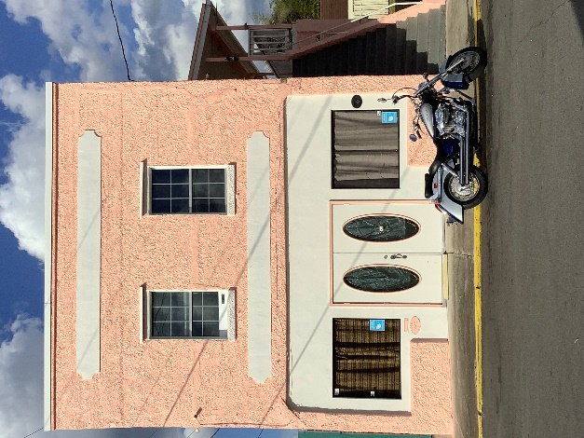  428 Julia Street

Historic Preservation Code
The Historic Preservation Code (HPC) was established by Chapter 29, Article VI of the City’s Code of Ordinances. The ordinance applies to all property located within the city limits of Titusville. The ordinance strives to protect properties of historic, cultural, archaeological, aesthetic, or architectural merit to promote the health, safety, education, and cultural and economic welfare of the public. The ordinance accomplishes this by:
- Establishing the position of Historic Preservation Officer (HPO)
- Defining the HPO’s duties
- Outlining a process to designate individual historic resources, archaeological sites and zones
- Establishing the process of issuing Certificates of Appropriateness (COAs) including an
appeals process
- Assisting the city and property owners with federal tax incentives, federal and state grant funds, and other “potential property tax abatement programs for the purpose of furthering historic preservation activities6F”
- And preventing urban decay by encouraging rehabilitation and revitalization and thus fostering civic pride providing sites and districts for the education, amusement, and welfare of citizens
The ordinance also contains definitions of relevant terminology and outlines the appointment and duties of the Historic Preservation Officer (HPO). The article states the City’s Historic Preservation Program is administered by the Planning and Growth Management Department of the City with a HPO appointed by the City Manager. The HPO serves as assistant to the Historic Preservation Board (HPB) and coordinates HPB meetings, prepares reports and National Register Nominations, reviews building permits, and participates in preservation programs. A full list, and specific details of the HPO’s responsibilities are in Section 29-115 (a)-(p) of Titusville’s Code of Ordinances Land Development Regulations.
The HPC requires owners of resources in a designated historic district to maintain their property so that they may not fall into disrepair. The HPB is given the ability to judge whether intentional neglect has resulted in the deterioration of the resource’s exterior or architectural features reducing the character or life of the resource. Per the ordinance, if the HPB determines that intentional neglect has occurred, they may refer the property to the Department of Building and Code Enforcement. The resource may then be subject to code violation fines and penalties.
The process for designating a site or zone is outlined in Section 29-116 and Section 29-117 of Titusville’s Code of Ordinances and is discussed in further detail in Chapter 3 of this report. The processes for listing a building in the NRHP and applying for a COA are also described in Chapter 3. Text of the full ordinance is included in Appendix E.

Historic Preservation Board
The City of Titusville’s Historic Preservation Board (HPB) was established by Chapter 31, Article VI of the City’s Code of Ordinances. The HPB was created to create, update, and maintain an appropriate plan for the historic sites and districts in the city. The HPB is also tasked with determining and recommending to City Council historical sites, historical architectural features of any new building or the modification of existing buildings within the city of a historical nature. The HPB is the official reviewer of exterior changes to sites and structures and new development within designated districts. This review process is conducted through the application and hearing of a COA.
The Planning and Growth Management Department serves as the staff liaison to the Historic Preservation Board and can be reached at 321-567-3860
The board consists of seven members and two alternates, serving two-year terms. Five out of seven of the regular members are required to have resided within the City of Titusville for at least one year. Members are appointed by the City Council and are expected to have an interest or experience in historic preservation. Relevant professions and hobbies include local art historians and architectural historians, architects, urban and regional planners, landscape architects, lawyers, engineers or building contractors, realtors or property appraisers, interested residents of city historic districts, and members of the Brevard County Historic Preservation Commission. These individuals, according to the Code of Ordinances, “will have the ability and desire to act in the public interest and represent, insofar as possible, the various special personal and professional interests required to make informed and equitable decisions concerning the preservation, conservation and protection of historic districts and structures”.7F
Historic Preservation Commission meetings must be held in a public setting and have a quorum of at least four members present. Chapter 31, Article VI of the City’s Code of Ordinances also establishes rules for voting. No specific requirements are established regarding the number of meetings held in a year or other requirements. More information can be found in the City of Titusville’s Code of Ordinances Land Development Regulations Chapter 31 Article VI.

Florida Master Site File Forms
Blank forms, manuals and other FMSF documentation may be downloaded at:

www.flheritage.com/preservation/sitefile

The Florida Master Site File is Florida’s official inventory of historical and cultural resources. Each of these resource types has a form, called an FMSF Form, which documents the resource’s features and information. The Master Site file maintains resource forms, reports, and surveys which are relevant to the history of, and preservation in, Florida. These documents are accessible upon request. Standard Site File forms and form manuals are available for historical standing buildings and structures, historical bridges, historical cemeteries, historic shipwrecks, historic districts and other resources.
Understanding Your Property’s FMSF
The FMSF Form is broken into seven sections:
Location and mapping
This section pinpoints the precise location of the property.
History
The History section provides a basic overview of the property. At a minimum, this section will include the construction date, original and current use of your building, and identify whether it has had alterations and additions. Additional information may include the Architect and/or Builder, information noting if the building has been moved, and, whether it is affected by the local preservation ordinance.
Description
This section is where you will find important architectural information about your property that should be considered when planning a rehabilitation, restoration, addition, or other type project. This section documents all of the character defining features of the property, and includes:
- architectural style
- roof type
- exterior materials
- types of windows
- distinguishing architectural features
- number and type of chimneys
- structural system
- main entrance and porch descriptions, and
- condition evaluation

Research Methods
This section documents the methods used and sources consulted by the recorder to research the property’s history.
Opinion of Resource Significance
This section contains the recorder’s opinion on whether the property is eligible for the National Register of Historic Places, under which category, and why.
Documentation
This section references important documents which were identified in researching the property that provide additional information not covered by the form.
Recorder Information
This section lists the recorder’s name, affiliation, and contact information.
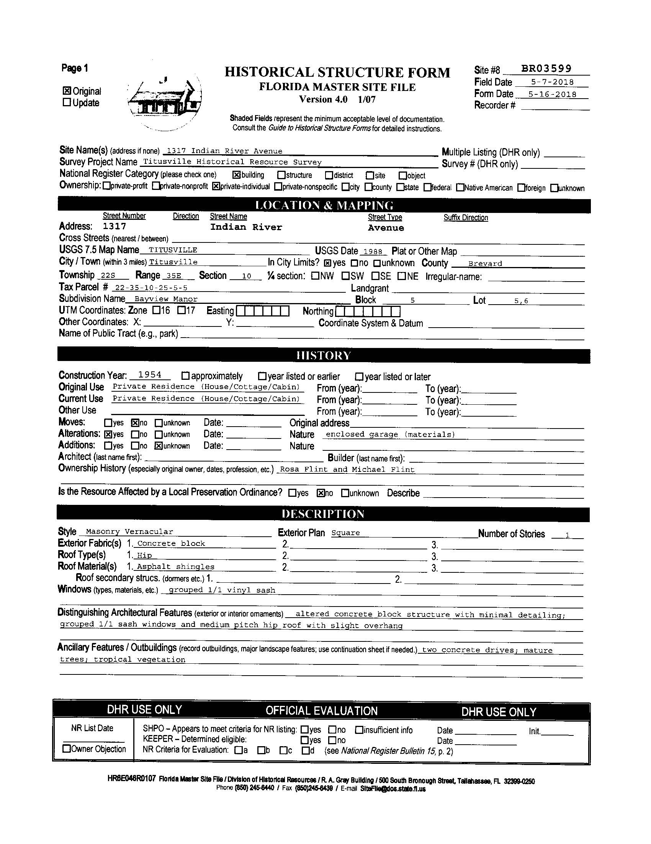
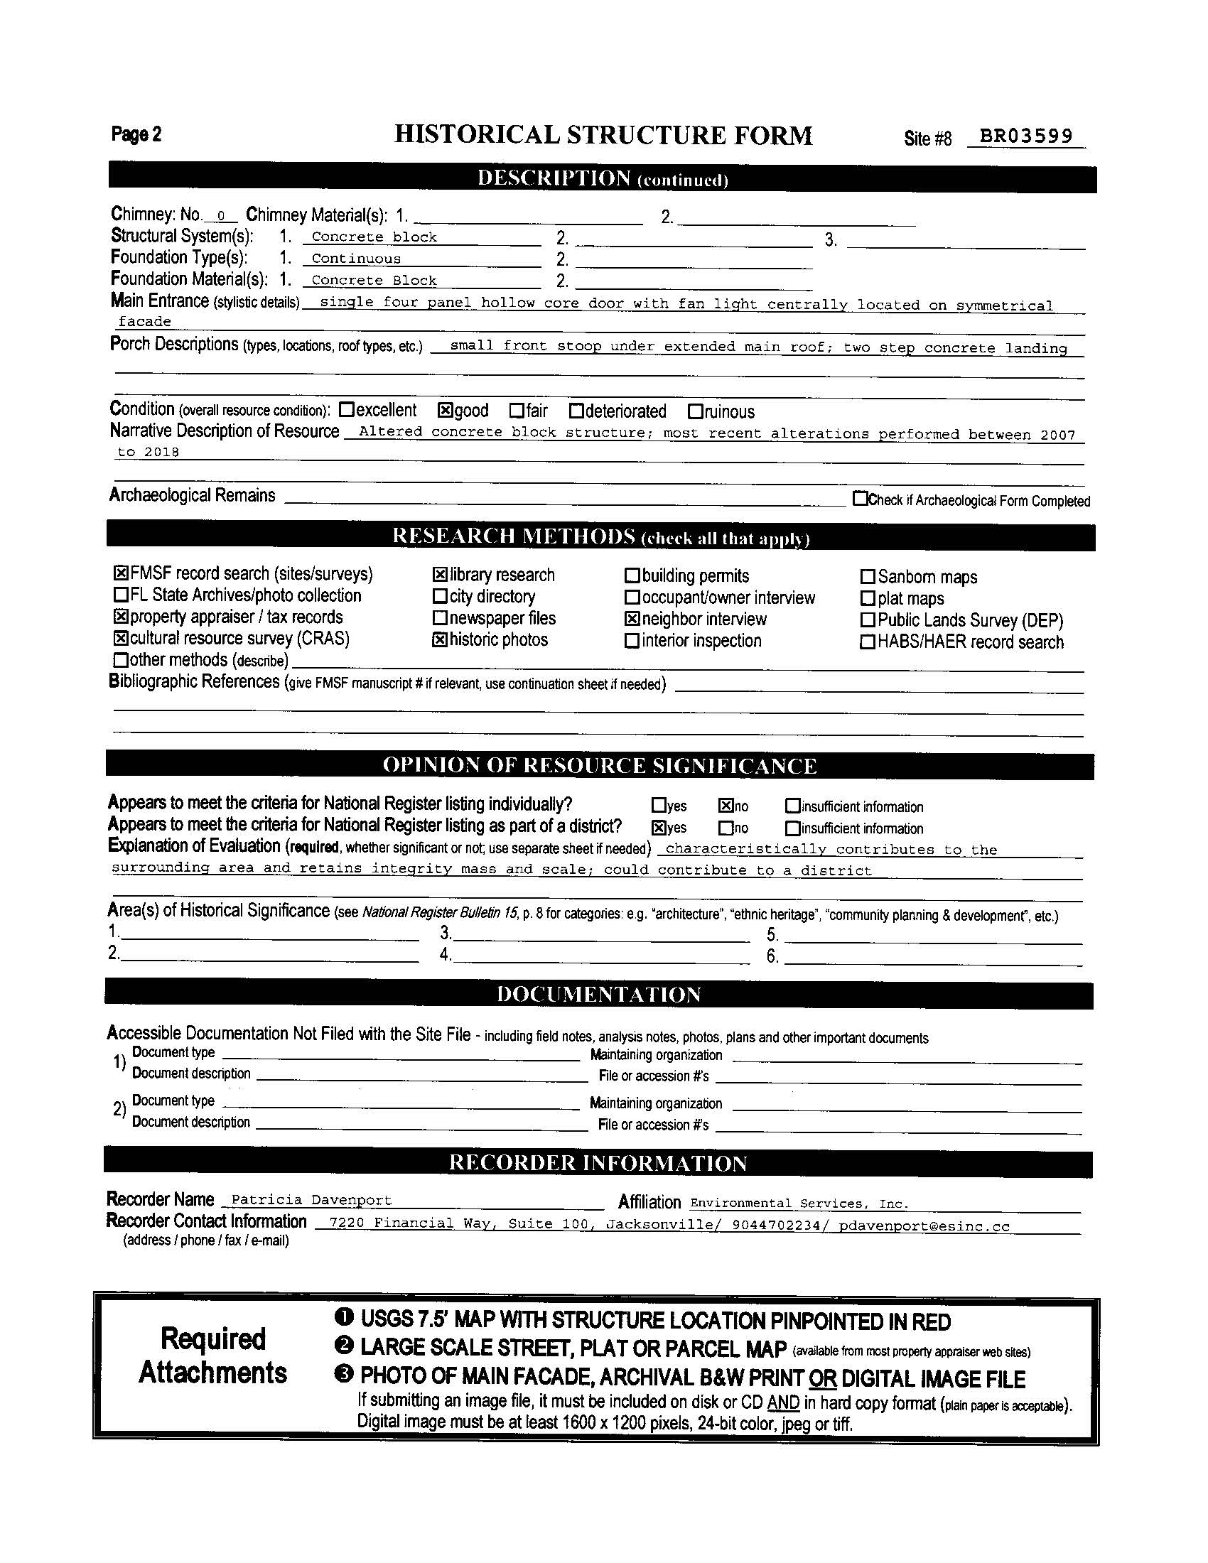

Chapter 3: Procedures
The Historic Preservation Board (HPB) is the City of Titusville’s official preservation review board. As part of its duties, the HPB oversees the nomination of historic resources within the city limits to the National Register of Historic Places (NRHP) and provides design review for proposed alterations to historic resources.
The process of nominating a resource to the NRHP or local designation includes notifying property owners and the public, hearing and recording public comment, and providing recommendations to the City Council and State of Florida. The following section outlines the procedures for those HPB duties.

Nominations to the National Register of Historic Places
The HPB receives and reviews all nominations to the NRHP. The HPB considers applications for all resources located within the city limits following the regulations of the Florida Bureau of Historic Preservation. The process of NRHP nomination includes notifying property owners and neighbors, soliciting public comments, and referring eligible resources to the state for further consideration.
The NRHP is the federal government’s official record of buildings, structures, sites, objects, landscapes, and other natural and cultural resources. Resources eligible for listing in the NRHP include:
- Buildings such as houses, barns, schools, hotels, or other constructions intended to shelter any type of human activity.
- Structures includes purpose-built constructions which are functional but primarily used for any reason other than human shelter. Examples of structures include bridges, dams, and lighthouses.
- Objects an object is a construction that is primarily artistic in nature or small in scale and simply constructed. Objects can be movable but will be associated with a specific setting or environment. Examples of objects include fountains, monuments, and statues/sculptures.
- Site a site is the location of an event or a prehistoric or historic occupation/activity or building/structure. Sites can be standing, ruined, or missing. The location of the site can possess its own historic, cultural, or archaeological value regardless of existing structures. Sites can include battlefields, trails, shipwrecks, and archaeological sites.
- District a district is a concentration of resources united historically or aesthetically by plan or physical development. Districts can be located anywhere and may include rural, commercial, residential, or industrial areas.

Historic resources nominated to the NRHP are recognized for their significance on a local, state, or national level. Resources listed in the register must meet one or more of the NRHP criteria for listing:
More information can be found in the National Register Bulletin “How to Apply the National Register Criteria for Evaluation”

https://www.nps.gov/subjects/nationalregister/upload/NRB-15_web508.pdf

- Criterion A resources that are associated with events that have made a significant contribution to the broad patterns of our history. Examples of this include a district which was constructed due to railroad development, or a church associated with the Civil Rights movement.
- Criterion B resources that are associated with the lives of persons significant in our past. Examples include the studio of a famous artist, or the home of one of America’s founding fathers.
- Criterion C resources that embody the unique characteristics of a type, period, or method of construction. Resources that represent the work of a master, or that have high artistic value are also eligible under this criterion. Examples include a house designed by Frank Lloyd Wright or a well-preserved Queen Anne style house.
- Criterion D resources that have yielded, or may be likely to yield, information important in
prehistory or history. This criterion is primarily used for archaeological resources and may include a prehistoric Native American settlement site.

For a resource to be listed or eligible for the NRHP, it must maintain historic integrity. "Integrity” describes the historic resource’s level of preservation A property that has historic integrity has retained enough of its defining characteristics to convey its significance.
There are seven aspects of integrity. They are:
- Location — The place where the resource was constructed, or the historic event took place. This element of integrity is related to whether or not the resource has been moved/relocated.
- Design — The combination of the original elements of a resource. This includes form, plan, space, structure, and style of a property.
- Setting — The setting is related to the resource’s location but refers to the entire surrounding environment. This includes surrounding buildings, landscape features, and other natural or constructed features.
- Materials — Materials are the physical elements that were combined or deposited during a particular time period and in a design to form the historic property. The integrity of materials relies on how much of the original building materials remain visible. Material integrity is maintained if repairs are made in-kind.
- Workmanship — Workmanship is closely related to materials and refers to the way something was constructed. Typically, the resource loses its integrity of workmanship if there is no integrity of materials.
- Feeling — Feeling is a subjective aspect of integrity that refers to a resource’s ability to convey aesthetic or historic sense of a specific time period. Feeling comes from the physical features of the resource, setting/design/materials/etc., that communicate the history of the property.
- Association — A resource’s direct link between a historic event or person and the historic property. Like feeling, physical features which convey the historic character of a property are required to relay the relationship between the place and the event or person.
When a local historic property is considered for listing in the NRHP, the HPB will seek written comment on the nomination from both the City Council and the Board of County Commissioners for Brevard County. The HPB will then schedule a public hearing and provide 30-75 days’ notice to the property owner(s).
The HPB will also seek comments from the public regarding the proposed nomination. The HPB will document all comments from the public in the nomination report. Any objections to the listing given by adjacent property owners will also be notarized and filed with the Historic Preservation Officer (HPO).
The nomination report and recommendations from the HPB will be submitted to the State Historic Preservation Office (SHPO) within 30 days of the meeting at which the nomination was heard. If the HPB recommends listing in the NRHP, the State Review Board for the National Register will consider the nomination in accordance with state and federal regulations at their next regular meeting.
If the HPB does not recommend listing in the NRHP, and the SHPO concurs, the SHPO will take no further action on the nomination. Interested parties may file an appeal for further consideration with the SHPO if necessary.

Local Designation
The Historic Preservation Code provides for local designation of historic resources including places, buildings, structures, objects, landscape features, archaeological sites and zones, and other improvements. Similar to NRHP listing, a local designation indicates the resource is significant for its architecture, history, or association with a significant person.
For more detailed information on the designation criteria and considerations see Titusville’s Code of Ordinances Chapter 29 Article VI Section 29-116.

Locally designated resources also have certain protections provided by the HPB. Primarily a designated resource, or property within a designated district, undergo a thorough review process for any type of alteration, improvement, addition, or demolition.
Potential historic properties are evaluated using criteria similar to the National Register Criteria for Evaluation. The site, district, or zone must possess adequate significance in Titusville’s history, architecture, archaeology, and/or culture. Additionally, the resource must possess historic integrity, and meet one of the following outlined criteria:
- Events — associated with an event or pattern in history which is significant to history.
- Persons — associated with the life or lives of person(s) significant in history.
- Design and Construction — has a quality of design and/or construction typical of an architectural type, style, period, or method of construction. This may include regional adaptations to architecture which are significant to the state or superior craftsmanship. Additionally, the resource may be associated with a significant builder or architect.
- Information Potential — typically used to describe archaeological resources, this describes a site’s potential to yield historical or pre-historical information which contributes to our understanding of human history or prehistory.
- National Register Listing — the resource is already listed in the NRHP.
- Distinctive Feature — The resource is part of or related to a landscaped park, environmental features or other distinctive area. This resource type is a feature of a neighborhood including a street clock or historic sign that contributes to the distinctive quality of a neighborhood or the city.

A property owner may initiate the designation of a property, site or zone by petitioning the HPB. The HPB may also initiate designation of a historic resource. When a potential resource has been identified for designation, the HPO will prepare a designation report and file the report with the HPB. A designation report will contain:
- A legal description of the property.
- Written account of the historical/cultural/architectural/archaeological significance of the property. This includes how the property meets the criteria for designation.
- A location map and photographs of all exterior surfaces and the interior, if applicable.
- Parcel identification information including the parcel and tax account numbers related to the property and the property appraiser’s records of the property.
- A copy of the public hearing notice as published in the newspaper.
- The report will be based on the existing conditions of the property and denote integrity.
- Boundaries for individual historic sites and a recommendation for boundaries for archaeological zones.
The report may include detailed proposed zoning regulations compatible with its designation. These may be new zoning regulations or alterations to the existing zoning and may include things like setbacks, lot size, and density.
Additional information on the designation report can be found in the City’s Code of Ordinances Chapter 29 Article VI Section 29-117(c).

Once the HPB receives the initial designation report, it must schedule a public hearing. The public hearing may not be scheduled sooner than 30 days from receipt of the designation report. The public must be notified of the scheduled hearing at least 10 days in advance via publication in a newspaper of general circulation in the City and Brevard County. These hearings are open to the public, and all interested parties who wish to give public comment during the meeting have the right to do so.
If the HPB, rather than a property owner, initiates the designation process the property owner(s) will be notified of the designation and scheduled public hearing. Property owner consent is required for individual designations. An individual designation application will not proceed without the owner’s permission.
Notification of the application will be provided to adjacent property owners (owners within a 500-foot radius of the proposed designation area). The notification will include a copy of the designation report and will be provided at least 15 days prior to the public hearing. If the proposed designation area is in or partially within an established City or County Redevelopment Agency, the agency will be notified of the designation and the public hearing.
At the public hearing, the HPB will decide to approve, deny, or amend the proposed designation. They may also postpone the decision if additional information or consideration is required.
In cases where the designation of a historic resource will require a modification or variance to the existing zoning, the HPB will send its recommendations to the Planning and Zoning Board (PZB) for review. The recommendations of PZB and HPB will then be sent to City Council simultaneously for final review and ruling.
City Council will make the final decision on the proposed designation following review of the recommendations from HPB and PZB, if applicable. The council may approve or deny the designation. City Council may also grant a conditional approval. Following approval, the council notifies all affected parties providing a copy of the resolution pursuant to Chapter 31 Article VI Section 29-116 of the City’s Code of Ordinances. Notified parties include:
- All affected City departments;
- The City Clerk who records the resolution in the Brevard County public record;
- Owners of affected properties;
- Other parties which have expressed interest in the property; and
- Any appropriate county and state officials per the requirements of the CLG program, including the SHPO.
City Council may also to amend or revoke any local designation in the future.
Upon completion of the designation report and owner notification, the city places a moratorium on the subject property. The moratorium lasts until City Council makes a final ruling decision; if 120 days have passed since the filing of the designation report; or if an appeal to City Council for the designation of the property is upheld. The moratorium prevents the property owner or occupant from erecting any structure, altering, restoring, rehabilitating, renovating, relocating, or demolishing the property.
The City also is prohibited from issuing any permits for new construction, alteration, rehabilitation, renovation, restoration, or demolition on the property during the designation review process. The permit ban lasts until a determination has been made by the council, 120 days have passed since the initial filing of the designation report, or an appeal to City Council has been upheld.

Certificates of Appropriateness (COA)
Certificates of Appropriateness (COA) are permits which are issued for all proposed work in a designated district or at an individually designated property. In districts, the city requires COAs for all buildings including new construction. Additional information on the specific features and types of work which require a COA can be found in Section 29-119 of the Code of Ordinances.
Landscape features and site improvements are those associated with the historic context of the property. These features may include individual plants or trees, groups of plants or trees, agricultural fields, planting beds, walls, fences, signs, sidewalks, driveways, and lighting. Alterations, additions, or removal of these features require a COA.
The HPB has been delegated regulatory authority to approve, deny, or approve with conditions the permits known as a COA. The HPB operates in this role as a quasi-judicial body, which makes decisions on an applicant’s proposed activity based on the adopted standards, these guidelines, and other appropriate factors.
COAs are typically issued by the HPB. However, the HPO may review and issue COAs without board approval for standard work. A standard COA may be issued by the HPO when:
- The proposed work will have minor effects to the historic resource.
  - Minor alterations to the rear of a building which are not visible from the right-of-way.
  - Work that does not obscure architectural features and work which is easily reversed or removed.
- When the work proposed is deemed a replacement in-kind.
  - Minor replacement of wood siding with wood siding painted to match the existing finish.
  - Repair of historic windows.
  - Replacement of a roof with the same material as the roof it is replacing.

Determining Whether a COA Is Required
A COA is not required for regular maintenance of any designated historic building, structure or object, or any building or structure or object in a designated district. Regular maintenance may include, but are not limited to:
- Cleaning with appropriate materials (i.e. no sandblasting or harsh chemicals-See The Secretary of the Interior’s Standards for the Treatment of Historic Properties)
- Replacement of lightbulbs on exterior light fixtures.
- Repainting previously painted surfaces.
A COA is required for any work being performed on the exterior of any designated building, site, or structure within the city limits. A COA is also required for exterior work on any building, site, or structure within a designated district in city limits. If a building’s interior has been designated according to Section 29-117 of the Code of Ordinances, interior work is also subject to a COA review and obtainment of a COA.

Procedural Steps: Obtaining a COA
COAs are issued by the city prior to the approval of applications for building permits or other City issued permits. COAs do not replace other permits (i.e. electrical or building permits) or approvals required from the City or other regulatory agencies (i.e. the Army Corps of Engineers).
During a COA application, the applicant is encouraged to work closely with the HPO and City staff. A pre-application conference should be conducted with the applicant and the HPO to review the proposed project. The meeting will also provide the applicant with comments and guidance and clarify city preservation objectives and design guidelines. This optional meeting is recommended prior to the submission of the COA application and seeks to minimize potential issues which may arise.

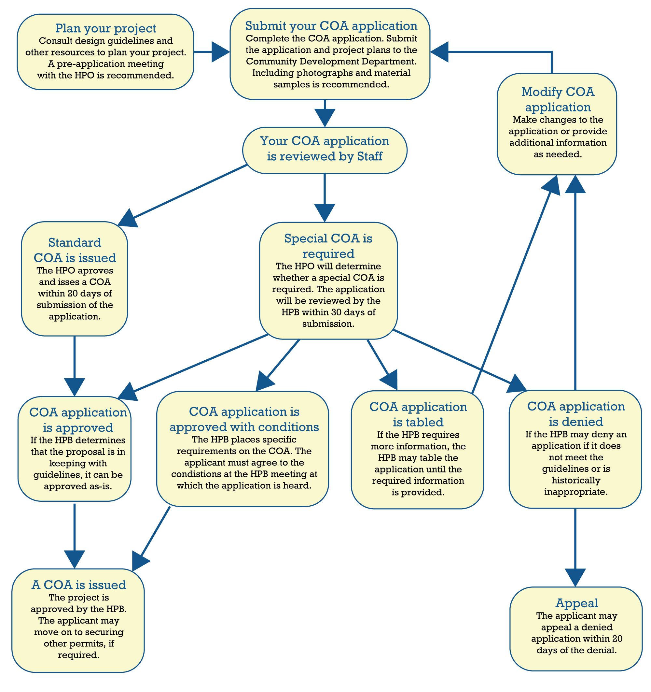

Standard Certificate of Appropriateness
For a standard COA, the HPO will review the completed application within 20 days of receipt and approve or deny the application. Following the HPO’s review and decision, the applicant will be notified and provided an explanation for the approval or denial.
Should the application be denied, the applicant may challenge the HPO’s decision by submitting a special COA. The special COA must be applied for within 30 days of the HPO’s original determination.
The applicant may request that the initial application be considered as a special COA. If the applicant requests the COA be heard as a special COA, it will follow the process for special COAs. In this case, the HPO will not make a determination on the application.
Special Certificate of Appropriateness
When the proposed project is more involved potentially including material alterations, relocation, additions, new construction or demolition, the application is considered a special COA. The HPO determines if the application requires consideration as a special COA. A special COA may be required if the project involves:
- Material alterations
- Relocation
- Additions
- New construction or
- Demolition
The HPB considers the application, in a public forum, within 30 days of receipt of the completed application. Public notice of the application hearing is given at least 10 days prior to the meeting date through a city or county-wide circulated newspaper.
After the meeting date has been set, the property owner(s) and adjacent property owners (those within 500-feet of the affected property) are be notified by mail. The addresses of adjacent owners are based on Brevard County Property Appraiser tax records and failure to notify an adjacent property owner does not invalidate an application.
At the public hearing, the HPB approves, denies, or approves the application with conditions. The applicant must accept the conditions during the hearing if they are conditional to the approval of the COA. The HPB may suspend action on an application to consult a professional for technical advice. The board may also suspend the meeting to meet with the applicant to revise or modify the application.
If the application is denied by the HPB, the applicant has the right to appeal the HPB’s decision to City Council. The appeals process is outlined in Section 29-120 of the Code of Ordinances and discussed in a following section.

Guidelines for COA review
All proposed projects subject to standard or special COA review are assessed in accordance with the Secretary of the Interior’s Standards for the Treatment of Historic Properties (the Standards).
The HPB review process highlights several standards which align with the Standards. These include:
- The property shall remain used for its original purpose. If the property’s use changes, the required alterations should require minimal changes to the defining characteristics of the building and its site and environment.
- The applicant will retain and preserve historic character. Alteration and removal of materials and features will not occur.
- Distinctive features and finishes and construction techniques or examples of craftsmanship that characterize a property shall be preserved.
- The applicant will retain and preserve historic age alterations that have acquired their own significance.
- Each property shall be recognized as a physical record of its time, place, and use. Changes that create a false sense of historical development will not occur. This may include adding speculative features or elements which make the feature appear older or younger.
- The applicant shall replace deteriorated or damaged historic features. Historic features will not be replaced unless necessary. Replacement elements will match the original element. replacement element will match the original in:
  - Design
  - Color
  - Texture
  - Other visual qualities
  - Original materials, when possible
  - Additionally, the replacement of missing features shall be substantiated by documentary, physical, or pictorial evidence
- Physical and chemical treatments which result in the loss of historic material, such as sand blasting, will not be used on historic materials. The gentlest methods of cleaning will be used.
- New additions and exterior alterations, or new construction, will not destroy historic materials that characterize the property. New work will:
  - Be compatible with the existing massing, size, scale, and architectural features of the original resource.
  - Be differentiated from the old or original construction.
  - Be completed so that if removed or reversed in the future, the integrity of the original property and environment will not be impacted.
- Archaeological sites and resources will be preserved so that such resources are not disturbed, and mitigation will be undertaken as necessary.
The HPB has the right to adopt additional standards which will “preserve and protect special features unique to the City”.8F The HPB does this by weighing the application, designation report, and additional information (photographs, drawings, plans, and sample materials) against the Standards. The board will determine if the proposed work aligns with the Standards. The design standards which are weighed against the Standards include:
- Architectural style, scale, massing, siting, and general arrangement,
- Type and texture of building materials,
- Type/style/materials of roofs/windows/doors/siding/signs,
- Significant architectural features (including porches, balconies, dormers, storefronts, etc.), and
- For exterior alterations: the original design of the building and other features.
If an applicant wishes to alter their approved COA, the proposed alterations will be reviewed by the HPO. The HPO is authorized to approve changes to the issued COA, by amending the original COA. The HPO can approve the amendment if the proposed changes do not materially affect the historic character of the resource. A COA amendment may also be approved by the HPB if the proposed changes are in accordance with approved guidelines and/or standards.
If the HPO determines that the proposed changes affect the materiality and/or historic character of the property or are not in accordance with approved guidelines and/or standards, the application for approved changes will be treated as a new COA application.
All work conducted under an approved COA must conform to the requirements of the issued certificate. The City will inspect the work as necessary, and the inspector has the right to issue a stop work order if the work is not in accordance with the approved COA.

Guidelines for COA Demolition Applications
Review of demolition requests are considered a COA demolition request. A COA demolition request applies to any resource or resource within a district including its improvements.
Within three working days of receipt of a demolition COA application, a notice of the COA demolition request is be posted on the subject property. The posted notification will be placed where it is clearly visible from the street and will remain in place for the duration of the application and permitting process.
Demolition requests are considered using six questions:
- Is the structure of such interest or quality that it would reasonably meet national, state, regional or local criteria for designation as a significant historic or architectural site or structure?
- Is the structure of such design, craftsmanship or material that it could be reproduced only with great difficulty or expense?
- Is the structure one of the last remaining examples of its kind in the city, county or region?
- Does the structure contribute significantly to the historic character of a designated district?
- Would retention of the structure promote general welfare of the city by providing an opportunity for study of local history, architecture and design or by developing an understanding of the importance and value of a particular culture and heritage?
- Are there definite plans for reuse of the property if the proposed demolition is carried out, and what will be the effect of those plans on the character of the surrounding area?
If a COA demolition request is approved, the HPB may encourage the applicant to salvage or preserve historic building materials, architectural details, ornaments, or fixtures for reuse in other restoration projects.
For approved COA demolition requests, the HPB may require the applicant to record the building for archival purposes prior to demolition. If the HPB requests recordation, it will be done at the owner’s expense and using photographs at a minimum.
Should the HPB deny a demolition COA request, the board provides the applicant with a written statement describing the reasons for denial. The HPB will provide this statement to the applicant within 15 days of the board’s denial of the COA application.
Guidelines for COA Structure Relocation Applications
A COA for relocation applies to resources which are individually distinguished or are in a historic district. Resources in a district which are being located within or without the district require a COA for relocation. A resource which is being relocated from outside a district into a historic district will also require a COA for relocation.

No individually designated resource may be relocated except through the COA for relocation process. The HPB will determine if any reasonable alternative is available for preserving the resource in its original site or not. The HPB will determine if the proposed location where the resource will be relocated to is compatible with the historic setting and architectural integrity of the resource.
Guidelines for COA Certificate to Dig
A certificate to dig is also issued through the COA process. This COA applies to archaeological zones which are areas in where there is a high likelihood of evidence of past cultures remaining in situ (undisturbed under or partially under the surface). A COA to dig is require for:
- Any construction
- Placement of utilities
- Stormwater retention
- Filling
- Digging
- Removal of trees
- Any other potentially disruptive activity
Any of these ground disturbing activities are prohibited without issuance of a COA certificate to dig.
A COA to dig is required for ground disturbing activities and applies to the City of Titusville and utility companies. A COA to dig may be subject to specific conditions including site excavation or an archaeological survey.
If ground disturbing activities are required at a known archaeological site, a phase I archaeological survey, as defined by the Florida Bureau of Historical Resources, is required. The survey will determine the extent of the archaeological site relative to the proposed construction and recommend plans for mitigating damage to the site. The archaeological survey must occur during a city specified time during the regular COA application timeframe.
Upon receipt of the HPB’s recommendation, the COA application is considered by City Council who may approve, deny, or approve with conditions the recommendation made by the board.
The HPB will either approve, approve with conditions, or deny the COA to dig application at a public hearing. Any approved COA certificate to dig has an effective date not to exceed 180 days.
If prehistoric or historic artifacts, such as pottery or ceramics, projectile points, dugout canoes, metal implements, historic building materials, or any other physical remains that could be associated with Native American, early European, or American settlement are encountered at any time within the project site area, the permitted project shall cease all activities involving subsurface disturbance in the vicinity of the discovery. The applicant shall contact the Florida Department of State, Division of Historical Resources. Project activities shall not resume without verbal and/or written authorization. In the event that unmarked human remains are encountered during permitted activities, all work shall stop immediately, and the proper authorities notified in accordance with Section 872.05, Florida Statutes.
Procedural Steps: Approving Paint Colors
Paint colors will be approved in the same manner as other work. Proposed changes to exterior paint schemes should be outlined in the COA application and color samples should be submitted. Guidance on selecting an historically appropriate color scheme can be found in Guidelines 6.12.4 and 6.14.5 of this document.
Appeals
Within 20 days of a COA denial, an applicant may appeal the HPB’s decision.
The applicant may file a written notice of appeal to the secretary of the HPB and pay the required appeal fee. A notice of appeal contains the decision which the applicant is appealing, grounds for an appeal, and a summary of the relief that is sought.
The appeal made to City Council at a public meeting where the council can affirm, modify, or reverse the HPB’s decision. The City Council’s ruling constitutes a final administrative review, and no further rehearing or petition will be heard by the city.
The council has the right to request additional information prior to its final decision. The final ruling is provided to the applicant in writing and a copy of the decision is given to the HPB.
Additional information on appeals, violations, emergency demolitions, and other administrative and enforcement provisions see Section 29-120 of Article VI in the City’s Code of Ordinances.

Chapter 4: Design Principals
The following design principles correspond to specific characteristics which contribute to the integrity of individual buildings, sites, and districts. Consideration of these principles will assist in planning projects, particularly within districts.

Alignment
Alignment is when buildings on the same street are constructed with the same setback distance, making them in line with one another.

Detail
Detail is the minute aspect of a form that indicates its assembly, function, or role in the larger compositional order.

Height
A building’s height is determined by the number of stories, as well as the shape of the roof and the presence or absence of projecting features such as chimneys and towers.
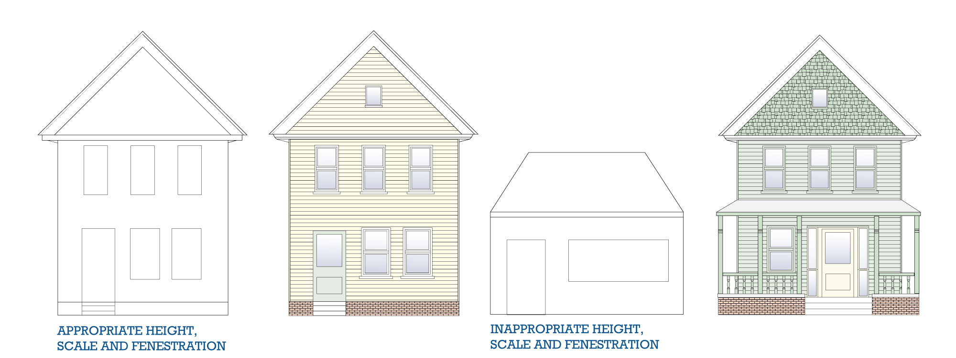

Massing
Massing refers to the large-scale units that make up a building. These masses define the overall shape and form of a building. Massing is a central part of a building’s architectural design and can be altered through additions or demolition of parts. Alterations of a building’s massing can adversely affect its overall form and diminish its historic integrity.

Orientation
The term “orientation” refers to the direction that a building faces in relation to the street. Most buildings are oriented so that the main entrance on the façade faces the street.

Proportion
The term “proportion” refers to the visual effect of the relationship between architectural elements and the building as a whole.

Rhythm
Rhythm is the repetition of architectural forms along a streetscape. Width, height, spacing, setback, and orientation, as well as the placement of architectural details, contribute to the rhythm of the street. Demolition of existing historic structures or the construction of new buildings that are incongruous with height, spacing, or other rhythm-defining elements can disrupt the historic rhythm of the street and alter the overall character of the historic district.
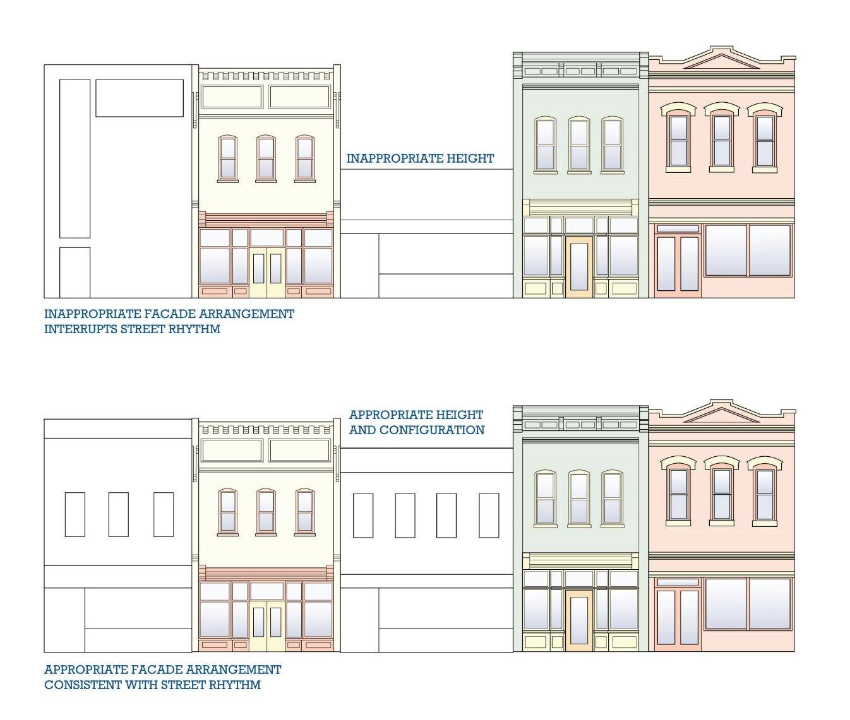

Scale
Scale is the size of a building in relation to the buildings that surround it. Scale can be expressed through the size of a building itself as well as though the size of building elements. Differences in scale, whether larger or smaller than the surrounding structures, can disrupt the rhythm and unity of a street or district.

Setback
Setbacks describe the distance between a building and its property line. It generally refers to the setback from the street-adjacent property boundary, forming a front yard on the property in many cases. It is common for residential properties to have setbacks but less common for commercial properties.
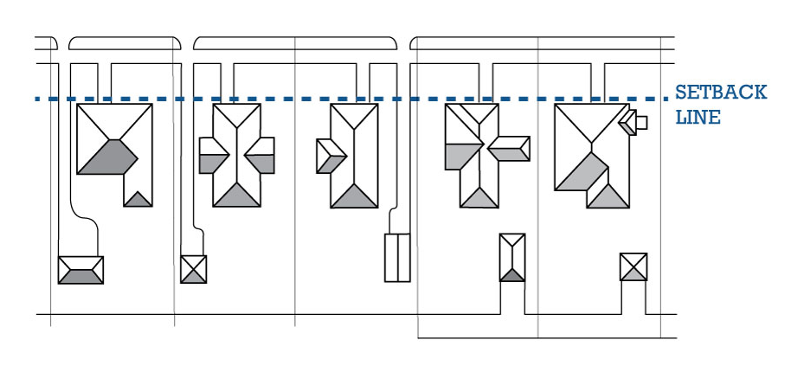

Style
A building’s architectural style is defined by its overall appearance and common features which refer to particular trends that were used in the region at a time period in which the building was designed and constructed. Architectural styles combine qualities of massing, scale, proportion, rhythm, detail, and ornamentation.

Symmetry
Symmetry refers to a façade arrangement in which both sides are equal in proportion and arrangement of architectural features. Asymmetry is the opposite, where the elements of a façade arrangement are organized with emphasis to one side of the façade. Symmetry or asymmetry can be closely associated with particular styles and a building’s symmetry, or asymmetry should be maintained.

Unity
The term “unity” refers to the effect created when all of the buildings in a district or area conform to a particular defined range of overarching building characteristics. This includes height, alignment, scale, massing, and spacing. New construction can disrupt unity when it is not consistent with the existing neighborhood.

Chapter 5: Architectural Style Guide

Introduction
The following has been adapted from the Historic Resources Survey of Titusville in 2017 by ESI with supplementary information from A Field Guide to American Houses by Virginia Savage McAlester.

Architectural style is the combined shape, proportion, materials, and ornamental detailing of a building. Few structures display all of the characteristics of a particular style, and many buildings exhibit eclectic details from a mix of styles. Architectural styles are grouped into two categories: vernacular and high style.
The term “vernacular” refers buildings constructed according to traditional methods of construction within a specific locality or for a particular group of people. Often created by carpenter-builders and designers, vernacular buildings combined vernacular forms, pattern book designs and the builder’s own ideas. Influenced by local climate, building traditions, and contemporary architectural styles, these builders created local variations in historic architectural styles.
“High style” refers to buildings constructed according to the doctrines of a specific, readily identifiable, national or regional architectural style. Often designed by professional architects and builders, or derived from architectural guidebooks, high style buildings vary widely in size, form, and detailing/ornamentation. Designers of high style buildings were often strongly influenced by contemporary trends, fashions and academic principles.
While some high style examples can be found throughout the City of Titusville, many of the buildings found in the city are vernacular. These are buildings with details reflecting architectural stylistic influence from the period in which they were designed and constructed. Residential architecture in Titusville presents both vernacular and high style examples.

Architectural Styles
The following section describes each of the major architectural styles, including vernacular styles, observed in Titusville. Each sub-section highlights the generally accepted period of construction, common characteristics, and local variations when observed.
Vernacular ca. 1800-1900
The term vernacular refers to buildings that are either built in a local, traditional form using locally available materials or buildings in which the builder creates a new form in response to the local environment and materials. Vernacular style buildings are generally referred to as such based on their exterior finish and construction type and categorized as “frame vernacular” or “masonry vernacular”.
Below is an early example of a Masonry Vernacular building in Titusville.

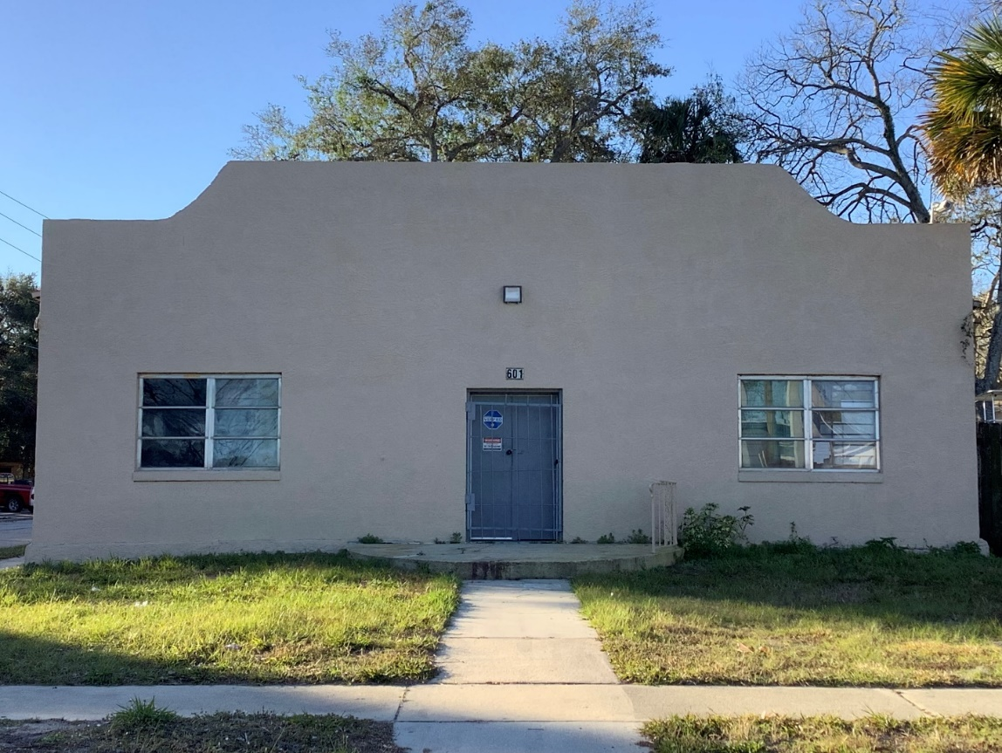
601 Tropic Street

Common Characteristics of Vernacular
Masonry structure
Decorative brickwork or limited ornamentation
One or two stories
Stucco finish (smooth or textured)
Painted or unpainted brick or CMU exterior
Raised stucco windowsills or surrounds

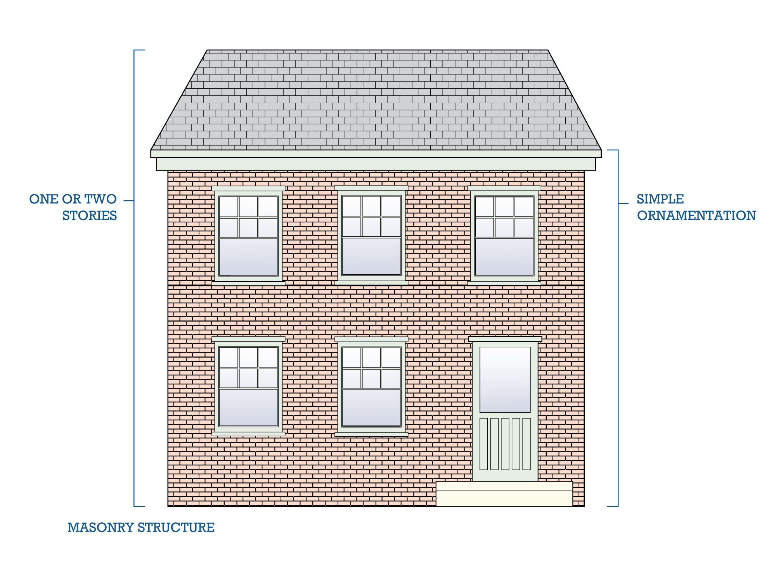
Gothic Revival ca. 1840-1880
The Gothic Revival style emerged from the Picturesque/Romantic Movement and was popularized in the pattern books of Andrew Jackson Downing. It was the earliest of the Victorian styles to challenge classical norms. The Romantic Movement lauded the art, literature, and architecture of Christian medieval times which is reflected in the style. The architectural movement abandoned the symmetry and order of Classicism in favor of asymmetry and variety in texture and color.
The Gothic Revival style became popular in America in the mid-nineteenth century (circa 1830-1860), reaching its peak in the 1830s and 1840s. Residential examples of the style could be symmetrical or asymmetrical and have a variety of ornamentation abstracted from Gothic traditions. These houses often gave a sense of the Gothic style while incorporating local traditions and forms.
Civic and religious examples of Gothic Revival tended to follow High Gothic examples and were more authentic. The popularity of Gothic Revival houses faded in the late nineteenth century. The Gothic Revival style remained popular for civic, religious, and educational buildings well into the twentieth century.
Below is a notable example of Gothic Revival architecture in Titusville.

St. Gabriel’s Episcopal Church
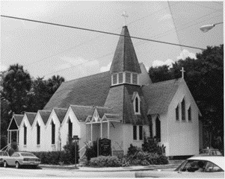
Corner of Pine Street and South Palm Avenue

Common Characteristics of Gothic Revival
One or two-stories
Pointed arches
Towers
Steeply pitched rooflines
Focus on verticality
Crenellation or crenellated parapets
Leaded stained glass
“Gingerbread” detailing, lace-like spandrels
Earthy or muted paint colors were common.

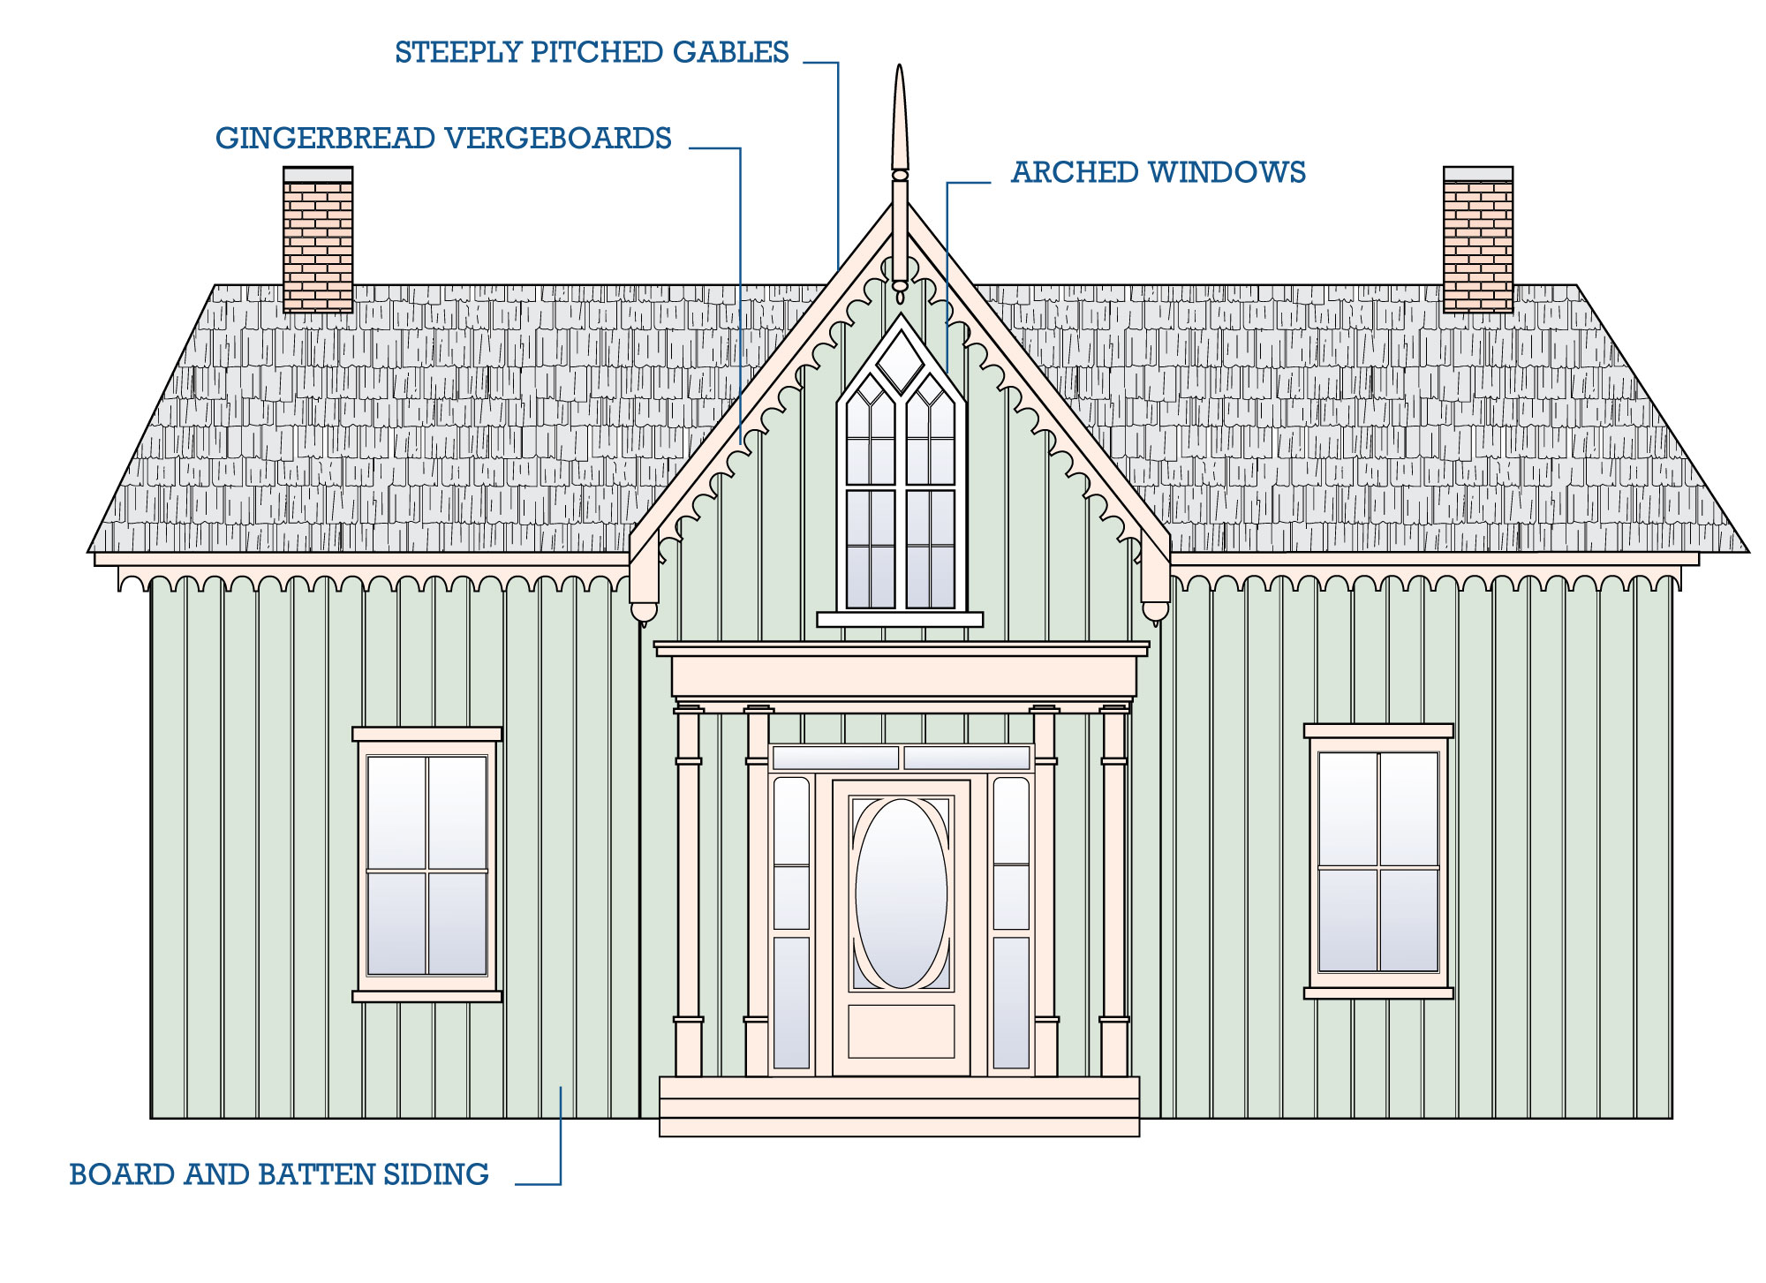
Folk Victorian ca. 1870-1910
The Folk Victorian style is less elaborate than high Victorian styles such as Queen Anne. It is characterized by the presence of Victorian era decorative detailing on simple folk house forms. These simple houses tend to mimic higher Victorian style dwellings while remaining more affordable.
The Victorian details (often referred to as “gingerbread” detailing) used in Folk Victorian houses are most commonly applied to the porch and cornice line. Window surrounds are generally unadorned but may have a simple pediment. Folk Victorian houses often have symmetrical façades and a lack of textured and varied wall surfaces unlike the true Queen Anne style houses they mimic.
Below are examples of Folk Victorian houses in Titusville.
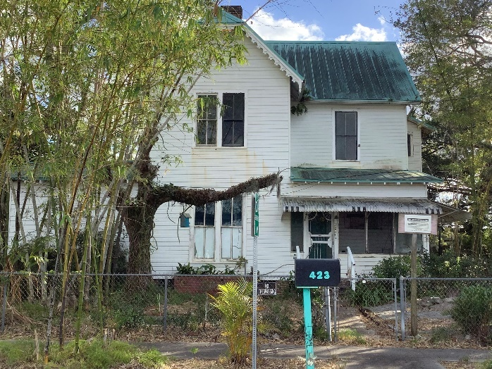
423 Main Street
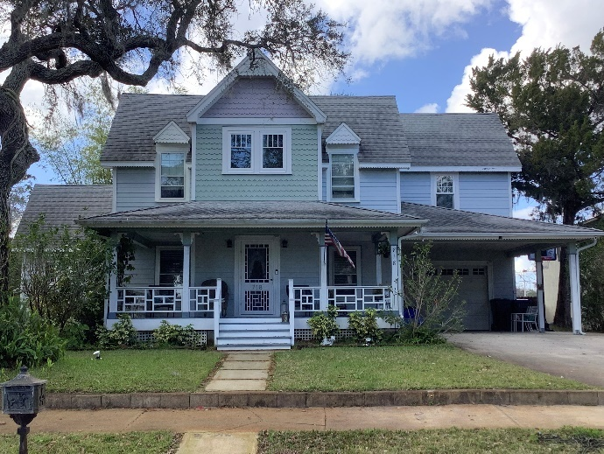718 Indian River Avenue

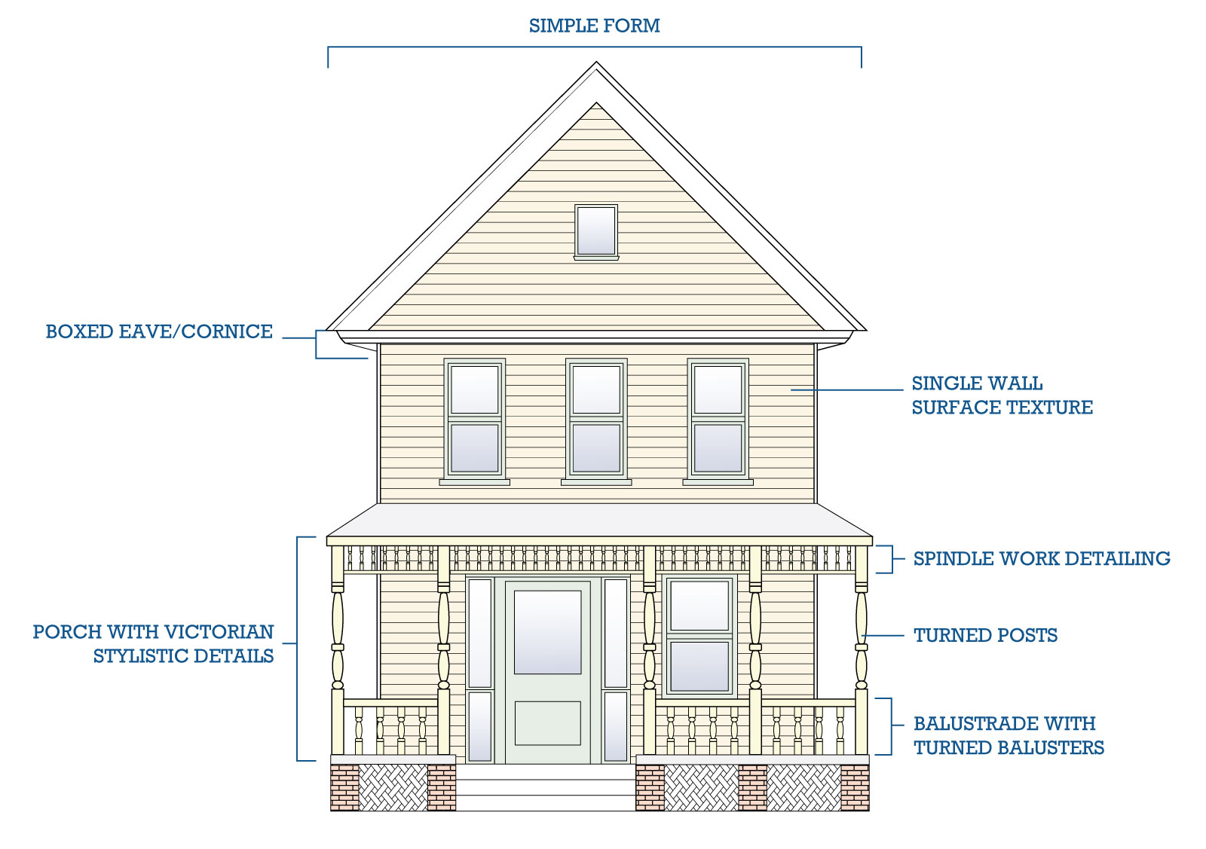
Common Characteristics of Folk Victorian
One or two-stories
Symmetrical façade (except in gabled ell type)
Lack multiple rooflines and textured or varied wall surfaces
Roof-wall junction may be boxed or open
Centered gable roofs often appear on side-gable or hipped pyramidal roof examples
Decorative elements are based on Italianate, Queen Anne, or Gothic Revival styles
Decorative elements are limited to the porch and cornice line
Unadorned window surrounds; may have simple pediment
“Gingerbread” or spindle work detailing, lace-like spandrels, and brackets under eaves are common
Porch supports are commonly turned wood spindles or square posts with beveled (chamfered) corners
- Turned wood balusters are used in porch railings and friezes suspended from the porch ceiling

Queen Anne ca. 1880-1910
The Queen Anne style merged a variety of classical and medieval ornamentation. Richly decorated, Queen Anne style houses are commonly recalled with the use of the generic “Victorian” label. It was popular from the 1880s to the 1900s.
The Queen Anne style was successfully adapted to residential, commercial, and institutional uses. These buildings are typically asymmetrical in plan, and feature turrets, window bays, towers, complex rooflines, decorated chimneys, and large and ornate porches. Queen Anne style buildings typical have a variety of materials with contrasting textures. These buildings commonly used materials include brick, wood, stone, slate, and tile which were combined to create a picturesque effect.
There are a few Queen Anne style dwellings in Titusville. The most recognizable is the Pritchard House located at 424 Washington Avenue which features several of the style’s signature elements. These include a turret porch, wood shingles, integral porches, and various detailing including the half-timbered vergeboard.
The Pritchard House
424 South Washington Street
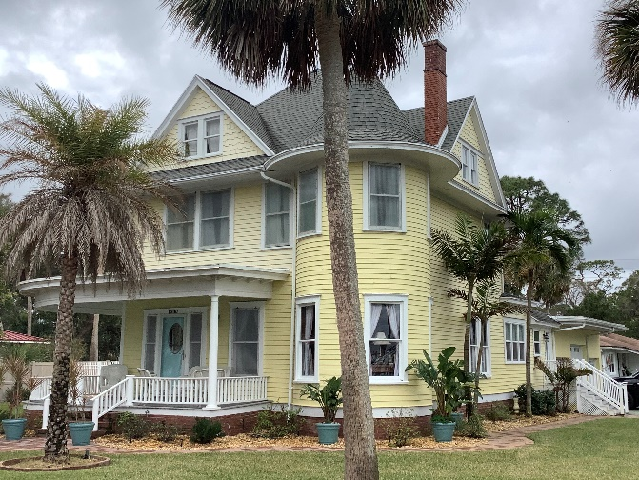
1200 Riverside Avenue

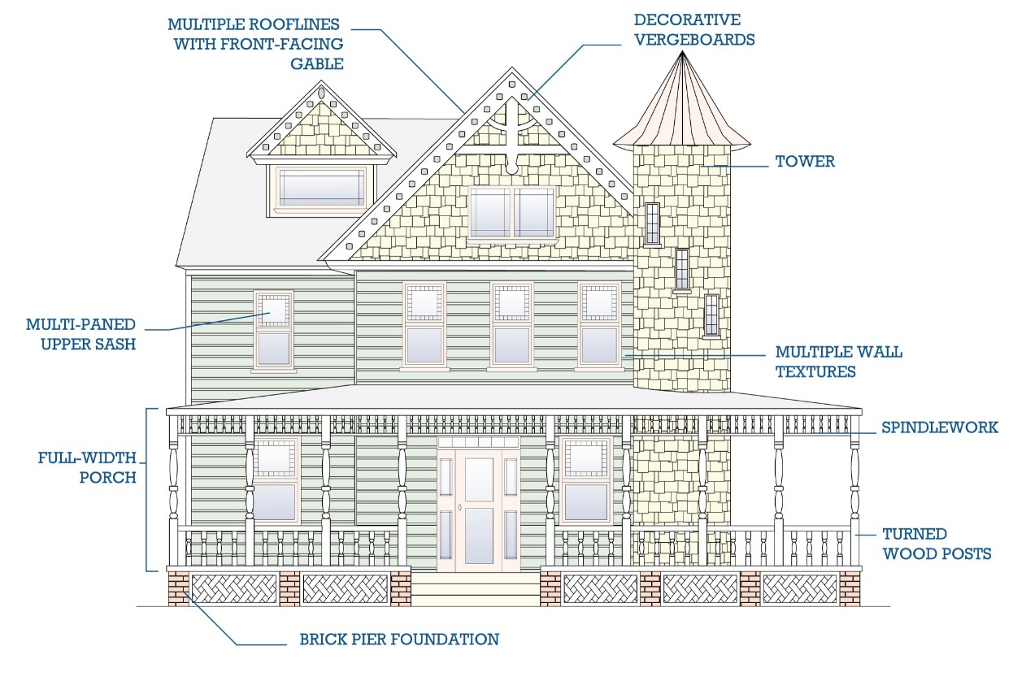
Common Characteristics of Queen Anne
Two or more stories and asymmetrical in plan
Steeply pitched irregular roof with multiple rooflines; often with dominant front-facing gable
Flat wall surfaces are avoided through use of wall insets or projections, cutaway bay windows, cantilevered gables or second stories, and false overhangs
Multiple wall textures and surfaces achieved with pattered shingles, different patterns or colors of brick courses, and clapboard/weatherboard siding
One-story partial or full-width porch that often extends along one or both side walls
Many examples feature round, square, or polygonal towers of varying heights
Door and window surrounds tend to be simple
Windows are usually single-pane fixed wood windows or one-over-one, double-hung wood sash windows; sometimes the top pane or single pane is surrounded by small, rectangular panes
Doors commonly feature delicate carved detailing and a single large pane of glass set into the upper portion of the door
Four principal shape subtypes include: (1) hipped roof with lower cross gables; (2) cross-gabled roof; (3) front-gabled roof; (4) town house
Four decorative detailing subtypes include: (1) spindle work; (2) free classic; (3) half-timbered; (4) patterned masonry
Commonly painted in a mix of bold colors

Frame Vernacular ca. 1880-1940
Frame Vernacular style buildings use wood as the main structural and exterior elements. Craftsman and builders constructed these buildings using balloon framing techniques. This type of construction used corner posts and horizontal members consisting of two-by-four posts nailed together. Floors were hung on the wall studs, and, on multi-story buildings, the wall studs rose continuously from the floor to the roof.
Frame Vernacular construction was very common in the United States from the late 1800s through the 1940s. Many Frame Vernacular houses built in the late 1910s and 1920s demonstrate Craftsman style elements including exposed rafter ends and wide, overhanging roof eaves. These houses are still modest and demonstrate less details and ornamentation than Craftsman style houses.
Examples of Frame Vernacular houses from the 1930s and 1940s are even more restrained than their forerunners and display modest roof overhangs and even fewer decorative elements. Vernacular style structures have square, rectangular, and "L" shape floor plans and are one or two-stories in height.
Below are examples of Frame Vernacular houses in Titusville.
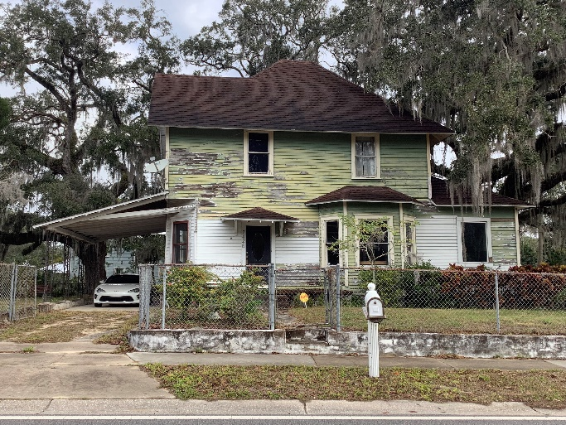  1426 Tropic Street | 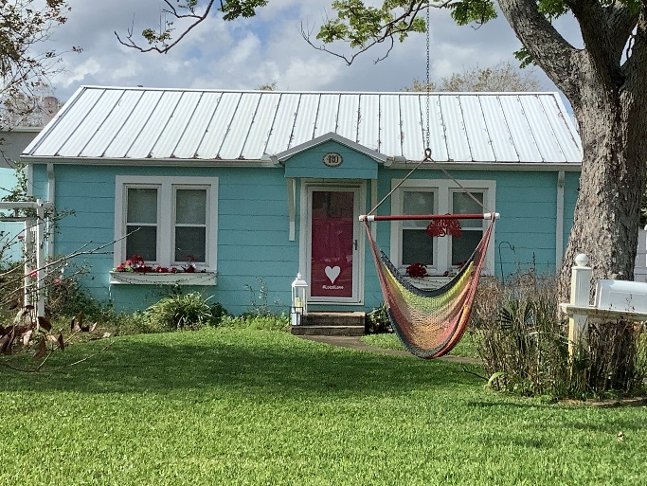  420 Indian River Avenue
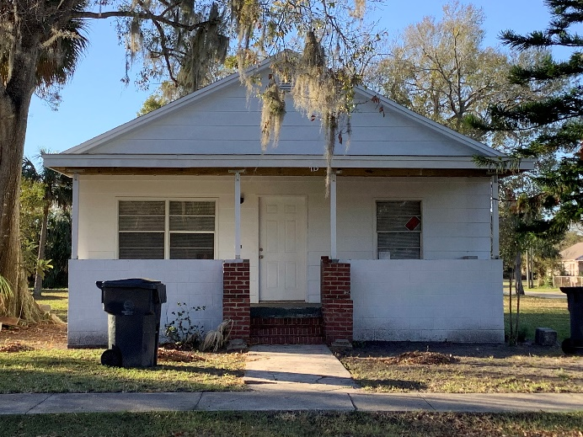 715 Palmetto Street | 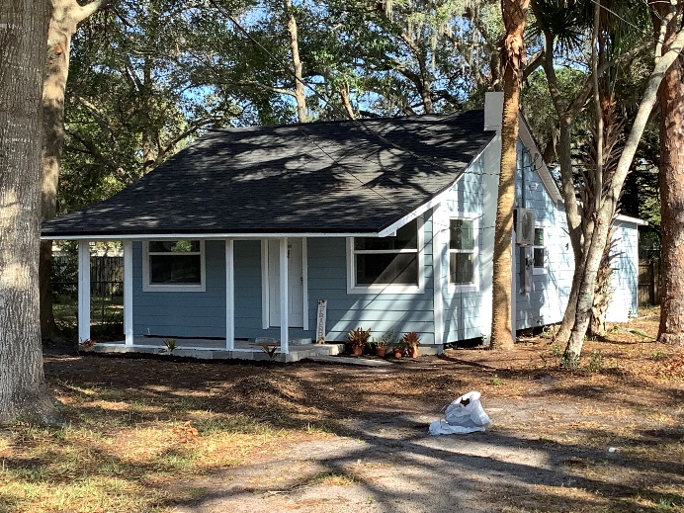 4385 Alpine Lane
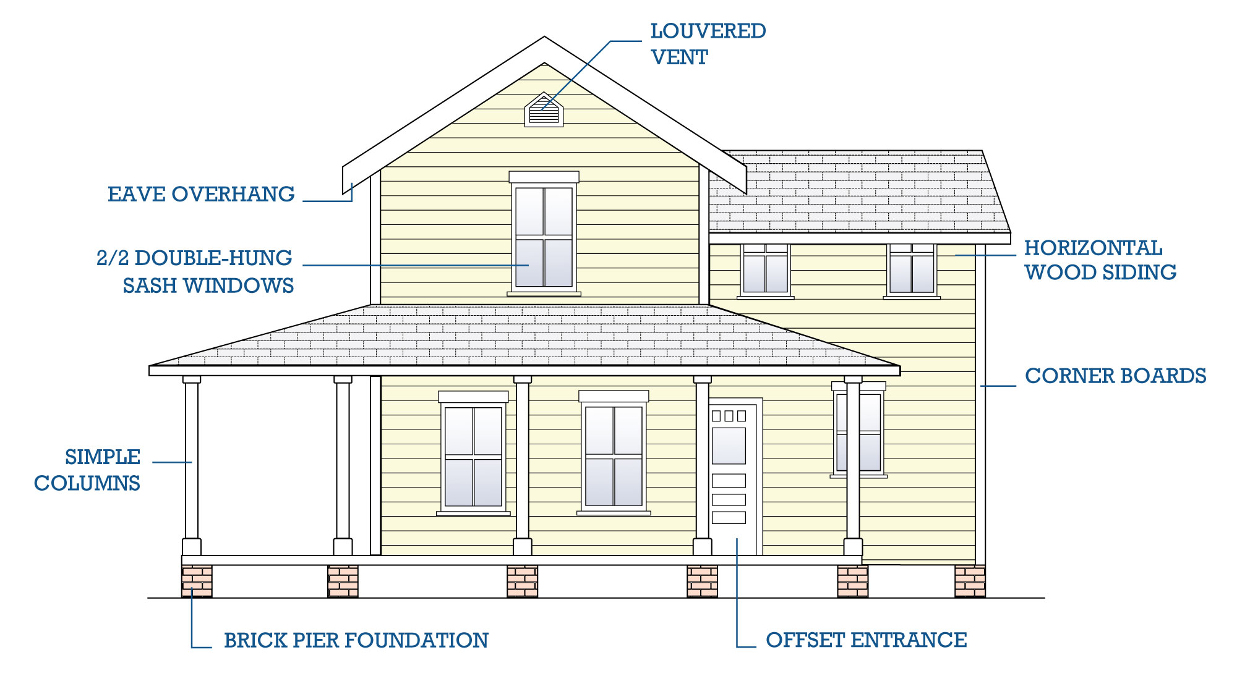
Common Characteristics of Frame Vernacular
One- or two-stories
Square, rectangular, or “L” shape in plan
Wood is the dominant structural and exterior element (often used balloon framing technique)
Balloon Frame set on pier foundations made of brick, concrete, or reticulated concrete block
Roofs are typically gable or hipped (earliest examples are steeply sloped); or original roofing materials were usually standing seam metal or asbestos shingles, however many of the houses now feature composition shingles
Exterior cladding is horizontal wood siding including weatherboard, clapboard or drop siding with corner boards
Windows are typically one-over-one or two-over-two, double-hung wood sash windows
Many feature porches or covered stoops
Detailing on houses tends to be basic and understated including the use of decorative shingles in front gables or simple ornamental railings on porches
Mediterranean Revival ca. 1880-1940
The Mediterranean Revival style was part of the Eclectic Movement. This architectural movement drew its inspiration from architectural traditions spanning from ancient times to modern. Sometimes referred to as Spanish Colonial Revival, the Mediterranean Revival style originated in the 1880s but was most popular from 1915-1945. Although closely associated with Spain, the style was influenced by the traditions established among other Mediterranean countries, including Italy, northern Africa, and France.
On a state level, this architectural style is most closely linked with the 1920s Florida land boom. The style was primarily popular in the state during the 1920s and 1930s. Although the Mediterranean Revival style did not originate in Florida, the style attributes its rise to Beaux Arts-trained architects' love of historicism. These architects had a desire to create a building style appropriate to the history of the Sun Belt areas of the United States. In Florida, this meant recalling the Spanish Colonial period.
For residential properties, the Mediterranean Revival style was primarily used in upper- and middle-class suburban housing developments. The style was also used in commercial, hotel, club, and school buildings. The style honored the state’s Spanish heritage and could be easily modified to suit Florida's hot and humid climate. The style suited the picturesque resort image the state created to attract winter visitors.
Below are examples of Mediterranean Revival buildings in Titusville.

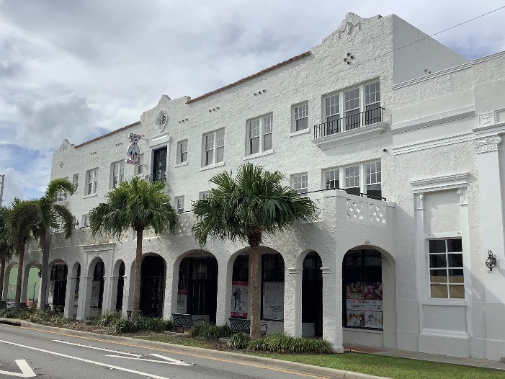  302-310 South Washington Street | 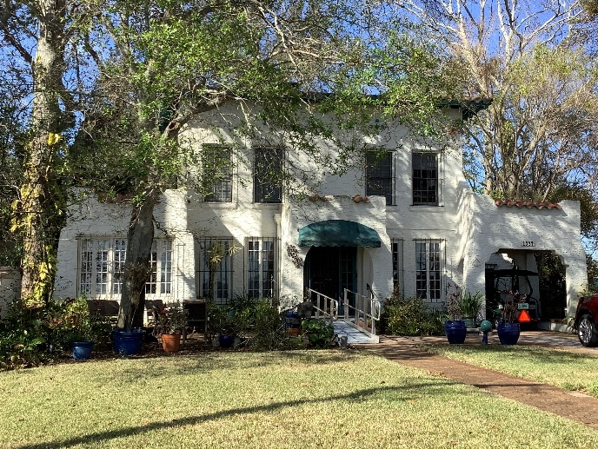  1534 Riverside Drive

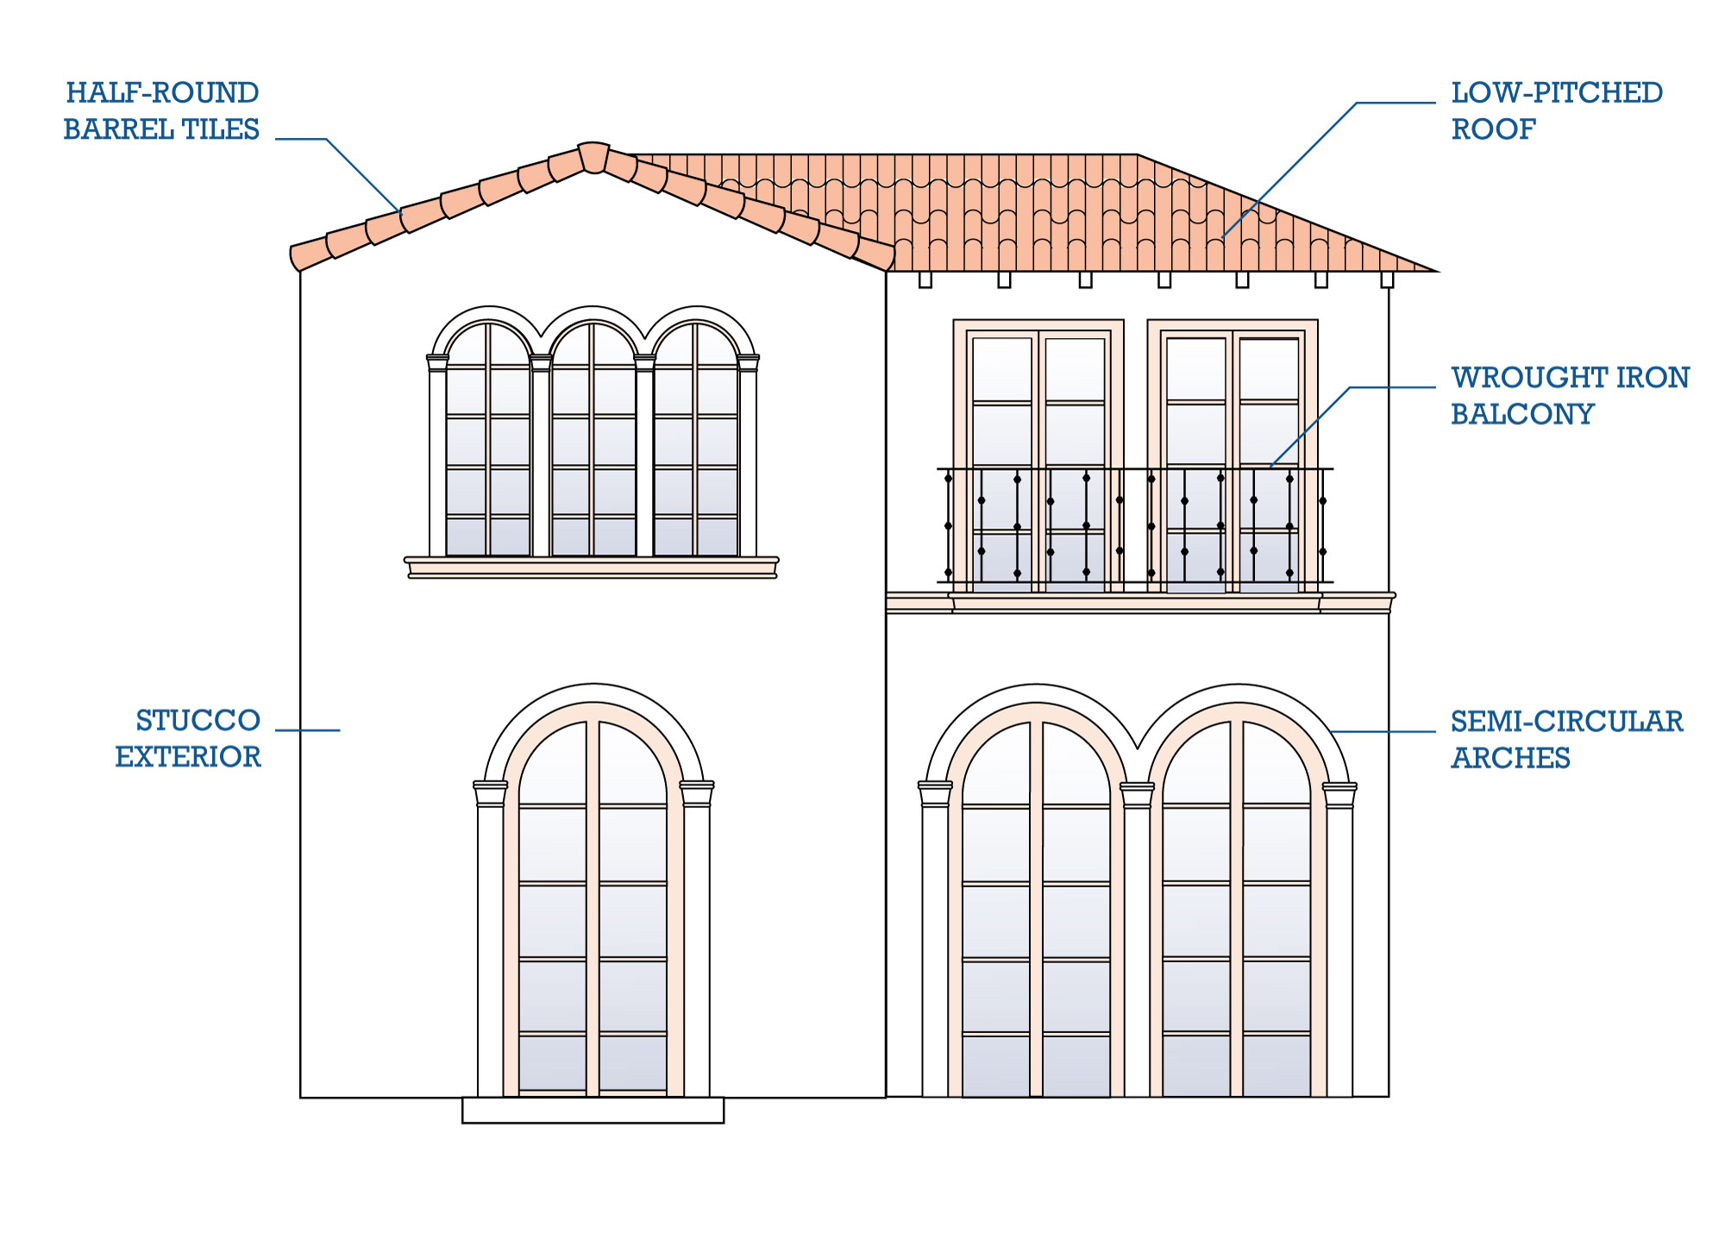
Common Characteristics of Mediterranean Revival
Primarily one or two-stories in height
Exterior walls are stuccoed
Low-pitched hipped roofs covered with red tiles (commonly half-round barrel tiles or interlocking pantiles)
Square towers are common design elements in larger constructions
Semicircular arches commonly highlight doors and major windows
Doors are typically wood and are often adorned with inset tiles, carved stone, columns, or pilasters
Buildings often feature a focal window, sometimes it is tripartite in arrangement and uses stained glass
Wrought iron or wood balconies and window grilles are common elements
Ornamentation can range from simple to dramatic
Paint colors commonly included shades of white, pale yellow, and other muted tones

Colonial Revival (including Dutch-Colonial) ca. 1880-1955
The Colonial Revival style emerged in the 1880s following America’s Centennial celebrations. These celebrations aroused civic pride and sought to restore order to what was perceived to be the Victorian excesses of American domestic architecture.
The Colonial Revival style recalled the American Georgian and Federal style architecture of the nation. The style became widely popular after 1925. During this time, the historic preservation movement was on the rise and projects including the restoration of Colonial Williamsburg, popularized the style. The style remained fashionable in the United States through 1955. The Colonial Revival style is sometimes referred to as Georgian Revival and Dutch Colonial Revival, which are more specific subtypes of this style.
The name “Colonial” encompasses several styles, all loosely associated with the revival of early American and “old world” buildings. The Colonial Revival style frequently combined authentic colonial details with contemporary features on a more exaggerated scale than its 18th century models. The use of details from a specific colonial type or period may result in the substyles such as Dutch Colonial Revival.
An excellent example of a Colonial Revival style house in Titusville is 620 Indian River Avenue which features a symmetric façade, half paneled sidelights, and sash windows. Another example includes 703 Indian River Avenue, the Judge George Robbins House.

Judge George Robbins House  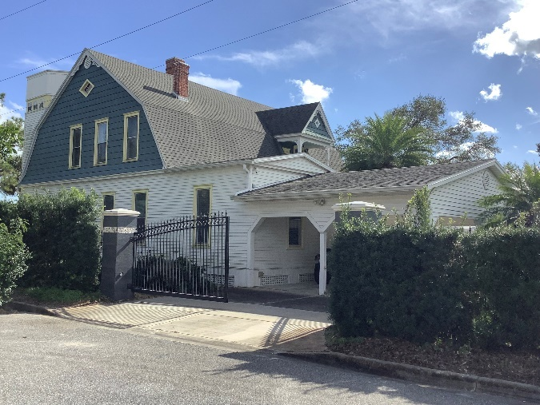  703 Indian River Avenue | 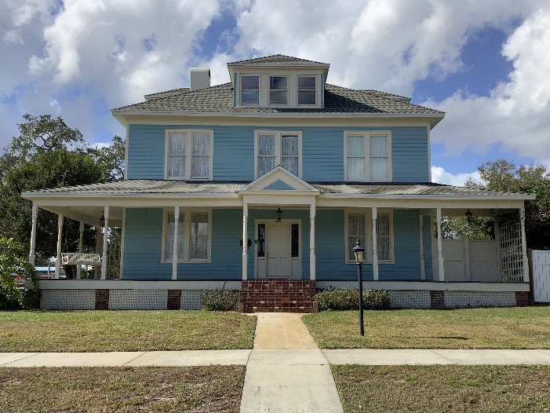  620 Indian River Avenue

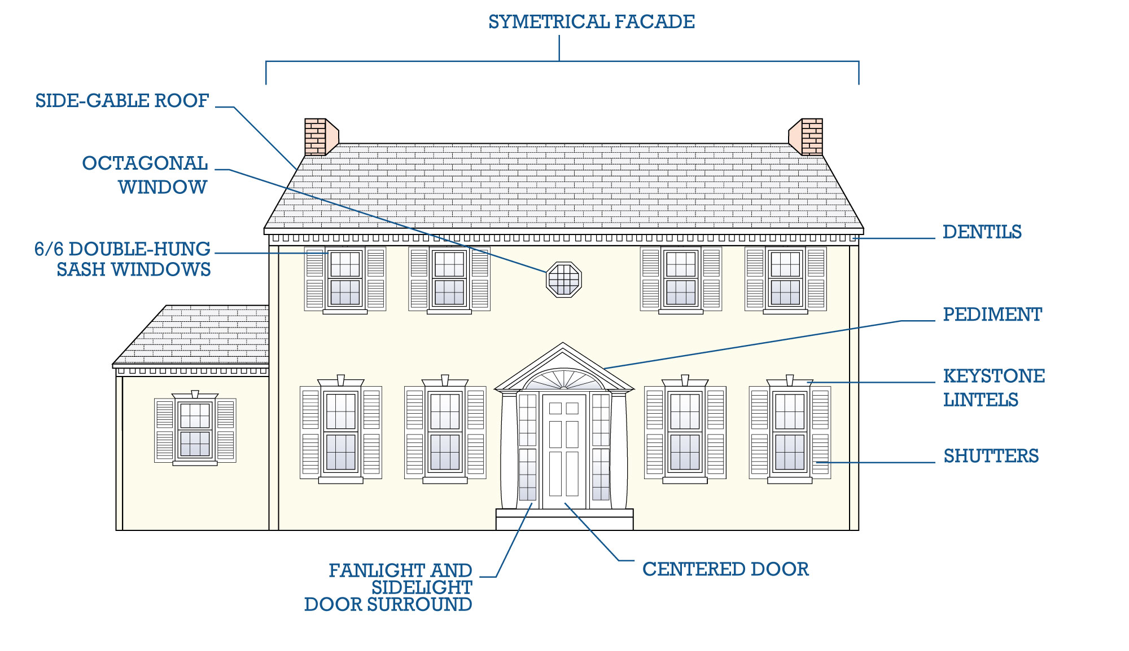
Common Characteristics of Colonial Revival
Symmetrical massing (symmetrically balanced windows and a centered door); less frequently the door is off-center
Front entrance adorned with decorative pediment supported by pilasters; sometimes entrance is sheltered by an entry porch
Front door often topped by fanlights or rectangular transoms and flanked by side lights
Windows are typically double-hung wood sash windows with multi-pane glazing in one or both sashes; windows frequently appear in adjacent pairs
Roof can be side gable, side gable with centered gable, hipped, or gambrel; roofs often feature boxed eaves with little overhang
The cornice is frequently adorned with dentils or modillions
Paint colors were typically muted, with shades of white, blue, and gray common

Mission ca. 1890-1920
The Mission style originated with the mission churches of California established by Father Junipero Serra during the 1700s. Originating in California during the 1890s, this style flourished throughout the western United States. The style is considered the western states’ equivalent of the east coast’s Colonial Revival. It was popular from the 1890s–1920s.
Influences from the Craftsman style and bungalow building type were evident in the smaller residential Mission style. During the early 20th century Florida also embraced its Spanish heritage using it as a source of architectural inspiration.
Despite its origins in California, the Mission style was one of the most popular residential architectural styles of the Florida Land Boom of the 1920s. Mission style buildings are often simple in form and feature stucco façades and simple parapets, some of which have a curvilinear design. Additional style elements include tiled pent or visor roofs, tiled copings, and scuppers and vents near the rooflines.
Many of the characteristics of the Mission style also are shared with the Mediterranean Revival style. Distinction between the two styles is blurred. The main distinction is the Mission style’s lack of ornamentation. It is more simple and less formal than the variants of Mediterranean Revival style. Mission structures emphasize texture and substance over ornate detail and style.
Below are examples of Mission buildings in Titusville.

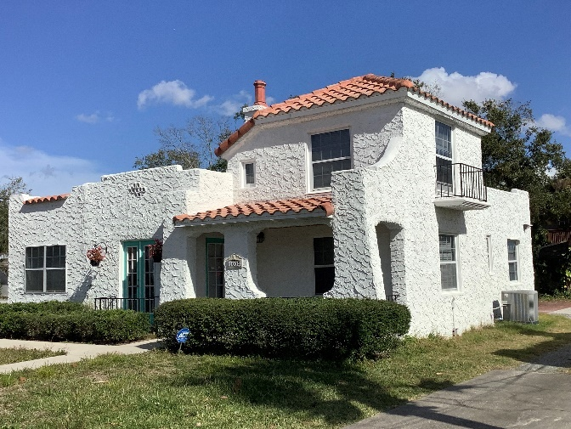  1003 South Washington Avenue | 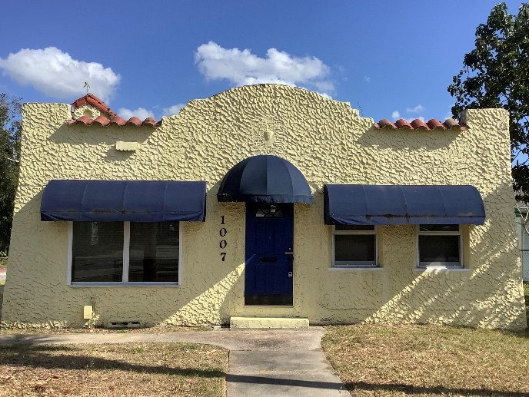  1007 South Washington Avenue
Common Characteristics of Mission
Commonly one-story, but sometimes two-stories
Simple form with symmetrical or asymmetrical façade
Stucco exterior
Hipped or gable roofs with widely overhanging eaves are covered in red tiles; eaves are usually open
A simple, curvilinear dormer or parapet is often located on the main roof or porch roof
Porches are common and are typically supported by large, square piers; porch openings can be arched
Decorative elements include, tiled pent or visor roofs, tiled copings, and scuppers and vents near the roofline

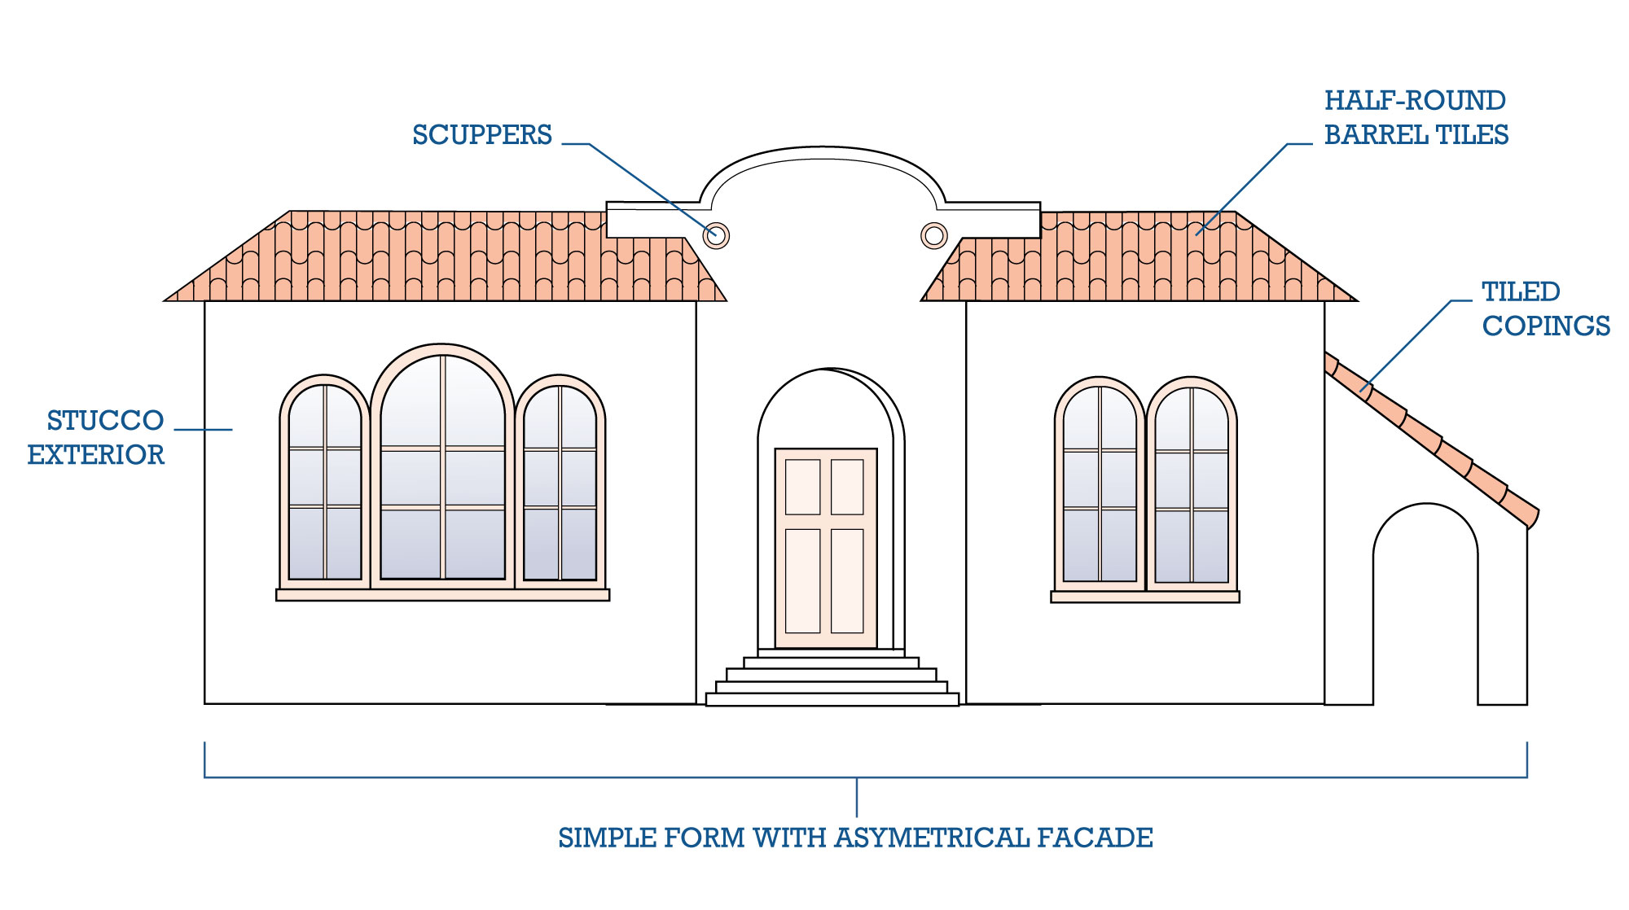
Neoclassical Revival ca. 1895-1950
The Classical Revival, or Neoclassical, style is based upon interpretations of classical Greek and Roman models. The style relies on order, symmetry, and detail to create a composition of formal and symmetrical features. This style is adaptable to a variety of materials. Wood, brick, and stone construction are common, and the style is popular in many regions of the nation.
Classical forms found in Neoclassical Revival style building construction were inspired by the 1893 World's Columbian Exposition in Chicago. Nearly all buildings at the Columbian Exhibition were designed based on classical precedents and were widely copied in the United States in the following decades. The Neoclassical Revival style was popular from the late 19th century through the mid-20th century partly due to the exposition.
Below are examples of Neoclassical Revival buildings in Titusville.
Brevard County Courthouse  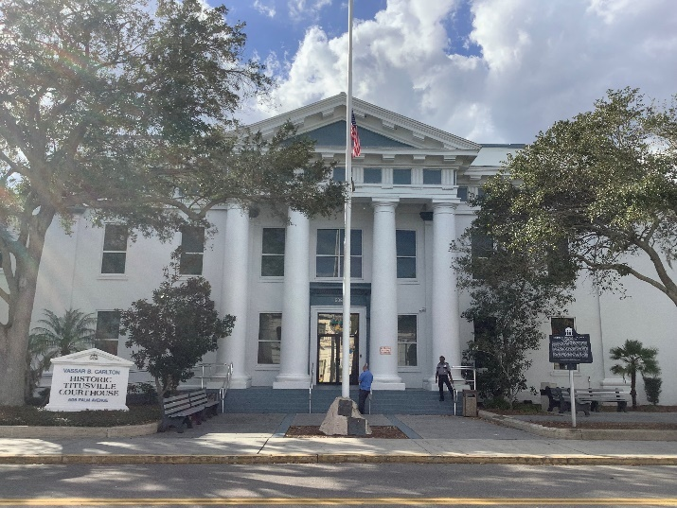  506 South Palm Avenue | 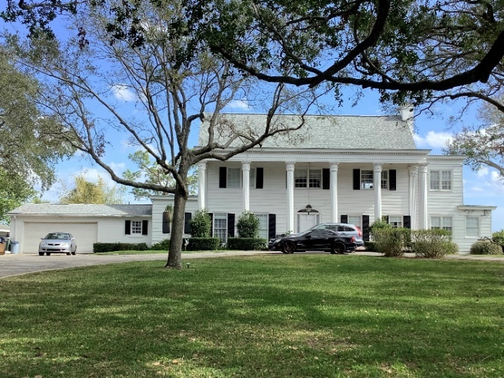  715 Indian River Avenue
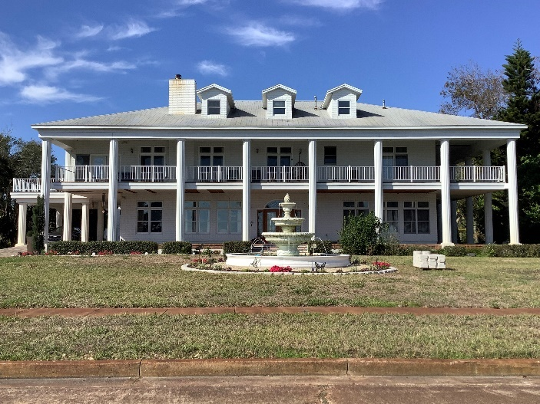
1530 Riverside Drive
Common Characteristics of Neo-Classical Revival
Symmetrical façade with balanced windows and center door
Roofs are low-pitched with boxed eaves and a moderate overhang; can be gable, hipped, or flat with parapets
Cornices often feature decorative dentils or modillions; balustrades at the roofline are also common
Dormers and prominent curved or arched center windows are common on the second story
Façades are dominated by full-width or entry porches that are full-height; porch roofs are supported by classical columns and triangular pediments
Windows and doors feature elaborate surrounds including keystone lintels
- Windows are rectangular with double-hung wood sashes; windows can be six-over-six or nine-over-nine or can have multi- or single-pane upper sashes and a single-pane lower sash
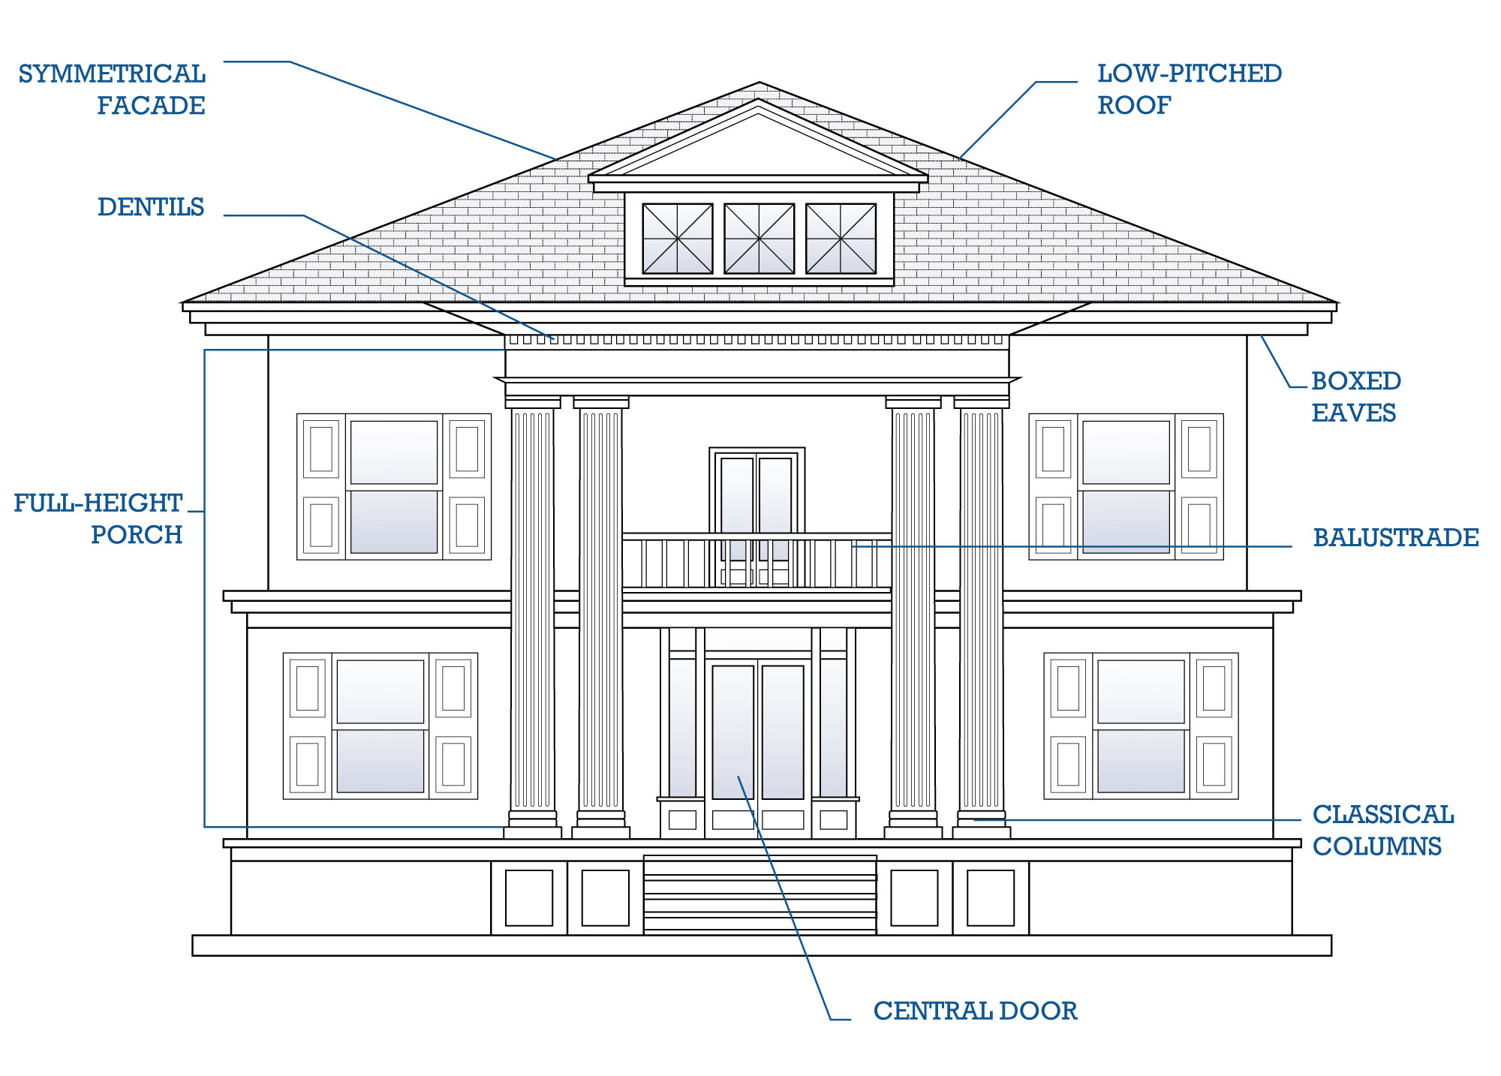

Prairie ca. 1900-1920
The Prairie style was created by the Prairie School, which included Frank Lloyd Wright, in Chicago in the early twentieth century. The style became popular due to its inclusion in several pattern books and popular magazines. Despite its popularity, the style was short lived and faded from fashion after World War I.
Prairie style houses were intentionally design by Wright and others to meet the needs of the American household. Some Prairie houses were designed with an American Foursquare plan with four rooms upstairs and four downstairs without a central hall. One of the style’s most defining characteristics is the use of massive square columns to support the porch or porte cochere. Also indicative of the style is its emphasis on horizontal lines as created by the rooflines, detailing, and often wide plan.

Below is the sole example of a Prairie building in Titusville
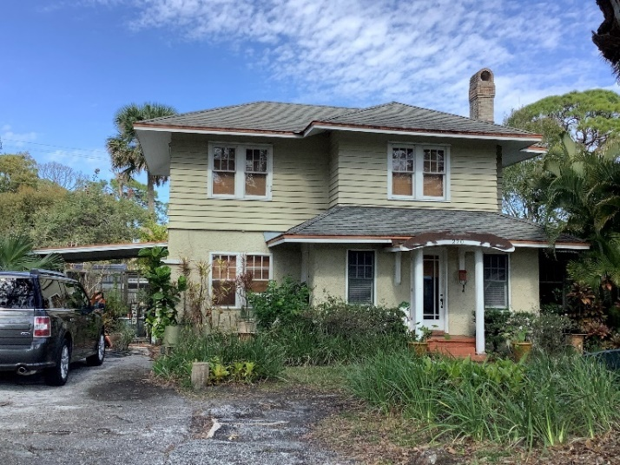
200 Pritchard Street

Common Characteristics of Prairie
Two-stories in height, sometimes with one-story wings
Low pitched roof, typically hip in form
Widely overhanging eaves typically boxed
Porches and porte cocheres are common
Detailing on eaves, cornices, and façade emphasize horizontal lines
Typical porch supports are large and square
Windows are rectangular with double-hung wood sashes; windows can be six-over-six or nine-over-nine or can have multi- or single-pane upper sashes and a single-pane lower sash
Paint colors were typically muted, earthy tones

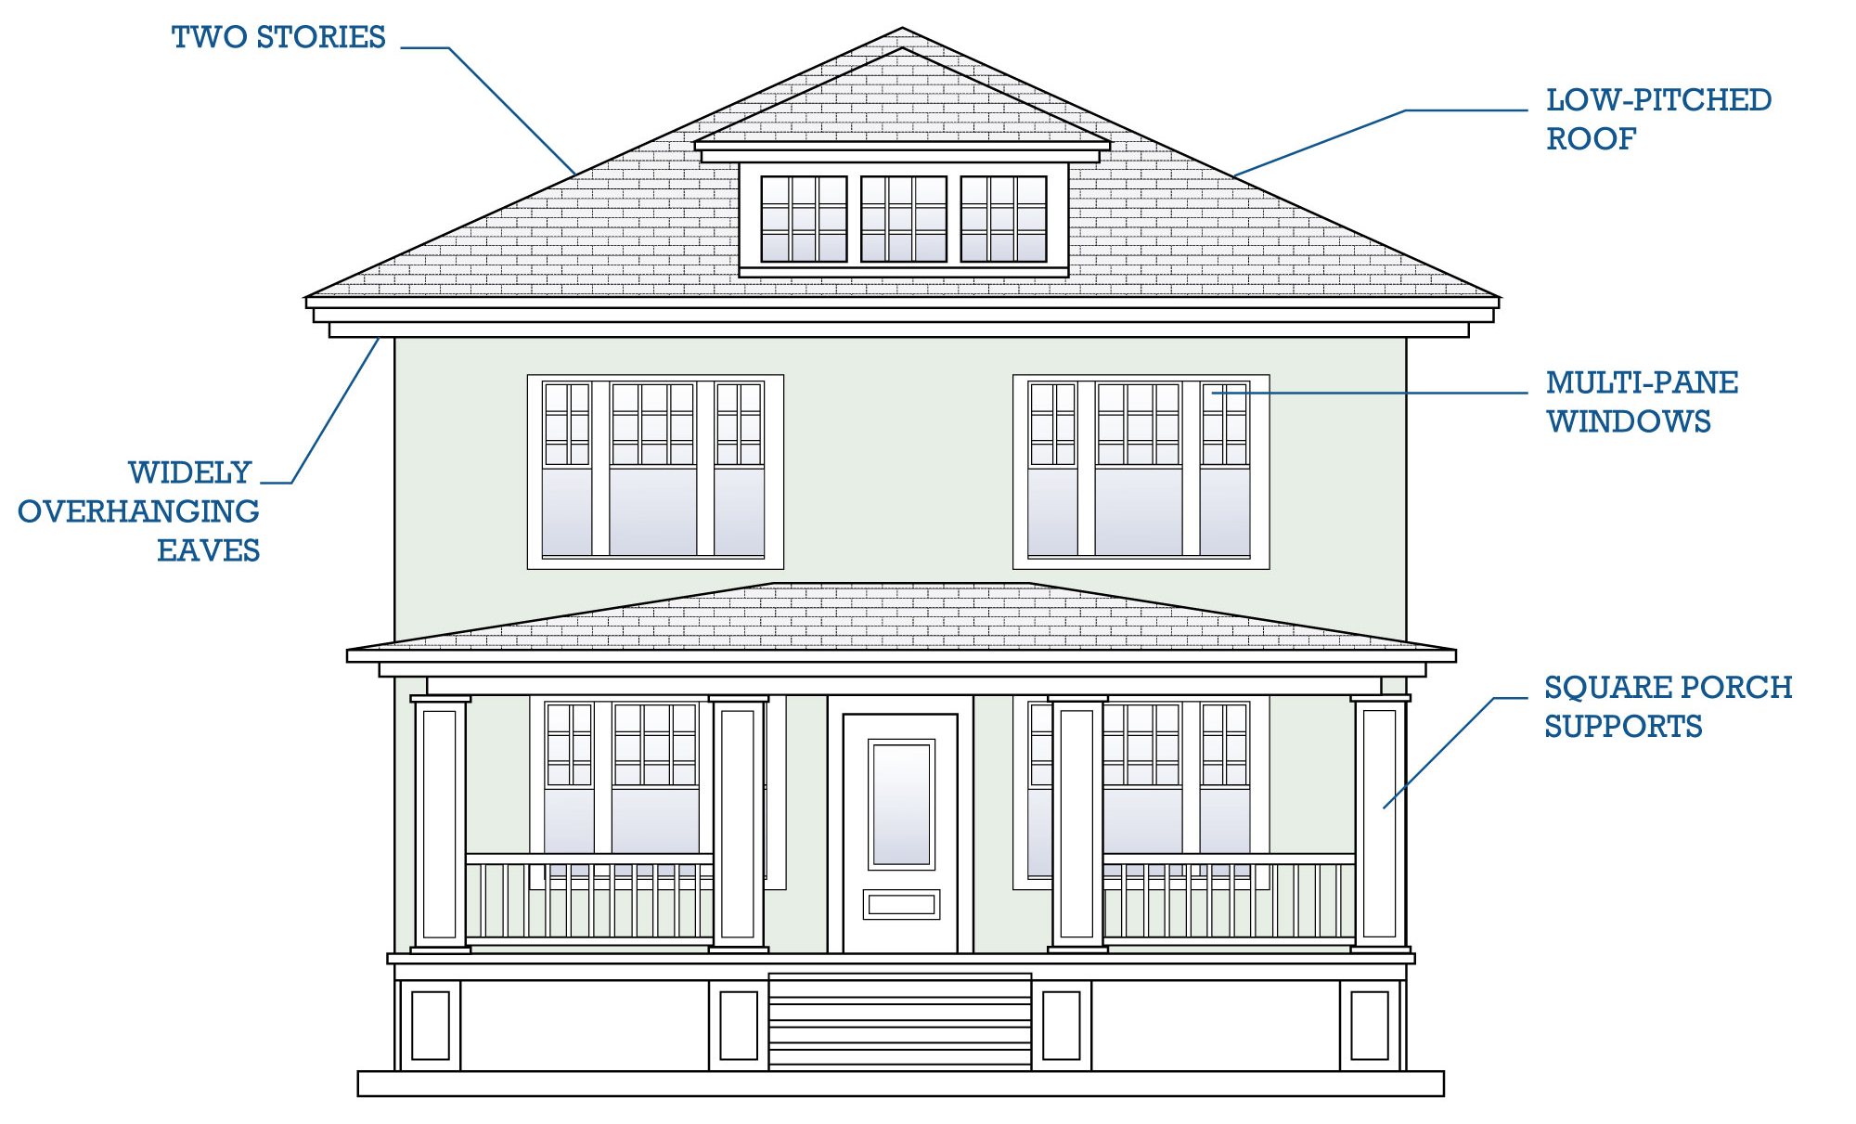
Masonry Vernacular (including Commercial) ca. 1900-1965
Examples of the Masonry Vernacular style buildings are seen throughout Titusville in both residential and commercial buildings. Similar to the Frame Vernacular style, the term “Masonry Vernacular style” is somewhat misleading as “vernacular” suggests a lack of style. Masonry Vernacular buildings, like Frame Vernacular ones, tend to be simple, largely unadorned, and constructed out of easily accessible materials.
Masonry Vernacular buildings were constructed using simple techniques common to Western architecture, adapted to the needs of the environment. The advent of ready-mixed concrete revolutionized masonry building techniques after 1920.
Cast concrete blocks provided the same amount of strength as other traditional masonry units, like brick, but were lighter and less expensive. Buildings constructed after 1920 used concrete blocks as the main structural element. Concrete block buildings were often clad in a veneer of brick or stone, painted or, reticulated block to enhance the exterior appearance. Exterior finishes also stucco or paint.
Below are examples of Commercial Masonry Vernacular buildings in Titusville.

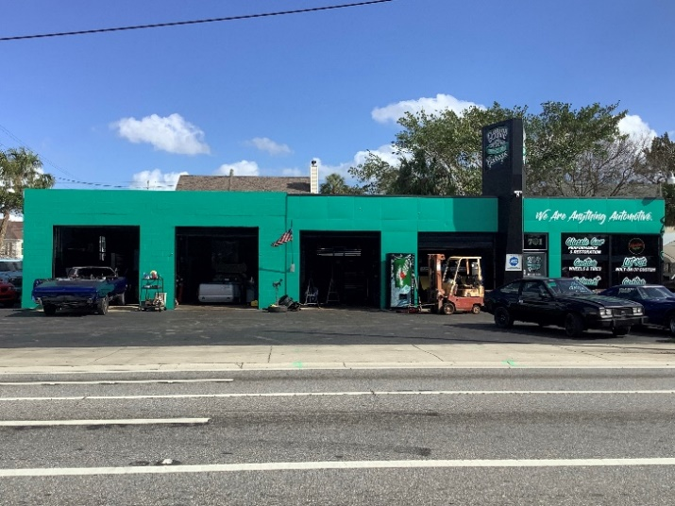  701 South Washington Avenue |   305 South Washington Avenue

Common Characteristics of Commercial Masonry Vernacular
One or two-stories
Masonry construction – earlier examples are brick; later examples include reticulated block or concrete block covered in a veneer
Concrete slab foundation
Flat roof with shaped or stepped parapet
Large, regularly placed windows dominate the façade
Windows are rectangular, wood or metal frame, fixed glass storefront/display windows or multi-pane pivot commercial windows
Simple ornamentation – limited to window and door lintels or parapet detailing including decorative stringcourses, corbelling, and coping scuppers and vents near the roofline

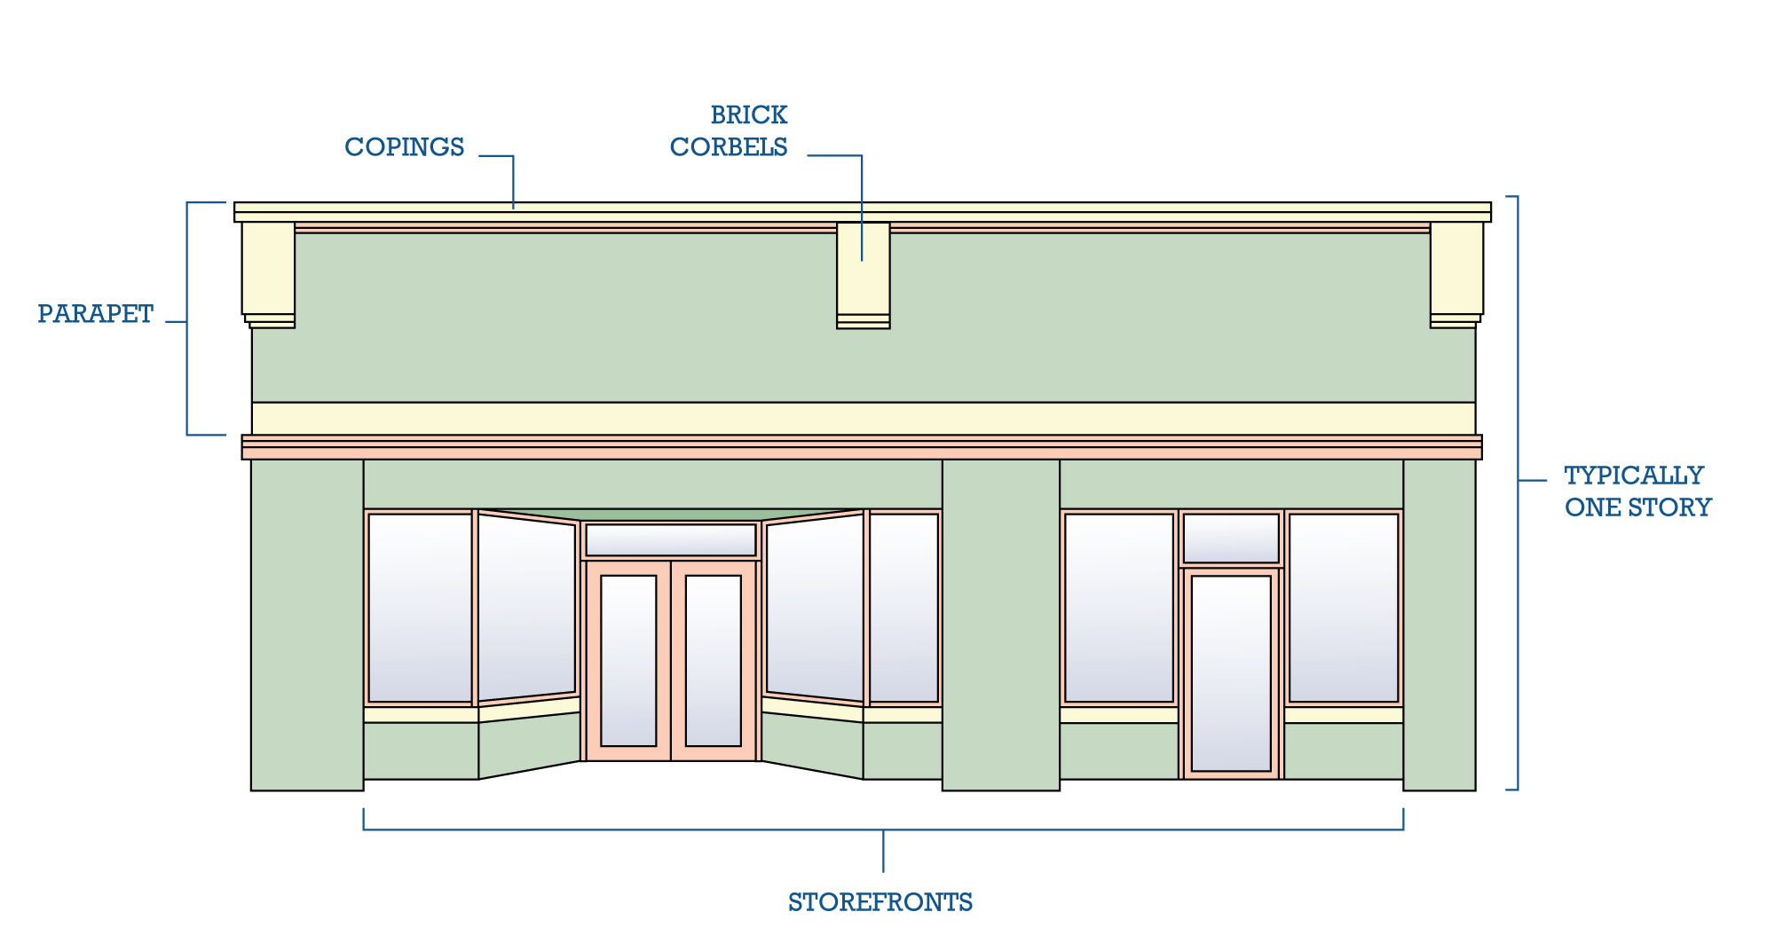

Below are examples of Residential Masonry Vernacular buildings in Titusville.
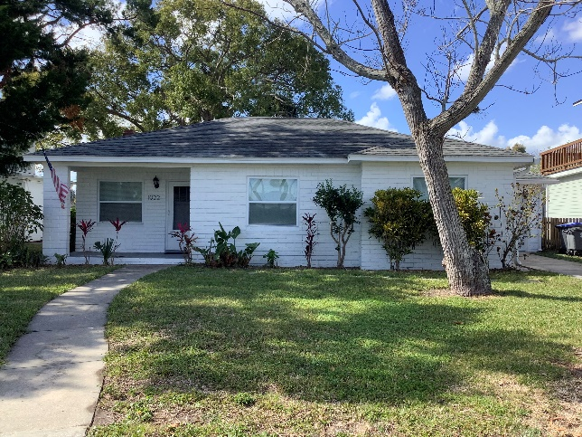  1022 Indian River Avenue | 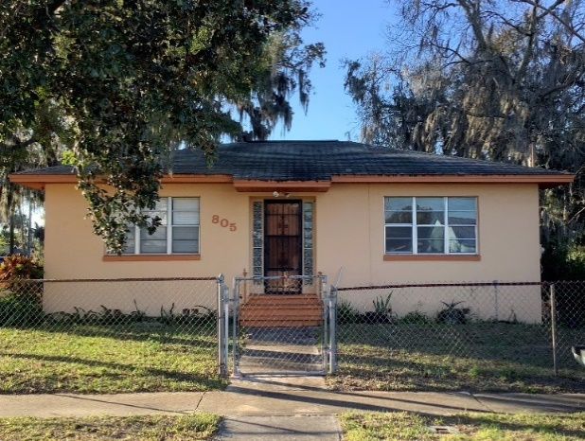  805 Tropic Street
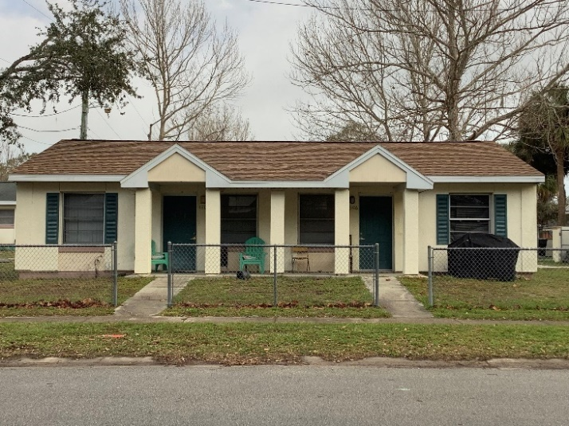  1306-1308 Tropic Street | 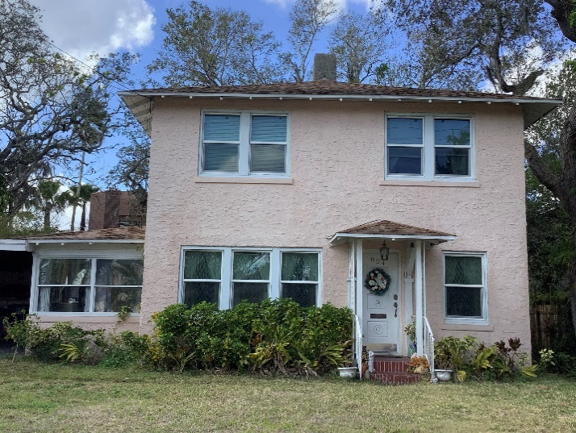  824 Indian River Avenue

Common Characteristics of Residential Masonry Vernacular
One or two-stories
Symmetrical façades – with vertically aligned fenestration on two-story examples.
Masonry construction – earlier examples are brick; later examples include reticulated block or concrete block covered in stucco a veneer.
Hipped roofs are the most commonly seen roof type.
Simple ornamentation – limited to cornice, string course, window and door lintels.
Earlier examples often feature gable roof porches.

Craftsman ca. 1905-1930
The Craftsman style emerged at the very end of the 19th century. The style was heavily influenced by the English Arts and Crafts Movement, which emphasized a return to the use of natural materials and traditional handcraftsmanship. It became highly popularized through pattern books and magazine depictions and was the dominant style for small houses from the turn of the 20th century through the 1930s.
A typical Craftsman style house has deep overhanging eaves with exposed rafter tails or widely overhanging eaves supported by large open brackets. These houses typically have a full or partial width porch integral to the main roof. Houses of this style usually have gabled roofs, and double-hung windows, often grouped, with multiple panes in the top sash.
Below are examples of Craftsman buildings in Titusville.
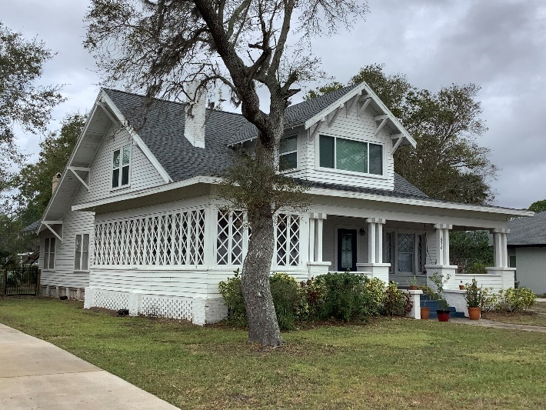  1326 Riverside Drive | 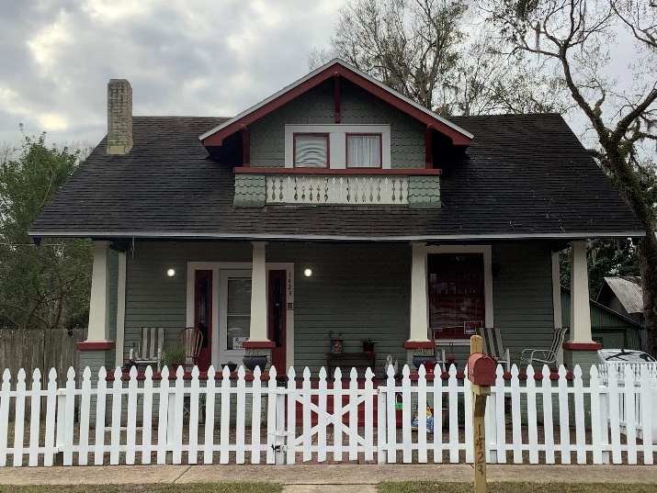  1423 Main Street
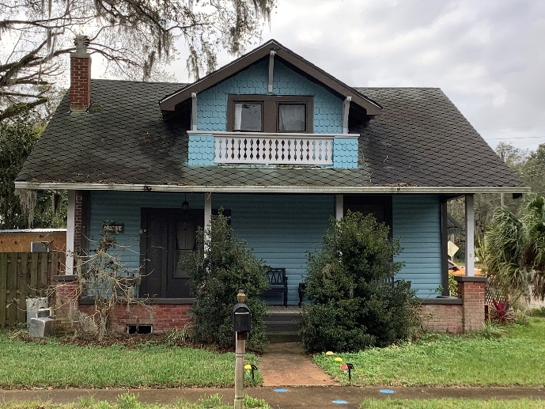  1431 Main Street | 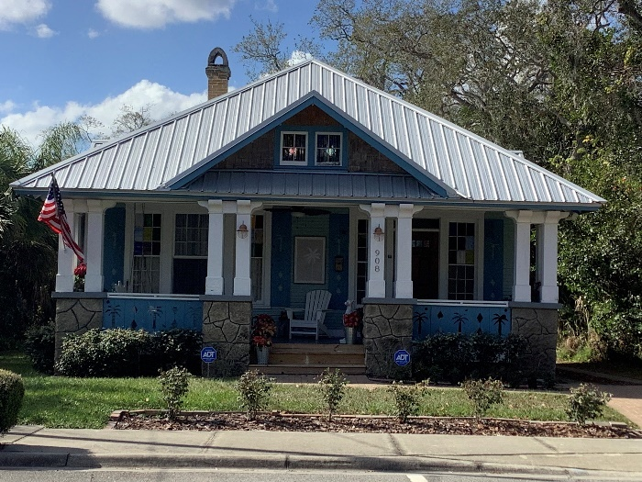  908 South Washington Avenue

Common Characteristics of Craftsman
One to two-stories in height
Wood frame with pier or continuous block foundations
Roofs can be front-gable, cross-gable, side-gable, or hipped and have widely overhanging, open eaves
Roofs can feature exposed wood rafter ends, brackets, or triangular knee braces
Exterior walls are typically weatherboard, wood drop siding, or stucco
Porches are featured on most examples and are usually full-width and deep-set
Variety of porch supports including battered and square posts, that can be either full height or set on brick piers or framed bases
Windows are usually one-over-one or four-over-one double-hung wood sash windows
Paint colors commonly included muted, earth tones

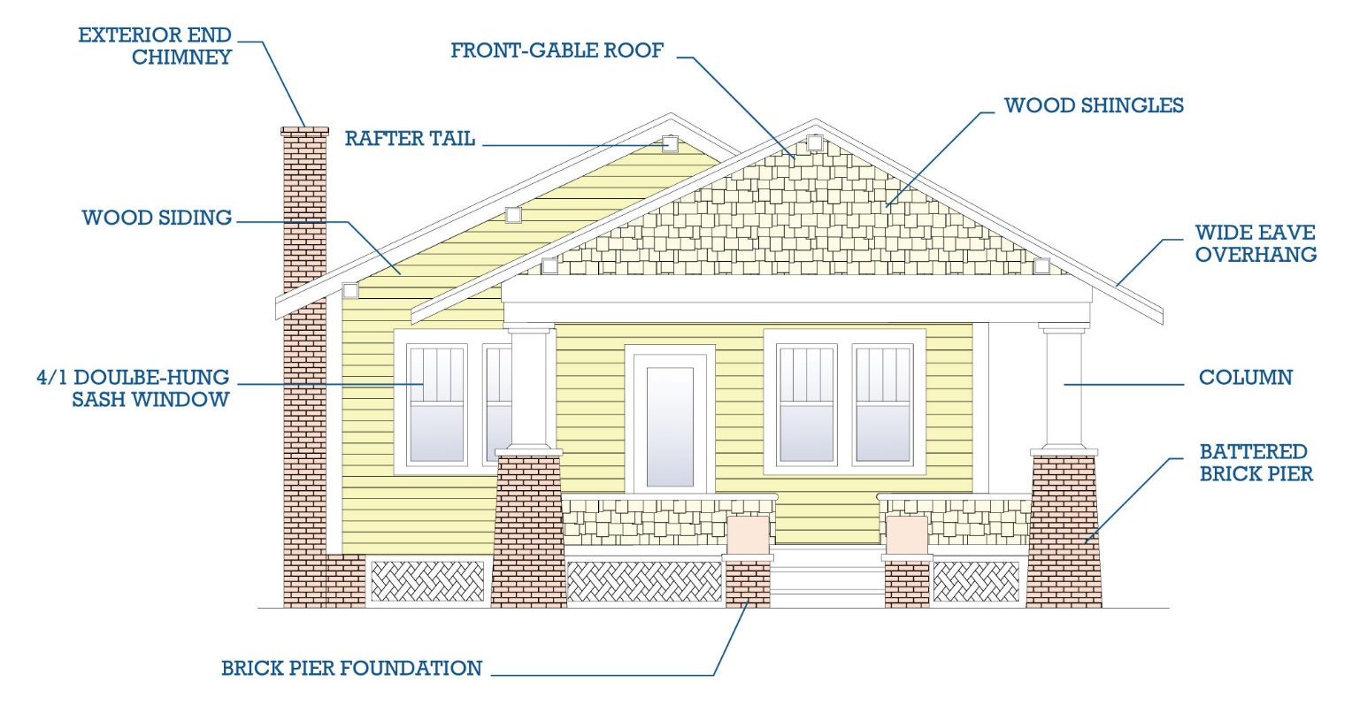
Minimal Traditional ca. 1935-1950
The term “Minimal Traditional” describes small, affordable, cottage-like dwellings constructed between the 1930s and 1950s. This style originally emerged at the height of the Great Depression and could be built with FHA-insured loans. After World War II, this style of house was built rapidly to provide the housing that was guaranteed to returning servicemen. The style was well-suited to suburban tract-house developments, which appeared in the late 1930s and 1940s. The style remained a fashionable throughout the United States into the 1950s when the Ranch style gained popularity. The style spread throughout the country due to architectural journals and popular magazines.
In Florida, the Minimal Traditional style gained popularity in the mid-1930s. The style was most popular in cities, such as Jacksonville, Miami, Orlando, and Tampa. The style was widely adopted by architects to help address housing needs in a struggling economy. The style acted as an alternative to the extravagance associated with house designs of the 1920s.
Minimal Traditional style houses were frequently constructed by local builders using architectural plan books. The house plans are usually simple; however, the design of these houses varies widely. They are often one-story tall with a front or side gabled or cross-gable roof. Notably the roof eaves tend to be very shallow with almost no overhang. Minimal Traditional houses have little ornamentation, and many houses do not reflect any particular historic architectural style. However, subtle details from Colonial Revival or Tudor Revival styles can often be identified. These houses can feature small porches at their entries. These porches are integral to the house under the main roof or are a small extension of the main roof. Porch ornamentation is subtle with simple wood columns with bases and capitals.
Below are examples of Minimal Traditional buildings in Titusville
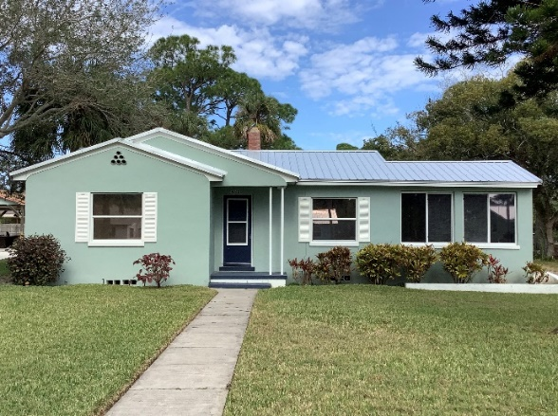  4040 Coquina Avenue | 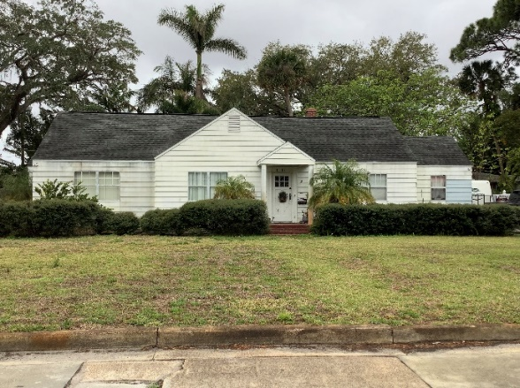  1216 Indian River Avenue
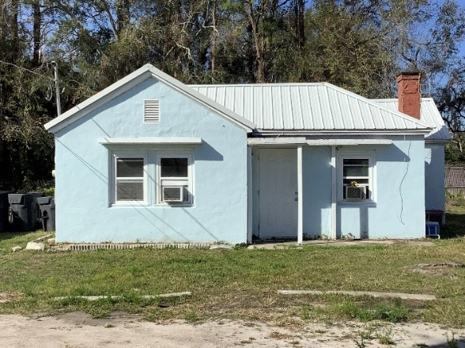  1214 South Hopkins Avenue | 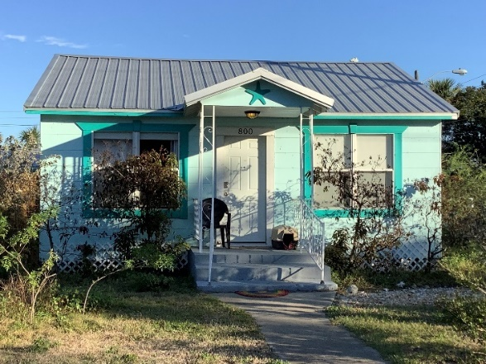  800 Tropic Street

Common Characteristics of Minimal Traditional
Usually one-story in height
Simple in type
Layout and design elements vary
Roofs are commonly side- or cross-gable; roof eaves are shallow with little overhang
Some feature subtle style elements derived from the Colonial Revival or Tudor Revival styles
Tudor Revival style might be referenced through the presence of a large chimney
Exterior material can be weatherboard, brick, stone, stucco, or a combination
Can feature small front porch
Variety of porch supports including battered and square posts, that can be either full height or set on brick piers or framed bases
Windows are usually one-over-one or four-over-one double-hung wood sash windows

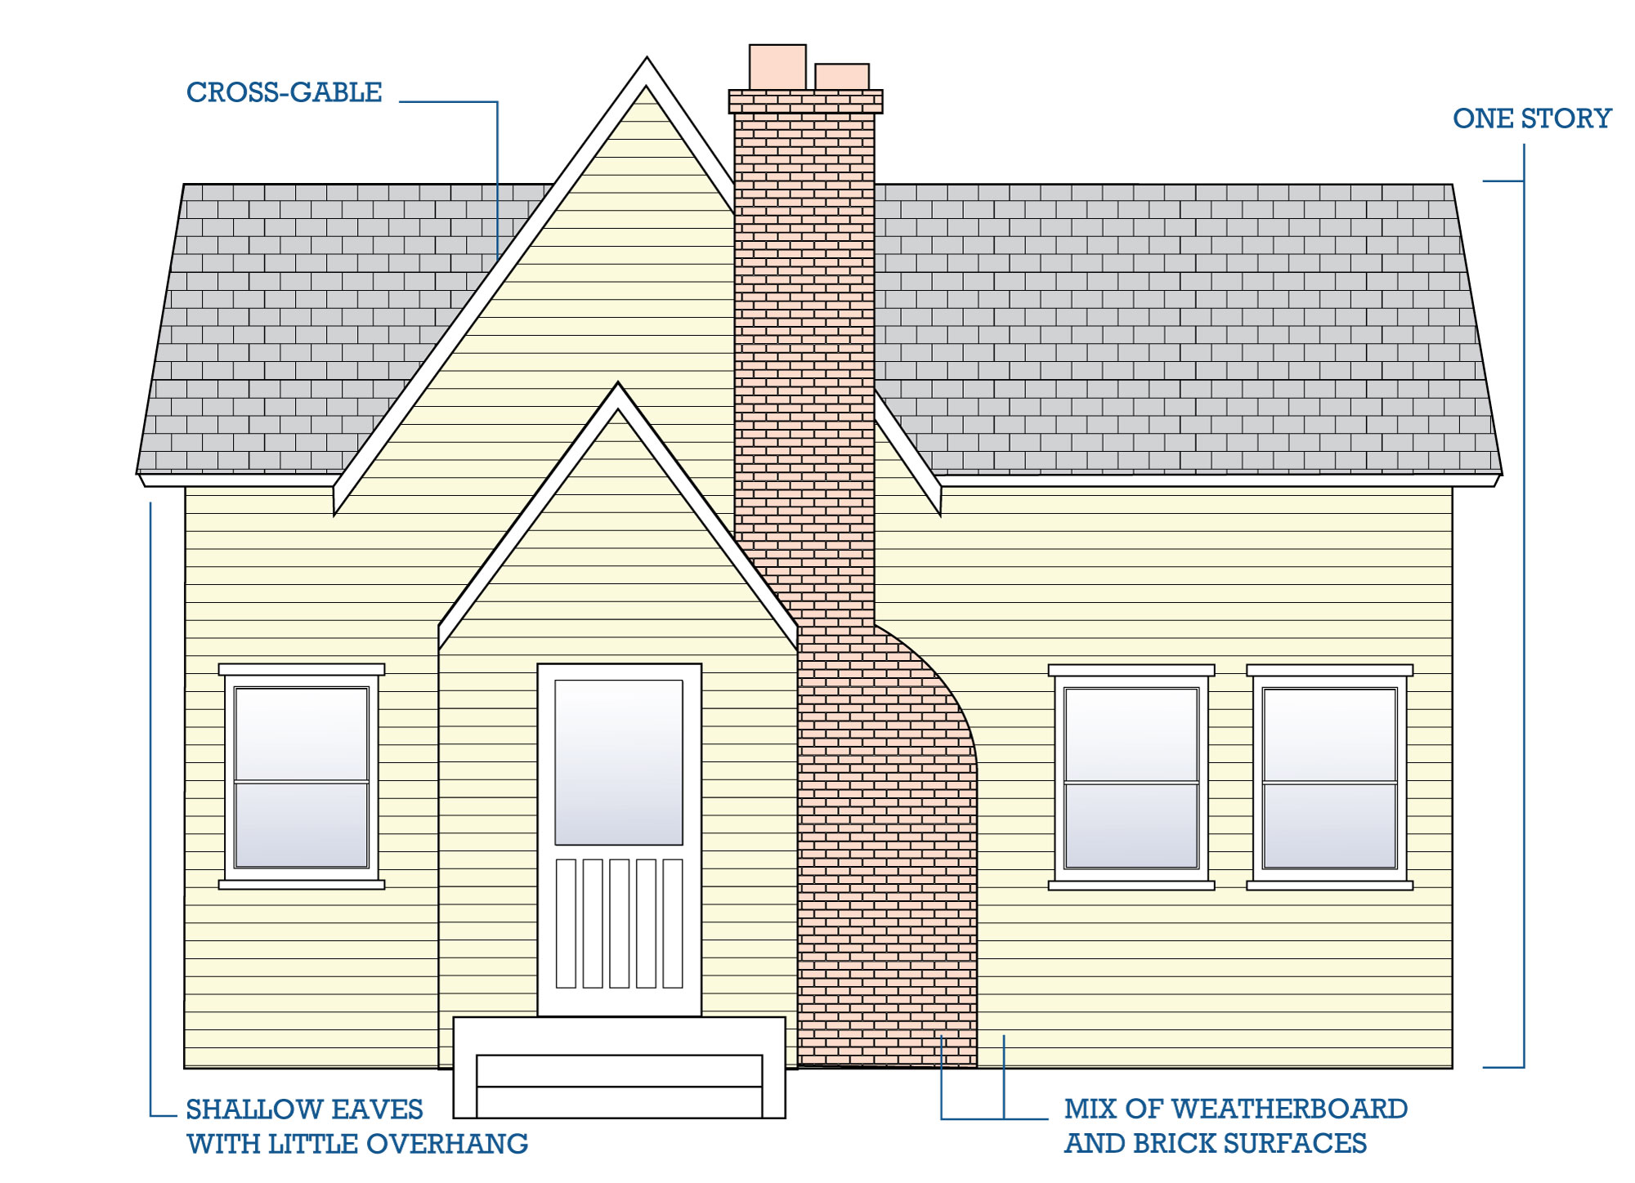
Ranch ca. 1935-1975
Created in California in the mid-1930s, the Ranch style is one of the nation’s leading housing types. It gained popularity in the early 1940s and dominated American single-family housing throughout the 1950s and 1960s.
Ranch style houses have a characteristic “rambling” plan. They are one story tall and have asymmetric facades. Ranch style house incorporate garages at one end of the house and emphasize width over depth in their floorplans. They often feature low-pitched gable or hipped roofs. Contrasting other earlier styles, porches are at the rear of the house rather than the front. This creates a more private porch setting. Ranch houses have several characteristic details including shutters and porch supports inspired by the Colonial Revival style.
There are several sub-styles of Ranch style houses which draw detailing or forms from various other styles, such as Contemporary Ranch houses. One of the most common Ranch sub-styles found in Florida is the Ranchette or Minimal Traditional Ranch. This sub-style has less details than a typical ranch usually using fewer exterior materials. They also, typically, have a narrower plan than a traditional Ranch.
Below are examples of Ranch buildings in Titusville.
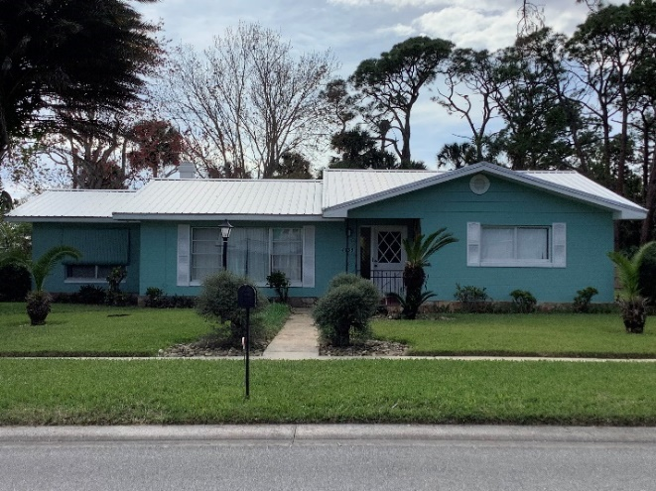  4035 Coquina Avenue | 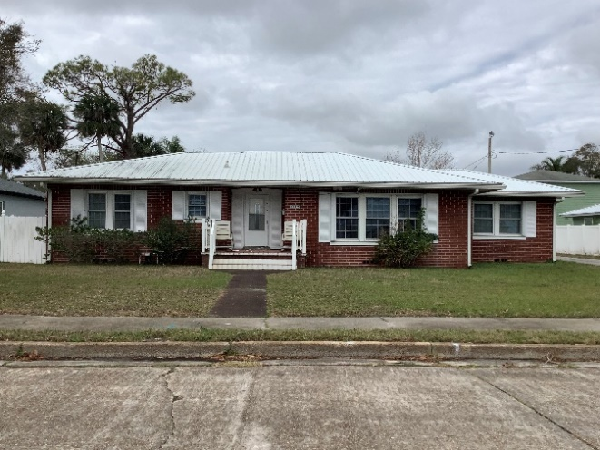  1322 Riverside Drive
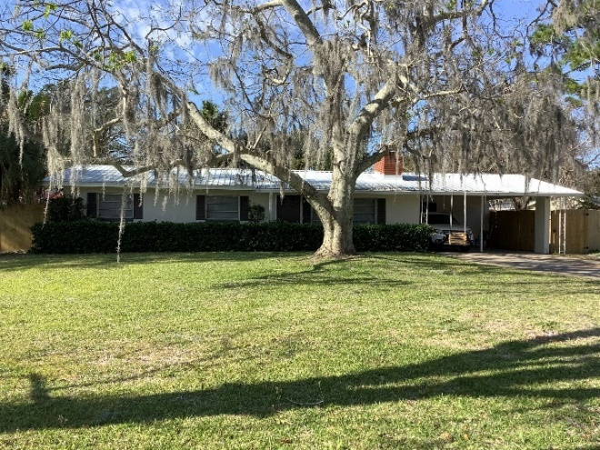

4380 Alpine Lane
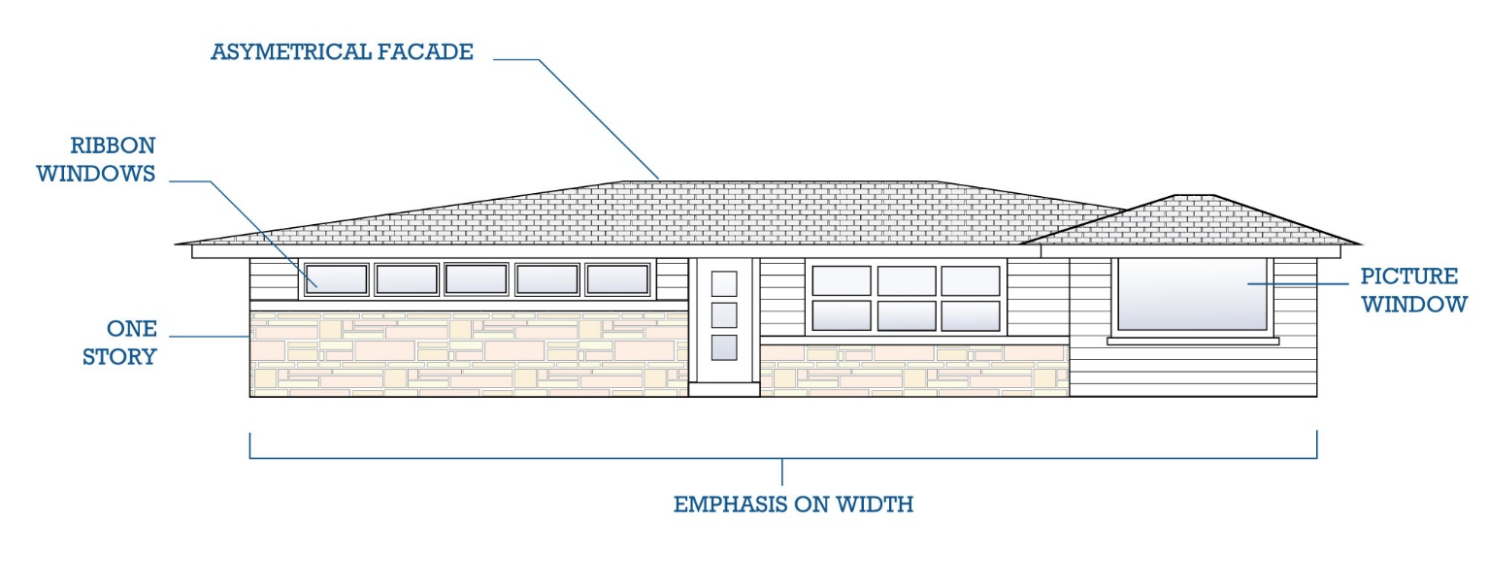
Common Characteristics of Ranch
One-story in height
Asymmetrical façade
Emphasis on the width instead of depth
Built-in garage
Low-pitched hipped, cross-gable or side-gable roofs; wide eave overhangs are common, and eaves can be open or boxed with exposed rafter ends
Rear porches are more prevalent than front or side porches
Ribbon windows and large picture windows are common
Wood or decorative iron porch-supports and decorative shutters are common

Bungalow
The term “Bungalow” typically describes an architectural form, however, in Florida Bungalow is used to describe a style of house commonly found in the state. A bungalow typically dates from the 1900s through the 1940s.
Bungalow style houses are one- to one- and one-and-a-half-story dwellings that were both economical and practical – they were both easy to build and fully customizable. Craftsman elements are common in Bungalow houses, particularly exposed rafter tails and porch supports. Common characteristics include compact size, projecting eaves, multiple gables, asymmetrical facades, and low-pitched roofs with large dormers as well as full-width front porches integrated into the building’s main roof.
Below are examples of Bungalow buildings in Titusville
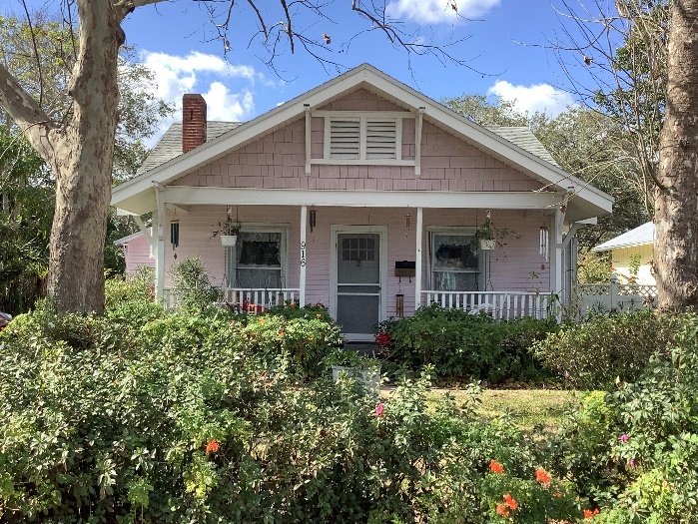  916 Indian River Avenue | 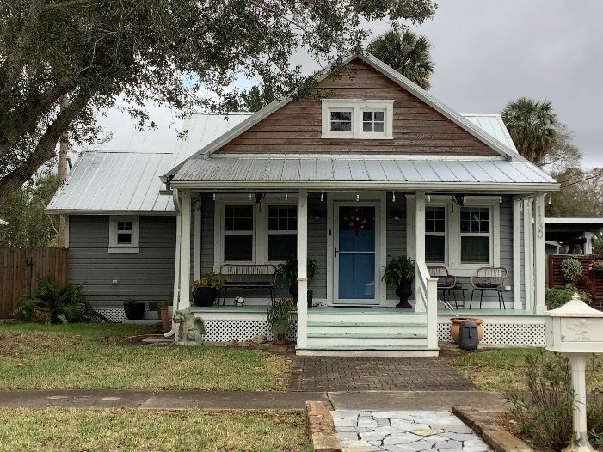  1130 Indian River Avenue
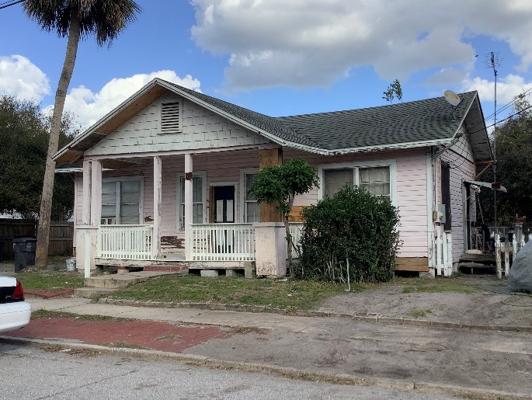  411 Dummitt Avenue | 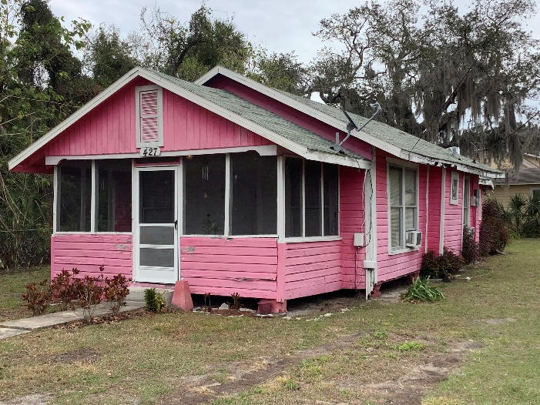  427 Olive Avenue

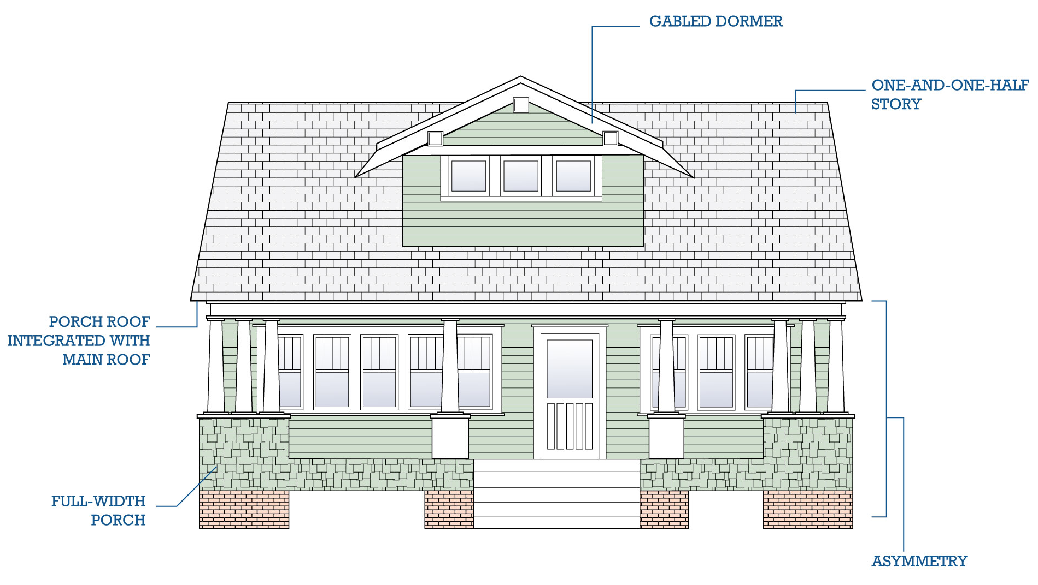
Common Characteristics of Bungalow
One to one- and one-half-stories in height
Wood frame with pier or continuous block foundations
Roofs can be front-gable, cross-gable, side-gable, or hipped and have overhanging, typically, open eaves
Roofs usually feature exposed wood rafter ends
Exterior walls are typically weatherboard, wood drop siding, or stucco
Porches are featured on most examples and are usually full-width
Windows are usually one-over-one or four-over-one double-hung wood sash windows
Reminiscent of a Craftsman style house with less detailing and smaller
Paint colors typically included muted, earthy tones

Contemporary ca. 1945-1980
The Contemporary style was popular for architect-designed buildings from about 1955 to 1970. This modern era style rejected preceding styles’ approach to decorative detail which focused on applied elements. These decorative details focused on apertures-windows and doors, porch supports, dormers, and wall junctions. Contemporary style buildings focus on the interior space and how it connects to the outside of the building. Architects therefore designed these buildings form the inside out.
These houses were commonly designed around outdoor spaces including courtyards or a variety of small garden like spaces which surround the structure. Contemporary style houses typically have reserved facades and use screening walls to diminish the deeply recessed entry.
In Titusville the Contemporary style manifested as Contemporary Ranch type houses with low pitched roof, mixed exterior materials, ribbon windows, and large groupings of windows. Other Contemporary style buildings include commercial properties used historically as autobody or repair shops or gas stations.
Below are examples of Contemporary buildings in Titusville.
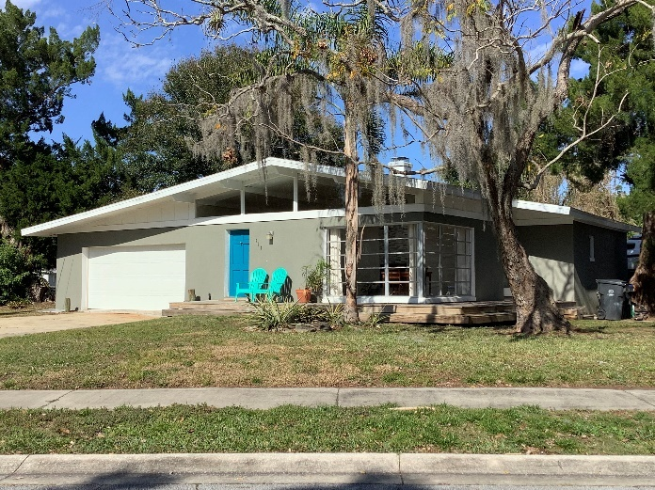  514 Delespine Avenue | 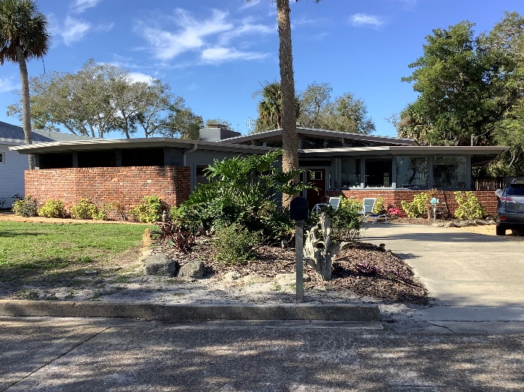  1600 Riverside Drive
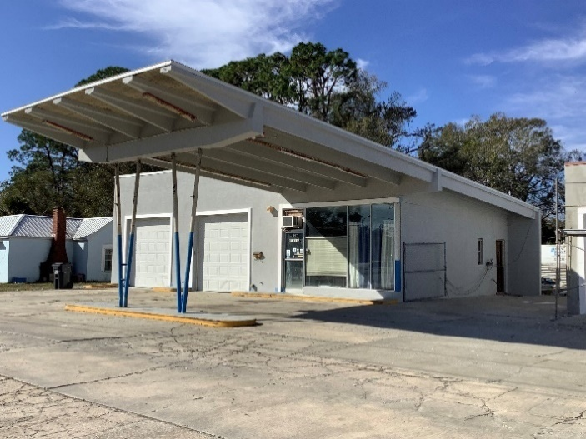  1210 South Hopkins Avenue | 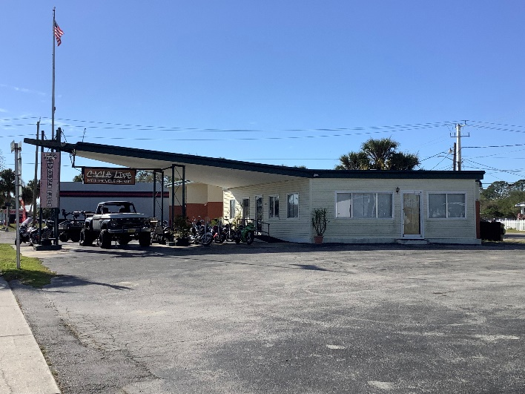  1231 South Hopkins Avenue

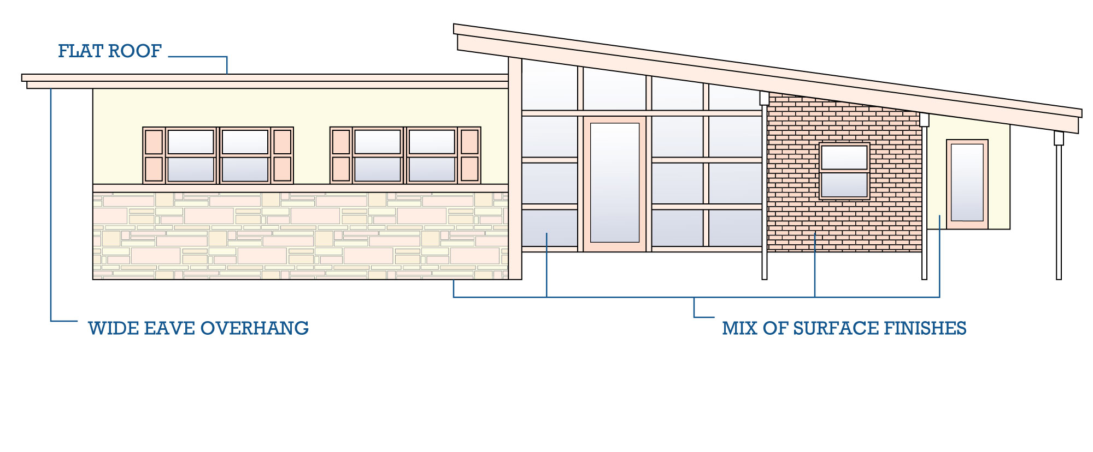
Common Characteristics of Contemporary
One or two-stories
Asymmetrical form
Roofs are typically flat or gabled
Gable roofs have widely overhangs, open eaves with exposed rafter ends; heavy piers may support gables
Examples with flat roofs lack traditional detailing
- Exterior materials can be a combination of wood, brick, and stone

Chapter 6: Design Guidelines
The following design guidelines are intended to provide a clear framework to ensure that any changes to the exterior of properties within Titusville’s designated historic districts, including the Downtown Residential Historic District, the Titusville Historic Downtown Commercial District, and any locally designated historic sites are made appropriately and consistently. While these guidelines should be followed for these identified resources, they can also be taken into consideration for buildings outside the historic district or those currently not a locally designated site in an effort to create buildings designed sympathetically to the City’s historic landscape. This chapter contains guidance for commercial and residential construction as well and infill and site design.

6.1 Secretary of The Interior’s Standards for the Treatment of Historic Properties
The Secretary of the Interior’s Standards for the Treatment of Historic Properties (the Standards) were originally created in 1976 and pertain to historic buildings of all construction types, sizes, materials, and occupancy and can be applied to the exterior and the interior, related landscape features and the building's site and environment as well as attached, adjacent, or related new construction. Since then, they have become the basis for the majority of locally created design guidelines for historic districts.
According to the Secretary of the Interior, there are four ways to approach work on historic structures: Restoration, Preservation, Rehabilitation, and Remodeling.
Restoration
Restoration is bringing a property back to its appearance at a previous time in the past. This can include removal of later additions or inappropriate features and the replacement or reproduction of missing original features. Restoration requires extensive research into the history and construction of the building and site to create an actual reconstruction of the building.
Preservation
Preservation or stabilization is the process of halting the deterioration of the historic resource. This entails making sure the building is weather-tight and structurally sound so future restoration or rehabilitation can occur.
Rehabilitation
Rehabilitation is a practical approach to the preservation of a historic resource. This entails updating the structure while maintaining and protecting the architectural character and defining features of the building. Rehabilitation may include structural repairs, repairing roofs and exterior finishes, upgrading mechanical systems and modernizing kitchens, and even changing the use(s) of the structure.
Remodeling
Remodeling is the least recommended approach to modernizing a building. Repairs and additions are undertaken with little or no regard for the overall design and architectural style.

6.2 General Guidelines
Guideline 6.2.1 Preserve Significant Historic Features
Every historic building, regardless of style has a set of distinctive details or, character defining features, that contribute to the overall character of the building. Care should be taken to preserve these features.
- Before beginning a project, determine if there is an existing Florida Master Site File (FMSF) Form for your building (see Chapter 2). This will provide accurate and thorough information about the style and historic characteristics of your building that will need to be considered throughout your project. Note that not every property will have a FMSF Form. If the property does not already have a FMSF, then you will need to identify the character defining features yourself based on the design principles described in Chapter 4.
- Avoid the removal of historic architectural features and materials. Historic architectural features include large scale characteristics including the building’s overall shape, roof form, and fenestration patterns, as well as small-scale features like moldings, brackets, ornaments, and other examples of skilled craftsmanship.
Figure 1: The wood trim on this balcony displays peeling paint and some damaged wood. Architectural features should be preserved rather than replaced.
- Retain existing historic building materials, including brick and stone masonry, wood shingles and siding, stucco, etc., to the greatest extent possible. Avoid removing historic materials that are in serviceable condition.
- Materials or additions which were added after the building’s initial construction – for example a porch, or a kitchen addition – may have since achieved historic significance in their own right and should be preserved.
- Historic outbuildings, including sheds and garages, should be maintained and preserved. Avoid removing or drastically altering historic outbuildings.

Guideline 6.2.2 Repair Rather than Replace
Where possible, repair historic materials and features rather than replacing them.
a. Repair rather than replace historic features wherever possible.
b. Use the recommended technical procedures for cleaning, refinishing, and repairing historic
materials. See Appendix B for technical resources. Some cleaning methods, including chemical and abrasive methods, and repair techniques can cause or exacerbate damage to historic materials of the building, particularly masonry. Always use the gentlest methods available.

Guideline 6.2.3 Restore Significant Historic Features
Whenever feasible, historic materials and details should be restored. It is appropriate to restore previously damaged or altered historic features to their historic appearance. Restoration should be based on physical evidence and/or documentation of the building’s historic appearance.
- Restorations of historic buildings should be completed under the direction of architects or professionals with specialized skills in building restoration and preservation.
- Inappropriate coverings, such as vinyl siding applied over historic wood siding, should be removed and the underlying material repaired or replaced with siding, which mimics the appearance of the historic material as closely as possible.
Figure 2: This well-preserved dwelling at 602 Indian River Avenue retains significant historic features such and original windows, wood siding, and decorative wood shingles that should be restored rather than replaced.
- Restore or replace underlying historic materials with new elements that closely replicate the historic appearance.
- Take care to remove non-historic materials in a way that does not damage underlying historic materials.
- Where no evidence of the feature’s original appearance exists, utilize a simple design consistent with the scale, massing, and style of the building and surrounding area.
- Historic additions that are in keeping with the overall design of the building and are over 50 years old have achieved significance in their own right and should be retained or restored.
- Recent additions that are not historically significant may be removed via a process that does not damage the visible significant features of the historic resource.

Guideline 6.2.4 Make Sensitive Replacements
When a historic element is deteriorated to the point that replacement is required, the replacement should replicate the element as closely as possible.
- Replace missing features (such as cornices, storefronts, etc.) with historically appropriate replacement features. The design of replacement features should be based on its historical appearance and substantiated by documentary, physical, or pictorial evidence. This may be accomplished by locating historic photographs which show the original appearance of the element, replicating existing but incomplete elements, or by reproducing elements visible on neighboring buildings of the same style and date range.
- Replace as little historic material as possible. This may include patching, splicing, or piecing-in replacement materials such as individual roofing tiles, shingles, or siding, masonry patches, or dutchman repairs for wood elements.
- Match the historic feature’s size, shape, profile, texture, and color to the greatest extent possible. The new materials should match the old when possible. In some cases, replacement with features recreated in synthetic materials may be appropriate (for additional information on substituting historic materials, see Appendix B).
- Avoid changing the character of historic features. For example, original horizontal board siding should not be replaced by vertically oriented siding or shingles, even of the same material.

Substitute materials should only be used if they do not cause damage or change the character of the historic resource. The new material should match the form, color, and texture of the historic feature (for additional information on substituting historic materials, see Appendix B). There are five situations where substitute materials may be approved:
- When historic material is unavailable,
- Where historic craft techniques or skilled artisans are unavailable,
- If little information exists about a building’s historic materials, or,
- Upon code-related changes
- When the commission determines that such a material is acceptable for the given situation.

Guideline 6.2.5 Context-Sensitive Design
- Where no evidence exists of the exact shape of missing details, a sensitive, often simplified design is preferred. The design should be consistent in massing, scale, material, and color to the historic feature.
- For inspiration and reference, look to similar building types constructed in similar styles within the district. New features (including new construction) should be sensitive to the size, scale, massing, proportion, and detail of similar buildings or the overall character of the surrounding neighborhood.

Guideline 6.2.6 Safety Codes and Accessibility
It is important that all buildings comply with local and state safety codes, including providing handicapped access to residents or visitors, as needed. This can be achieved without compromising the significance or integrity of historic buildings.
- Compliance with health and safety codes and handicapped access requirements must be carried out with minimum impact on the historic character of buildings.
- When permitted by law, fire escapes or fire towers shall be placed at the rear of buildings as a secondary means of egress.
- Provide barrier-free access that promotes independence for the disabled to the highest degree practicable, while preserving significant historic features.
- Construction of ramps, lifts, fire escapes, and similar accessibility features should be constructed in an area that is hidden from public view, such as on a rear or side elevation, when possible.
- Ramps should have little to no visual impact or should be designed to be as unobtrusive as possible.
- Install ramps and other accessibility features in a manner that is reversible where practical and does not permanently impact the historic building.
- Access ramps shall be in scale and visually compatible in design and materials with the building.

Best Choice
Constructing an access ramp on the rear or side, rather than at the front entrance of a property

Good Choice
Constructing an access ramp which is removable and does not damage existing historic features

Not Appropriate
Demolishing an existing historic porch or entry steps and installing a permanent ramp in its place

Guideline 6.2.7 Adaptive Reuse
Adaptations of a property to a new use should retain the building’s historic character and significant features and conform to existing zoning code.
For example, conversion of a single-family residence to a multi-unit apartment may require the addition of new exterior entrances. These should be designed sensitively and positioned on a non-visible façade whenever possible.
- Adhere to Titusville’s zoning code for permitted uses.
- It is preferable to retain a building’s historic use whenever possible.
- Retain the building’s historic character when adapting to a new use. A residential building converted to a commercial use should retain the building’s residential character, and vice versa.

6.3 Maintenance
Regular maintenance is key to preserving the original design and historic features of a property. Preserving original building features through maintenance and repair saves money in the long run as compared to replacing deteriorated features and is better for individual property values and the neighborhood as a whole. The protection and maintenance of existing historic features is the first preferred approach for treating historic properties.
Property owners do not need to seek approval from the Historic Preservation Board (HPB) for general maintenance activities that do not require replacement of materials or alterations to existing finishes. Light cleaning (without the use of abrasives or pressure), yard work, and minor repainting of painted surfaces are all considered maintenance activities; however, if a building permit is required, your project will require review by staff or the HPB, as appropriate, of the project’s consistency with these guidelines.
Often the simplest and cheapest approaches to maintaining historic buildings are overlooked in favor of high-tech methods that are more costly and complex. For example, periodic cleaning of masonry walls with mild soap and water and a bristle brush produces the same result and is more cost-effective than high-pressure washing or chemical cleaning techniques. The gentlest methods are most effective when they are applied proactively and regularly.
There are a wide range of maintenance activities that are recommended for historic buildings. A good starting place for additional information is Preservation Brief 47, “Maintaining the Exterior of Small and Medium Sized Historic Buildings,” published by the National Park Service and available for reference here: https://www.nps.gov/orgs/1739/upload/preservation-brief-47-exteriors-small-medium-buildings.pdf.

6.4 Universal Guidelines for Exterior Walls including Siding
Please see General Guidelines at the beginning of this chapter, for additional guidance.

Guideline 6.4.1 Match Existing or Historic Siding
- The historic material found on the exterior walls of a building is a character-defining feature and should be preserved, maintained, repaired, rehabilitated, and restored whenever feasible.
- If replacement is required, apply the new siding in a way that matches the existing or historic.
  - Changing the size of historic shingles, the width of wood boards or corners and seam details will change the appearance and perceived scale of the building and will not accurately reflect the construction methods of the period, therefore should be avoided.

Guideline 6.4.2 Stucco Surfaces
- Surfaces that have been stuccoed may remain stuccoed. Removing stucco that covers masonry could damage the masonry beneath.
- When repairing stucco, match the finish to that on the remainder of the historic building.
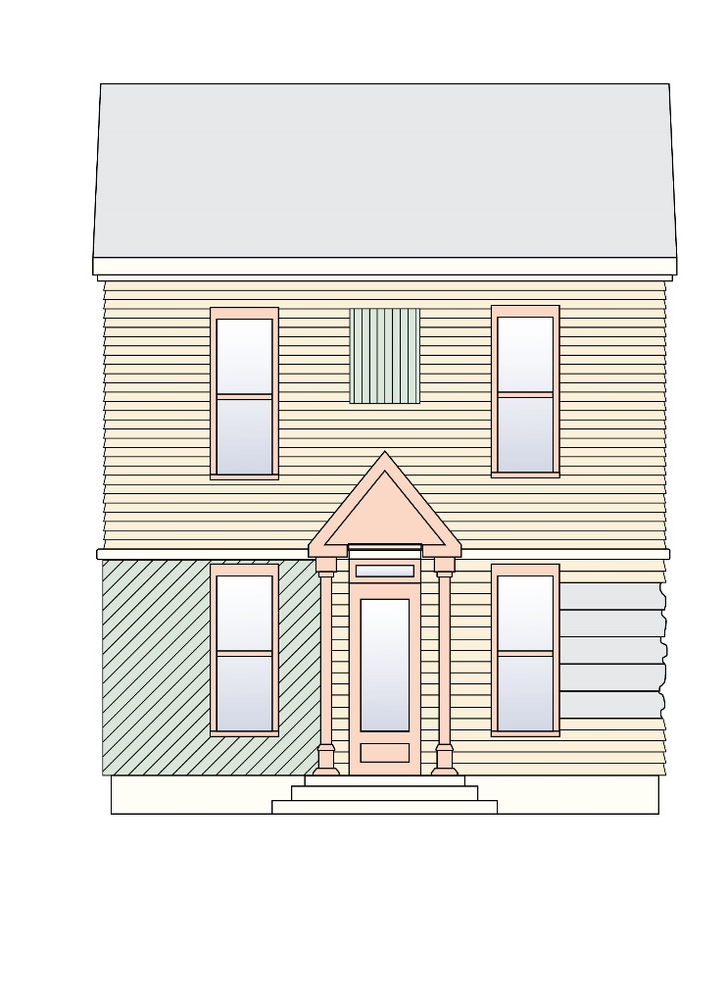
It is generally not appropriate to:
- use incongruous materials such as un-faced concrete, plastic, vinyl, fiberglass, concrete block, stucco, and corrugated or other metal sidings as the dominant building material on historic buildings
- cover masonry walls that were not historically covered

Figure 3: Illustration showing an inappropriate combination of siding.
Figure 4: A stucco finished building at 915 South Washington Avenue | Figure 5: A stucco finished building at 214  Julia Street
Guideline 6.4.3 Synthetic Siding
Synthetic siding is an umbrella term used to describe siding not made from naturally found material. Most common are vinyl and asphalt, where chemical processing is required to develop the product. Wood and stone (including slate) are found and used in their raw form while brick, metals, cement, and glass are processed from naturally found materials and are therefore not considered synthetic.
- Maintain existing 20th-century asbestos shingle siding due to safety concerns.
- The use of new synthetic siding is discouraged, but the use of cementitious/fiber cement siding (sometimes known as HardiPlank®) may be approved on a case-by-case basis if one or more of the following conditions are present:
  - If the applicant can prove to the HPB that existing siding is so deteriorated or damaged that it cannot be repaired;
  - If substitute material can be installed without irreversibly damaging or obscuring the buildings architectural features;
  - If the applicant can provide samples and/or documentation of the existing historic siding as well as the proposed replacement siding to ensure that the substitute material matches the historic material in size, profile, and finish (this should be smooth, lap siding finish and not a manufactured wood grain finish);
  - If substitute material matches the historic material in size, profile, and finish and is appropriate to the style of the building, and, there is no change in the character of the historic building;
  - If non-historic artificial siding has already been applied to the building.
- Trim details including but not limited to corner boards, header and sill conditions, cornices and roof trim should be applied as appropriate.
- Substitute materials should be installed by a skilled installer. Poor installation can result in erroneous vertical seams, which will make the replacement more obvious and result in low performance.
It is generally not appropriate to:
- remove or cover historic decorative details with synthetic siding including, but are not limited to, roof cornices, window molding, roof eaves, and window and door trim
- use imitation brick

- install synthetic siding over brick walls

Guideline 6.4.4 Replacing or Repairing Exterior Masonry Walls
- If it is necessary to replace damaged stone or brick, be selective and use material of similar size, color, and texture and install it in the historic bond pattern with duplicated mortar joints.
- Mortar composition should match the existing or historic mortar composition, strength, and hardness.
It is generally not appropriate to:
- replace or rebuild major portions of exterior walls that could otherwise be repaired and whose replacement would result in unnecessary new construction
- use Portland cement products in combination with historic brick and mortar as this product is typically much harder and stronger than historic materials and will exacerbate deteriorative conditions

Guideline 6.4.5 New Exterior Walls
- For additions to existing structures, select building materials that are in keeping with materials used on the primary building.
- For new construction, select building materials that are in keeping with/complementary to materials used on nearby buildings within the district.
- For masonry walls, use bricks of a similar size, color, and texture to those historically used. Do not use concrete block or jumbo brick.
- Wood surfaces were historically painted. Do not leave wood surfaces unpainted or treated with only with wood preservatives, even if tinted.
- Synthetic materials, such as cementitious siding will be reviewed on a case-by-case basis.

6.5 Universal Guidelines for Exterior Materials including Siding
Please see General Guidelines at the beginning of this chapter, for additional guidance.
Wood
Wood is both structural and decorative and is used on nearly all building types and architectural styles. Even when the predominant building material is masonry, wood is used for windows and doors, roofs, porch supports, and more.
Typical projects involving historic wood include the repair of broken or missing architectural elements, repairing historic siding, and painting or repainting wood surfaces.
When an architectural feature is significantly deteriorated, consider first how to repair the feature before replacing it. If problems persist, it is important to try to determine the cause of the issue to prevent future problems. Deteriorating wood can sometimes be consolidated with an epoxy. Splicing or piecing wood can be used to replace only the affected area of a feature, rather than replacing the feature in its entirety. In general, it is important to retain as much original material as possible.
If repair is not possible and the replacement of siding or architectural trim is necessary, the new material must match the existing in material, design, color, texture, dimension, scale, and other visual qualities.
The type, width, and thickness of wood boards affect the overall look of the building and are considered to be character-defining features which are important to retain. When repairing or replacing historic siding, these characteristics must be preserved or replicated. More information about the use of synthetic material is provided in Appendix B.
Painting or repainting historic woodwork is an important task that will extend the longevity of the material.
Guideline 6.5.1 Wood Siding
Figure 6: Wood sided house at 427 Olive Street
- Siding shall be repaired or replaced with the same material, orientation (horizontal or vertical), board width, and length as the existing.
- Replacement of siding shall maintain existing decorative trim around windows and doors, corner boards, and/or corner detailing and trim along rooflines.
- New material must match the existing in material, design, texture, dimension, scale, and other visual qualities.

It is generally not appropriate to:
- use a non-historic covering over wood, such as aluminum, vinyl, stucco, Tl -11, or permastone. Such coverings hide details and trap moisture, which can cause damage to the underlying wood
- strip paint or other coatings to expose the original coated or raw surface and use a clear finish or stain as the finished surface
- replace historic wood siding, which has a smooth surface when painted, with cementitious siding with a raised wood-grain texture

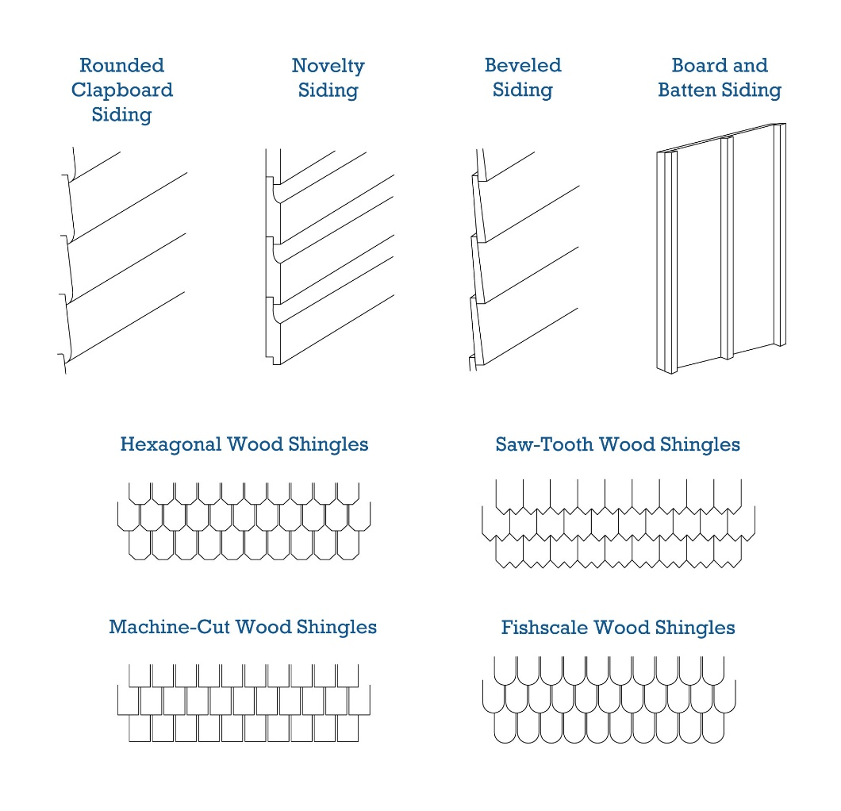
Figure 7: Examples of wood siding patterns

MASONRY
Brick is a common façade material for all types of buildings. The molds used to manufacture brick give it its texture, shape and size. The type of clay and the temperature at which it is fired in the kiln gives brick its color. The way bricks are laid in the wall (called coursing) and the width, profile, texture, and color of the mortar and mortar joints contribute to the character of brick walls.
Prior to the 1860’s, most bricks were hand-made in wood molds. Fired in kilns that used wood or charcoal as fuel, the finished product was somewhat soft with an uneven appearance. These soft bricks were frequently painted for protection and to achieve a more uniform look. By the 1880’s gas kilns, which could produce much higher temperatures, were in widespread use. Gas kilns produced a harder brick that was non-porous and could be left unpainted. Not all bricks produced by gas-fired kilns were of the same hardness. The softer, more porous bricks from the cooler, central portion of the kiln were reserved for use in party walls, or rear and side walls, while the hard-fired brick was used for primary elevations.
Stone and brick are among the most durable of building materials, but they are susceptible to erosion from environmental and chemical factors. Stone and brick should not be painted, as the resulting surface is neither as attractive nor as durable as the original, unpainted version. Painting brick results in added maintenance requirements as the coating will need to be reapplied as it wears. Once masonry has been painted, it is very difficult to restore it to its original appearance.
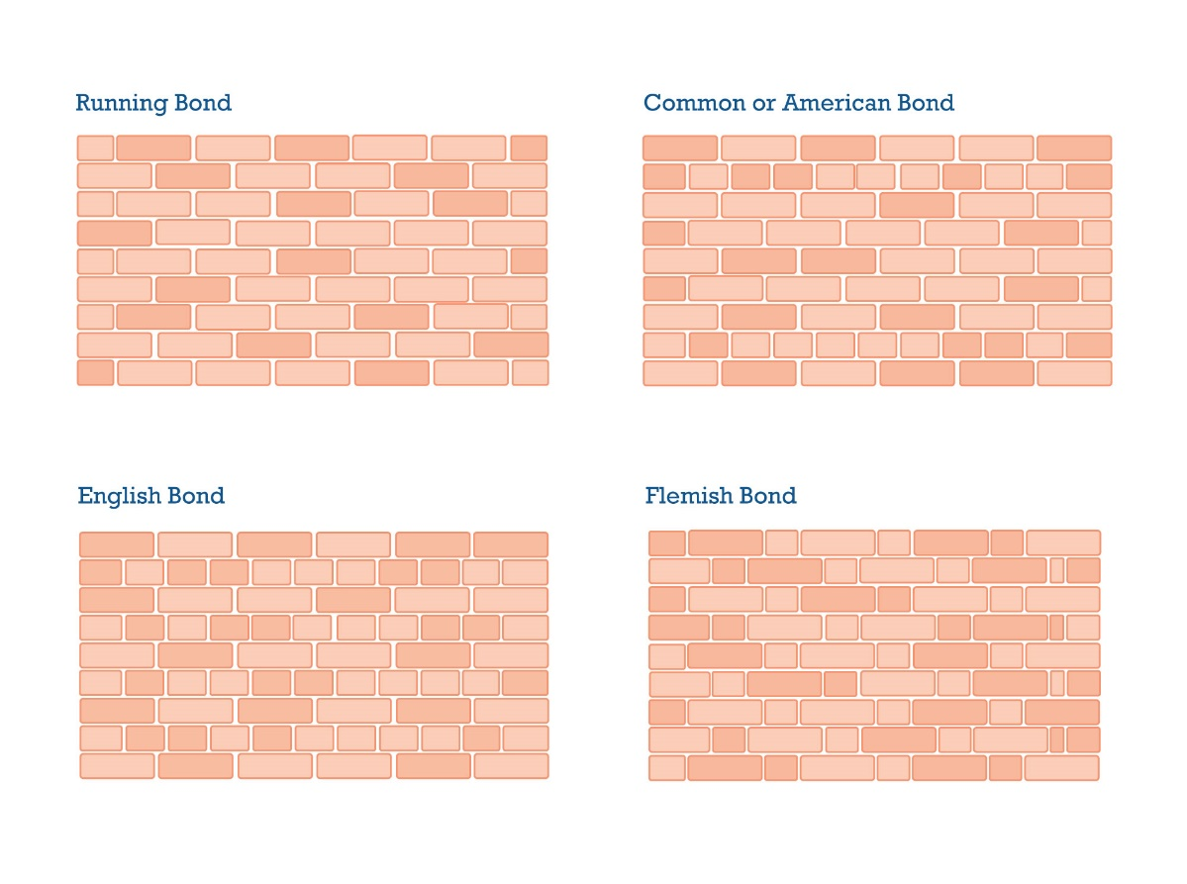
Historic brick walls and foundations are often laid in running, English, common (or American), or Flemish bond with mortar joints usually ranging from 1/4" to 1/2" in width. Common mortar joint profiles include struck, weather, and flush. Other less common profiles include raked, vee, concave, and rope. Most mortar was naturally a gray-white color, although some mortar used in historic brick walls and foundations was tinted, often red, by adding brick dust or pigments to the mortar mix.
Figure 8: Examples of brick bonds

Guideline 6.5.2 Masonry
- Masonry shall be repaired or replaced with the same masonry, using the same patterns and color, and for stucco surfaces using the same texture and pattern.
- Brick or stone shall not be painted unless the brick or stone is already painted, or when a masonry surface is deteriorated beyond repair and painting is the only means to prevent further deterioration of the surface.
- Replacement mortar composition should match the existing or historic mortar composition, strength, and hardness.
It is generally not appropriate to:
- use a non-historic covering over masonry, such as aluminum, vinyl, stucco, Tl -11, or permastone. Such coverings hide details and trap moisture
- use Portland cement products in combination with historic brick and mortar as this product is typically much harder and stronger than historic materials and will exacerbate deteriorative conditions
- use waterproof coatings or sealants on historic masonry as these trap moisture within the historic materials, eventually causing erosion of the surface

Figure 9: A brick building at 1022 Indian River Avenue

6.6 Universal Guidelines for Site Design
Please see General Guidelines at the beginning of this chapter, for additional guidance.
Guideline 6.6.1 Walkways, Driveways and Parking Lots
- Walkways and driveways that have fallen into disrepair should be repaired rather than replaced wherever possible.
- New sidewalks within parcel boundaries should be constructed with material historically appropriate to the area.
- New sidewalks along the street should blend with adjacent sidewalks using the same or similar material and patterning.
- Establishing a new pattern using concrete pavers or brick may be appropriate if it is compatible with the historic quality of the street and will be reviewed on a case-by-case basis.
- Sidewalks must provide curb cuts per code and Americans with Disabilities Act (ADA) guidelines.
- Historic walkways that have been lost or altered may be restored based on documentation of the original design, or if no documentation is available, a new feature may be designed to be compatible with the overall historic layout of the property. The new design should be compatible with the location, configuration, dimension, scale, materials, and color of the historic property and the surrounding district.
- Walkway and driveway materials and colors should be consistent with those used historically, including brick, flagstone, and gravel. Concrete and asphalt are other options that may be appropriate.
- Establishing a new driveway configuration, such as a circular driveway, may be permitted on a case-by-case basis. However, if allowed, alternative parking areas must be available (i.e. parking pad or garage), so vehicles do not block or detract from the historic façade.
- Construction of new parking lots for subdivided residential properties should be avoided or located at the rear or side of the property.
Figure 10: View of Julia Courts walkway.

Figure 11: Pedestrian area at Julia Court
Good Choices
Restore damaged or lost circulation features with new synthetic materials that mimic the appearance of historic materials (ex: stamped concrete to mimic materials appropriate to the style of the property)

Design new circulation features which are compatible with and are complementary to the property’s overall historic design

Best Choices
Maintain and restore existing historic walkways and driveways using like materials

Restore lost circulation features by matching the historic feature based on documentary evidence

Not Appropriate
Expanding a single-width driveway to a double-width or large driveway

Converting front yards to parking areas

Locating driveways in the front or side yard when there is an alley at the rear of the property

Demolition of existing historic structures for the creation of surface parking lots

Guideline 6.6.2 Fences, Walls and Gates
- Maintain and preserve existing historic fences.
- Fencing and walls shall match the style of the building in scale and material.
- Fencing and walls should be of an appropriate height relative to the building and should conform to the City’s Fence Code (Land Development Code, Article III, Sec. 30-180 to Sec. 30-183).
- When replacement is necessary, in-kind replacements are the first choice. A simple fence in a style that complements the surrounding architecture may also be appropriate.
- Walls or fences that create a long continuous span (over 50 feet) shall contain some form of architectural relief such as pattern breaks in the wall plane, use of columns, or a mix of solid and open spans.
- Designs for new fences must be complementary to the surrounding architecture and must comply with existing zoning.
- Appropriate wood fence for Frame Vernacular, Colonial Revival, and Bungalow includes board-on-board and white picket. White plastic fences that emulate wood board-on-board or picket are acceptable alternatives.
- Dumpster enclosures shall conform to Section 4.8 Universal Guidelines for Docks and other Accessory Structures of this manual and the construction specifications of the City Code.
- Automatic security gates may be permitted, provided they are properly located and comply with existing zoning requirements. They must be appropriate to the design of any existing fence or the style of the historic building.
Best Choices
- Maintaining, repairing, or restoring an existing historic picket fence

- Installing a new picket fence, similar in style to other properties on the street

Not Appropriate
Replacing a historic fence with incongruous materials, such as chain-link or plain concrete block, or constructing a new fence of non-historic, incongruous material

Good Choices
Replacing a historic fence that is beyond repair with a new fence that matches the historic fence as closely as possible

Installing a new steel, wrought iron or aluminum fence with a simple design
and finish that is complementary to the property and streetscape

Figure 12: Fence at the Pritchard House | Figure 13: Fence and gate at 804 Indian River Avenue

Guideline 6.6.3 Landscaping and Site Features
- In general, historic landscaping features should be maintained and preserved like any other historic feature on the property. The removal of historic landscaping features, including front lawns and hedgerows, should be avoided.
- Removal of trees may require a tree removal permit. Please consult with the city staff and reference the City’s Tree Ordinance (Ordinance No. 20-2021).

6.7 Universal Guidelines for Garages, Outbuildings, other Accessory Structures
Please see General Guidelines at the beginning of this chapter, for additional guidance.

Guideline 6.7.1 Locating Accessory Structures
- Accessory structures such as sheds shall be located in the rear yard or the side yard close to the rear yard.
- Accessory structures that are permitted to be located along the public right-of-way or within the public view shall be designed in the same architectural style as the principal building but should not replicate or duplicate the primary structure exactly.
- New decks, patios, swimming pools, pool cages, and playground equipment requiring a permanent foundation should be situated in the rear yard out of sight from the public right-of-way. If placement in a side yard is the only viable option, these additions should be screened from view with landscaping or vegetation fitting for the area.
- Bathhouses associated with pools should be in rear yards.

Figure 14: Rear garage at 803 South Washington Avenue

6.8 Universal Guidelines for Additions
Please see General Guidelines at the beginning of this chapter, for additional guidance.

Guideline 6.8.1 Additions
- New additions should respect the historic setbacks, even in cases where this historic setback is greater than the zoning setback requirement.
- Although it is not impossible to add one or more stories to historic buildings, it is normally more difficult to avoid adverse impact on the building’s original design, character, and detailing.
- Additions to historic buildings shall be sited in a way that the principal building massing/form is dominant to the addition. They should be located to the rear or the side (but set back from the principal building) and shall not encroach into the front yard.
- Additions should be constructed in materials compatible with those used in the original building. This does not mean that the same materials have to be used.
- Frame additions can be added to brick and stucco buildings successfully.
- New additions should be secondary to the main building. This can be achieved by making the addition smaller in scale than the main building, or by keeping the roofline or parapet below that of the main building.
- Additions should not duplicate the architecture and design of the main building but should generally pick up overall design “cues” from the main building, such as window proportions, overall massing and form, and type of ornamentation. This includes:
  - Roof form and materials
  - Siding materials and dimensional features (width, style, and orientation)
  - Fenestration pattern (type of windows, placement of windows, window trim, relation of solids to voids, and other façade architectural details such as roof brackets or shutters)
  - Entrances
- New additions should be compatible with existing historic buildings in terms of scale, mass, and form but should be visually different from the original to avoid creating a false historic appearance. Additions to historic structures should be identifiable as a new addition to an original building.

Figure 15: Sympathetic addition at 820 Indian River Avenue

Guideline6.8.2 Windows on Additions
- On additions, use window types, sizes, and alignment typical of the type on the primary building and sensitive to the historic style.
- Similar window spacing patterns should be used on additions as are used on historic buildings of the same type in the same neighborhood.
- The ratio of windows to wall on the primary street elevations for additions should be similar to historic structures.
- Historic window mullions should be simulated or mirror true divided light that coordinates with those in the historic building. Removable, snap-in, or “between the glass” muntin should be avoided.
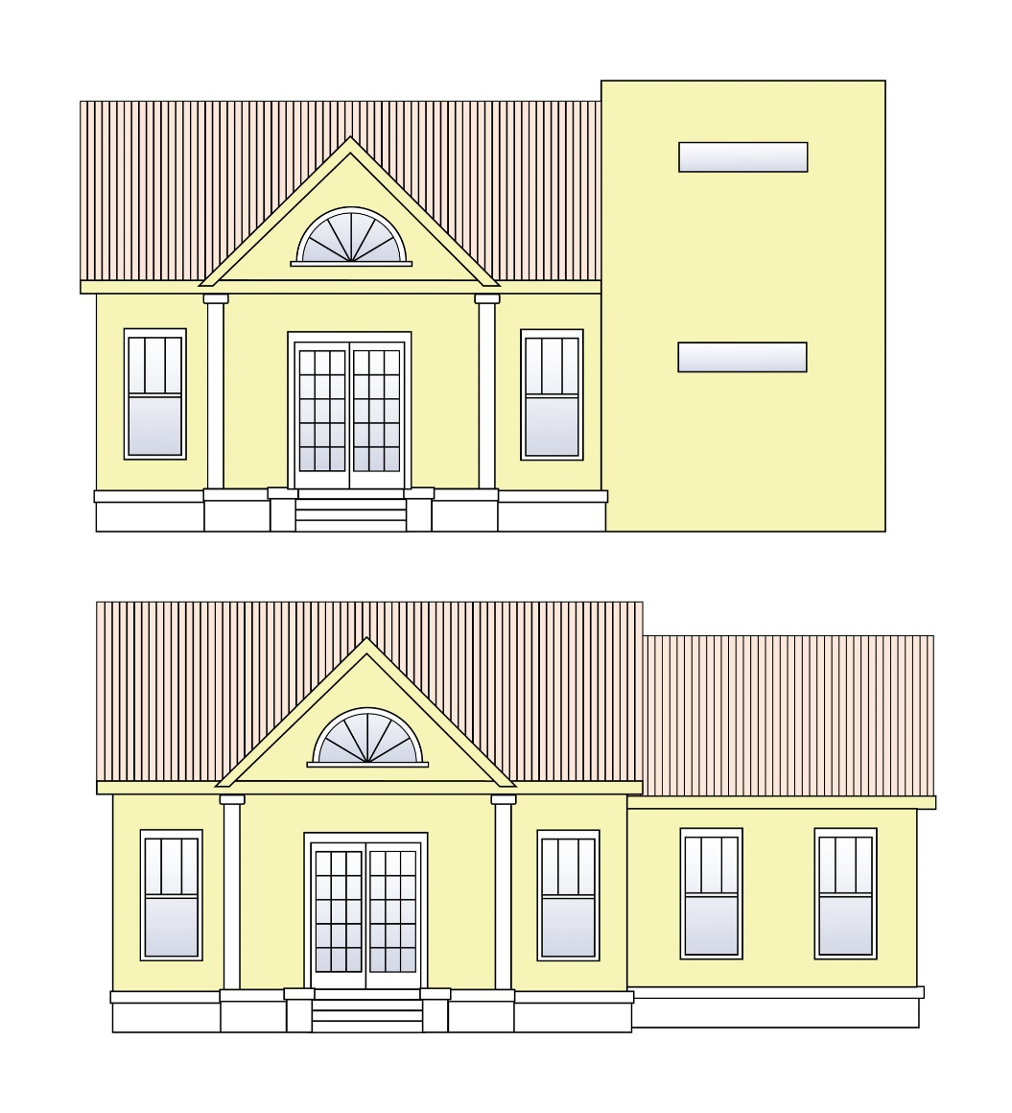
Figure 16: The top illustration shows an example of an inappropriate addition while the bottom illustration shows an example of an appropriate addition.

Guideline 6.8.3 Doors on Additions
- Doors on additions to historic buildings should be complementary to the style, scale, and design of the doors on the main body of the historic building.

Guideline 6.8.4 Roofing Material on Additions
- Roofing material on additions or secondary structures to historic buildings should be similar to or compatible with the material used on the primary historic building.
- The addition of roof features such as brackets, dormers, or parapet walls shall be permitted if such features do not destroy existing significant historic features and are historically a design element of the architectural style of the building.

Guideline 6.8.5 Roof Shape and Slope on Additions
- On additions, use roof shapes similar to those found historically in the neighborhood.
- Roof shapes on additions should be complementary to the architectural style of the main building.
- Look at the roof shapes of other structures (porches, small wings) that were historically attached to buildings of your type and style. For example, gable-roofed buildings generally had additions with gable or shed roofs.
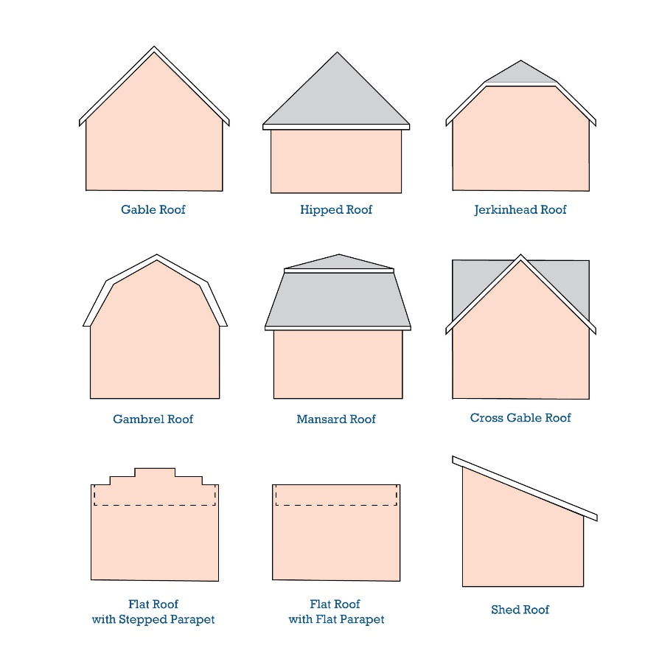
- Additions to flat-roof buildings should generally also have flat roofs; otherwise, flat roofs should be avoided if possible.
Figure 17: Illustration of roof shapes

6.9 Universal Guidelines for New Construction
Please see General Guidelines at the beginning of this chapter, for additional guidance.

Building form, which refers to the shape and massing of a building, is an important component of a streetscape, it is largest element within the streetscape, and tends to command our attention.
In planning new construction, building form and streetscape elements should be carefully considered. Streetscape elements can reinforce the area’s attractiveness and make it a desirable place to live or do business. All new construction must meet all applicable Zoning Ordinance requirements.

Guideline 6.9.1 New Construction
- New buildings should be compatible with adjacent structures in terms of massing, proportion, size, and scale.
It is generally not appropriate to:
- place a building on a site in a location that is greatly different from the location of buildings on adjacent sites
- use massing and building forms that are foreign to the historic district.
- For a taller building, transitions in height shall be created by matching building heights at the front façade and at sides facing adjacent buildings. Taller parts of the building shall be set back from the front façade.
- For wider buildings, compatibility of width shall be created by breaking up building mass, using building articulation (details, windows, or doors), or dividing the building into widths that match or are proportional to widths of nearby buildings.
- New buildings should be placed on existing vacant lots whenever possible and should match the setback of surrounding structures.
- Parking lots or parking structures should be placed at the rear of the lot whenever possible. Ideally, access to them should be from an alley to lessen the number of curb cuts along main streets.
- New buildings should be oriented to face the street rather than turned inward, skewed, or oriented at angles to the existing street grid.
- The principal façade and main entrances shall face the street. Blank or windowless walls on the front façade or street-side are not appropriate.
- Building setbacks shall conform with the historic or predominant setback along the street.
- Spacing between buildings shall be consistent with the historic buildings along the street.
- The alignment of porches, bay windows, balconies, and delineation between lower and upper floors shall be similar to the alignment of these same features on adjacent buildings.
- The relationship of the window openings (size and shape), pattern and placement, and placement of entrances (size and shape) along the street shall be similar to the nearby buildings.
- Vehicular access to the property shall be compatible with the district’s historic context. For example, the use of alleys as opposed to creating front yard driveways.
- For commercial districts, parking areas and access should be placed to the rear. The side yard may be used as an alternative location for access and parking if no other feasible alternative can be found.
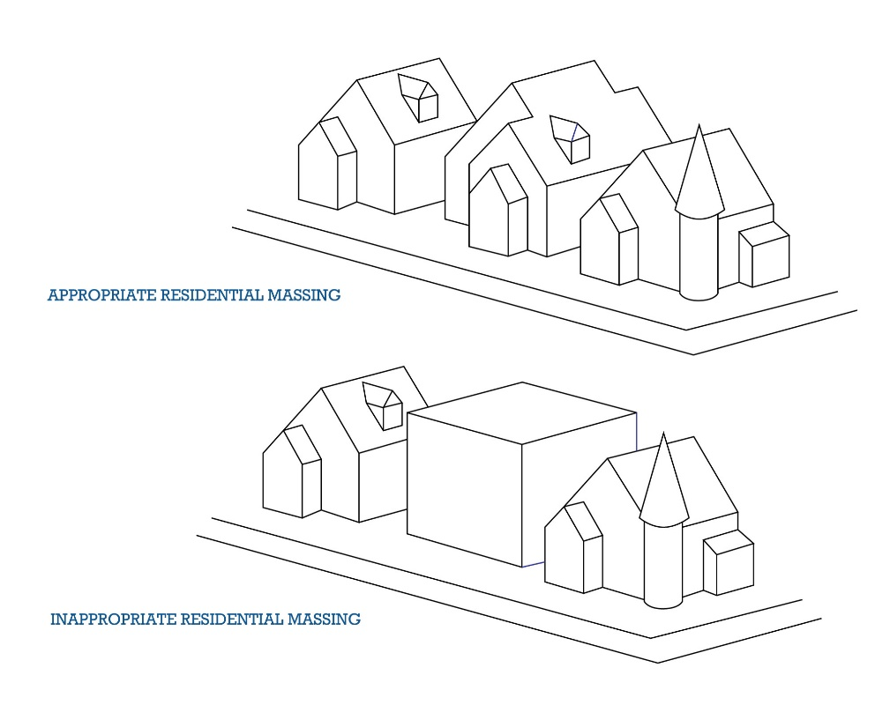
- For commercial areas, there shall be a continuous rhythm of buildings located side-by-side.
Figure 18: Illustration showing appropriate and inappropriate residential massing.
Guideline 6.9.2 Multi-Family Projects
New construction of multi-family projects will be approved by the HPB on a case-by-case basis with specific attention paid to the following guidelines:
- Multi-family projects should be compatible with adjacent structures in terms of massing, proportion, size, and scale.
- For a taller building, transitions in height shall be created by matching building heights at the front façade and at sides facing adjacent buildings. Taller parts of the building shall be set back from the front façade.
- For wider buildings, compatibility of width shall be created by breaking up building mass, using building articulation (details, windows, or doors), or dividing the building into widths that match or are proportional to widths of nearby buildings.
- Multi-family projects should be placed on existing vacant lots whenever possible and should match the setback of surrounding structures; historic buildings should not be demolished to make room for multi-family projects.
- Multi-family projects should be oriented to face the street rather than turned inward, skewed, or oriented at angles to the existing street grid.

Guideline 6.9.3 Parking Structures
The footprint, scale, and proportion of parking structures (including parking garages) tend to be oversized as compared to more historic development. For alternative parking options, see Guideline 6.14.11 Parking Lots. The HPB may approve construction of parking garages on a case-by-case basis if the following guidelines are met:
- Parking structures should be placed at the rear of the lot whenever possible. Ideally, access to them should be from a side street to lessen the number of curb cuts along main streets.
- Parking structures should be minimally visible from the street, and therefore must align with the scale and massing of the primary structure located at the front of the lot.
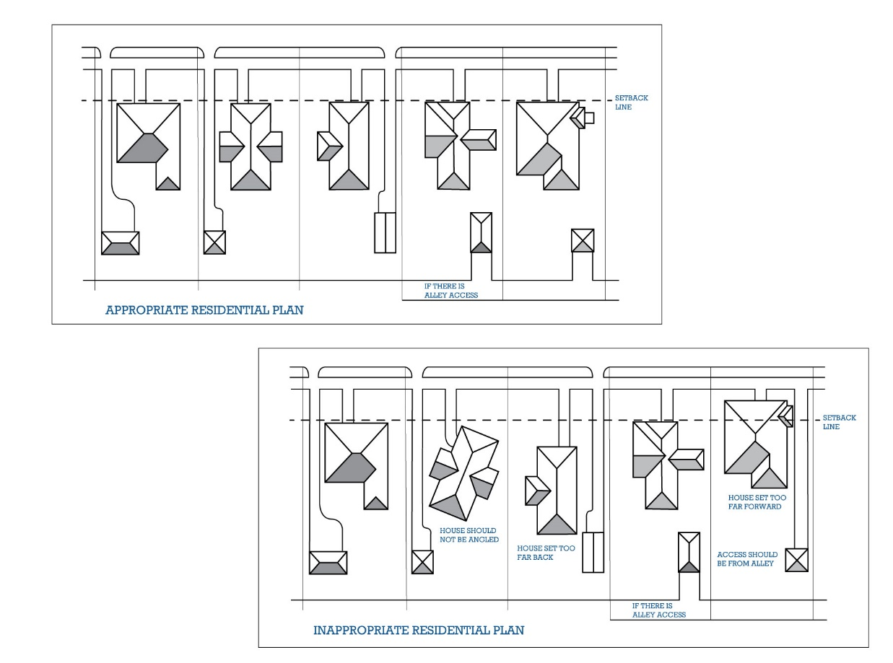
- If the parking structure is the primary structure on the site, it must be screened or architecturally treated to be unobtrusive.
Figure 19: Diagram of appropriate and inappropriate residential street plans.

Guideline 6.9.4 New Garage or Outbuilding Construction
- The new garage shall be compatible with the primary building in terms of scale, massing, and style.
It is generally not appropriate to:
use vinyl applied detailing on garage doors
- The scale of the new garage shall also be compatible with both the street and alley environments of the historic district.
- Prefabricated, non-permanent sheds are permitted in the rear of the property. They should be small in scale and congruous with the style of the primary building, including materials.

Figure 20: Appropriate new garage at 620 Indian River Avenue

Guideline 6.9.5 Windows on New Construction
- On new buildings, window types, sizes, and alignment should be typical of the type of building being constructed and sensitive to the historic district.
- Similar window spacing patterns should be used on new construction as are used on historic buildings of the same type in the same neighborhood.
- Historic window mullions should be simulated or mirror true divided light that coordinates with those in the historic building. Removable, snap-in, or “between the glass” muntins should be avoided.
- The ratio of windows to wall on the primary street elevations for new construction should be similar to historic structures.

Guideline 6.9.6 Doors on New Construction
- Doors on new construction should be complementary to the style and scale of the design of the building and complementary to similar buildings throughout the district.
It is generally not appropriate to:
orient primary entrances to the rear or side when the prevalent pattern on the block is to orient entrances to the front.

Guideline 6.9.7 Roofing Material on New Construction
- Roofing materials on new construction should be consistent with the prevalent roofing material on surrounding buildings or extant buildings on the property.

Guideline 6.9.8 Roof Shape and Slope on New Construction
- On new buildings, use roof shapes similar to those found historically in the area.
  - Roof shapes on new construction should be consistent with the architectural style of the main building.
  - Look at the roof shapes of other structures (porches, small wings) that were historically attached to buildings of your type and style. For example, gable-roofed buildings generally had additions with gable or shed roofs.

Guideline 6.9.9 Chimneys on New Construction
- New chimneys on new construction should be consistent with the height, massing, and proportions of chimneys found on buildings of similar style.
It is generally not appropriate to:
construct wood-framed boxed chimneys pattern on the block is to orient entrances to the front

Guideline 6.9.10 Porches on New Construction
- On a new building, porches visible from the street should maintain the typical orientation and dimensions of extant porches found on buildings of similar style.

6.10 Universal Guidelines for Relocation
Relocation – into or out of a historic district - shall only be considered when there are no other reasonable alternatives to preserving a historic building. Relocation methods include:
- moving the entire structure to a new setting
- moving the structure in parts to a new setting
- dissembling and moving materials from the structure and rebuilding on a new setting
Regardless of how it is moved, relocating a historic building compromises the building’s historic setting and unavoidably impacts original historic material. The goal with this section is to minimize impacts on the historic building to be relocated and the impacts on the properties surrounding the proposed relocation site.

Guideline 6.10.1 Guidelines for Relocation of Historic Properties
- Demonstrate that the structure cannot remain within the district and be adaptively reused.
- The new site shall be within the same district or district of similar historic context (age, setting, and architecture).
- Document the existing historic building’s setting and site conditions prior to the relocation of any building through photographs and other written or graphic means such as site plans.
- Minimize damage to the historic building during and after the move by assessing its structural condition prior to the move,
  - taking all necessary precautions to prevent damage during the move,
  - working with contractors experienced in moving historic buildings, and
  - securing and protecting the building from weather damage and vandalism.
- The orientation of the relocated building must be compatible with the orientation of the buildings adjacent to the proposed relocation site. Consideration should also be given to maintaining the original compass orientation of the relocated building, if possible.
- The relocated building should maintain the same height above grade that it had in its original location unless required to meet flood elevation requirements. This is to discourage elevating the property significantly above its original height for the purpose of obtaining more space for parking or creating additional enclosed space.
- The proposed relocation site must be landscaped to make the structure appear original to the lot and harmonious with its neighboring properties. Street trees shall be planted as needed to provide continuity with the neighborhood.
- The significant features of the original site and the proposed relocation site shall be protected during relocation.
- The historic building shall be relocated as a single unit, when practical. Otherwise, partial disassembly is permissible. Complete disassembly is strongly discouraged as it often results in a substantial loss of original building material and detail.
- All character-defining features of the relocated building shall be retained (i.e. the exterior end chimney shall be relocated/reconstructed with the historic building).
- The historic structure shall be protected from weather damage and vandalism during the relocation process.
- Repair or replace any damaged features to match the original.
- The building shall be sited to be compatible with the new surrounding context related to setbacks and orientation.
- New foundation design and materials and first-story elevation shall match the original.

6.11 Universal Guidelines for Demolition
Historic buildings contribute to the overall historical and physical significance of the city; the loss of any one of these historic buildings is a historic loss for the city. As such, demolition is strongly discouraged for any historic building. Demolition results in a loss of architectural and historical integrity and can dramatically change the character of a neighborhood. Demolition is generally discouraged; however, it may be approved in certain situations.
The decision to demolish a historic structure is a measure of last resort and shall be based on the demonstration that there is no other feasible alternative. Demolition can have a significant impact on the historic context of the district. Many older buildings offer character and quality that cannot be economically replicated today. Older buildings can be retrofitted to provide modern amenities.
The City of Titusville Ordinance Section 29-119 sets the following criteria to be considered in the review of demolitions:
- Is the structure of such interest or quality that it would reasonably meet national, state, regional or local criteria for designation as a significant historic or architectural site or structure?
- Is the structure of such design, craftsmanship or material that it could be reproduced only with great difficulty or expense?
- Is the structure one (1) of the last remaining examples of its kind in the City, county or region?
- Does the structure contribute significantly to the historic character of a designated district?
- Would retention of the structure promote the general welfare of the city by providing an opportunity for study of local history, architecture and design or by developing an understanding of the importance and value of a particular culture and heritage?
- Are there definite plans for reuse of the property if the proposed demolition is carried out, and what will be the effect of those plans on the character of the surrounding area?

Guideline 6.11.1 Guidelines for Demolition of Historic Properties
- Establish a permanent record of the property prior to demolition. The level of documentation and the person responsible for producing the documentation will be determined by the Titusville HPB.
- Identify salvageable building materials and potential buyers or recipients of salvaged material before demolition.
- Protect historic site features, including mature trees and potential archaeological resources.
- Ensure the safety of the adjacent properties and historic resources.
- The site must be cleared of debris, reseeded, and properly maintained until it is reused. If the site is to remain vacant for over one year, it must be improved to reflect an appearance consistent with other open space areas in the district.

Guideline 6.11.2 Demolition by Neglect
Demolition by neglect is defined as the willful neglect in the maintenance and repair of a building or structure that does not result from a property owner’s financial inability to maintain and repair the property. Property owners are expected to maintain their property in good condition and in compliance with Health and Safety codes.

  - Additional Guidelines for Residential Properties
Guideline 6.12.1 Windows
Windows are one of the most important architectural elements of a building. The decorative elements of windows, such as the sash, muntins, and sill, as well as the wood or masonry materials that surround them, are designed to complement the exterior detailing of the building. When properly maintained, historic wood windows can have a serviceable life of 150 years+, however, in cases where neglect or other factors have necessitated their replacement, many suitable replacement options exist. While replacement in-kind is generally preferred, new wood windows are often not of the same quality as historic wood windows due to the unavailability of old-growth lumber.
Vinyl windows are generally not manufactured in historic proportions and are not appropriate replacement windows for historic properties. Wood, aluminum, aluminum-clad wood, and fiberglass are potentially appropriate replacement materials and may be approved if the appearance is complementary to the existing historic windows and architectural style. For additional information on substitute materials, see Appendix B.
When replacing historic windows, consider how the windows will affect the historic integrity of the building as a whole. Type, configuration, and material should all be considered and evaluated on a case-by-case basis.
Weather-stripping and caulking can be used to improve the thermal and acoustic performance of an existing window.
Some window companies have specific solutions for replacing historic windows. The following links can be helpful when planning your project.
- Marvin - https://www.marvin.com/historic
- Weather Shield - https://www.weathershield.com/Products/Historic-Windows
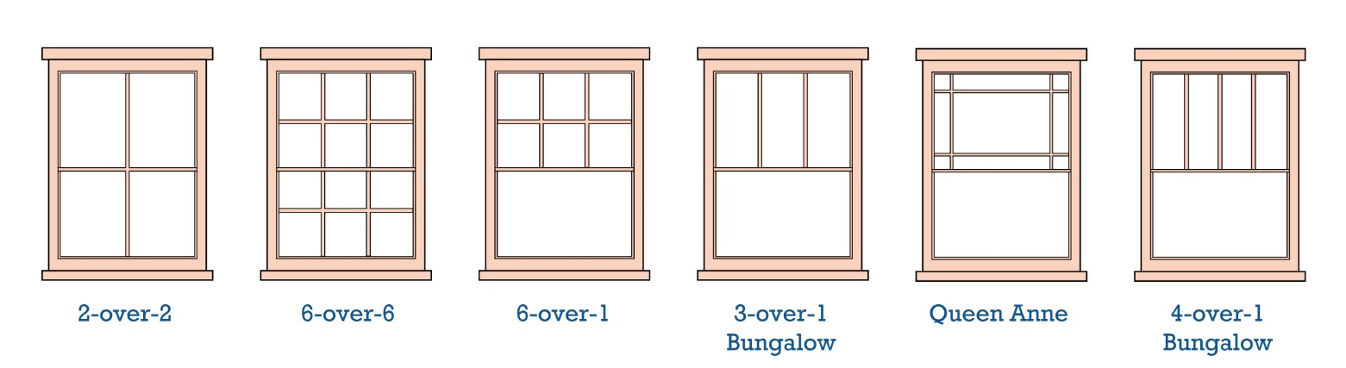
- Andersen - https://www.andersenwindows.com/ideas-and-inspiration/home-style-library/
Figure 21: Illustrations of various muntin designs

Best Choice
Replace decorative divided light, wood windows on a Queen Anne with wood windows of the same design

Good Choice
Replace the original windows with windows of the same design of an alternate material

Not Appropriate
Replace decorative divided light, wood windows with one-over-one, double-hung vinyl or aluminum windows

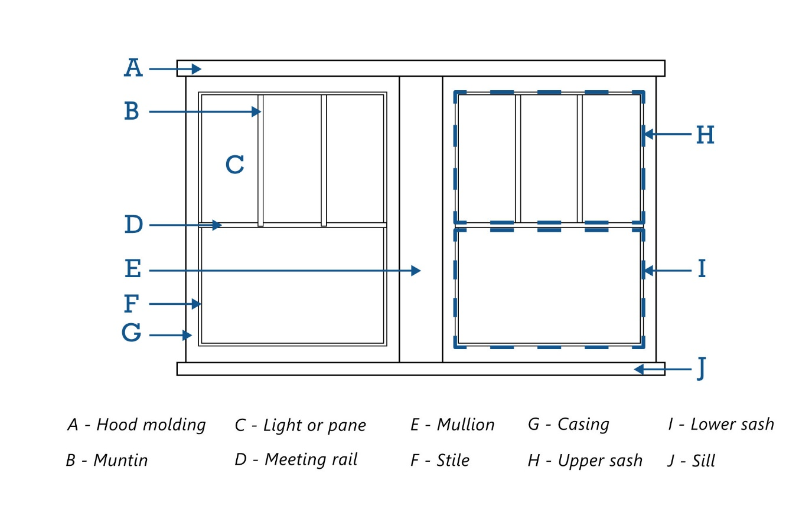
Figure 22: Diagram of typical window parts
Guideline 6.12.1.a Retain Historic Windows
- Maintain or restore the historic shape, size, alignment, pattern, and details of existing historic windows.
It is generally not appropriate to:
alter or enclose window openings, nor shall window trim be removed on entrances to the front.
- Consider reopening windows that have previously been infilled or blocked.
- Retain historic hardware components, including locks and shutter hinges, where possible.
- Maintain or restore all historic window trim and casing including but not limited to sash, frame, and sill.
- HistoriFor guidelines on storefront windows, see Guideline 6.14.2
Figure 23: Historic 12-over-1 double-hung wood window
Figure 24: Historic 12-over-1double-hung wood windows
Figure 25: Historic 2-over-2 double-hung wood windows flanking a wood picture window

Guideline 6.12.1.b Replacement Windows
- If 50% or more of the windows are deteriorated or missing, then the wholesale replacement of all windows is permitted, provided that the new proposed windows match the key design elements of the original windows. Replacement windows can be wood, aluminum-clad wood, anodized aluminum (not raw aluminum), or composite. Vinyl windows are rarely appropriate but may be approved on a case-by-case basis.
- Where window replacement is necessary, the new window should match the historic window in location, size, type, glazing pattern, profile, and color. The number of windowpanes, and the approximate muntin and mullion profile of the replacement window should also match the historic window.
- Maintain the historic window opening size and surrounding trim and surrounds including but not limited to sash, frame, and sill.
- Retain the window type typical to the historic style of the building. For example, do not replace a historic double-hung window with a new casement window.
Best Choice
Maintain and preserve your existing historic wood windows
Good Choices
Replace in-kind i.e. a wood window with the same configuration, dimensions, and key design elements. This includes matching the muntin, mullion, sill, and trim profiles and dimensions
Replace a single-hung window with a double-hung or vice-versa as long as all other elements match
It is also acceptable to replace a wood window with aluminum clad, composite or fiberglass as long as the configuration, dimensions, profiles, and design elements all match

Not Appropriate
Increase or decrease the historic opening to accommodate smaller or larger windows, or remove or cover surrounding trim, including wood or masonry details

Figure 26: 8-over-8 double hung replacement window with simulated divided lights.
Figure 27: Replacement window in keeping with original opening size.
Guideline 6.12.1.c New Window Openings and Infill
Altering window openings in historic façades alters the building’s historic appearance significantly, and is typically not appropriate, but may be considered in some situations.
- If new openings are required for additional light, consider placing them on the rear or side elevations of the building or installing a skylight on a non-visible roof slope.
- Where recent changes have altered historic window openings, restoration of the historic configuration and materials is encouraged.
It is generally not appropriate to:
- place new window openings on the front façade
- infill existing window openings on the front façade
- tint new windows

Guideline 6.12.1.d Storm Windows
- Storm window frames may be made of wood, vinyl, or plastic; however, unfinished aluminum should not be used.
- Custom shape storm windows should be used for specialized window shapes.
- The choice to use interior storm windows for their “invisible” appearance from the outside should be weighed carefully against the possibility of condensation forming between the interior window and the historic window, thereby causing the historic window to potentially deteriorate.

It is generally not appropriate to:
apply ornamentation that would not have been typical of the period or style in which your building was constructed

Guideline 6.12.1.e Shutters
- Shutters must be appropriate to the size and scale of the window opening and architectural style. They should be large enough to cover the entire window when closed but should not cover any part of the surrounding wall. If they are not operable, they should appear as they are and have the appropriate hardware.
- Shutters and appropriate operable hardware, i.e., shutter dogs, must be of a style appropriate to the architectural details of the building to which they are applied.
- The repair or replacement of shutters and awnings shall match the original.
- Shutters should be made of wood and attached to the window casing and not the exterior finish. Shutters shall be the full height and one-half the width of the window.

It is generally not appropriate to:
install shutters that will permanently cover a window

Guideline 6.12.2 Doors
Historic doors are character defining features of a historic buildings and are designed to complement the exterior detailing of the building. The original door with its frame and trim should be preserved.
If a replacement door is necessary, the new door should match the original as closely as possible in material, size, and style. This includes any panels and windows that were present in the original door. Most contemporary door designs are not appropriate for homes built in the 19th and early 20th centuries. For additional information on substitute materials, see Appendix B.
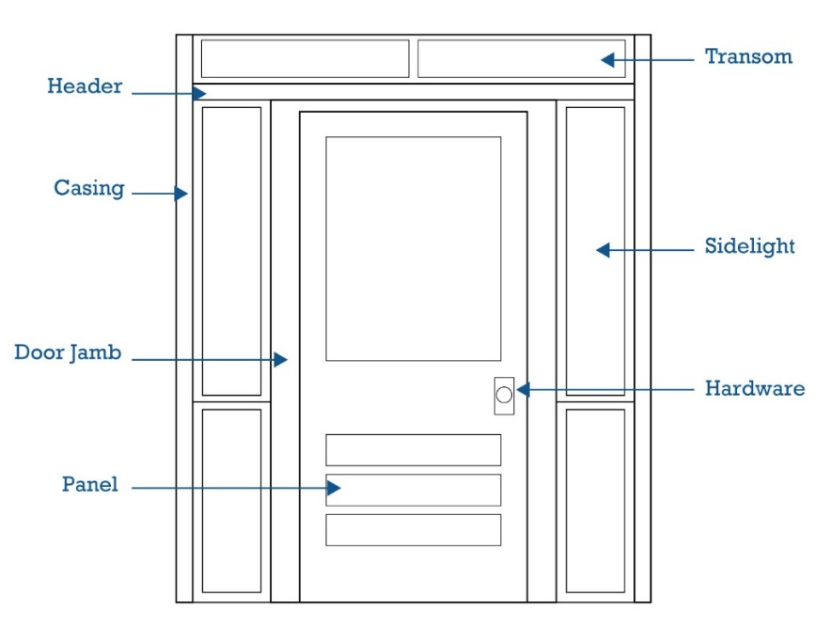
If a screen door is desired, it should match as closely as possible the style of the dwelling. If it is not possible to obtain a stylistically appropriate door, a simple design should be used. If a storm door is desired, it should be of a simple design with a large glass pane that reveals as much of the door behind it as possible.

Figure 28: Diagram of typical door parts
Guideline 6.12.2.a Retain Historic Doors
- Maintain and repair historic doors and historic door hardware.
- Match new or replacement hardware to the original finish, type, and style.

It is generally not appropriate to:
install kickplates, closers, padlocks, deadbolts, locksets, security hardware, or other elements that are not compatible with the original hardware

Guideline 6.12.2.b Transoms and Sidelights
A transom is a window or series of windows located above a door or display window, while sidelights vertically flank doorways. Both should be preserved along with their character-defining elements that include trim work.
- Preserve and maintain existing historic transoms, sidelights and trim.
- Where the condition necessitates replacement, the new transom and/or sidelights should match the original character-defining features of the arrangement, including shape, proportion, scale, trim, and glass type.
It is generally not appropriate to:
fill, block or otherwise remove or obscure a transom and/or sidelights

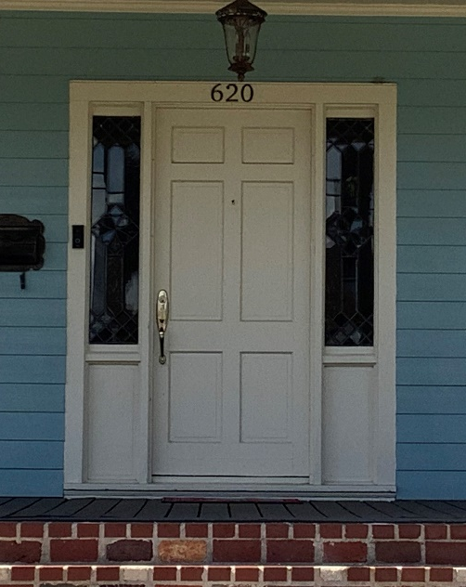  Figure 29: Six panel door with sidelights | 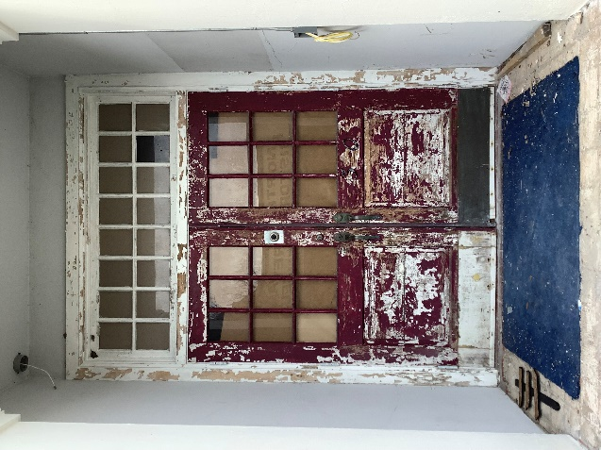  Figure 30: Six light and panel door with a multi-light transom | 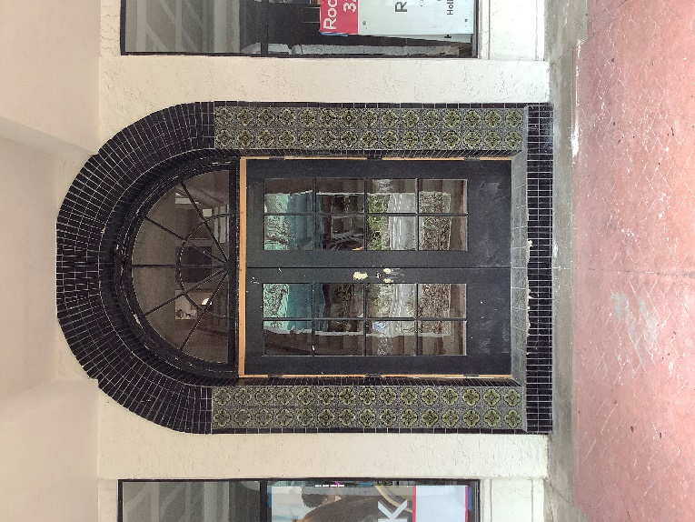  Figure 31: Multi-light door with multi-light fanlight
Guideline 6.12.2.c New Door Openings
- New doors or enlarging door openings is prohibited unless such alteration is shown to be compatible with the existing door and window openings of the façade.
- Where a new door opening is required on the main elevation, it should be integrated with the overall fenestration pattern to complement the building.
- Where recent changes have altered historic door openings, restoration of the historic placement and material is encouraged.
It is generally not appropriate to:
create a new door opening on the front façade of the building

Guideline 6.12.2.d Storm or Screen Doors
- Screen doors are not encouraged for the front door. However, if screen doors are installed, they shall be simple or compatibly designed screen doors that match the architectural style/details of the building.
- Select a storm or screen door style typical of the period or style in which your building was constructed. Avoid a door that completely lacks detail as well as excess ornamentation that would not have been typical of the historic character.

Guideline 6.12.3 Roofs and Chimneys
The roof is one of the prominent defining features of historic buildings. Historic roof shapes and elements such as chimneys, gables, dormers, and steeples are important character-defining features.
A roof’s original shape and pitch should be retained. The construction of new dormers should be carefully considered so as not to compromise the original design of the house. If a dormer is added, its size, design, and placement should be in scale with the overall size of the building, its siding and roofing materials should match those on the rest of the house, and its window should be consistent with the existing windows on the house in style, orientation, and material. Other alterations, such as roof decks, vents, skylights, and mechanical and electrical equipment, should be installed so that they are not visible from the public right-of-way and do not damage the historic fabric.
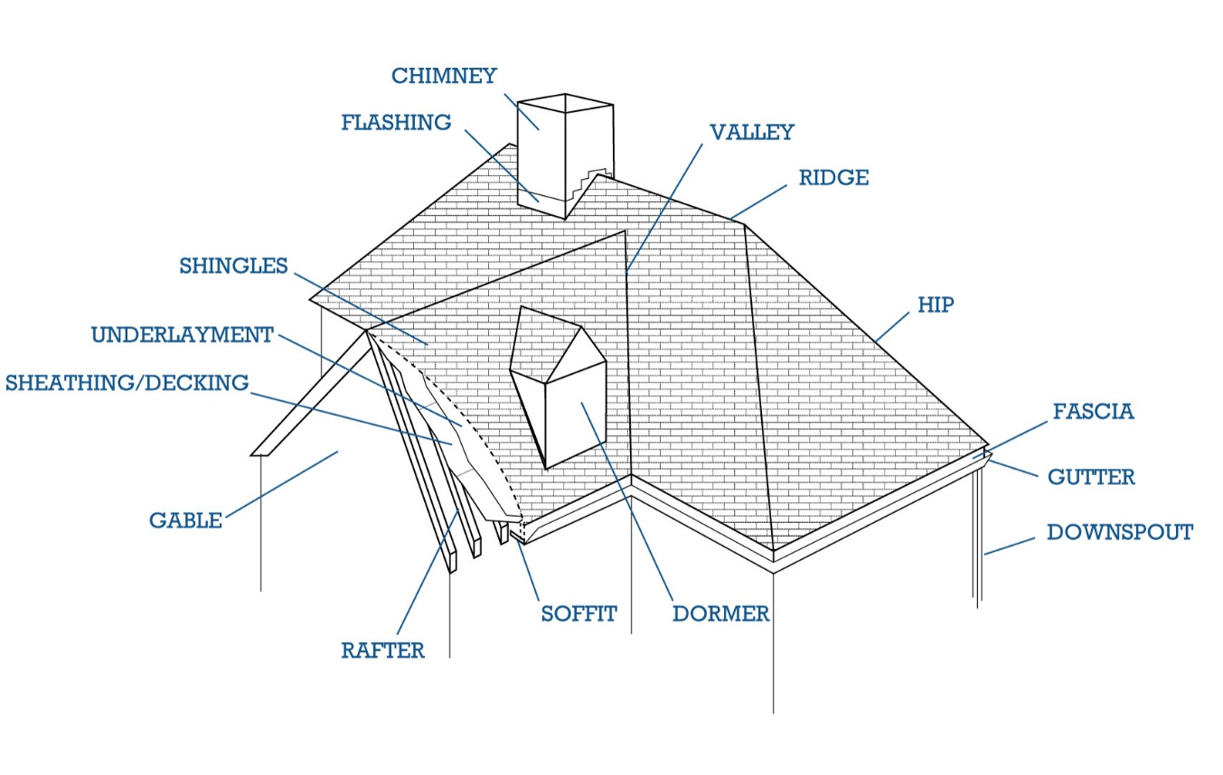
Gutters and downspouts should be regularly cleaned and kept in good condition. Downspouts should be inconspicuously located on the exterior of the house and be compatible in color with that of the exterior of the building.
Figure 32: Diagram of roof parts
Guideline 6.12.3.a Roofing Material
- Retain and repair the historic roof materials where feasible. Repairs can include replacing panels or sealing pinholes with an elastomeric/silicone material.
- If all roofing material is to be removed, then the new roofing material shall match the existing or be characteristic of the architectural style in terms of material, size, and pattern.
- Requests for substitute roofing materials will be reviewed on a case-by-case basis.
- When replacing asphalt shingles, heavyweight architectural shingles are preferred.
- Repair of isolated sections of a roof must match the existing in material composition, style, size, and color.
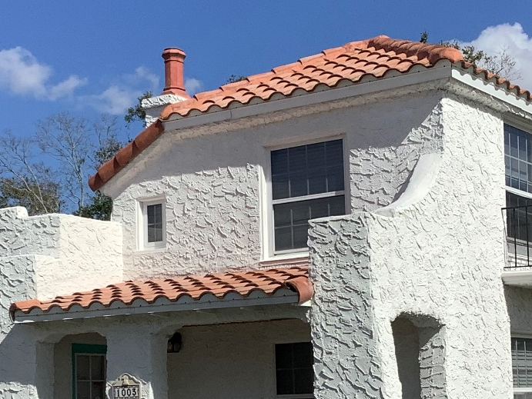  Figure 33: Clay tile roofing | 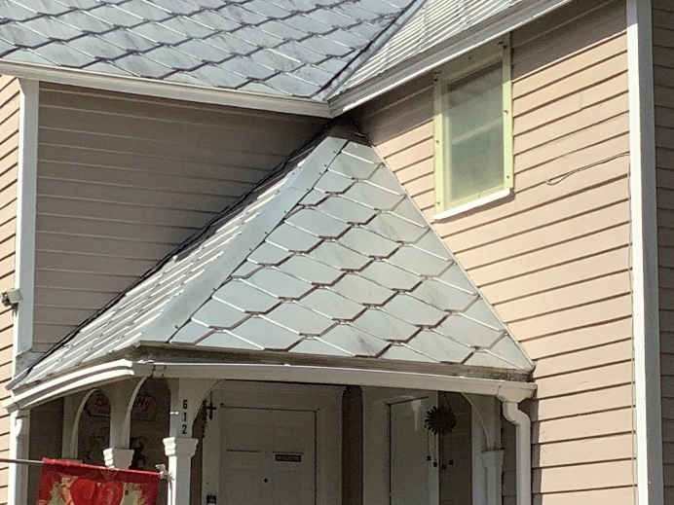  Figure 34: Metal shingle roofing
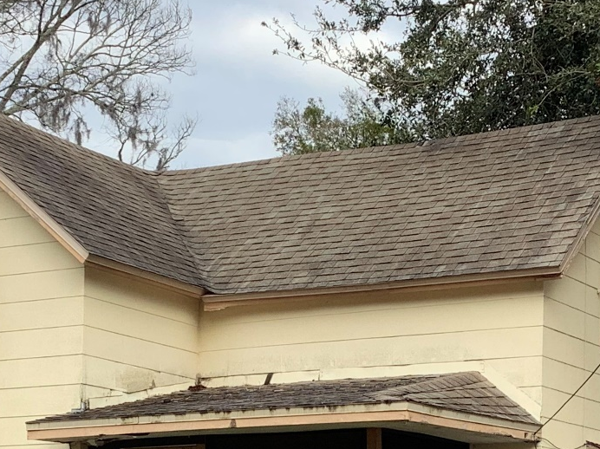  Figure 35: Asphalt shingle roofing | 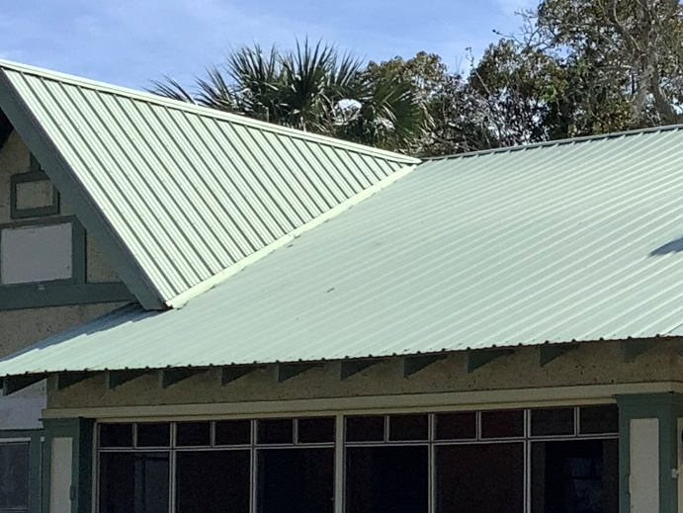  Figure 36: Standing seam metal roofing  Best Choice  Replace a historic standing seam metal roof with a new standing seam metal roof  Good Choices  Replace a slate roof with new synthetic slate shingles that mimic the texture and pattern of the historic slate roof  Not Appropriate  Replacing a slate roof with a new standing seam metal roof

Guideline 6.12.3.b Roof Shape and Slope
- Preserve the historic shape and slope of the roof.
- Roof shapes on secondary structures should be consistent with the architectural style of the main building.
  - Look at the roof shapes of other structures (porches, small wings) that were historically attached to buildings of your type and style. For example, gable-roofed buildings generally had additions with gable or shed roofs.
  - Roof slope should be roughly consistent with that of the primary structure.
- If the entire roof structure is to be replaced, it shall be replaced with the same roof form or a roof form characteristic of the architectural style.

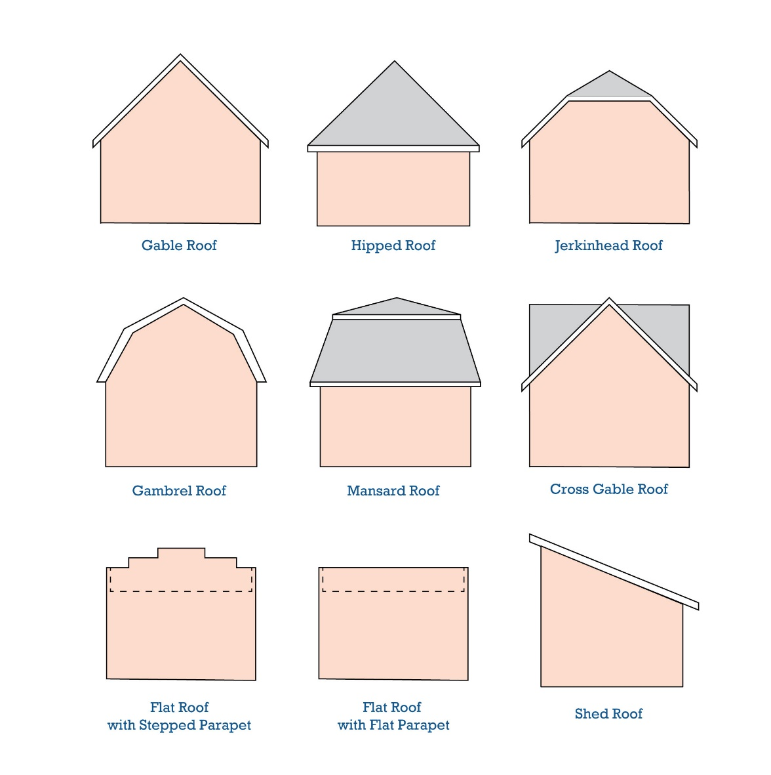
Figure 37: Illustration of roof shapes and lines

Guideline 6.12.3.c Eaves and Brackets
- Consideration may be given to covering (not enclosing) eaves or roof brackets provided the covering material is compatible with the architectural style of the structure, and the shape and detailing of the bracket and/or eave is maintained.
It is generally not appropriate to:
- remove or cover existing eaves and/or brackets
- install roof brackets on a structure if the brackets are not an original feature of the structure or architectural style
- Missing brackets, rafters, and/or eaves shall be rebuilt with the same materials, design, and color as the existing.

Guideline 6.12.3.d Dormers
- Maintain the size and shape of historic dormers, including historic details such as windows, trim, eaves, roof material, and siding.
- The addition of new dormers should be avoided but may be considered on a case-by-case basis. New dormers should complement the overall massing and style of the building.
- Dormers on additions must be consistent with existing historic dormers on the main body of the historic building. They should match in form, size, shape, and materials wherever possible.
- Roof features shall be repaired using the same design profile, materials, and detailing patterns. For example, the siding under the roof gable on the dormer shall be the same material and orientation (horizontal or vertical pattern) as the existing.

Guideline 6.12.3.e Skylights
- Flat-sloped skylights are recommended.
It is generally not appropriate to:
- install new skylights where they are visible from the public right-of-way
- install bubble or domed skylights as they are not historically appropriate
- Skylights should protrude no more than 6-8 inches above the surface of the roof.
- Products like solar tubes may be explored on a case-by-case basis.

Guideline 6.12.3.f Gutters and Downspouts
- Replace damaged gutters and downspouts in-kind wherever possible. The system should be similar to the historic system. Replacement materials may be permitted; however, the size and profile of the replacement should match the historic feature as closely as possible.
- New gutters and downspouts should match the existing historic drainage features found elsewhere on the building. New gutters and downspouts must not obscure important architectural details, such as cornice lines.
- Gutters and downspouts are part of a good drainage system; install them so that they convey water away from the roof and foundation.
- Half-round gutters are preferred.
- Downspouts should always run vertically. Orienting downspouts diagonally across roof planes and walls is strongly discouraged.

Guideline 6.12.3.g Chimneys and Vents
- Maintain existing chimneys, even if they are no longer used as functioning chimneys. When repairs are necessary, match the existing materials, colors, shape, brick pattern, and details as closely as possible.
- If a replacement chimney is necessary, the new one should be a reproduction of the historic one, based on photographs or comparison to buildings of the same style and type. If a chimney must be removed, the original exterior portion should be retained in place. In limited cases, a false replica could be put back in place to maintain the original appearance. HPB approval is required for this option.
- New vents should be placed in a location that is not visible from the public right-of-way.
- It is generally not appropriate to change the height, massing, or scale of existing chimneys.
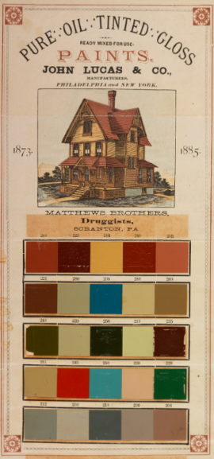
Guideline 6.12.4 Paint Colors
Figure 38: Historic paint swatches
Some of the construction materials used for buildings have colors that are integral to their manufacture including brick, stone, cast stone, concrete, copper, and bronze. Other materials are painted or finished with other types of applied architectural coatings. They include wood, tin, zinc and stucco. The paint or other architectural coatings applied to the latter materials protect them from the weather as well as contribute to the character of a building.

Besides aesthetic appearance, paint can play a role in the durability of building materials. Paint is a protective coating for wood and metal surfaces but can cause damage to masonry surfaces which were not intended to be coated.

The following links can be helpful when planning your project.

Sherwin Williams
https://www.sherwin-williams.com/homeowners/historic-collection/exterior-historic-colors

Benjamin Moore
https://www.benjaminmoore.com/en-us/paint-colors/historical-collection

PPG
https://www.ppgpaints.com/color/color-collections/historic

Guideline 6.12.4.a Maintain Painted Surfaces
        - The painted surface of historically painted buildings, or building features, should be maintained.
        - New or replacement building features of the type that were historically painted, such as wood siding or trim, should be painted to match like features on the building.
        - Do not leave new wood surfaces exposed. Paint or stain them to protect from water and sun damage.
- Avoid using sandblasting or other abrasive methods to strip paint from wood, masonry, tin or zinc. Avoid using flame or heating iron to remove paint from wood surfaces.
- Paint applied to buildings built prior to 1978 should be tested for lead before scraping or sanding. If found, appropriate abatement or encapsulation should be undertaken.

Guideline 6.12.4.b Choose Appropriate Color Schemes
        - Choose a harmonious color palate. Avoid mixing clashing colors.
        - Use contrasting colors to accent details, such as trim, dentil molding, etc.
        - Use the paint scheme to tie elements of the building together.
        - Consider whether the building is usually in shadow or bright light when choosing paint colors. Darker colors are more appropriate on well-lit facades, and lighter colors on shadowed facades.
        - If the building is listed in the National Register, a paint analysis to determine historic colors and paint composition is recommended. Strong consideration should be given to repainting using the historic color scheme.

Guideline 6.12.4.c Match Colors When Patching or Piecing Materials
              - Ensure that patched siding, roofing, or masonry matches the surrounding surface in terms of color.
- Match colors for related elements. For example, the color of a handrail for a stair should generally match the color of the stringers and risers.

Guideline 6.12.5 Porches
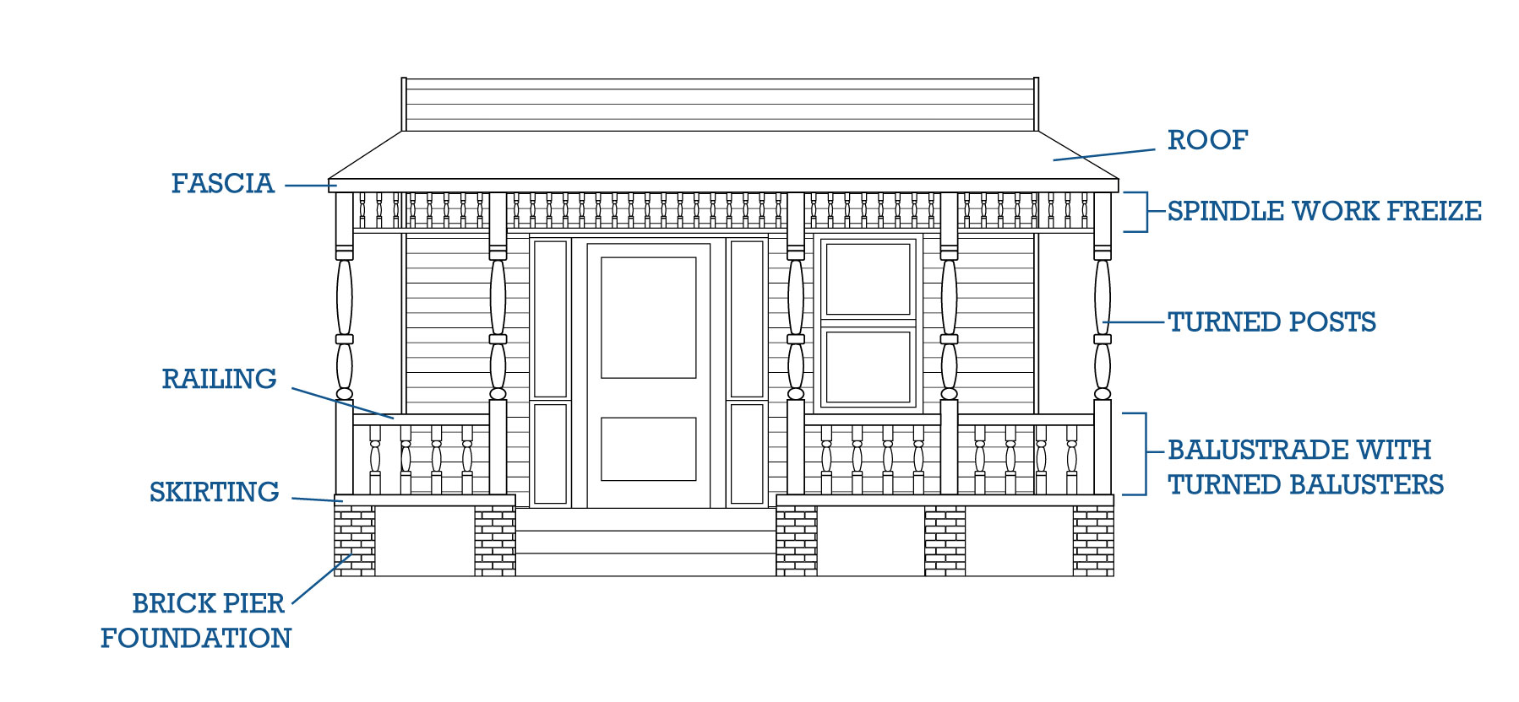
Figure 39: Diagram of typical porch parts

Guideline 6.12.5.a Preserve Historic Porches
        - Maintain and repair original porches, including steps, flooring, ceiling, columns, roof, details and ornamentation.
- Avoid enclosing a porch located on the front façade or visible from a primary public right-of-way. If the porch is not visible from a primary public right-of-way, it may be enclosed if done in a manner that does not significantly alter the original character of the porch. Note: screening-in is not considered enclosing the porch.
- It is appropriate to remove enclosures to reveal original porch and details.
- Screen porches in such a way that original details are not altered or destroyed may be appropriate.
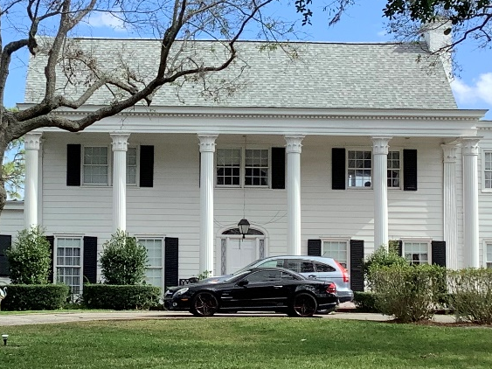  Figure 40: Well preserved porch at 715 Indian River Avenue | 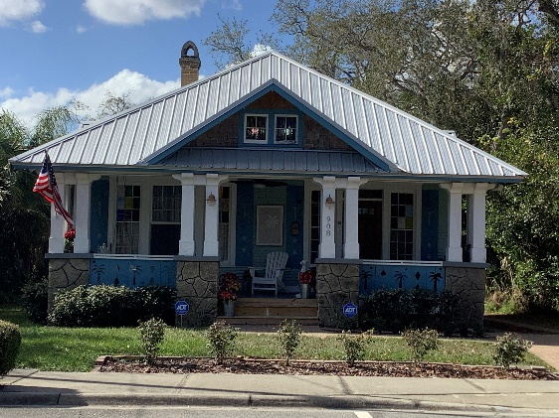  Figure 41: Well preserved historic porch at 908 South Washington Avenue
Guideline 6.12.5.b Restore Historic Porch Features
- The original appearance and features of the porch (such as roof brackets, exposed rafters, balustrades, railings, column supports, location of steps, and spindle work) and porte-cochère shall be maintained. If porch features are to be repaired or replaced, they shall match the original feature in material, size, design, detail, scale, and finish.
- Maintain the historic porch or stoop on your building, where feasible. Keep wooden surfaces painted and keep up with general maintenance.
- If repair or restoration is necessary, keep as much of the historic materials, proportion, and ornamentation as possible. Maintain the porch’s design and proportion to the greatest extent possible.
- Replace missing posts and railings where necessary to match size, shape, profile, proportion, and spacing to the historic feature.
- Use wood for porch details and structural parts, including steps and foundations, unless it can be documented that other materials were historically used on the house or used at an early date.
- Synthetic material may be allowable on a case-by-case basis if the new material, size, scale, and overall appearance matches the historic feature.

Guideline 6.12.5.c Make Sensitive Replacements
- Replace missing posts and railings where necessary to match size, shape, profile, proportion, and spacing to the historic feature.
- Use wood for porch details and structural parts, including steps, decking, and foundations, unless it can be documented that other materials were historically used on the building.
- Alternate materials may be allowable on a on side or rear porches if the new material, size, scale, and overall appearance matches the historic feature.
- Front porches on contributing historic structures are held to a higher standard than side or rear porches.

Guideline 6.12.5.d Adding New Porches
- Avoid adding a new porch to the front façade of a contributing building unless historical evidence exists to indicate a porch previously existed.
- A new porch may be added to a side or rear façade if it is designed to be compatible with the overall character of the building/neighborhood.
- Do not obscure the historic building entry when locating a new front or side porch. An open porch maintains the historic building entry, but an enclosed front porch would violate this guideline.
Guideline 6.12.5.e Replacement Porches
- If porch replacement is necessary in whole or in part, reconstruct it to match the historic porch in size, scale, and overall design. Where possible, detail and ornamentation should be replicated.
It is generally not appropriate to:
install decorative elements that are not appropriate to the style of the building
- Use the same or similar materials wherever feasible.
- Whenever possible, choose accurate details based on historic photographs or similar properties of the same period and style.

Guideline 6.12.6 Utilities and Energy Efficiency

Guideline 6.12.6.a Utilities
- Place electric, telephone, and cable services underground whenever possible.
It is generally not appropriate to:
design and construct utility systems at the street side elevation or above the roofline of a building
- Modern equipment shall not eliminate or cover significant architectural features.
- HVAC equipment, utility meters, utility boxes, wires, piping, and conduits should be installed in the least visible and unobtrusive locations. If possible, any utility housing should be painted to match the exterior surface to which it is applied.
- Where underground placement is not possible, utilize the rear or a non-visible side of the property when possible.
- Exterior conduit and housing should be located inconspicuously.
- Central air-conditioning units should be located at a side or rear elevation and screened with fences and landscaping.
- Window air conditioning units should be installed on a non-visible elevation whenever possible. Through-the-wall installations are discouraged (because they damage the historic fabric and disturb the overall façade configuration) but may be allowed on a non-visible elevation.
- If mechanical equipment must be located such that it is visible from the street, proper screening materials such as shrubbery or fencing material should be utilized.
Guideline 6.12.6.b Guidelines for Energy Efficiency in Historic Properties
- Before committing to a system that requires the installation of new equipment onto the exterior of your historic building, the HPB requests that a property owner obtain an energy audit from a certified energy efficiency contractor. This will inform the property owner where a building is losing energy and provide a prioritized list of recommended retrofits.
It is generally not appropriate to:
locate and install energy-generating technology where it will damage, obscure, or result in the removal of significant features or materials
- Install weatherization strategies in a way that does not alter or damage significant materials and their finishes.
- Install additional insulation in an attic, basement, or crawl space as a simple method to make a significant difference in a building’s energy efficiency. Provide sufficient ventilation to prevent moisture build-up in the wall cavity.
- Use operable systems such as storm windows, insulated coverings, curtains, and awnings to enhance the performance of historic windows.
- Install equipment where it can be easily removed without damaging the historic character.

Guideline 6.12.6.c Satellite Equipment
- Satellite equipment should be installed in the least visually obtrusive location possible.
- Equipment should be installed in a manner that will minimize damage to historic building materials (ex: through a mortar joint rather than through a masonry unit).
- Consider painting the equipment a color that blends with the building’s primary color.
- When installing ground-based satellite equipment, use vegetation or other materials to screen the equipment.
It is generally not appropriate to:
place a satellite dish in view of the public right-of-way

Guideline 6.12.6.d Solar Panels
- If at all possible, solar panels should be installed on a roof side, not visible from the street.
- Panels should not be installed in a vertical position where their appearance is most noticeable, but rather on horizontal or sloped surfaces.
- When placed on the roof, the solar panels shall not affect the roof façade elevation or roofline.
- Solar panels shall be low profile and exposed hardware, frames and piping shall have a matte finish and be of a color similar to the roofing material color.
- Consider solar shingles, a shingle that looks and functions like common roofing materials; however, it absorbs sunlight as a source of energy for generating electricity. Solar shingles facing the street will need to be approved by the HPB.
- If ground-mounted equipment must be located such that it is visible from the street, proper screening materials such as shrubbery or fencing material should be utilized.

It is generally not appropriate to:
- install solar panels that project above the plane of the roof if it is visible from the public right-of-way
- place a solar panel in view of the public right-of-way
- install solar panels on historic materials or in a manner that will damage historic materials

Guideline 6.12.7 Lighting
- Repair rather than replace damaged historic light fixtures when possible.
- Install lighting fixtures that are appropriate to the location and style of your property and surrounding neighborhood.
- Lighting fixtures proposed for masonry buildings should be attached to the mortar, not to the masonry unit itself.
- Light fixtures on buildings should be indicative of the period and style of the building architecture. Contemporary light fixtures may be used provided they are in keeping with the architectural style and scale of the building. Light fixtures on buildings should be flush-mounted on the wall or on the soffit.
- Light fixtures (luminaries) on poles located adjacent to the public right-of-way shall be:
  - The same or similar to the light fixture/pole design for Downtown, or,
  - Of a style in keeping with the architectural style of the building.
It is generally not appropriate to:
install high-intensity lights or light which intrudes upon adjacent properties

6.13 Additional Guidelines for Commercial Properties
The following guidelines are specific to commercial properties. Please see General Guidelines at the beginning of this chapter, for additional guidance. Businesses located in structures originally built as residential buildings should refer to residential guidelines as well.

Guideline 6.13.1. Commercial Facades and Storefronts
Guideline 6.13.1.a Façade Configuration
- Maintain the historic compositional principles of historic commercial buildings.
- For two- and three-part block configurations, maintain the division of the upper and lower stories.
- Where historic features are missing, consider restoring the façade to a composition appropriate to the historic design of the building.
- New commercial buildings should follow the same compositional layout of surrounding buildings in order to maintain the scale and pattern of the area.
- Maintain the historic layout of commercial storefronts.
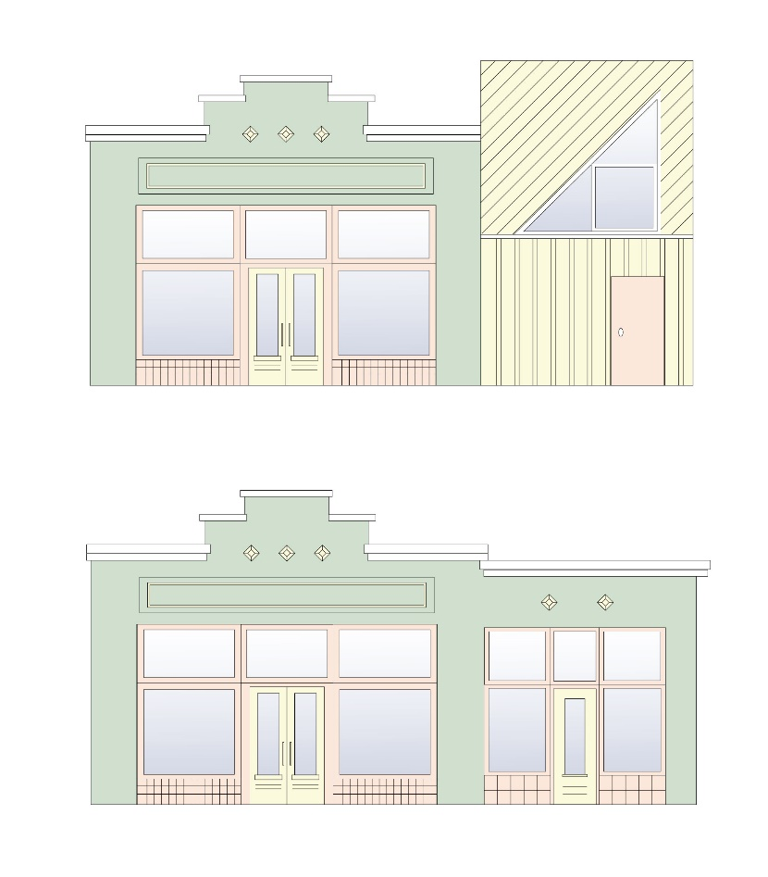
- Maintain the window and door pattern of the storefront. Historic entrances were typically flanked by glass display windows.
- Improve access to upper floors in a manner sensitive to the configuration of the historic storefront. A second set of stairs to access the upper stories is often required to comply with current fire codes.
- If the original storefront or early storefront no longer exists or is too deteriorated, the historic character of the building shall be retained through contemporary design that is compatible to the scale, design, materials, detailing, and façade rhythm of the historic building; or replaced with an accurate historic building design.
- Residential structures converted to commercial use shall follow the design guidelines for residential buildings.
Figure 42: The top illustration shows an example of an inappropriate addition while the bottom illustration shows an example of an appropriate addition.

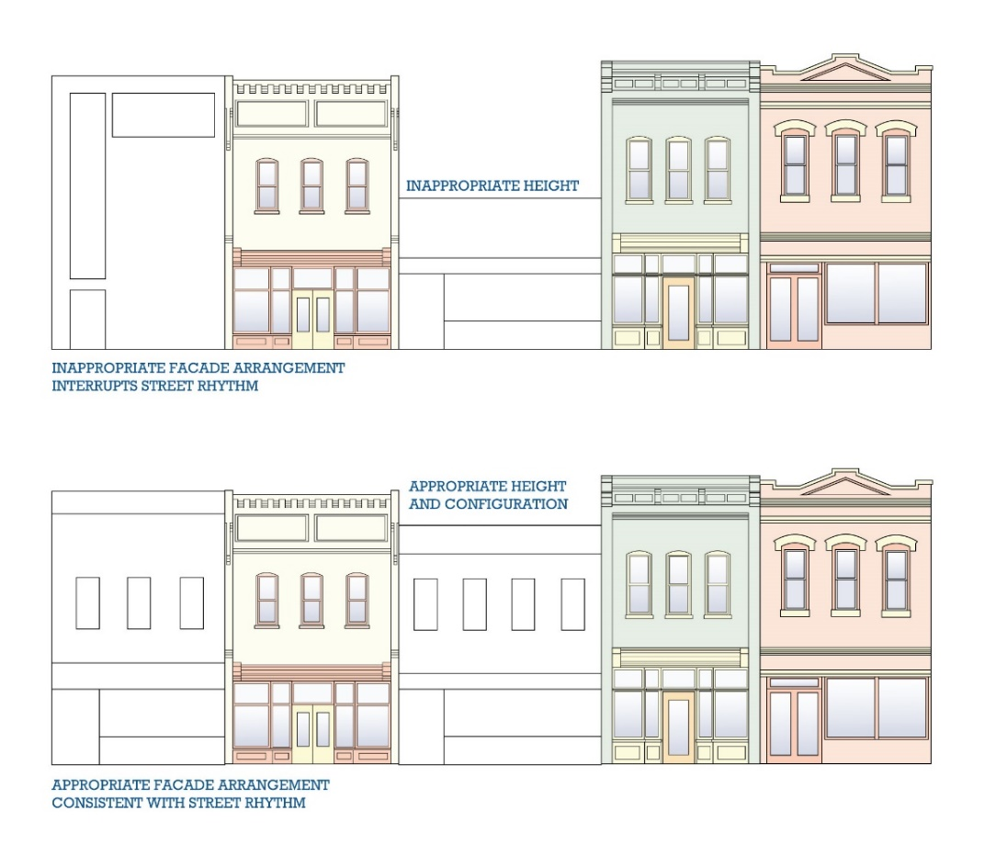

Figure 43: Illustration of appropriate and inappropriate infill and construction within a commercial stretch

Best Choices
Maintain the existing historic façade configuration, including fenestration and ornamentation

Restore the historic configuration of altered commercial properties based on physical or documentary evidence
Good Choices
Alter the layout of historic storefronts to accommodate changing needs while maintaining as much of the original fabric and configuration as possible

Alter the existing façade configuration in the least invasive manner possible. Provide additional access points in a location that will not disrupt the rhythm of the historic façade
Not Appropriate
Wholesale reconfiguration of a building’s façade to create a different appearance

Infilling existing window openings

Creating new window openings that are not complementary to the historic character of the building

Guideline 6.13.1.b Commercial Building Ornamentation
- Maintain and restore character-defining features of your commercial building. Character defining features include historic storefronts, transoms, signboards, bulkheads, windows, cornices, and other architectural details.
- Do not add arbitrary or conjectural ornamentation to the building. Replacement of missing historic features should be supported by documentary evidence to avoid creating a false historic appearance.
- Maintain the original ornamental cap or cornice of the building. If replacement is required, in-kind replacement matching the historic element in design, scale, color, and material is recommended. Replacement materials, such as fiberglass, may be approved if the element’s profile can be satisfactorily matched.
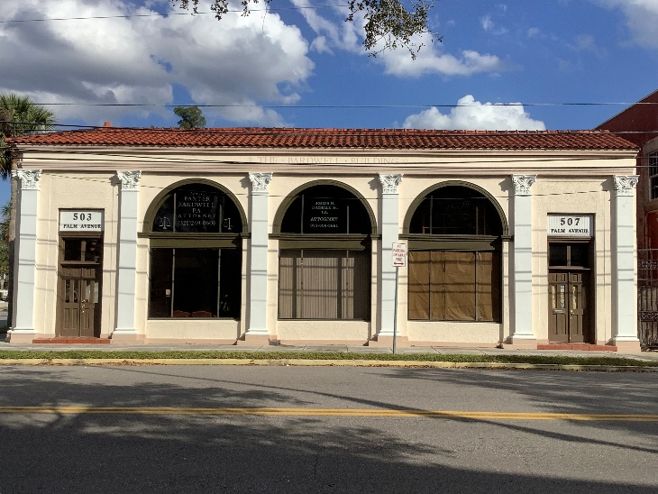  Figure 44: Building ornamentation at 503-507 Palm Avenue include pilasters with Corinthian capitals and clay tile roof | 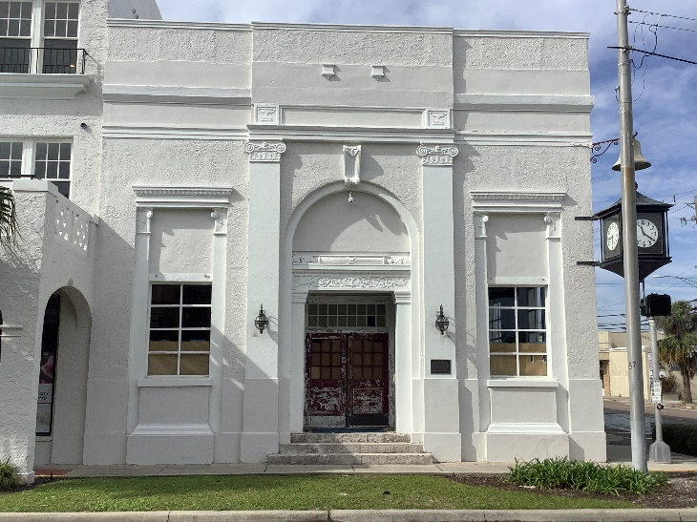  Figure 45: Ornamentation includes original pilasters, window and door surrounds, and doors and transom at 300 South Washington Avenue

Guideline 6.13.2 Windows
For additional information on substitute materials, see Appendix B.

Guideline 6.13.2.a Storefront Windows
- The size of storefront windows should be in keeping those on surrounding storefronts.
- Wood, finished anodized aluminum, and other metal storefront systems in a variety of finishes are appropriate.
- Preserve or restore the historic size and configuration of glass display windows where possible.
- Where window replacement is necessary, the new window should match the historic window in size, type, glazing pattern, and profile. The number of windowpanes and the approximate muntin and mullion profile should match the historic window.
- Storefront windows should retain their historic material and be consistent with the prominent styles and eras of the building.
- While wood was often the traditional framing material of choice for storefronts, some 19th-century buildings employed cast-iron members, these should be restored where feasible; otherwise, an appropriate substitute that shares the look and scale of the historic framing member may be considered.
- Replacing glass windows with an opaque surface detracts from the authenticity of the historic storefront and deters potential customers from entering the building.
- Retain the panel that is located below the display window. Where replacement is necessary, use wood, stone, or painted metal and coordinate the color with the historic color scheme or that of other storefront elements.
- Retain or restore storefront transom windows and the mullion divisions of the historic transom.
- Use glass in the transom where possible.
- In some cases, air conditioner units have been placed in one of the transom panels, usually just over the entry. These units are a visual deterrent and should be relocated to the rear or replaced by a rooftop system, where feasible in full building rehabilitation.
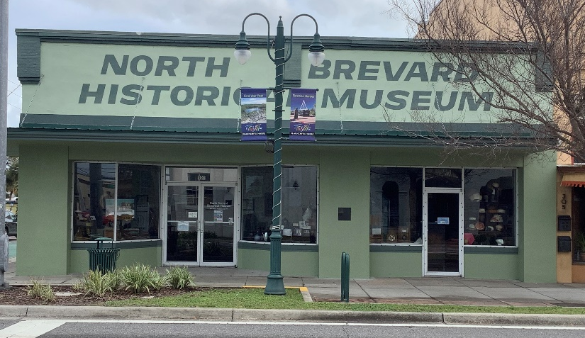

Figure 46: Historic commercial windows at 301 South Washington Avenue

Guideline 6.13.2.b Replacement Windows for Commercial Properties
- Where window replacement is necessary, the new window should match the historic window in size, type, glazing pattern, and profile. The number of windowpanes and the approximate muntin and mullion profile should match the historic window.
It is generally not appropriate to:
use removeable, snap-in, or “between the glass” muntins
- Vinyl windows are generally not manufactured in historic proportions and are not appropriate replacement windows for historic properties. Aluminum, aluminum-clad wood, and fiberglass are appropriate replacement materials and may be approved if the appearance is complementary to the existing historic windows and architectural style.
- Maintain the historic window opening size and surrounding trim. Do not alter the size of the historic window opening to accommodate larger or smaller windows. Do not remove or cover surrounding trim, including wood and masonry details
Guideline 6.13.3 Doors
Certain styles of buildings have distinct types of doors. On many historic buildings doors stylistically complement the exterior detailing of the building. The original door with its frame and trim should be preserved. If a replacement door is necessary, the new door should match the original as closely as possible in material, size and style. This includes any panels and windows that were present in the original door. Because many commercial doors were replaced in the mid-20th century, it is also appropriate to retain simple, metal and glass doors from this period, or choose a replacement with a simple design that compliments the building where the original door style is unknown.
For additional information on substitute materials, see Appendix B.
Guideline 6.13.3.a Maintain Historic Doors and Entranceways
- Maintain and repair historic doors and historic door hardware.
- Replaced damaged elements, such as trim or hardware, in-kind.
- Match new or replacement hardware to the original type, style, and finish.
- Avoid surface-applied kick plates, closers, padlocks, security hardware, and other elements that are not compatible with the original hardware.
- Maintain and repair historic transoms and side lights.
- Maintain paint coatings on historic wood doors to protect the wood from water and sun damage.

Guideline 6.13.3.b Make Sensitive Replacements
- Where replacement is necessary, the new door should match the historic door in placement, size, type, and configuration wherever possible.
- When restoring missing historic doors, it is encouraged to use pictorial evidence to produce the replacements. A salvaged replacement in the same style that fits the opening or a new door in a complementary style are also appropriate choices.
- Where code compliance requires a specific, non-historic door configuration, err on the side of simplicity.
- Maintain the historic door opening size and surrounding trim, including sidelights and transoms. Do not alter the size of the opening to fit a smaller or larger door unless required by code.

Guideline 6.13.3.c Storm Doors and Screen Doors
- Select a storm or screen door in a style typical of the period or style in which your building was constructed.
- Wood storm and screen doors are typically the most appropriate, however, metal doors with an enamel finish may be appropriate in some cases.
- The color should match the existing door sash or trim.

Guideline 6.13.3.d Adding Doorways
- New openings in historic walls are generally discouraged.
- Where new openings are necessary, placement on a non-visible façade is encouraged.
- Where a new door opening is required on the main elevation, it should be integrated with the overall fenestration pattern to compliment the building.

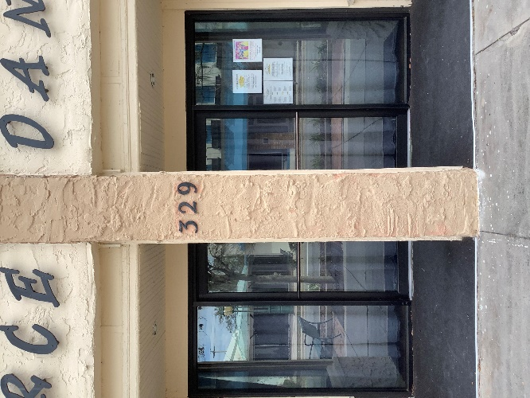 | 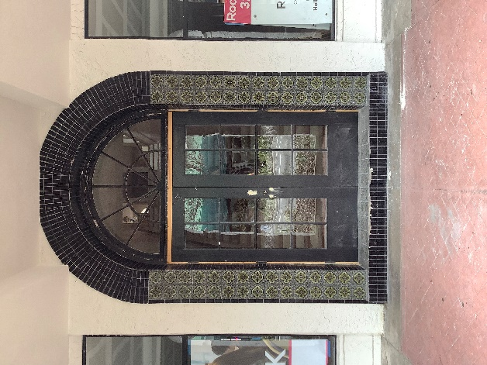  Figure 47: Appropriate commercial doors in Titusville
Guideline 6.13.4 Roofing and Chimneys
Roof shape is a major component of building form and is a major character-defining feature. Certain roof types have close association with architectural styles and are integral to a building’s design.

Guideline 6.13.4.a Maintain Historic Roof Shape
- Preserve the historic shape and slope of the roof. If a roof will be replaced completely, it shall be replaced with the same roof form or a similar form complimentary to the architectural style.
- The addition of dormers should be undergone sensitively. If a dormer is added, its size, design, and placement should be in keeping with the character of the building and in scale with its size. Its siding and roofing should match the existing, and its windows should be consistent with the building’s other windows in terms of style, type, and material.
- Do not increase the height or change the shape of parapets unless to restore an inappropriately altered condition to its historic appearance.
- Roofs on secondary structures should be consistent with the architectural style of the main building in terms of shape and slope.

Guideline 6.13.4.b Perform Regular Roof Maintenance
- Inspect, evaluate, and monitor roof for signs of deterioration, leaks, and to ensure that flashings, downspouts, and gutters are properly functioning. Check seams of metal roofs and keep metal surfaces painted, except for copper.
- Coat and seal flat roofs per the manufacturer’s recommendation, typically every five years

Guideline 6.13.4.c Roof Material
Like roof shape, roof material, when visible, is often a character defining feature. Historic roofing materials include wood shingles, slate shingles, ceramic or composite tiles, and several types of membranes for flat roofs.
- Retain and repair visible historic roofing materials where feasible.
- Where total replacement of all roofing material is required, the new roofing should match the existing material or be a roofing material that is consistent with the building’s architectural style.
- Heavy-weight architectural shingles are preferred when existing asphalt shingles are replaced.

Best Choice
Replace a historic metal roof with a new metal roof

Good Choices
Replace a slate roof that has reached the end of its useful life with new, heavyweight shingles that mimic the texture and pattern of the historic slate roof

Not Appropriate
Replacing a slate roof with a new, standing seam metal roof

Guideline 6.13.5 Paint Colors
A building’s color scheme, which is determined by paint choice and the natural colors of other materials, has a big impact on its overall appearance. Historic pattern books and style guides can provide inspiration for choosing a palette.

Guideline 6.13.5.a Choose Appropriate Color Schemes
- Choose a harmonious color palate. Avoid mixing clashing colors.
- Use contrasting colors to accent details, such as trim, dentil molding, etc.
- Use the paint scheme to tie elements of the building together.
- Consider whether the building is usually in shadow or bright light when choosing paint colors. Darker colors are more appropriate on well-lit facades, and lighter colors on shadowed facades.

Guideline 6.13.5.b Match Colors When Patching or Piecing Materials
- Ensure that patched siding, roofing, or masonry matches the surrounding surface in terms of color.
- Match colors for related elements. For example, the color of a handrail for a stair should generally match the color of the stringers and risers.
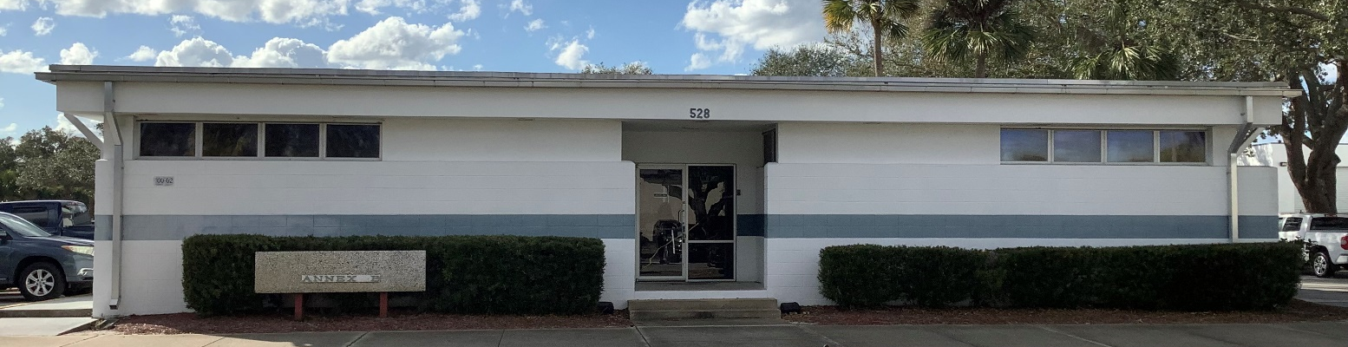
Figure 48: The paint used at 528 S Palm Street reflects the simplicity of the buildings style

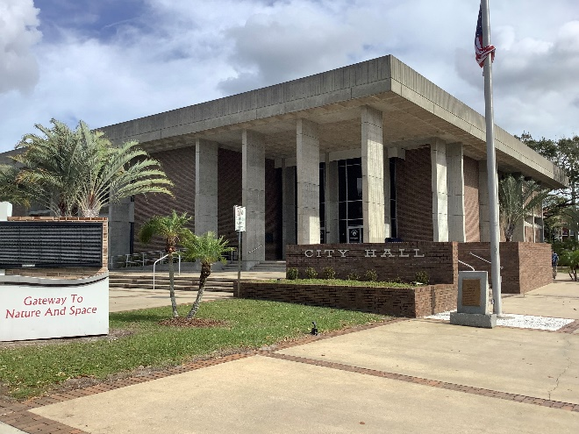  Figure 49: The style of Titusville City Hall should remain unpainted | 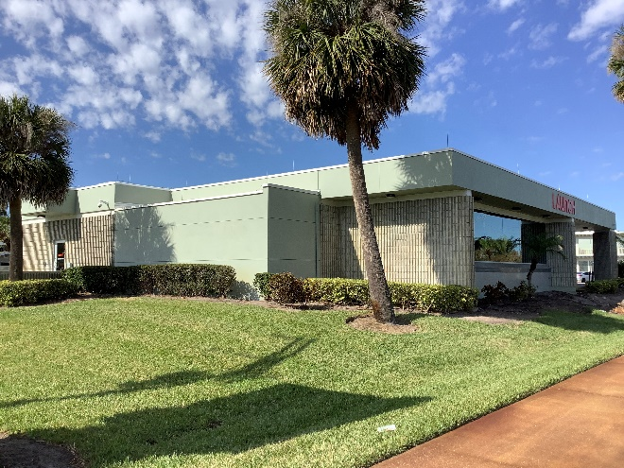  Figure 50: Any painting should reflect the style and time period of the building

Guideline 6.13.6 Utilities and Mechanical Equipment
Guideline 6.13.6.a Mechanical Equipment
- Rooftop mechanical systems should be positioned so they are not to be visible from the street.
- HVAC units, if not located on a non-visible rooftop, should be located at a side or rear elevation and screened with fences and landscaping.
- Rear window air conditioning units are preferable.
- If mechanical equipment must be located such that it is visible from the street, proper screening materials such as shrubbery or fencing material should be utilized.

Guideline 6.13.6.b Security Systems
- To the extent possible, security measures other than labels providing notice that such systems are in place should not be visible from the streets.
- Bars and gates on windows and doors must be approved by the HPB.
- Video cameras must be visually unobtrusive in size and attached with respect to the historic material of the building. On masonry structures, they should be attached to the mortar, not the masonry unit itself. Seek ways to minimize attachments and visibilities by painting cords or attachments to match the building color or using a roof-mounted apparatus to avoid damage to historic material.

Guideline 6.13.6.c Trash and Refuse Containers
- Locate dumpsters and other trash receptacles in the rear or on a non-visible side elevation.
- Employ opaque fencing or screening to limit the view from public rights-of-way.

Guideline 6.13.9 Signs and Awnings
Construction of signs is subject to the City’s sign code. Each sign will be reviewed for location, total sign area, and aesthetic style or look of the sign. Monument signs must have a solid base that is complementary to the streetscape, and the base should be masonry or stucco.

Guideline 6.13.9.a Preserve Historic Signs
- Historic signs, such as those constructed directly into an architectural detail of the structure, should be maintained and should be restored if necessary.
- Restore or recreate historic signs where sufficient documentation exists.

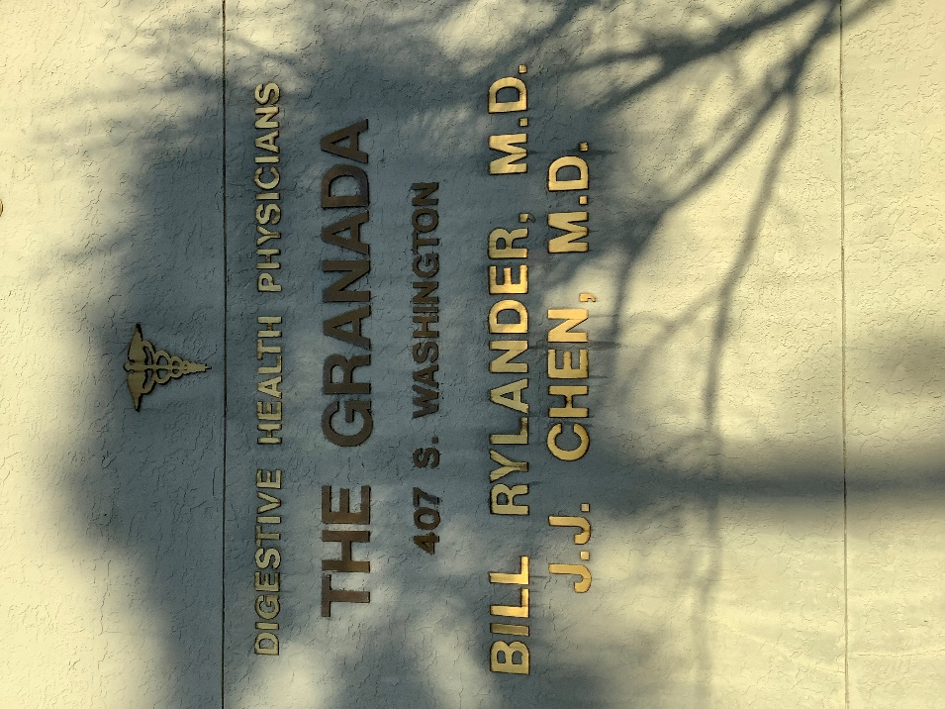 | 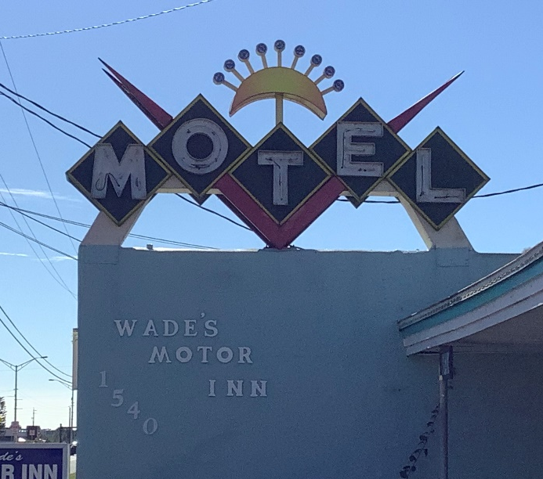
Figure 51: Types of historic signs in Titusville

Guideline 6.13.9.b Sign Placement
On most commercial buildings, a continuous brick ledge or corbelling is used to separate the second floor and above from the entry-level storefront below. This space is ideal for sign placement, as it was often created for this purpose. In some instances, newer buildings contain areas above the highest windows for signage.
- New signage shall be located on the flat, unadorned parts of a façade, such as the horizontal band between the storefront and second floor, or on windows, awning flaps, fascia, and frieze, or other areas where signs have been historically placed on the building.
- Decorative neon light banding is prohibited; however, neon lettering is permitted pursuant to sign regulations.
- Signs should be mounted to historic masonry buildings through the mortar joints rather than through masonry units wherever possible.
It is generally not appropriate to:
obscure or hide significant historic features or details with signs. This includes windows, cornices, and architectural trim.

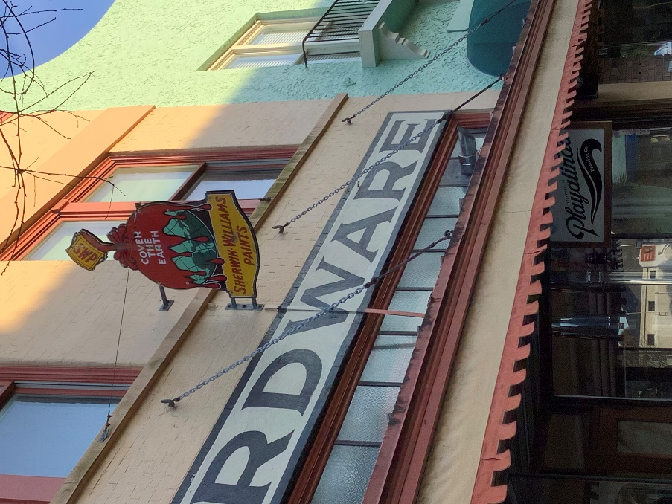

Figure 52: Examples of an appropriate commercial sign in Titusville

Guideline 6.13.9.c Awnings
- Awnings should be mounted to historic masonry buildings through the mortar joints rather than through masonry units wherever possible.
- Awnings should be appropriate to the architectural style, or historically accurate.

It is generally not appropriate to:
obscure or hide significant historic features or details with awnings. This includes windows, cornices, architectural trim, and entryway features such as transoms

Guideline 6.13.10 Lighting
Guideline 6.13.10.a Maintain Historic Fixtures
        - Retain and maintain historic light fixtures.
- Repair deteriorated or damaged light fixtures, keeping their historic appearance.

Guideline 6.13.10.b Choose Appropriate New or Replacement Fixtures
        - Replace missing or damaged light fixtures with replacements that replicate the originals or other similar examples appropriate to the architectural character of the building.
- Modern light fixtures may be appropriate as replacement or where light fixtures did not exist. They should be unobtrusive and not damage or obscure architectural features.

Guideline 6.13.10.c Façade Illumination
Illuminating historic commercial buildings can help to draw attention to businesses as well as create a more inviting environment after dark. Historically, lighting was confined to business signs, entries and, sometimes, architectural features such as cornices. Public, religious, and institutional buildings were often fully illuminated, confirming their importance to the entire community. Exterior illumination on historic residential buildings was typically confined to porch lights, entry lights, and sometimes lighting at driveway and sidewalk entries.
        - Illuminate significant features and details such as cornices on commercial buildings.
- Illuminate public, institutional, and religious buildings in such a manner so that their façades and features are highlighted.
- Illuminate recessed entries of commercial buildings using recessed ceiling fixtures.
- Illuminate doors, porch ceilings, and entries to driveways and sidewalks on residential properties.
- The design, scale and materials of external fixtures should complement the design of the façade that they are illuminating.
- Use unshielded floodlights to illuminate a building façade. Ensure that lighting remains on the property.
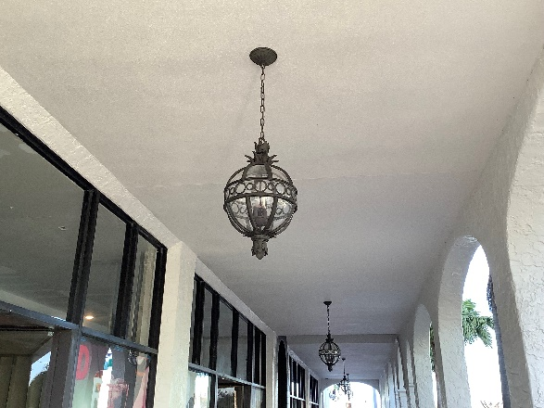 | 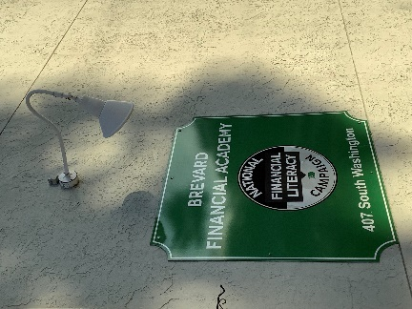
Figure 53: Commercial lighting in Titusville

Best Choices
Maintain existing historic lighting features

Install new fixtures that are compatible with the property’s architectural character in a manner that limits damage to existing historic features
Good Choices
Replace damaged fixtures with new fixtures that are compatible with the property’s architectural character in the same location as the original feature

Replace damaged fixtures with new fixtures that are compatible with the property’s architectural character in a new location different from the original feature in a manner that limits damage to existing historic features
Not Appropriate
Installing new fixtures that are inappropriate to the building or district’s character

Installing new fixtures in a manner that causes damage to existing historic features

Installing neon or flashing lights

Guideline 6.13.11 Parking Lots
Public and private parking lots in the commercial areas of Titusville’s historic district are important to the economic vitality of its businesses. They provide both long- and short-term parking for workers, residents, and visitors. Many are appropriately located in or near the commercial core of the central business district. While a few are well designed and landscaped, most are very utilitarian in nature and thus do not contribute to the appearance of the historic districts. Few surface parking lots are present in residential areas. Those that are present are usually associated with religious and educational buildings.

Guideline 6.13.11.a Universal Guidance for Parking Lots
        - Provide adequate lighting on all parking lots.
        - Clearly mark entries and exits to the parking lots and provide directional signs at appropriate locations.

Guideline 6.13.11.b New Parking Lots
              - Locate new parking lots in the rear of existing buildings, so that they are not visible from a primary public right-of-way.
- Avoid adding new surface parking lots that front on major streets.
- Provide a minimum 3-foot-wide landscape street front edge for all new parking lots, where possible. Landscaping should be 42 inches in height to screen automobiles from immediate view but allow visual access.
- Provide a low brick wall, fence or some other form of compatible screening to separate the sidewalk or street from parking lots where a 3-foot-wide landscaping buffer is not possible.
It is generally not appropriate to:
- locate parking lots on the street sides of
buildings
- tear down historic buildings and replace them entirely with on-site parking lots

APPENDIX A: Glossary

A
Accessory (or Ancillary) Building: A subordinate building or portion of the main building, the use of which is located on the same lot and is incidental to the dominant use of the main building or premises.
Adaptive Use (Adaptive Re-use): The restrained alteration of an historical or architectural resource to accommodate uses for which the resource was not originally constructed, but in such a way as to maintain the general historical and architectural character.
Addition: An increase in floor area of a building, or a modification to the roof line of a building, such as the construction of a dormer, that increases the amount of floor space devoted to human use or occupancy.
Alignment: The arrangement of objects along a straight line.
Alteration (Change): The erection of a building or structure on a site, the movement of a building or structure from or to a site, the demolition of a building or structure, the reconstruction or restoration of a building or structure or any action to change, modify, reconstruct, remove, or demolish any exterior feature of a building or structure.
Appropriate: Typical of the historic architectural style, compatible with the character of the historic district, and consistent with local preservation criteria.
Arch: Curved construction which spans an opening and supports the weight above it. See flat arch, segmental arch, and semi-circular arch.
Architectural Shingles: Composition asphalt roof shingles that are heavier weight and are irregularly sized and that resemble the random textured look of wood shingles.
Architectural Style: A category of architecture of similar buildings distinguished by similar characteristics of construction, design, materials, etc. See Chapter 3.
Awning: A roof-like cover, temporary in nature, which projects from the wall of a building.

B
Balcony: A platform that projects from the exterior wall of a building above the ground floor, which is exposed to the open air, has direct access to the interior of the building, and is not supported by posts or columns extending to the ground.
Balloon Framing: Eliminated the use of hewn joints and heavy timbers. Balloon-frame houses are supported entirely by closely spaced two-inch boards of varying widths. This system allowed for cheaper and more rapid construction, and with some minor modifications it remains the dominant method of American house construction today.
Baluster: A banister; the upright, often vase-shaped, support of a rail, in the railing of a staircase, balcony, or porch.
Balustrade: A railing held up by balusters.
Bargeboard (Vergeboard): A board which hangs from the outside rafters of a gable roof and is often sawn into a decorative pattern.
Base: The lowest of three principal parts of a column; the lowest part of a wall or pier.
Bay: The portion of a facade between columns or piers providing regular divisions.
Bay window: A projecting window that forms an extension to the floor space of the internal rooms. See also oriel window.
Belt course: A horizontal band of stone or brick on the exterior wall of a building, usually marks the floor levels.
Board and batten: Siding fashioned of boards set vertically and covered where their edges join by narrow strips called battens.
Bond: Anything that holds two or more objects together, including the pattern of interlocking units and joints in a masonry structure; the connection between masonry units or the unit and the mortar bed.
Bracket: A projecting segment, often decorative, usually of masonry or wood.
Building Type: Describes a structure’s function and form. Building types, such as “Double Pile,” “American Foursquare,” “rowhouse,” or “twin” houses are sometimes associated with one or more architectural styles.
Bulkhead: The vertical panels below display windows on store fronts. Bulkheads can be both supportive and decorative in design.

C
Capital: The top part of a column or pilaster. Examining the capital is usually the simplest means of determining the order of a column.
Casement: A hinged window frame that opens horizontally like a door.
Certificate of Appropriateness (COA): A certificate issued by the Titusville Historic Preservation Board indicating its approval of plans for alteration, construction, or removal or demolition of a local designated historic resource or of a structure within a local historic district.
Certified Local Government (CLG): Any city, county, parish, township, municipality, borough or any other general-purpose subdivision enacted by the National Preservation Act Amendments of 1980 to further delegate responsibilities and funding to the local level.
Character: Distinctive traits or qualities and attributes in any structure, site, street, or district.
Character-Defining: Those architectural materials and features of a building that define the historic nature of that building. Such elements may include the form of the building, exterior cladding, roof materials, door and window design, exterior features, exterior and interior trim, etc.
Clapboards: Narrow wooden boards, thinner at the top edge, which are placed horizontally, overlapping to provide a weather-proof exterior wall surface.
Classical Order: The combination of column and entablature components used in a classical style; each has a column with base, shaft, and capital. The most common orders: Doric, Tuscan, Ionic, Corinthian, or Composite, each order has its own rules of proportion for the various elements.
Clipped gable: A gable roof where the ends of the ridge are terminated in a small, diagonal roof surface.
Column: A circular or square free standing vertical structural member.
Compatible: In harmony with location and surroundings.
Configuration: The arrangement of elements and details on a building or structure which help to define its character.
Context: The setting in which a historic element, site, structure, street, or district exists.
Corbeling: Courses of masonry set with each course stepped forward supporting an element.
Corinthian Order: The most ornate of the classical orders characterized by a column decorated with acanthus leaves.
Cornice: The uppermost, projecting part of an entablature, or feature resembling it. Any projecting ornamental molding along the top of a wall, or portion of a wall, or building, at porch, etc.
Course: A continuous row or layer of stones, tile, brick, shingles, etc. in a wall.
Cresting: An ornamental ridge along the top of a wall or roof, often made of metal.
Cross-gable: A secondary gable roof which meets the main roof at right angles.

D
Demolition: Activity requiring a building permit(s) which results in the permanent destruction and removal of a building or structure, up to and including the foundation of a building or structure.
Dentils: A row of small decorative blocks alternating with blank spaces, resembling teeth and usually on a molding or cornice.
District: An officially designated area with defined boundaries which has been formally established through the National Register of Historic Places or as identified in the City’s local designation and listing process.
Door Frame: The part of a door opening to which a door is hinged. A door frame consists of two vertical members called door jambs and a horizontal top member called a lintel or head.
Door Jamb: The vertical portion of the door frame onto which the door is attached.
Doric Order: The simplest of the classical orders with simple, unadorned capitals fluted (with vertical grooves) columns and no base.
Dormer: A window set upright in a sloping roof. The term is also used to refer to the roofed projection in which this window is set.
Double-hung: A window where both sashes slide up and down by means of cords and weights.

E
Eave: The lower edge of a roof that projects beyond the face of a wall.
Element: A material part of detail of a site, structure, street, or district.
Elevation: Any one of the external faces or façades of a building. The front elevation is often referred to as the façade.
Engaged Column: A round column attached to the wall, also referred to as half-rounded columns.
Engaged Porch: A porch whose roof is continuous structurally with that of the main section of the building.
Epoxy Consolidants or Epoxy Fillers: Multiple part compounds that can help stabilize decayed wood members.

F
Fabric: The physical material of a building, structure, or community, connoting an interweaving of component parts.
Façade: The primary elevation of a structure, typically containing the main entrance.
Fanlight: A semi-circular or fan shaped window set over a door with radiating muntins.
Fascia: A projecting flat horizontal band; forms the trim of a flat roof or a pitched roof.
Fenestration: The arrangement of windows on a building façade.
Finial: A projecting decorative element at the top of an object, such as a fence post, weathervane, roof turret, or gable.
Fish Scale Shingles: A decorative pattern of wall shingles composed of staggered horizontal rows of wooden shingles with half-round ends.
Flashing: Sheets, usually metal, used to weatherproof joints or edges, especially on a roof.
Fluting: Vertical grooving, usually found on columns or pilasters.
Form: The overall shape of a structure.
Foundation: The base of a building that rests directly on earth and carries the load of the structure above.
Frieze: The middle portion of a classical cornice; also applied decorative elements on an entablature or parapet wall.

G
Gable: The triangular section of an exterior wall supporting a pitched roof.
Gable roof: A pitched roof with one downward slope on either side of a central, horizontal ridge, forming a gable at each end.
Gambrel roof: A pitched roof with two slopes on each side of the ridge.
Glazing: Fitting glass into windows and doors.

H
Half-story: A partial story under the roof, usually denoted by the presence of dormer windows or by full windows within gables.
Half-timbering: Timber frame wall construction with spaces between timbers filled with brick, stone, stucco, or other materials.
Harmony: Pleasing or agreeable; a congruent arrangement.
Height: The distance from the bottom to the top of a building or structure.
High Style: The more ornately detailed version of a particular architectural style; used in contrast to simpler examples, both from different periods or the same period; the opposite of vernacular.
Hipped roof: A roof with uniform sloping on all sides.
Historic District: An area designated as a “historic district” by ordinance of the City Council, and which may contain within definable geographic boundaries one or more landmarks and which may have within its boundaries other properties or structures that, while not of such historic or architectural significance to be designated as landmarks, nevertheless contribute to the overall historic or architectural characteristics of the historic district.
Historic imitation (historic replica): New construction or rehabilitation where elements, components, or buildings mimic an architectural style but are not of the same historic period as the original being mimicked.
Hood molding: A projecting molding above an arch, door, or window; also called a drip mold

I
In Kind: To replace existing materials or features with materials of identical appearance and composition (or approved substitute).
Infill: New construction where there had been an opening before, such as a new building between two older structures; or block infill between porch piers or in an original window opening.
Integrity: The ability of a property to convey its historic significance through the retention of location, design, setting ,materials, workmanship, feeling, and association.
Ionic Order: One of the classical orders; it has decorative capitals with volutes scroll-like ornaments, which turn downward.

J
Jalousie: A type of window comprised of a series of horizontal slats connected to a mechanical device operated by a crank.
Jerkinhead Roof: A gable roof where the peak is clipped, forming a slope, and resulting in a truncated gable on the wall below. Also known as a clipped gable roof.

K
Keystone: The central topmost element of an arch.
Kickplate: A metal plate (usually brass) attached to the bottom of a door to protect the door from damage.

L
Landscape: The whole of the exterior environment of a site, district, or region, including landforms, trees and plants, rivers and lakes, and the built environment.
Lattice: An openwork grill (diagonal or vertical and horizontal) of wood strips used as decorative infill screening.
Leaded Glass: Small panes of glass which are held in place with lead strips; the glass may be clear or stained.
Light: A section of a window, also called a “pane” or “sash light.”
Lintel: The horizontal support member above a window, door, or other opening.

M
Maintain: To keep in an existing state of preservation or repair.
Mansard Roof: A roof with two slopes on all four sides, with the lower slope steeper than the upper.
Masonry: Construction of brick, stone, or terra cotta laid up in units.
Mass or Massing: Building mass is established by the arrangement and proportions of its basic geometric components – the main block and side blocks, the roof, and the foundation. Similarly, massing helps create rhythm along the street, which is one of the appealing aspects of historic districts.
Material Change: A change that will affect either the exterior architectural or environmental features of a historic property or any structure, site, or work of art within a historic district.
Modillion: An ornamental bracket used in a series under a cornice and sometimes supporting the cornice.
Mortar: A mixture of sand, limestone, cement, and water used as a binding agent in masonry construction.
Mortar Joint: Masonry joint between masonry unit, such as brick or stone, filled with mortar to transfer the load, provide a bond between the units, and keep out the elements.
Mullion: A vertical divider between individual windows or doors.
Multi-light: A window sash or door light composed of more than one pane of glass
Muntin: A secondary framing member to divide and hold the individual panes of glass.

N
New Construction: Construction which is characterized by the introduction of new elements, sites, buildings, or structures or additions to existing buildings and structures in historic areas and districts.
Non-Contributing: A building, object, site, or structure that neither adds to nor detracts sense of time and place and historical development.

O
Object: A material thing of functional, aesthetic, cultural, historical, or scientific value that may be by nature or design, movable, yet related to
Obscured: Covered, concealed, or hidden from view.
Order: Any of several specific styles of Classical and Renaissance architecture characterized by the type of column used (e.g. Doric, Ionic, Corinthian, Composite, Tuscan).
Oriel Window: A bay window built out from the wall resting on a bracket or corbel.
Orientation: The manner in which a building relates to the street.

P
Palladian Window: A window opening with three parts, the central one arched and wider than the rectangular flanking ones. The tops of the flanking windows align with the base of the arch.
Paneled Door: A door composed of solid panels (either raised or recessed) held within a framework of rails and stiles.
Parapet: A low wall at the edge of a roof.
Pediment: A triangular element formed by the gable of a roof; any similar triangular element used over windows, doors, etc.
Period of Significance: The length of time when a property was associated with important events, activities, or persons, or attained the characteristics which qualify it for National Register Listing.
Pier: A square or rectangular column.
Pilaster: A square pillar attached to a wall.
Pitch: The angle of the slope of a roof.
Porch: A roofed space, open or partly enclosed, often at a building entrance, often with columns and a pediment, and generally with support piers, but occasionally with a full foundation.
Porte Cochere: A large covered entrance porch through which vehicles can drive.
Portico: A porch or ambulatory, supported by columns on at least on side, especially at the main entrance to a building in the Greek, Roman, or Neoclassical style.
Portland Cement: A strong, inflexible cement used to bind mortar. Mortar or patching materials with a high Portland cement content should not be used on pre-1920 buildings. Portland cement is harder than the earlier masonry, causing serious damage over time.
Preservation: Generally saving from destruction or deterioration old and historic buildings, sites, structures, and objects and providing for their continued use by means of restoration, rehabilitation, or adaptive use.
Pressed Tin: Decorative and functional metalwork made of stamped tin used in sheath roofs, bays, and cornices.
Proportion: Harmonious relation of parts to one another or to a whole.
Pyramidal Roof: A roof with four identical sides rising to a central peak.

Q
Quoins: Units of stone or bricks used to accentuate the corners of a building.

R
Rafter: Any of the parallel beams that support a roof.
Rafter Tail: Exposed rafter supporting the eave.
Rail: A horizontal member of a railing or fence; may support vertical elements. Also, a main horizontal member of a door or window.
Ramp: A sloped surface that makes a transition between two different levels; typically used to provide access to a building or raised surface for those persons with disabilities.
Reconstruction: The act or process of reproducing by new construction the exact form and detail of a vanished building, structure, or object, or a part thereof, as it appeared at a specific period of time.
Rehabilitation: The process of returning a property to a state of utility, through repair or alteration, which makes possible an efficient contemporary use while preserving those portions and features of the property which are significant to its historic, architectural and cultural values.
Replication: Creating an object that is an exact imitation of a historic architectural style or period.
Repointing: Repairing existing masonry joints by removing defective mortar and installing new mortar.
Restoration: The act or process of accurately taking a building’s appearance back to a specific period of time by removing later work and by replacing missing earlier features to match the original.
Retain: To keep secure and intact. In these guidelines, “retain” and “maintain” describe the act of keeping an element, detail, or structure and continuing the same level of repair to aid in preservation of elements, sites and structures.
Re-use: To use again. An element, detail, or structure might be reused in historic districts. See also Adaptive use.
Reveal: The vertical side of a door or window opening between the frame and the wall surface.
Rhythm: Regular occurrence of elements or features such as spacing between buildings.
Ridge: The top horizontal member of a roof where the sloping surfaces meet.
Room: An enclosure or division of a house separated from other divisions, designed to be habitable four seasons a year and fully heated.
Rustication: Masonry cut in massive blocks separated by deep joints.

S
Sash: The framework containing the glass in a window.
Sawtooth Shingles: Shingles with pointed edges, which when placed in rows are reminiscent of sawteeth.
Scale: Proportional elements that demonstrate the size, materials, and style of buildings.
Screening: Construction or vegetation of which the essential function is to separate, protect, conceal, or shield from view but not support.
Segmental Arch: An arch whose profile is less than a semi-circle.
Semi-circular Arch: An arch whose profile is a half-circle.
Semi-engaged Porch: A porch whose roof forms a continuous surface with, but is in a different plane than, the roof of the building.
Setback: An architectural device in which the upper stories of a tall building are stepped back from the lower stories.
Setting: The attributes of a locality, neighborhood, or property that defines its character.
Shaft: The main part of a column between the base and the capital.
Shake: A split (by hand), rather than sawn wood, shingle.
Shape: The physical configuration of structures of buildings or monuments and their component parts, including but not limited to roofs, doors, windows, and elevations.
Sheathing: An exterior covering of boards or other surface applied to the frame of the structure. See siding.
Shed Dormer: A dormer with a series of separate windows connected by sections of the elevation material, with a shed roof. May stretch the entire length of a house.
Shed Roof: A low-pitched roof with only one slope.
Shingles: A thin piece of wood, slate, asphalt, etc. laid with other in a series of overlapping rows covering the roof or sides of a house. In the early 1800s, the shingles were hand split. Today, hand-split shingles are called shakes.
Shutter: A solid panel of wood or metal made to close over a window.
Sidelight: A vertical area of fixed glass on either side of a door or window.
Siding: The exterior wall covering (sheathing) of a structure.
Significant: Having particularly important associations within the contexts of architecture, history, and culture. The importance of an element building or a site, owing to its involvement with a significant event, person, or time period, or as an example of an architectural style. Also, historically significant.
Sill: The projecting horizontal base of a window or door, may be of any material, angles to repel water. Also, the horizontal piece of lumber, or built-up section that rests on the foundation and forms the base for the wood frame in construction.
Soffit: The horizontal underside of an eave or cornice.
Spindles: Slender wood dowels or rods turned on a lathe often used in screens and porch trim. See also baluster.
Stabilization: The act or process of applying measures essential to the maintenance of a deteriorated building as it exists at present, establishing structural stability and a weather-resistant enclosure.
Standing Seam Roof: A sheet metal roof with vertical folded seems joining adjacent flat panels; the parallel seams run along the slope.
Stile: One of the main vertical members of a millwork frame to which the other are attached, the vertical framing at the edge of a door or window.
Streetscape: The distinguishing character of a particular street as created by its width, degree of curvature, paving materials, design of the street furniture, and forms of surrounding buildings.
Stucco: An exterior finish, usually textured; composed of Portland cement, limestone, and sand mixed with water.
Style: A type of architecture distinguished by special characteristics of structure and ornament and often related in time; also a general quality of a distinctive character.
Surround: An encircling border or decorative frame, usually at windows or doors.
Swag: Carved ornament in the form of a cloth draped over supports or in the form of a garland of fruits and flowers.
Synthetic Materials: Building materials that are manufactured with man-made or artificial components as opposed to materials derived from natural sources such as plants, trees, or earth. Examples of synthetics include vinyl, aluminum, fiber cement, and plastic resin.

T
Terra Cotta: A fine-grained fired clay material used for decorative masonry, often used in imitation of stone.
Texture: The feel, appearance, or consistency of a surface or substance.
Transom: An opening above a door or window.
Trim: The decorative framing of openings and other features.
Turret: A small tower projecting from a building usually at a corner.

V
Vergeboard: An ornately curved board attached to the projecting edge of a gable roof, sometimes referred to as bargeboards.
Vernacular: A regional form or adaptation of a traditional architectural style; a building built without being designed by an architect or someone with similar training.
Visual Continuity: A sense of unity or belonging together that elements of the built environment exhibit because of similarities among them.

W
Wall Dormer: A dormer created by the upward extension of a wall and a breaking of the roofline.
Water Table A projecting horizontal ledge, intended to prevent water from running down the face of a wall’s lower section.
Weatherboard: Wood siding consisting of overlapping boards usually thicker at one edge than the other, or a board at the top of an exterior wall that covers the joint at an overhanging eave or verge.
Workmanship: The physical evidence of the crafts of a culture, people, or artisan.

Y
Yard: An open space at grade, other than a court or plaza, between a structure and the adjacent lot lines. In measuring a yard for the purpose of determining depth, the minimum horizontal depth between the lot line and a building or structure shall be used.

APPENDIX B: Substitute Material

For additional information and guidance, see the National Park Service’s Preservation Brief 16 The Use of Substitute Materials on Historic Building Exteriors.

While the preferred method for treatment of historic properties emphasizes repairing original features to the greatest extent possible, and to replace historic features with like materials where repair is not possible, there are several instances in which utilizing substitute materials may be permissible. Substitute materials are new materials or technology which are designed to simulate the appearance of a historic material.

Substitute materials are new materials designed to simulate the appearance of a historic material. Substitute materials are often made of synthetics.

Situations in which the use of substitute materials may be appropriate include:
- When the historic material is unavailable (for instance, a particular type of slate, or old growth lumber)
- Where historic craft techniques or skilled artisans are not available
- When the historic feature has already been lost and little is known about its original appearance
- Where the historic material does not meet existing code requirements

Substitute materials may only be used if they will not cause damage to existing historic features. Their use must not negatively alter the appearance of the historic resource, and the new material must copy the original as closely as possible. A replacement feature should match the original in form, profile, color, and perceived texture. A substitute material cannot be chosen for sake of convenience alone when a more historically appropriate material is viable and covering or wrapping existing historic materials with synthetic materials is not appropriate.

The Historic Preservation Board will consider the use of a substitute material in place of historic materials on a case-by-case basis and may approve or deny such materials based on the significance of the feature and compatibility of the replacement unit. Factors to consider when evaluating the use of substitute materials on a historic building include:
- Is the existing material historic? If it a character defining feature of the building?
- Will the new materials cover or replace existing historic fabric?
- Will the new produce be physically compatible with the surrounding building materials?
- Will the new product be physically compatible with the remaining materials? Will the product realistically match the original feature or material in size, proportion, detail, profile, texture, and finish?
- Is the new product durable as compared to the historic material in the same environment?

Appropriate use of substitute materials includes:
- Where the historic material does not meet existing code requirements
- When the historic material is unavailable, such as a particular type of slate or old growth lumber
- Where historic craft techniques or skilled artisans are unavailable
- When the historic feature has already been lost and little is known about its original appearance

Common Substitute Materials
Architectural Details and Trim
Architectural details help convey the style of a building. Architectural details should be retained and never permanently removed. When formerly hidden ornamentation is discovered, it should be maintained and preserved.
High-quality synthetics may be an appropriate replacement for wood or plaster details where the profile, size, and dimension of the element can be accurately reproduced. Synthetic material use on architectural details and trim will; be considered on a case-by-case basis by the HPB and all synthetics are subject to a painting requirement.
Cellular PVC
Polyvinyl chloride is more commonly known as PVC. Cellular PVC board is used to produce trim, moldings, and other decorative architectural elements. These are durable products that can be painted.

Metal
Metal is only appropriate for architectural details and trim when it was the original material.

Vinyl
Vinyl is not an appropriate material for architectural detail and trim replacements unless the details are not visible from the street.
Deck and Porch
Historic deck and porch materials typically include wood, brick, stone, and concrete. There are few appropriate substitutes available for brick, stone, and concrete and therefore these elements should be replaced in-kind. Porch elements such as columns, railings, balusters, floors, and ornaments are typically made from wood. Repairing and maintaining historic wood porches is the preferred approach, though alternative materials may be appropriate on a case-by-case basis.

Composite
Composite materials are made from a mixture of plastic and wood fibers and is manufactured for use as floorboards and stair treads. These materials are formed into plants to imitate wood decking and are installed in a manner similar to traditional wood planks. The product is sometimes available in a paintable finish. Composite materials are appropriate for installations on non-visible sections of a property.

Fiberglass
Fiberglass can be used to replicate decorative features, such as columns and balusters, and are available in a variety of shapes and sizes. Fiberglass products which mimic historic forms are commercially available. Fiberglass is typically more expensive than their wooden counterparts. A fiberglass replacement may be appropriate if it closely matches the design and proportion of the original elements.

Metal
Railings, balusters, and porch columns can be constructed of metal. Metal porch elements made of cast iron may be of historic age, or may be a later, possibly historic age modification to a property. Aluminum may be appropriate for mid-20th century properties but would be an inappropriate choice for an older property. Metal on front porches should only be used when there is evidence that it was the original material. Metal may be appropriate on a rear, non-public visible porch on a case-by-case basis.

Pressure Treated Lumber
Pressure treated lumber is preserved through a process that uses high pressure to inject a preservative into the wood, adding years to the life of the material. Pressure treated lumber is not stronger than untreated wood, but pressure treated does withstand the elements better than untreated while still being susceptible to deterioration of checks, warping, and splitting. Pressure-treated wood can be effective when used for hidden structural elements such as posts, joists, and sills. It is not a good substitute for visible porch parts.

Vinyl
Vinyl is a common material for replacement columns and railings, often used in new construction. Vinyl can be appropriate for buildings constructed in the late 20th century or later. Vinyl is susceptible to fading and warping with a low lifespan.

Roofing
Roofing materials are among the most frequently substituted. Substitute materials have been designed to replace historic shingles and traditional metal roofs. While it may be appropriate to replace a deteriorated historic shingle roof with new, synthetic shingles similar in color and texture to the historic material, it would not be appropriate to replace a historic metal paneled roof with modern asphalt shingles. The original roofing type should be maintained.

Roofs may be re-roofed with substitute materials if the original materials are determined beyond repair, are no longer present or available, or if the retention of the original roof material is not economically feasible.

Asphalt
Asphalt roll style covering are not historically appropriate on any building older than the mid-20th century. New asphalt roofs should be one color and compatible with the historic colors and style period of the building.

Composite and Synthetic
Composition shingles are a heavy-duty asphalt product made with a fiberglass backing and a facing made from ceramic-coated mineral grains, suspended in an asphalt coating. Also known as laminated shingles, architectural shingles, or dimensional shingles, these differ from traditional asphalt tab shingles as they are more dimensional and provide a more irregular, natural looking pattern. Architectural shingles may be an appropriate replacement for severely deteriorated slate or timber shingle roofs, as well as existing tab-style asphalt shingles. Composition roofing may be determined to be appropriate for flat or low-pitched roofs to prevent structural damage.

Metal
Sheet metals – tin, copper, zinc, tin plate, terne plate, and galvanized iron – are common historic metal roofing materials. Corrosion, pitting, and streaking are common deteriorations to metal roofs. Metal roofs are only appropriate where a metal roof was part of the original structure and should be replaced with similar details and proportions.

Tile and Slate
Clay tile and slate were common historic roofing materials as well as some of the most durable. Tile and slate require a level of craftsmanship and specialization that is not attainable to mimic exactly. When feasible, it is preferred to replace a historic tile or slate roof in-kind. If a roof historically did not have clay tile, it would not be an appropriate material.

Siding
Maintaining and preserving existing historic wood siding, where present, is the general recommendation. Mixing siding materials, either within a wall or on different walls of a building is never appropriate. Only when the entirety of the siding on a building needs to be replaced should substitute materials be considered. The HPB will determine the appropriateness of substitute siding materials on a case-by-case basis. In all cases, the replacement siding should match the historic siding in terms of width, texture, profile, and overall appearance.

Engineered Polymer
Polymer siding products are more durable than other synthetics, such as vinyl. However, it is not an appropriate covering for visible elevations of a historic building.

Engineered Wood
Engineered wood products, such as LP Smartsiding, can be an appropriate replacement siding for the rear, non-visible elevations of a building.

Fiber Cement Board
Fiber cement board siding is made from combining wood pulp or cellulose with Portland cement, silica, and other products. It is commonly known as HardiPlank or Hardiboard. These products may be approved for repairing the rear, non-visible elevations of a building. Avoid using fiberboard that comes in a wood-grain texture, as it is not historically appropriate.

Metal
Metal is not an appropriate siding choice in the historic districts, including products that try to mimic historic patterns.

Synthetics
Synthetic siding, such as vinyl, is not an appropriate covering in the historic district. Asbestos cladding that is original to a dwelling should be kept stained or painted to avoid any health hazards. If the asbestos siding is deteriorating, it may be removed and replaced with wood or other substitute siding.

Wood
Wood siding or shingles, when the historic covering, are always the best choice due to their durability and repairability. In many cases where wood siding is in poor condition, spot replacements using in-kind materials to replace boards that are deteriorated beyond repair is the best approach. Wood siding and shingles should be replaced to match the original size, placement, and design.

Windows and Doors
Windows and Doors are character-defining features that help convey the age and architectural style of a building, especially when located on the primary façade. For windows and doors on the primary façade, it is always preferred to repair and retrofit the original material.

Wood
Most historic-age buildings, excepting those of the more recent past, have wood windows. Replacement of an existing historic wood window or wood door with a new wood window or door matching the dimensions and configuration of the original is considered a replacement in-kind. However, most wood building products that are commercially available now are made from faster-growing trees and are inferior in quality to historic, old growth lumber products. New wood windows and doors are not as durable as historic windows. If wood windows or doors are desired, consider repairing these historic wood elements.

Fiberglass
Fiberglass windows and doors have a matte finish and are available in proportions that mimic their historic replacement.

Composite
Composite windows and doors are made from a mixture of materials, typically fiberglass and wood fibers. Composite is paintable and is a good lower-cost option for residences in historic districts.

Metal
Metal doors and windows may be appropriate for later architectural styles or non-visible elevations. Aluminum is a common metal for windows. Aluminum clad windows are wood or composite windows with an aluminum facing on the trim, sashes, and muntins. Aluminum clad windows may be approved for replacement of historic windows in cases where the historic windows are deteriorated beyond repair and where the replacement match the original in size, proportion, and configuration. Aluminum clad windows typically have an anodized or baked enamel finish, rendering them unpaintable, which can be a drawback when building paint schemes are changed. Shiny metal screen doors look out of place on a historic home, and main façade doors should avoid replacement with metal.

Vinyl
Vinyl can either be used as a cladding on wood or composite materials in the same way as aluminum, or vinyl windows or doors can be completely constructed out of PVC. Vinyl products are problematic for use in historic districts, as they are not typically available in proportions or finishes that are compatible with historic buildings. Because of the way vinyl is manufactured, vinyl windows have narrow stiles and rails on the sashes which do not match the thicker proportions on historic window openings. Vinyl windows and doors are not paintable and are the least durable option with a lifespan of 10 to 15 years.

Nonetheless, vinyl materials may be appropriate for use in properties constructed in the mid-20th century, on nonvisible elevations, and on non-contributing properties.

Appendix C: Additional Resources

Local Resources (Website Links)
Application for Certificate of Appropriateness (COA) for Historic Resources

City of Titusville Historic Preservation Plan
Titusville’s Local Historic Designations
Titusville’s Historic Preservation Board (HPB)

Historic Designation FAQs

Brevard County History
Brevard County Historic Landmarks

Brevard County Historical Commission

Florida Division of Historical Resources
Funding Resources
Florida Property Tax Exemption for Historic Properties

Federal Rehabilitation Tax Credit
https://www.nps.gov/tps/tax-incentives.htm
National Park Service Preservation Briefs
All of the below listed technical publications may be accessed at: https://www.nps.gov/orgs/1739/preservation-by-topic.htm

Overarching Guidance for the Rehabilitation of Historic Properties (Website Links)
- The Secretary of the Interior’s Standards for the Treatment of Historic Properties with Guidelines for Preserving, Rehabilitating, Restoring, & Reconstructing Historic Buildings
- Part 1: Preservation and Rehabilitation (PDF)
- Part 2 - Reconstruction and Restoration (PDF)
- The Secretary of the Interior’s Standards for the Treatment of Historic Properties & Guidelines for the Treatment of Cultural Landscapes
- The Secretary of the Interior's Standards for Rehabilitation, regulatory for the Historic Preservation Tax Incentives Program
- The Secretary of the Interior’s Standards for Rehabilitation & Illustrated Guidelines for Rehabilitating Historic Buildings also PDF
- The Secretary of the Interior’s Standards for Rehabilitation & Illustrated Guidelines on Sustainability for Rehabilitating Historic Buildings also PDF
- The Secretary of the Interior's Standards for Rehabilitation & Guidelines on Flood Adaptation for Rehabilitating Historic Buildings, also PDF
A
Abatement
Appropriate Methods for Reducing Lead-Paint Hazards in Historic Housing, Preservation Brief 37
Accessibility
Codes and Regulatory Requirements for Rehabilitating Historic Buildings
Designing New Additions to Provide Accessibility, ITS No. 53
Making Historic Properties Accessible, Preservation Brief 32
Additions/Rooftop Additions
Adding or Modifying Fly Lofts on Historic Theaters, ITS No. 45
Compatible new additions, INCENTIVES: A Guide to the Federal Historic Preservation Tax Incentives Program for Income-Producing Properties
Completing Never-Built Portions of a Historic Building, ITS No. 34
Exterior Stair/Elevator Tower Additions, ITS No. 10
New Additions to Historic Buildings
New Additions to Mid-Size Historic Buildings 1, ITS No. 3
New Additions to Mid-Size Historic Buildings 2, ITS No. 18
New Construction within the Boundaries of Historic Properties
New Exterior Additions to Historic Buildings: Preservation Concerns, Preservation Brief 14
Rear Additions to Historic Houses, ITS No. 37
Rooftop Additions
Rooftop Additions, ITS No. 36
Rooftop Additions on Mid-Size Historic Buildings, ITS No. 47
Affordable Housing
Carnegie Place Apartments, Sioux City, Iowa, Case Studies in Affordable Housing Through Historic Preservation No. 2
Northern Hotel, Fort Collins, Colorado, Case Studies in Affordable Housing Through Historic Preservation No. 4
Pacific Hotel, Seattle Washington, Case Studies in Affordable Housing Through Historic Preservation No. 1
Shelly School, York, Pennsylvania, Case Studies in Affordable Housing Through Historic Preservation No. 3
Van Allen Apartments, Clinton, Iowa, Case Studies in Affordable Housing Through Historic Preservation No. 5
Alterations to the Rear of Buildings
Alterations to Rear Elevations, ITS No. 33
Rear Additions to Historic Houses, ITS No. 37
Alterations without Historical Basis
Alterations Without Historical Basis, ITS No. 38
Alterations Without Historical Basis, ITS No. 56
Aluminum
Aluminum and Vinyl Siding on Historic Buildings: The Appropriateness of Substitute Materials for Resurfacing Historic Wood Frame Buildings, Preservation Brief 8
From Asbestos to Zinc: Roofing for Historic Buildings
Maintenance and Repair of Historic Aluminum Windows, Preservation Tech Note-Windows No. 22
Metals in America’s Historic Buildings
Aluminum Siding (see Aluminum, Substitute Materials)
Architectural Features (see also Character-Defining Features, Meeting the Standards for Rehabilitation)
Alterations Without Historical Basis, ITS No. 38
Alterations Without Historic Basis, ITS No. 56
Architectural Character: Identifying the Visual Aspects of Historic Buildings as an Aid to Preserving Their Character, Preservation Brief 17
Cumulative Effect and Historic Character
Entrance Treatments, ITS No. 26
Identifying Primary and Secondary Interior Spaces in a Historic Building
Inappropriate Porch Alterations, ITS No. 9
Preserving Historic Wood Porches, Preservation Brief 45
Rehab: The Rehab Yes/No Learning Program
Rehabilitating Interiors in Historic Buildings: Identifying and Preserving Character-defining Elements, Preservation Brief 18
Repair/Replacement of Missing or Altered Storefronts, ITS No. 13
Retaining Distinctive Corridor Features, ITS No. 31
Retaining Industrial Character in Historic Buildings, ITS No. 55
Reusing Special Use Structures, ITS No. 50
Walk Through Historic Buildings: Learn How to Identify the Visual Character of a Historic Building: Inside + Out
Asbestos
From Asbestos to Zinc: Roofing for Historic Buildings
Awnings
Adding Awnings to Historic Storefronts and Entrances, ITS No. 27
Awnings
Rehabilitating Historic Storefronts, Preservation Brief 11
The Secretary of the Interior’s Standards for Rehabilitation & Illustrated Guidelines on Sustainability for Rehabilitating Historic Buildings
The Use of Awnings on Historic Buildings: Repair, Replacement, and New Design, Preservation Brief 44
Window Awnings, Preservation Tech Note-Windows No. 7
B
Brass
Metals in America’s Historic Buildings
Brick (see also Masonry)
Altering the Character of Historically Finished Interiors, ITS No. 25
Assessing Cleaning and Water-Repellent Treatments for Historic Masonry Buildings, Preservation Brief 1
Dangers of Abrasive Cleaning to Historic Buildings, Preservation Brief 6
Exposing Interior Masonry Walls and Ceilings
A Glossary of Historic Masonry Deterioration Problems and Preservation Treatments
Keeping it Clean: Removing Exterior Dirt, Paint, Stains and Graffiti from Historic Masonry Buildings
Maintaining finished character, INCENTIVES: A Guide to the Federal Historic Preservation Tax Incentives Program for Income-Producing Properties
Repointing Mortar Joints in Historic Masonry Buildings, Preservation Brief 2
Removing Interior Plaster to Expose Brick, ITS No. 5
Treatment of Interiors in Industrial Buildings, ITS No. 15
Bronze
Metals in America’s Historic Buildings
Brownstone (see Sandstone)

Building Codes
Codes and Regulatory Requirements for Rehabilitating Historic Buildings
Modifying Historic Interior Railings to Meet Building Code, ITS No. 46
C
Cast Iron
The Maintenance and Repair of Architectural Cast Iron, Preservation Brief 27
Metals in America’s Historic Buildings
Character-Defining Features (see also Architectural Features, Meeting the Standards for Rehabilitation)
Architectural Character: Identifying the Visual Aspects of Historic Buildings as an Aid to Preserving Their Character, Preservation Brief 17
Cumulative Effect and Historic Character
Rehab: The Rehab Yes/No Learning Program
Rehabilitating Interiors in Historic Buildings: Identifying and Preserving Character-defining Elements, Preservation Brief 18
Retaining Industrial Character in Historic Buildings, ITS No. 55
Walk Through Historic Buildings: Learn How to Identify the Visual Character of a Historic Building: Inside + Out
Churches
Preserving Historic Church Interiors, ITS No. 6
Subdividing Assembly Spaces in Historic Buildings
Subdividing Significant Historic Interior Spaces, ITS No. 44
Clapboard
Aluminum and Vinyl Siding on Historic Buildings: The Appropriateness of Substitute Materials for Resurfacing Historic Wood Frame Buildings, Preservation Brief 8
The Use of Substitute Materials on Historic Building Exteriors, Preservation Brief 16
Codes (see Building Codes)
Commercial Buildings
Adding Awnings to Historic Storefronts and Entrances, ITS No. 27
Entrance Treatments, ITS No. 26
Introduction to Federal Tax Credits for Rehabilitating Historic Buildings: Main Street Commercial Buildings
The Maintenance and Repair of Architectural Cast Iron, Preservation Brief 27
The Preservation of Historic Pigmented Structural Glass (Vitrolite and Carrara Glass), Preservation Brief 12
The Preservation of Historic Signs, Preservation Brief 25
Rehabilitating Historic Storefronts, Preservation Brief 11
Repair/Replacement of Missing or Altered Storefronts, ITS No. 13
Replacement of Missing or Altered Storefronts, ITS No. 48
The Use of Awnings on Historic Buildings: Repair, Replacement, and New Design, Preservation Brief 44
Concrete
Assessing Cleaning and Water-Repellent Treatments for Historic Masonry Buildings, Preservation Brief 1
Dangers of Abrasive Cleaning to Historic Buildings, Preservation Brief 6
From Asbestos to Zinc: Roofing for Historic Buildings
Keeping it Clean: Removing Exterior Dirt, Paint, Stains and Graffiti from Historic Masonry Buildings
The Maintenance, Repair and Replacement of Historic Cast Stone, Preservation Brief 42
The Preservation and Repair of Historic Clay Tile Roofs, Preservation Brief 30
Preservation of Historic Concrete, Preservation Brief 15
Repointing Mortar Joints in Historic Masonry Buildings, Preservation Brief 2
Substitute Materials: Replacing Deteriorated Serpentine Stone with Pre-Cast Concrete, Preservation Tech Note-Masonry No. 1
Copper
From Asbestos to Zinc: Roofing for Historic Buildings
Metals in America’s Historic Buildings
D
Decks (see Porches)
Deteriorated and Damaged Buildings
Deteriorated and Damaged Buildings
Deteriorated, Damaged, or Previously Altered Buildings
Documentation Required in Establishing the Structural Condition of a Building
Doors/Entrances (see also Garages/Garage Doors)
Adding Awnings to Historic Storefronts and Entrances, ITS No. 27
Adding New Entrances to Historic Buildings, ITS No. 22
Adding New Openings on Secondary Elevations, ITS No. 21
Adding Vehicular Entrances and Garage Doors to Historic Buildings, ITS No. 29
Designing New Additions to Provide Accessibility, ITS No. 53
Entrance Treatments, ITS No. 26
Historic Garage and Carriage Doors: Rehabilitation Solutions, Preservation Tech Note-Doors No. 1
Inappropriate Porch Alterations, ITS No. 9
Inappropriate Replacement Doors, ITS No. 4
New Entries on Mill Buildings, ITS No. 30
Preserving Historic Wood Porches, Preservation Brief 45
Repair and Reproduction of Metal Canopies and Marquees with Glass Pendants, Preservation Tech Note-Metals No. 6
Retaining Industrial Character in Historic Buildings, ITS No. 55
E
Energy Conservation/Efficiency (see also Sustainability)
Energy Efficiency, Sustainability, and Green Building Practices in Historic Buildings
Improving Energy Efficiency in Historic Buildings, Preservation Brief 3
Incorporating Solar Panels in a Rehabilitation Project, ITS No. 52
Installing Green Roofs on Historic Buildings, ITS No. 54
Preserving Historic Wood Porches, Preservation Brief 45
The Secretary of the Interior’s Standards for Rehabilitation & Illustrated Guidelines on Sustainability for Rehabilitating Historic Buildings also PDF
The Use of Awnings on Historic Buildings: Repair, Replacement, and New Design, Preservation Brief 44
Weatherization of Historic Buildings
Window Awnings, Preservation Tech Note-Windows No. 7
Entrances (see Doors/Entrances)
Exposed brick
Altering the Character of Historically Finished Interiors, ITS No. 25
Dangers of Abrasive Cleaning to Historic Buildings, Preservation Brief 6
Deteriorated Plaster Finishes, ITS No. 19
Exposing Interior Masonry Walls and Ceilings
Historically-Finished Secondary Spaces—Avoiding Problematic Treatments at Project Completion (exposed masonry, structure, ceilings; new MEP systems; "white box" condition in historically-finished secondary spaces)
Maintaining finished character, INCENTIVES: A Guide to the Federal Historic Preservation Tax Incentives Program for Income-Producing Properties
Removing Interior Plaster to Expose Brick, ITS No. 5
Treatment of Interiors in Industrial Buildings, ITS No. 15

F
Factory Buildings (see Industrial Buildings)
Federal Historic Preservation Tax Incentives Program (see Historic Preservation Tax Incentives)
Flooding
The Secretary of the Interior's Standards for Rehabilitation & Guidelines on Flood Adaptation for Rehabilitating Historic Buildings
Flooring
Preserving Historic Ceramic Tile Floors, Preservation Brief 40
G
Garages and Garage Doors (see also Doors/Entrances)
Adding Parking to the Interior of Historic Buildings, ITS No. 17
Adding Vehicular Entrances and Garage Doors to Historic Buildings, ITS No. 29
Historic Garage and Carriage Doors: Rehabilitation Solutions, Preservation Tech Note-Doors No. 1
New Infill for Historic Garage Openings, ITS No. 2
New Infill for Historic Loading Door Openings, ITS No. 16
The Preservation and Reuse of Historic Gas Stations, Preservation Brief 46
Glass/Glazing (see Windows)
Granite
Assessing Cleaning and Water-Repellent Treatments for Historic Masonry Buildings, Preservation Brief 1
Dangers of Abrasive Cleaning to Historic Buildings, Preservation Brief 6
A Glossary of Historic Masonry Deterioration Problems and Preservation Treatments
Keeping it Clean: Removing Exterior Dirt, Paint, Stains and Graffiti from Historic Masonry Buildings
Repointing Mortar Joints in Historic Masonry Buildings, Preservation Brief 2
H
Heating, Ventilating, and Air Conditioning
Features, Finishes + Spaces, INCENTIVES: A Guide to the Federal Historic Preservation Tax Incentives Program for Income-Producing Properties
Heating, Ventilating, and Cooling Historic Buildings: Problems and Recommended Approaches, Preservation Brief 24
Installing New Systems in Historic Buildings, ITS No. 51
Installing New Systems in Historic Corridors, ITS No. 24
HVAC (see Heating, Ventilating, and Air Conditioning)
I
Industrial Buildings
Adding New Entrances to Historic Buildings, ITS No. 22
Adding New Openings on Secondary Elevations, ITS No. 14
Features, Finishes + Spaces, INCENTIVES: A Guide to the Federal Historic Preservation Tax Incentives Program for Income-Producing Properties
Landscape Treatments Around Industrial Buildings
New Infill for Historic Loading Door Openings, ITS No. 16
Retaining Industrial Character in Historic Buildings, ITS No. 55
Subdividing Significant Historic Interior Spaces, ITS No. 44
Treatment of Interiors in Industrial Buildings, ITS No. 15
Insulation (see also Energy Conservation/Efficiency, Sustainability, Weatherization)
Improving Energy Efficiency in Historic Buildings, Preservation Brief 3
Iron and Iron Alloys
Converting Fire Escapes into Balconies in Mill Complexes, ITS No. 43
From Asbestos to Zinc: Roofing for Historic Buildings
Industrial Bridges in Mill Complexes, ITS No. 42
The Maintenance and Repair of Architectural Cast Iron, Preservation Brief 27
Metals in America’s Historic Buildings
Rehabilitating a Historic Iron Bridge, Preservation Tech Note-Metals No. 4
Rehabilitating a Historic Truss Bridge Using a Fiber Reinforced Plastic Deck, Preservation Tech Note-Metals No. 5
The Seismic Retrofit of Historic Buildings: Keeping Preservation in the Forefront, Preservation Brief 41
L
Landscape (see also Site)
Landscape Treatments Around Industrial Buildings
Protecting Cultural Landscapes: Planning, Treatment and Management of Historic Landscapes, Preservation Brief 36
The Secretary of the Interior’s Standards for the Treatment of Historic Properties & Guidelines for the Treatment of Cultural Landscapes
Lead Paint
Appropriate Methods for Reducing Lead-Paint Hazards in Historic Housing, Preservation Brief 37
Codes and Regulatory Requirements for Rehabilitating Historic Buildings
Limestone (see also Masonry)
Assessing Cleaning and Water-Repellent Treatments for Historic Masonry Buildings, Preservation Brief 1
Dangers of Abrasive Cleaning to Historic Buildings, Preservation Brief 6
A Glossary of Historic Masonry Deterioration Problems and Preservation Treatments
Keeping it Clean: Removing Exterior Dirt, Paint, Stains and Graffiti from Historic Masonry Buildings
Non-destructive Evaluation Techniques for Masonry Construction, Preservation Tech Note-Masonry No. 4
Repointing Mortar Joints in Historic Masonry Buildings, Preservation Brief 2
Water Soak Cleaning of Limestone, Preservation Tech Note-Masonry No. 3
M
Maintenance
Exterior Paint Problems on Historic Woodwork, Preservation Brief 10
From the Roof Down . . . and Skin Deep
Maintaining the Exteriors of Small and Medium-Size Historic Buildings, Preservation Brief 47
Marble
Assessing Cleaning and Water-Repellent Treatments for Historic Masonry Buildings, Preservation Brief 1
Dangers of Abrasive Cleaning to Historic Buildings, Preservation Brief 6
A Glossary of Historic Masonry Deterioration Problems and Preservation Treatments
Keeping it Clean: Removing Exterior Dirt, Paint, Stains and Graffiti from Historic Masonry Buildings
Repointing Mortar Joints in Historic Masonry Buildings, Preservation Brief 2
Masonry
Assessing Cleaning and Water-Repellent Treatments for Historic Masonry Buildings, Preservation Brief 1
Dangers of Abrasive Cleaning to Historic Buildings, Preservation Brief 6
Exposing Interior Masonry Walls and Ceilings
A Glossary of Historic Masonry Deterioration Problems and Preservation Treatments
Keeping it Clean: Removing Exterior Dirt, Paint, Stains and Graffiti from Historic Masonry Buildings
Maintaining the Exteriors of Small and Medium-Size Historic Buildings, Preservation Brief 47
The Maintenance, Repair and Replacement of Historic Cast Stone, Preservation Brief 42
Non-destructive Evaluation Techniques for Masonry Construction, Preservation Tech Note-Masonry No. 4
The Preservation and Repair of Historic Stucco, Preservation Brief 22
The Preservation of Historic Adobe Buildings, Preservation Brief 5
Preservation of Historic Concrete, Preservation Brief 15
The Preservation of Historic Glazed Architectural Terra-Cotta, Preservation Brief 7
Removing Graffiti from Historic Masonry, Preservation Brief 38
Repointing Mortar Joints in Historic Masonry Buildings, Preservation Brief 2
Substitute Materials: Replacing Deteriorated Serpentine Stone with Pre-Cast Concrete, Preservation Tech Note-Masonry No. 1
Stabilization and Repair of a Historic Terra Cotta Cornice, Preservation Tech Note-Masonry No. 2
Water Soak Cleaning of Limestone, Preservation Tech Note-Masonry No. 3
Mechanical Systems (see Heating, Ventilating, and Air Conditioning)
Meeting the Standards for Rehabilitation
Acquired Significance and Standard 4
Continued Historic Use and Standard 1
Cumulative Effect and Historic Character
INCENTIVES: A Guide to the Federal Historic Preservation Tax Incentives Program for Income-Producing Properties: Meeting the Standards for Rehabilitation
Interpreting the Standards Bulletins (ITS)
Planning Successful Rehabilitation Projects
Rehab: The Rehab Yes/No Learning Program
Metals
Aluminum & Vinyl Siding on Historic Buildings: The Appropriateness of Substitute Materials for Resurfacing Historic Wood Frame Buildings, Preservation Brief 8
Conserving Outdoor Bronze Sculpture, Preservation Tech Note-Metals No. 1
From Asbestos to Zinc: Roofing for Historic Buildings
Historic Decorative Metal Ceilings and Walls: Use, Repair, and Replacement, Preservation Brief 49
In-Kind Replacement of Historic Stamped-Metal Exterior Siding, Preservation Tech Note-Metals No. 3
Maintaining the Exteriors of Small and Medium-Size Historic Buildings, Preservation Brief 47
The Maintenance and Repair of Architectural Cast Iron, Preservation Brief 27
Metals in America’s Historic Buildings
Restoring Metal Roof Cornices, Preservation Tech Note-Metals No. 2
Rehabilitating a Historic Iron Bridge, Preservation Tech Note-Metals No. 4
Rehabilitating a Historic Truss Bridge Using a Fiber Reinforced Plastic Deck, Preservation Tech Note-Metals No. 5
Repair and Reproduction of Metal Canopies and Marquees with Glass Pendants, Preservation Tech Note-Metals No. 6
Roofing for Historic Buildings, Preservation Brief 4
Moisture Problems
All Wet & How to Prevent It: Managing Moisture in Your Historic Home
Assessing Cleaning and Water-Repellent Treatments for Historic Masonry Buildings, Preservation Brief 1
From the Roof Down…and Skin Deep
A Glossary of Historic Masonry Deterioration Problems and Preservation Treatments
Holding the Line: Controlling Unwanted Moisture in Historic Buildings, Preservation Brief 39
Maintaining the Exteriors of Small and Medium-Size Historic Buildings, Preservation Brief 47
Mortar
All Wet & How to Prevent It: Managing Moisture in Your Historic Home
A Glossary of Historic Masonry Deterioration Problems and Preservation Treatments
Repointing Mortar Joints in Historic Masonry Buildings, Preservation Brief 2
Multi-Story Buildings
Altering the Character of Historically Finished Interiors, ITS No. 25
Corridors in Historic Highrise Apartment Buildings and Hotels, ITS No. 28
Installing New Systems in Historic Corridors, ITS No. 24
Preserving Historic Corridor Doors and Glazing in High-Rise Buildings, Preservation Tech Note-Historic Interior Spaces No. 3
Preserving Historic Corridors in Open Space Office Plans, Preservation Tech Note-Historic Interior Spaces No. 1
Preserving Historic Office Building Corridors, Preservation Tech Note-Historic Interior Spaces No. 2
Retaining Distinctive Corridor Features, ITS No. 31
Retaining the Floor Plan/Circulation Pattern, INCENTIVES: A Guide to the Federal Historic Preservation Tax Incentives Program for Income-Producing Properties
N
Nickel and Nickel Alloys
Metals in America’s Historic Buildings
O
Office Buildings
Corridors in Historic High Rise Apartment Buildings and Hotels, ITS No. 28
Preserving Historic Corridor Doors and Glazing in High-Rise Buildings, Preservation Tech Note-Historic Interior Spaces No. 3
Preserving Historic Corridors in Open Space Office Plans, Preservation Tech Note-Historic Interior Spaces No. 1
Preserving Historic Office Building Corridors, Preservation Tech Note-Historic Interior Spaces No. 2
Rehabilitating Interiors in Historic Buildings: Identifying and Preserving Character-defining Elements, Preservation Brief 18
Retaining Distinctive Corridor Features, ITS No. 31

P
Paint
Assessing Cleaning and Water-Repellent Treatments for Historic Masonry Buildings, Preservation Brief 1
Dangers of Abrasive Cleaning to Historic Buildings, Preservation Brief 6
Exterior Paint Problems on Historic Woodwork, Preservation Brief 10
A Glossary of Historic Masonry Deterioration Problems and Preservation Treatments
Keeping it Clean: Removing Exterior Dirt, Paint, Stains and Graffiti from Historic Masonry Buildings
Maintaining the Exteriors of Small and Medium-Size Historic Buildings, Preservation Brief 47
Painting Historic Interiors, Preservation Brief 28
Paint Removal from Wood Siding, Preservation Tech Note-Exterior Woodwork No. 2
Process-Printing Decals as a Substitute for Hand-Stenciled Ceiling Medallions, Preservation Tech Note-Finishes No. 1
Proper Painting and Surface Preparation, Preservation Tech Note-Exterior Woodwork No. 1
Removing Graffiti from Historic Masonry, Preservation Brief 38
Parking (see also Historic District)
Adding Parking to the Interior of Historic Buildings, ITS No. 17
Changes to Historic Site, ITS No. 39
Plaster
Altering the Character of Historically Finished Interiors, ITS No. 25
Deteriorated Plaster Finishes, ITS No. 19
Finishes + Spaces, INCENTIVES: A Guide to the Federal Historic Preservation Tax Incentives Program for Income-Producing Properties
Preserving Historic Ornamental Plaster, Preservation Brief 23
Removing Interior Plaster to Expose Brick, ITS No. 5
Repairing Historic Flat Plaster - Walls and Ceilings, Preservation Brief 21
Plumbing (see Heating, Ventilating, and Air Conditioning)
Porches
Coatings for Porches and Decks
Exterior Paint Problems on Historic Woodwork, Preservation Brief 10
Inappropriate Porch Alterations, ITS No. 9
Preserving Historic Wood Porches, Preservation Brief 45
Preservation Briefs
Preservation Tech Notes
R
Roofing
From Asbestos to Zinc: Roofing for Historic Buildings
Green Roofs on Historic Buildings
Incorporating Solar Panels in a Rehabilitation Project, ITS No. 52
Installing Green Roofs on Historic Buildings, ITS No. 54
Metals in America’s Historic Buildings
The Preservation and Repair of Historic Clay Tile Roofs, Preservation Brief 30
The Repair and Replacement of Historic Wooden Shingle Roofs, Preservation Brief 19
The Repair, Replacement, and Maintenance of Historic Slate Roofs, Preservation Brief 29
Roofing for Historic Buildings, Preservation Brief 4
Roofing Materials: Slate Roof Treatments, ITS No. 32
S
Sandstone (see also Masonry)
Assessing Cleaning and Water-Repellent Treatments for Historic Masonry Buildings, Preservation Brief 1
Dangers of Abrasive Cleaning to Historic Buildings, Preservation Brief 6
A Glossary of Historic Masonry Deterioration Problems and Preservation Treatments
Keeping it Clean: Removing Exterior Dirt, Paint, Stains and Graffiti from Historic Masonry Buildings
Repointing Mortar Joints in Historic Masonry Buildings, Preservation Brief 2
Sealants (see Masonry)
Secretary of the Interior’s Standards and Guidelines (see Overarching Guidance)
Siding
Exterior Paint Problems on Historic Woodwork, Preservation Brief 10
Signs and Signage
The Preservation of Historic Signs, Preservation Brief 25
Rehabilitating Historic Storefronts, Preservation Brief 11
Solar Panels (see also Sustainability)
Incorporating Solar Panels in a Rehabilitation Project, ITS No. 52
Solar Panels on Historic Properties
Stabilization
The Secretary of the Interior’s Standards for Rehabilitation & Illustrated Guidelines for Rehabilitating Historic Buildings also PDF
Stairs (see also Building Codes, Interiors)
Modifying Historic Interior Railings to Meet Building Code, ITS No. 46
Temporary Protection of Historic Stairways During Rehabilitation Work, Preservation Tech Note-Temporary Protection No. 1
Steel
Metals in America’s Historic Buildings
The Seismic Retrofit of Historic Buildings: Keeping Preservation in the Forefront, Preservation Brief 41
Stone (see Masonry)
Storefronts
Adding Awnings to Historic Storefronts and Entrances, ITS No. 27
Entrance Treatments, ITS No. 26
The Maintenance and Repair of Architectural Cast Iron, Preservation Brief 27
Metals in America’s Historic Buildings
The Preservation of Historic Pigmented Structural Glass (Vitrolite and Carrara Glass), Preservation Brief 12
The Preservation of Historic Signs, Preservation Brief 25
Rehabilitating Historic Storefronts, Preservation Brief 11
Repair and Reproduction of Prismatic Glass Transoms, Preservation Tech Note-Historic Glass No. 1
Repair and Reproduction of Historic Sidewalk Vault Lights, Preservation Tech Note-Historic Glass No. 2
Repair/Replacement of Missing or Altered Storefronts, ITS No. 13
Replacement of Missing or Altered Storefronts, ITS No. 48
Replacement Storefronts, ITS No. 49
Storefronts, INCENTIVES: A Guide to the Federal Historic Preservation Tax Incentives Program for Income Producing Properties
The Use of Awnings on Historic Buildings: Repair, Replacement, and New Design, Preservation Brief 44
Storm Windows
Exterior Storm Windows: Casement Design Wooden Storm Sash, Preservation Tech Note-Windows No. 3
Interior Metal Storm Windows, Preservation Tech Note-Windows No. 5
Interior Storm Windows, Magnetic Seal, Preservation Tech Note-Windows No. 9
The Repair of Historic Wooden Windows, Preservation Brief 9
Structural System
Metals in America’s Historic Buildings
The Seismic Retrofit of Historic Buildings: Keeping Preservation in the Forefront, Preservation Brief 41
Stucco (see also Masonry)

Substitute Materials
Aluminum & Vinyl Siding on Historic Buildings: The Appropriateness of Substitute Materials for Resurfacing Historic Wood Frame Buildings, Preservation Brief 8
Evaluating Substitute Materials in Historic Buildings
The Use of Substitute Materials on Historic Building Exteriors, Preservation Brief 16
Sustainability
Energy Efficiency, Sustainability, and Green Building Practices in Historic Buildings
Green Roofs on Historic Buildings
Improving Energy Efficiency in Historic Buildings, Preservation Brief 3
Incorporating Solar Panels in a Rehabilitation Project, ITS No. 52
Installing Green Roofs on Historic Buildings, ITS No. 54
Preserving Historic Wood Porches, Preservation Brief 45
The Secretary of the Interior’s Standards for Rehabilitation & Illustrated Guidelines on Sustainability for Rehabilitating Historic Buildings
Solar Panels on Historic Properties
Weatherization of Historic Buildings
T
Tax Credits / Tax Incentives (see Historic Preservation Tax Incentives)
Temporary Protection
Protecting a Historic Structure During Adjacent Construction, Preservation Tech Note-Temporary Protection No. 3
Specifying Temporary Protection of Historic Interiors During Construction and Repair, Preservation Tech Note-Temporary Protection No. 2
Temporary Protection of Historic Stairways During Rehabilitation Work, Preservation Tech Note-Temporary Protection No. 1
Terra Cotta (see also Masonry)
The Preservation of Historic Glazed Architectural Terra-Cotta, Preservation Brief 7
The Use of Substitute Materials on Historic Building Exteriors, Preservation Brief 16
V
Vinyl Siding (see Substitute Materials)
W
Warehouse Buildings (see Industrial Buildings)
Water-Proof / Water-Repellant Coating (see Masonry)
Weatherization (see also Energy Conservation/Efficiency, Sustainability, Windows)
Weatherization of Historic Buildings
Windows
Adding New Openings in Secondary Elevations or Introducing New Windows in Blank Walls, ITS No. 14
Aluminum Replacement Windows for Steel Projecting Units with True Divided Light and Matching Profiles, Preservation Tech Note-Windows No. 20
Aluminum Replacement Windows with Sealed Insulating Glass and Trapezoidal Muntin Grids, Preservation Tech Note-Windows No. 13
Aluminum Replacement Windows with True Divided Lights, Interior Piggyback Storm Panels and Exposed Historic Wooden Frames, Preservation Tech Note-Windows No. 18
Aluminum Replacements for Steel Industrial Glass and Integral Muntins, Preservation Tech Note-Windows No. 12
Documentation Requirements for Proposed Window Replacements
Evaluating Historic Windows for Replacement or Repair
Evaluating Tinted and Reflective Glazing
Exterior Storm Windows: Casement Design Wooden Storm Sash, Preservation Tech Note-Windows No. 3
Installing Insulating Glass in Existing Steel Windows, Preservation Tech Note-Windows No. 2
Installing Insulating Glass in Existing Wooden Sash Incorporating the Historic Glass Preservation Tech Note-Window No. 11
Interior Metal Storm Windows, Preservation Tech Note-Windows No. 5
Interior Storm Windows, Magnetic Seal, Preservation Tech Note-Windows No. 9
Interior Storms for Steel Casement Windows, Preservation Tech Note-Windows No. 15
Maintenance and Repair of Historic Aluminum Windows, Preservation Tech Note-Windows No. 22
Planning Approaches to Window Preservation, Preservation Tech Note-Windows No. 1
The Preservation and Repair of Historic Stained and Leaded Glass, Preservation Brief 33
Reinforcing Deteriorated Wooden Windows, Preservation Tech Note-Windows No. 14
Repair and Retrofitting Steel Windows, Preservation Tech Note-Windows No. 17
The Repair and Thermal Upgrading of Historic Steel Windows, Preservation Brief 13
The Repair of Historic Wooden Windows, Preservation Brief 9
Repairing and Upgrading Multi-Light Wooden Mill Windows, Preservation Tech Note-Windows No. 16
Repairing Steel Casement Windows, Preservation Tech Note-Windows No. 19
Replacement Windows that Meet the Standards
Replacement Windows Where No Historic Windows Remain
Replacement Wood Sash Utilizing True Divided Lights and an Interior Piggy-back Energy Panel, Preservation Tech Note-Windows No. 21
Replacement Wooden Frames and Sash, Preservation Tech Note-Windows No. 4
Replacement Wooden Sash and Frames with Insulating Glass and Integral Muntins, Preservation Tech Note-Windows No. 6
The Secretary of the Interior’s Standards for Rehabilitation & Illustrated Guidelines on Sustainability for Rehabilitating Historic Buildings
Selecting New Windows to Replace Non-Historic Windows, ITS No. 23
Temporary Window Vents in Unoccupied Historic Buildings, Preservation Tech Note-Windows No. 10
Thermal Retrofit of Historic Wooden Sash Using Interior Piggyback Storm Panels, Preservation Tech Note-Windows No. 8
Window Awnings, Preservation Tech Note-Windows No. 7
Windows, INCENTIVES: A Guide to the Federal Historic Preservation Tax Incentives Program for Income Producing Properties
Wood
Exterior Paint Problems on Historic Woodwork, Preservation Brief 10
From Asbestos to Zinc: Roofing for Historic Buildings
Introduction to Federal Tax Credits for Rehabilitating Historic Buildings: Wood Frame Houses
Log Crown Repair and Selective Replacement Using Epoxy and Fiberglass Reinforcing Rebars, Preservation Tech Note-Exterior Woodwork No. 3
Maintaining the Exteriors of Small and Medium-Size Historic Buildings, Preservation Brief 47
Paint Removal from Wood Siding, Preservation Tech Note-Exterior Woodwork No. 2
Preserving Historic Wood Porches, Preservation Brief 45
The Preservation and Repair of Historic Log Buildings, Preservation Brief 26
Proper Painting and Surface Preparation, Preservation Tech Note-Exterior Woodwork No. 1
Protecting Woodwork Against Decay Using Borate Preservatives, Preservation Tech Note-Exterior Woodwork No. 4
The Repair and Replacement of Historic Wooden Shingle Roofs, Preservation Brief 19
Z
Zinc
From Asbestos to Zinc: Roofing for Historic Buildings
Metals in America’s Historic Buildings

Appendix D: Selected Bibliography

Architectural Style Guide Sources
Carley, Rachel. The Visual Dictionary of American Domestic Architecture. New York. Henry Holt and Company: 1994.
Longstreth, Richard. The Buildings of Main Street: A Guide to American Commercial Architecture. Washington, DC, The National Trust for Historic Preservation: 1987.
Lounsbury, Carl R., Ed. An Illustrated Glossary of Early Southern Architecture and Landscape. Charlottesville. University Press of Virginia: 1994.
McAlester, Virginia Savage. A Field Guide to American Houses. New York. Alfred A. Knopf: 1984.
"Minimal Traditional Architecture." Antique Home. 2007. http://www.antiquehome.org/Architectural-Style/minimal-traditional.htm (accessed April 7, 2020).
Poppeliers, John C., S. Allen Chambers Jr., and Nancy B Schwarz. What Style Is It? A Guide to American Architecture. The Preservation Press: 1983.
Rifkind, Carole. A Field Guide to American Architecture. New York. Bonanza Books: 1980.
Spain, Rebecca Ann. The Development of the Mediterranean Revival Style in Florida. Masters Thesis, Gainesville: University of Florida, 1987.
Vogel, Robert M. "Industrial Structures." In Built in the U.S.A. American Buildings from Airports to Zoo. by ed. Diane Maddex. Washington, D.C.: The Preservation Press, 1985.
Whiffen, Marcus. American Architecture Since 1780: A Guide to the Styles. Revised. Cambridge: MIT Press, 1992.

Historical Context
Air Force Space and Missile Museum. “Banana River Naval Air Station Exhibit.” https://ccspacemuseum.org/artifacts/banana-river-naval-air-station/. Accessed April 18, 2023. n.d.
Bradford County Telegraph. Bradford County Telegraph. 12 November 1954.
City of Titusville. “History of Titusville.” The City of Titusville. https://titusville.com/652/History-of-Titusville. Accessed April 18, 2023. n.d.
Divine, R. A. The History of Citrus Culture in Florida: 1565-1895. 1952.
Faherty, William Barnaby. Florida’s Space Coast. Gainesville: University Press of Florida. 2002.
Foster, Rosalie “Roz”. “History of the Gibson Family and the Gibson Tenement Houses, Titusville, Florida.” North Brevard Heritage Foundation. July 10, 2005. https://nbbd.com/npr/preservation/GibsonHouses/index.html. Accessed April 18, 2023.
Graham, Thomas. The Awakening of St. Augustine, The Anderson Family and the Ancient City 1821-1924. 1978.
No Author. “The Historic 1891 Pritchard House”. May 1, 2012, updated September 13, 2022. https://www.nbbd.com/godo/PritchardHouse/index.html. Accessed April 18, 2023.
No Author. “The Negro School in Titusville, Florida 1883”. North Brevard Business Directory, North Brevard Historical Society. http://www.nbbd.com/godo/history/NegroSchool/index.html. Accessed April 18, 2023.
Pettengil, George W. The Story of Florida Railroads. Boston, Massachusetts. 1952.
Powell, Meghan; Patricia Davenport-Jacobs. “City of Titusville Historical Resources Survey”. Environmental Services, Inc. 2018.
Schene, Michael G. Hopes, Dreams, and Promises, A History of Volusia County Florida. 1976.
Stone, Elaine Murray. Brevard County: From Cape of the Canes to Space Coast. Northridge, California: Windsor Publications. 1988.
Tebeau, Charlton W. A History of Florida. Coral Gables: University of Miami Press. 1971.
Titusville-Cocoa Airport Authority. “History & Administration.” https://flyspacecoast.org/history-administration/. Accessed April 18, 2023.
U.S. Fish & Wildlife Service. “Merritt Island national Wildlife Refuge-About Us”. U.S. Fish and Wildlife Service. https://www.fws.gov/refuge/merritt-island/about-us. Accessed April 18, 2023.
Walters, Lori C. “The World Was There: A Photographic History of Cape Canaveral’s Launch Complex 14”. Florida Historical Quarterly, Vol. 82, no. 1. 2003.
Weaver, Paul; “Historic Properties Survey”. FMSF Manuscript 01567. Historic Property Associates. 1987.
Additional Sources
12 Economic Benefits of Historic Preservation. Washington, DC. The National Trust for Historic Preservation: 2011. Web. http://my.preservationnation.org (accessed 5/15/2017).
Cheong, Caroline and Donovan Rypkema. “Measuring the Economics of Preservation: Recent Findings.” Advisory Council on Historic Preservation: June 2011.
City of Titusville. Titusville Land Development Regulations. Titusville, FL. 2022.
McLendon, Timothy, JoAnn Klein, David Listokin, Ph.D, and Michael L. Lahr, Ph.D. Executive Summary: Economic Impacts of Historic Preservation in Florida. Center for Governmental Responsibility, University of Florida Levin College of Law Center for Urban Policy Research, Edward J. Bloustein School of Planning & Public Policy, Rutgers, The State University of New Jersey: 2010.
Park, Sharon D., AIA. The Use of Substitute Materials on Historic Building Exteriors. Preservation Brief no. 16. Washington, D.C.: Technical Preservation Services, U.S. Department of the Interior, 1989.
Rypkema, Donovan. The Economics of Historic Preservation: A Community Leader’s Guide. Washington, DC. The National Trust for Historic Preservation: 1994.
The Secretary of the Interior’s Standards for Rehabilitation and Guidelines for Rehabilitating Historic Buildings. Washington, DC. US Department of the Interior National Park Service Heritage Preservation Services: 1990.
Thomason and Associates, Preservation Planners. Alternative Materials and Their Use in Historic Districts. Columbus: Ohio. City of Columbus, Ohio Planning Division: 2013.
Whole Building Design Guide Historic Preservation Subcommittee. Sustainable Historic Preservation. Washington

Appendix E: Historic Preservation Code

ARTICLE VI. HISTORIC PRESERVATION (HPA)

Sec. 29-111. Short title.
This article shall be known and may be cited as the "Historic Preservation Code."

Sec. 29-112. Scope of regulations.
(a) This article is intended to and shall govern and be applicable to all property located in the incorporated City Limits of Titusville, Florida.
(b) The Historic Preservation Ordinance shall be filed, and it shall address the following sections: The establishment of a Historic Preservation Officer and duties, the creation of a process to designate individual historic resources, archaeological sites and zones, a process of issuing certificate of appropriateness, and an appeal process. The City shall also submit the Ordinance to the U.S. Department of Interior, National Park Service, for its certification in order to be eligible for the federal income tax credits under the Economic Recovery Tax Act of 1981, as amended, Public Law 97-34.

Sec. 29-113. Purpose and intent.
(a) The purpose of this article is to promote the health, safety, education, and cultural and economic welfare of the public by preserving and protecting properties of historic, cultural, archaeological, aesthetic and architectural merit which serve as visual reminders of the City's cultural, social, economic, political, scientific, religious, and architectural history. Furthermore, it is the purpose of this article to strengthen the economy of the City by stabilizing and improving property values in historic areas, by combating urban decay through rehabilitation and revitalization, and by encouraging new construction and developments that are harmonious with neighboring historic structures.
(b) In addition, the provisions of this article will assist the City and property owners to be eligible for federal tax incentives, federal and state grant funds, and other potential property tax abatement programs for the purpose of furthering historic preservation activities, including, but not limited to, Section 193.502, Florida Statutes or subsequent statutes and the National Register of Historic Places Program.
(c) It is also the purpose of this article to foster civic pride in the accomplishments of the past, to protect and to enhance the City's attraction to visitors, and to promote the use of individual sites and districts for the education, pleasure, and welfare of the people of the City.

Sec. 29-114. Definitions.
The following words, terms and phrases, when used in this article, shall have the meanings ascribed to them in this section, except where the context clearly indicates a different meaning:
Adaptive use. The process of converting a building to a use other than that for which it was designed.
Addition. A construction project physically connected to the exterior of a historic building.
Allee. A broad walk, planted on either side with trees, usually at least twice as high as the width of the walk.
Alteration. Any change affecting the exterior or appearance of an existing improvement by additions, reconstruction, remodeling, or maintenance involving change of form, texture of materials, or any such changes in appearance of specially designated interiors.
Archaeological site. A single specific location that has yielded or is likely to yield information on local history or pre-history. Archaeological sites may be found within historic districts or places.
Artifact. Any object, which is a product of human modification, or objects that have been transported to a site by a people.
Board. The City Historic Preservation Board created by Chapter 31, Article VI, of the Land Development Regulations.
Certificate of appropriateness. The permit, which is required by the Historic Preservation Board prior to any action.
Certificate to dig. A type of certificate of appropriateness issued by the Historic Preservation Board that gives the Board's permission for certain ground disturbing activities, such as filling, grading, swimming pool excavation and the removal of vegetation or trees that may involve the discovery of as yet unknown or known archaeological resources within a designated archaeological zone.
Certificate of recognition. A certificate issued by the Historic Preservation Board recognizing properties designated pursuant to this article.
Certified local government. A government satisfying the requirements of the United States National Historic Preservation Act amendments of 1980 (Public Law 96-515) and the implementing of regulations of the U.S. Department of the Interior and the State of Florida.
Contributing resource. A building, landscape feature, object, structure or archaeological site or zone that adds to the historic architectural qualities, historic associations, or archaeological values for which a property is significant because (a) it was present during the period of significance, it relates to the documented significance of the property and it possesses historic integrity reflecting character at that time or is capable of yielding important information about the period, or (b) it independently meets the National Register Program criteria.
Demolition. The act or process of wrecking, destroying or removing any building or structure, or any portion thereof.
Department. The City's Planning and Growth Management Department.
Designated exterior. All outside surfaces of any improvement listed in the designation report as having significant value to the historic character of the building or district.
Designation report. A document prepared by the Historic Preservation Officer for all properties and districts that are proposed for local historic designation. The designation report at a minimum must include a boundary description of the proposed historic property or district, an evaluation of its historic significance as it relates to the criteria for significance, location map, representative photographs, and physical description of the historic resource.
Documentation. Photographs, slides, drawings, plans and/or written descriptions submitted to support a decision by the Historic Preservation Board or City Council.
Historic district. A geographically defined area, which includes or encompasses such historic sites, landmarks, buildings, signs, appurtenances, structures or objects as the City Council may determine to be appropriate for historical preservation.
Historic site. A site, structure, building or object meeting one (1) or more of the criteria specified herein and designated as such by the City Council.
Historic survey. The results of the systematic process of identifying significant buildings, sites and structures through visual inspection and research, with the results archived in the Florida Master Site File maintained by the Florida Department of State, Division of Historic Resources.
Infill. Descriptive of buildings that have been designed and built to replace missing structures or otherwise fill the gaps in the streetscape.
Integrity. Any resource proposed for historic designation must retain its historic integrity. Integrity is measured by the retention of location, design, feeling and association. For example, if a building has been subject to unsympathetic alterations that have compromised the quality of its design, it may not be designated. With regard to association, if the property proposed for designation has been moved, or the context of its original use or setting has been compromised, it may not be designated.
Material alteration. Any construction, or change in appearance of the exterior. For buildings, structures or objects, material alteration shall include, but it is not limited [to], the changing of roofing or siding substances; changing, eliminating, or adding doors, door frames, windows, window frames, shutters, fences, railings, porches, balconies or other trim or ornamentation. For buildings, structures, or objects, material alteration shall not include ordinary maintenance, repair or repainting consistent with the criteria of the Uniform Design Manual.
Minor alteration. Any work proposed that is deemed to have a minimal impact on historic resources or when the work is deemed to be a replacement in kind. Examples of work that may be considered to have a minimal impact could include: minor alterations to the rear of the historic building that is not visible from the public right-of-way or the construction of a deck to the rear of a historic building that does not obscure architectural features, and that is easily removable.
Ordinary maintenance or repair. Work done to repair damage or to prevent deterioration or decay of a building or structure or part thereof by restoring the building or structure or part thereof as nearly as practicable to its condition prior to such damage, deterioration or decay.
Resource(s). Sites, buildings, structures, objects and areas, whether public or private, either singly or in combination, as defined in this section of the chapter.
Significant properties. Individual properties that meet the criteria for listing in the Register of Historic Places set forth in Section 29-116 of this chapter, and if located in a district listed in the Register of Historic Places that meet the criteria for structures that contribute to a district.
Titusville Register of Historic Places. A list of various sites, buildings, structures, objects, areas, and districts as historically and/or architecturally significant to the City of Titusville.

Sec. 29-115. Appointment and duties of the Historic Preservation Officer.
The Historic Preservation Program provided for in this article shall be assigned to the Planning and Growth Management Department of the City, but such assignment may be altered from time to time as determined by the City Manager. The City Manager shall appoint a person to serve as Historic Preservation Officer to assist the Historic Preservation Board. The appointee shall be experienced with, and knowledgeable in, architectural history, urban design, local history, landscape materials, site planning and land use regulations. The Historic Preservation Officer shall:
(a) Schedule meetings of the Historic Preservation Board, prepare agendas for the Historic Preservation Board meetings, and ensure that proper notice is given to the public for all regular and special Historic Preservation Board meetings and hearings.
(b) Prepare local historic designation reports and make recommendations to the Historic Preservation Board as to whether or not the subject property, resource or district meets the designation criteria established in Section 29-116.
(c) Prepare and review National Register of Historic Places Nominations.
(d) Provide advice to applicants for certificates of appropriateness regarding the standards and guidelines incorporated within the Secretary of the Interior's Standards.
(e) Serve as a resource to applicants concerning the criteria as well as the process and procedures for the designation of historic resources, historic districts, archaeological sites and zones.
(f) Review completed applications for a certificate of appropriateness for a designated historic property or for contributing properties within a historic district; provide any necessary field checks of the site and make approval/denial recommendations to the Historic Preservation Board.
(g) Maintain and update an official inventory that includes photographs and maps for all officially designated historic resources, districts, archaeological sites and zones listed in the Titusville Register of Historic Places.
(h) Prior to issuance of any building permits, review all final development plans for designated historic resources and historic districts for their compliance with terms and conditions of the approved certificate of appropriateness.
(i) Issue all certificates of recognition for designated historic resources.
(j) Issue all approved certificates of appropriateness for designated historic resources and for properties within historic districts.
(k) Coordinate with other city departments, public agencies and private groups, and the general public, as required, to provide a continuing effort to protect and preserve significant elements of the manmade and the natural environment through public education and encouragement of preservation policies.
(l) Serve as the certified local government coordinator between the Historic Preservation Board and the Division of Historical Resources, Florida Department of State.
(m) Promote the awareness of historic preservation and its community benefits to the general public and to school children through promotional materials, guidebooks, tours, informational brochures, educational tools, workshops, lectures, and presentations.
(n) Apply for preservation awards and grants.
(o) Participate in other preservation programs, as appropriate.
(p) Prepare and submit a Board-approved annual report to the State Historic Preservation Office by November 1 covering activities of the previous October 1 through September 30. Information to be included in the annual report (at a minimum):
(1) A copy of the Rules and Procedures.
(2) A copy of the Historic Preservation Ordinance.
(3) Resumé of Board members.
(4) Changes to the Board.
(5) New local designations.
(6) New National Register listings.
(7) Review of survey and inventory activity with a description of the system used.
(8) Grant-assisted activity.
(9) Number of projects reviewed.

Sec. 29-116. Historic designation criteria.
Consistent with the criteria established by the National Register of Historic Places, the Historic Preservation Board shall recommend for designation places, buildings, structures, objects, landscape features, archaeological sites, archaeological zones, and other improvements as historic sites, archaeological sites or zones.
These sites or zones must be significant in Titusville's history, architecture, archaeology and culture, and possess integrity of location, design, setting, materials, workmanship or association; and must meet one (1) or more of the following criteria:
(a) Events. Is associated with events that have made significant contributions to the pattern of history in the community, Brevard County, the State or the Nation. In order to justify eligibility for a property under the "events" criterion, the property must have an important association with the event or historic trend, and retain its historic integrity. Examples of properties associated with events could be the site of a battle; the building in which an important invention was developed; or an archaeological site at which a major new aspect of prehistory was discovered, such as the first evidence of man and extinct Pleistocene animals being contemporaneous. Properties associated with a pattern of events could include the following: A trail associated with migration; a railroad station that served as the focus of a community's transportation system and commerce; a building used by an important social organization; or a downtown district representing a town's growth as the commercial focus of the surrounding area.
(b) Persons. Is associated with the lives of persons significant in the past of the community, Brevard County, the State or Nation. In order to justify eligibility for a property under the "person" criterion, the property is usually associated with the person's productive life, reflecting the time period when he or she achieved significance. In some instances that may be the person's home; in other cases, a person's business, office, laboratory, or studio may best represent his or her contribution. Properties associated with a person significant in the past could include the following: The home of an important merchant; the studio of a significant artist; or the business headquarters of an important businessman or woman.
(c) Design and construction. Recognizes the quality of design and construction and embodies the distinctive characteristics of an architectural type, period, style or method of construction; or the work of a prominent designer or builder; or contains elements of design, detail, materials, or craftsmanship of outstanding quality; or that represents a significant innovation or adaptation to the local Florida environment; or represents a distinguishable entity whose components may lack individual distinction. In order to justify eligibility for a property under the "design and construction" criterion, the property must physically convey the qualities for which it is nominated. Distinctive characteristics refer to the physical features or traits that commonly recur in individual types, periods or methods of construction. Characteristics may be expressed in terms such as form, proportion, structure, plan, style or materials. They can be general, referring to ideas of design and construction such as basic plan or form, or they can be specific, referring to precise ways of combining particular kinds of materials. Properties associated with design and construction could include a residence or commercial building representing a significant style of architecture; a movie theater embodying high artistic value in its decorative features or a bridge representing technological advances.
(d) Information potential. Has yielded, or is likely to yield, historical or pre-historical information. In order to justify eligibility under the "information potential" criterion, the property must have, or have had, information to contribute to our understanding of human history or prehistory, and the information must be considered important. The site must retain the ability to convey its association as the repository of important information, the location of historic events, or the representation of important trends.
(e) National Register Listing. Is listed in the National Register of Historic Places as established by the National Historic Preservation Act of 1966 (as amended).
(f) Distinctive feature. Is a part of, or related to, a landscape, park, environmental feature or other distinctive area, and should be developed or preserved according to a plan based upon a historical, cultural, or architectural motif; or because of its prominent or spatial location, contrast of siting, age, or scale is an easily identifiable visual feature of a neighborhood or the City and contributes to the distinctive quality of such neighborhood or the City.
(g) Other criteria considerations. Ordinarily cemeteries, birth places, or graves of historical figures, properties owned by religious institutions or used for religious purposes, structures that have been moved from their original locations, reconstructed historic buildings, properties primarily commemorative in nature and properties that have achieved significance within the past fifty (50) years shall not be considered eligible for the Titusville Register of Historic Places. However, such properties will qualify for designation if they are integral parts of districts that do meet the criteria, or if they fall within the following categories:
(1) A building or structure that has been removed from its original location but is significant primarily for architectural value, or is the surviving structure most importantly associated with a historic person or event; or
(2) A birthplace or grave of a local historical figure of outstanding importance if there is no appropriate site or building directly associated with his or her productive life; or
(3) A cemetery that derives its primary significance from graves of persons of outstanding importance, from age, from distinctive design features, or from association with historic events; or
(4) A reconstructed building when accurately executed in a suitable environment and presented in a dignified manner as part of a restoration master plan and no other building or structure with the same association has survived; or
(5) A property primarily commemorative in intent if design, age, tradition, or symbolic value has invested it with its own exceptional significance; or
(6) A property achieving significance within the past fifty (50) years if it is of exceptional importance; or
(7) A religious property deriving primary significance from architectural or artistic distinction or historical importance.
The Historic Preservation Board or the Planning and Growth Management Department may adopt specific operating guidelines for historic structure, site, and district designation providing such are in conformance with the provisions of this ordinance [chapter].
Sec. 29-117. Historic site and resource designation process and procedure.
Properties that meet the criteria for local historic resources and sites, archaeological sites and zones, shall be designated according to the following procedures:
(a) Petition of the owner. The owner of any property in the City may petition the Historic Preservation Board for designation of the property as an individual resource, site or archaeological site or zone by submitting a preliminary application for historic designation to the Historic Preservation Officer. The Historic Preservation Board shall either accept or deny the application only after written verification that the applicant is the owner of record or their authorized agent. By accepting the application, the Historic Preservation Board must set a date for a public hearing and shall direct staff to complete the designation report and notify the proper parties of the public hearing as provided below.
(b) Directive of Historic Preservation Board. The Historic Preservation Board is empowered to initiate the designation process pursuant to this section. If the Historic Preservation Board is initiating designation, the preliminary application will be waived and the full application presented at the public hearing.
(1) No individual historic resource or site will be designated without consent of the property owner. For those individual designations initiated by the Historic Preservation Board, the Historic Preservation Officer will notify the legal owner of record of the proposed designation (as determined by the most current Brevard County Tax Rolls), by registered or certified U.S. mail, return receipt requested, at least thirty (30) days before the Historic Preservation Board meeting at which the matter is scheduled.
(2) The notice will explain the designation process and its implications, and inform the owner that they may object to the designation of their property. The notice from the City will also include the required form, which must be completed by the owner of record indicating their support or objection. Evidence of their objection will be documented by a copy of the required form, which must be received by the Historic Preservation Officer within twenty-one (21) days after the owner's receipt of the notification. If the owner objects to the designation within sixty (60) days of notification, then the designation process will be withdrawn.
(c) Designation reports. After establishing the owner's consent for the designation of a historic resource or site, and prior to the designation of an individual resource, a site, or an archaeological site or zone, an investigation and designation report must be prepared by the Historic Preservation Officer and filed with the Historic Preservation Board. All reports must address the following:
(1) Legal description of the property;
(2) Historical, cultural, architectural or archaeological significance of the property and how the property fulfills the criteria for designation;
(3) Boundaries for individual historic sites and a recommendation of boundaries for archaeological zones. Boundaries shall be drawn to encompass, but not exceed the extent of the significant resources and land areas comprising the property. For example, in defining the boundaries for a residence, the boundary should be drawn so that it incorporates the footprint of the building as well as the yard, as the green space acknowledges the setting and context of the property. Buffer zones, or acreage not directly contributing to the significance of the property shall not be included;
(4) Every historic site and historic district designation report may include detailed zoning regulations compatible with its designation. Such regulations may be designed to supplant or modify elements of existing zoning regulations, including, but not limited to, use, floor/area ratio, density, height, setbacks, parking, minimum lot size and transfer of development rights, or create any additional regulations provided for in this section. The zoning amendment may identify individual properties, improvements, landscape features, or sites; or categories of properties, improvements, landscape features or sites for which different regulations, standards and procedures may be required;
(5) All reports shall be based on the existing conditions of the property, and shall address whether or not the historic integrity of the property has been maintained;
(6) The report shall also contain a location map and photographs of all exterior surfaces and interior if applicable;
(7) Optional designation of interiors. Normally interior spaces shall not be subject to regulation under this section. However, in cases of existing structures having exceptional architectural, artistic or historical importance, interior spaces that are normally open to the public may be specifically designated. The designation report shall describe precisely those features subject to review;
(8) Designation reports shall also include the parcel identification number and tax account number related to such property, the property appraiser's records of such property, and a copy of the public hearing newspaper advertisement.
(d) Procedures for notifications and hearings. Notification to property owners and surrounding properties of the proposed public hearings shall be in accordance with the following procedures:
(1) Notification of owners. For each proposed designation of a historic resource, site, or archaeological site or zone, the Historic Preservation Board shall, at least fifteen (15) days prior to a public hearing held pursuant to this section, mail a copy of the designation report and a notice of the public hearing to all property owners of record, as determined by the latest ad valorem tax records as published by the Brevard County Property Appraiser, whose properties are located within the boundaries of the designation. A courtesy notice shall also be mailed to property owners of record within a radius of five hundred (500) feet of the affected property to the last known address of the party being served. Failure to receive such notice shall not invalidate the same as such notice shall also be published in a newspaper of general circulation in the City and County. This notice shall serve as notification of the intent of the Historic Preservation Board to consider designation of the property.
(2) Public hearing. For each historic resource, historic site, archaeological site or archaeological zone proposed for designation, a public hearing shall be held at least thirty (30) days after the date a preliminary designation report has been presented to the Historic Preservation Board. Such notice shall be given by publishing notice of the time and place of the public hearing in a newspaper of general circulation in the City and the County at least ten (10) days prior to the date of the hearing. All interested persons will be provided an opportunity to be heard at the public hearing on the proposed designation.
(3) Notification to the community redevelopment agencies. Upon the proposal for designation, notification of such proposal shall be furnished to any City or County Community Redevelopment Agency within which the site, resource or archaeological zone is located. The Community Redevelopment Agency may submit comments or make recommendations to the Historic Preservation Board concerning the designation of such property prior to the date of the public hearing.
(e) Moratorium. In addition to the provisions provided herein, upon the filing of a designation report, the owner of the real property, which is the subject matter of the designation report or any individual or private or public entity shall not:
(1) Erect any structure on the subject property, or
(2) Alter, restore, rehabilitate, renovate, move or demolish any structure on the subject property, until such time as a final administrative action as provided for in this article is completed, or one hundred twenty (120) days from the date of filing the designation report, whichever event first occurs; or an appeal to the City Council for the designation of the property is upheld.
(f) Permitting. No permits shall be issued by the City for any new construction, alteration, rehabilitation, renovation, restoration or demolition, of the real property that is the subject of the designation report, until such time as a final administrative action as provided for in this article is completed, or one hundred twenty (120) days from the filing of the designation report, whichever event first occurs; or an appeal to the City Council for the designation of the property is upheld.
(g) Decision of the Historic Preservation Board. The Historic Preservation Board shall make its decision to approve, deny or amend the proposed designation at the public hearing. It may also continue the matter for additional information or cause. Should the Historic Preservation Board find that the historic resource is eligible for designation pursuant to the criteria set forth in Section 29-116 that recommendation will be forwarded to the City Council for final consideration within sixty (60) days after approval of the eligibility for designation.
(h) Modification of zoning. For the designation of individual resources, archaeological sites and archaeological zones that require a modification or variance in the zoning, the Historic Preservation Board must first send its recommendations to the Planning and Zoning Board for its review. The Planning and Zoning Commission shall then send its recommendations along with the Historic Preservation Board's recommendation to the City Council for final approval.
(i) City Council actions. The City Council shall approve, deny or approve with conditions the designation, and shall designate pursuant to the criteria set forth in Section 29-116 for the property by resolution. The following parties shall be notified of its actions with a copy of the resolution:
(1) All affected City departments;
(2) The City Clerk, so that the resolution is recorded in the Brevard County public record;
(3) Owner of the affected property and other parties having an interest in the property, if known; and
(4) Appropriate county and state officials as per the requirements for the Certified Local Governments Program. Notify the State Historic Preservation Officer immediately of all new historic designations or alterations to existing designations.
(j) Amendment or rescission. The City Council may amend or rescind any designation provided the amendment or rescission request complies with the criteria set forth in Section 29-116 and the same procedures used in the original designation.

Sec. 29-118. Nomination to the National Register of Historic Places.
As part of the duties under the Certified Local Government Program, the Historic Preservation Board shall receive all nominations of local property to the National Register of Historic Places following the regulations of the Florida Bureau of Historic Preservation.
(a) Notice requirements. The Historic Preservation Board shall give notice to the owner of the property at least thirty (30) days but not more than seventy-five (75) days prior to the Historic Preservation Board meeting at which the nomination will be considered. The Historic Preservation Board shall also obtain a written recommendation from the City Council and the Board of County Commissioners regarding the nomination to the National Register.
(b) Owner notification and requirements for comment. The Historic Preservation Board shall obtain comments from the public that shall be included in the report making a recommendation. Objections to the National Register listing by surrounding property owners must be notarized and filed with the Historic Preservation Officer. Within thirty (30) days after its meeting, the Historic Preservation Board shall forward the nomination and Board recommendations to the State Historic Preservation Officer.
(c) Referral to the Florida State Historic Preservation Officer. The State Historic Preservation Officer will take further steps on the nomination in accordance with federal and state regulations. If the Historic Preservation Board and/or local officials support the nomination, the State Historic Preservation Officer will schedule the nomination for consideration by the State Review Board for the National Register at its next regular meeting. If both the Historic Preservation Board and the local officials recommend against the nomination to the National Register, the State Historic Preservation Officer will take no further action on the nomination unless an appeal is filed with the State Historic Preservation Officer.
Sec. 29-119. Certificate of appropriateness procedures and review criteria.
No building, structure, object, or landscape feature within the City of Titusville which has been designated as a historic resource will be erected, altered, restored, rehabilitated, renovated, excavated, relocated, or demolished until a certificate of appropriateness regarding any architectural features, landscape features, or site improvements has been approved under the procedures in this article. Architectural features shall include, but not be limited to, the architectural style, scale, massing, siting, general design and general arrangement of the exterior of the building or structure, including the type, style and material and color of roofs, windows, doors, siding, masonry, porches, storefronts and other architectural features. Architectural features shall include, when applicable, interior spaces where interior designation has been given pursuant to Section 29-117(c).
(a) A certificate of appropriateness shall be a prerequisite to the application of any other permits required by law or this Code. The issuance of a certificate of appropriateness shall not relieve the applicant from obtaining other permits or approvals required by the City, or other regulatory agency. A certificate of appropriateness must be obtained for the proposed work prior to the application for a building permit or other City permit.
(b) The construction of new buildings or structures within a historic district (infill) will require the same review procedure as described in this section.
(c) Landscape features and site improvements that are associated with the historic context of the property will include, but are not limited to, individual plants, such as a specimen tree, or groups of plants, such as a hedge, allee, agricultural field, planting bed, or naturally occurring plant community or habitat, walls, fences, signs, sidewalks, planters, driveways, paving and exterior lighting.
(d) No certificate of appropriateness will be approved unless the architectural plan for said construction, reconstruction, relocation, alteration, excavation, restoration, rehabilitation, renovation, or demolition is approved by the Historic Preservation Board or the Historic Preservation Officer, as provided in this section.
(e) Relocation of a building or structure will include, but not be limited to, moving a building or structure into or within any historic district, and moving a historic building or structure within or out of the City or any historic district, and will require the same review procedures as described in this section. Relocation of historic buildings and structures to other sites will not take place unless it is shown that their preservation on their existing or original sites is not consistent with the purposes of this ordinance [chapter] or would cause undue hardship to the property owner.
(f) A certificate of appropriateness will not be required for ordinary maintenance of any historic building, structure or object, or any building, structure or object within a historic district.
(g) The Historic Preservation Board may delegate to the Historic Preservation Officer the authority to review and grant standard certificates of appropriateness without their referral to the Historic Preservation Board. A standard certificate of appropriateness is authorized when the work proposed is deemed to have a minimal impact to the historic resource, or when the work proposed is deemed a replacement in-kind. Examples of work that may be considered to have a minimal impact could include: minor alterations to the rear of a historic building that is not visible from the public right-of-way or the construction of a deck to the rear of a historic building that does not obscure architectural features, and that is easily removable.
(h) General procedures for the certificate of appropriate application and hearings shall be as follows:
(1) Pre-application conference. Before submitting an application for a certificate of appropriateness, an applicant may confer, at such applicant's election, with the Historic Preservation Officer to obtain information and guidance before entering into binding commitments or incurring substantial expense in the preparation of plans, surveys, and historic data. The purpose of such conference is to further discuss and clarify preservation objectives and design guidelines. In no case, however, shall any statement or representation made prior to completion of official application review be binding on the City.
(2) Standard certificate of appropriateness. Where the action proposed in an application is a minor alteration to a designated historic resource or a resource within a historic district, the Historic Preservation Officer shall, within twenty (20) business days from the receipt of a complete application, approve or deny the application. The findings of the Historic Preservation Officer shall be mailed to the applicant, accompanied by a statement that explains the officer's decisions. The applicant shall have the opportunity to challenge the officer's decision by applying for a special certificate of appropriateness within thirty (30) days of the officer's findings. Further, the applicant may initially request that his/her application be classified as a special certificate of appropriateness so that the Historic Preservation Board will consider it.
(3) Special certificate of appropriateness. When the action proposed involves a material alteration, relocation, addition, new construction or demolition of a designated historic resource, or where the Historic Preservation Officer finds that the application is more appropriately considered by the Historic Preservation Board, the application shall be classified as a "special certificate of appropriateness" and the following procedures shall govern:
a. Time limit and public hearing. The Historic Preservation Board shall be presented the application within thirty (30) days of receipt of a completed application. The Historic Preservation Board shall hold a public hearing with notice provided to the applicant at least ten (10) calendar days prior to the meeting.
b. A courtesy notice shall be mailed to the owner of record for properties within a five-hundred-foot radius of the affected property using addresses as determined by the latest ad valorem tax records as published by the Brevard County Property Appraiser. Failure to receive such notice shall not invalidate the same as such notice shall also be published in a newspaper of general circulation in the City and county.
c. An advertisement shall be placed in a newspaper at least ten (10) calendar days prior to the hearing.
d. At the public hearing, the Historic Preservation Board shall approve, deny, or approve with conditions, subject to the acceptance of those conditions by the applicant. The Historic Preservation Board may suspend action on the application in order to seek technical advice from outside its members or to further meet with the applicant to revise or modify the application.
e. In the event the Historic Preservation Board denies any completed application, the applicant may appeal the Historic Preservation Board's decision to the City Council in the manner provided for in this article (refer to Section 29-120).
(i) Guidelines for review and issuance. The U.S. Secretary of the Interior's Standards for Rehabilitation are hereby adopted as the standards as adopted on the effective date of this ordinance [Ord. No. 29-2012] and as may be amended from time to time. In adopting these guidelines, it is the intent of this article to promote the proper maintenance, restoration, preservation, rehabilitation, or reconstruction appropriate to the property, and compatible contemporary designs, that are harmonious with the exterior architectural and landscape features of neighboring buildings, and streetscapes. The salient points of these standards are as follows:
(1) A property shall be used for its historic purpose or be placed in a new use that requires minimal change to the defining characteristics of the building and its site and environment.
(2) The historic character of a property shall be retained and preserved. The removal of historic materials or alteration of features and spaces that characterize a property shall be avoided.
(3) Each property shall be recognized as a physical record of its time, place, and use. Changes that create a false sense of historical development, such as adding conjectural features or architectural elements from other buildings, shall not be undertaken.
(4) Most properties change over time; those changes that have acquired historic significance in their own right shall be retained and preserved.
(5) Distinctive features, finishes, and construction techniques or examples of craftsmanship that characterize a historic property shall be retained and preserved.
(6) Deteriorated historic features shall be repaired rather than replaced. Where the severity of deterioration requires replacement of a distinctive feature, the new feature shall match the old in design, color, texture, and other visual qualities and, where possible, materials. Replacement of missing features shall be substantiated by documentary, physical, or pictorial evidence.
(7) Chemical or physical treatments, such as sandblasting, that cause damage to historic materials shall not be used. The surface cleaning of structures, if appropriate, shall be undertaken using the gentlest means possible.
(8) Significant archaeological resources affected by a project shall be protected and preserved. If such resources must be disturbed, mitigation measures shall be undertaken.
(9) New additions, exterior alterations, or related new construction shall not destroy historic materials that characterize the property. The new work shall be differentiated from the old and shall be compatible with the massing, size, scale, and architectural features to protect the historic integrity of the property and its environment.
(10) New additions and adjacent or related new construction shall be undertaken in such a manner that, if removed in the future, the essential form and integrity of the historic property and its environment would be unimpaired.
(j) From time to time, the Historic Preservation Board may adopt additional standards to preserve and protect special features unique to the City. Based on the Secretary of the Interior's Standards for Rehabilitation, the designation report, a complete application, any additional plans, drawings, photographs, and samples of materials to fully describe the proposed project, the Historic Preservation Board may approve, with or without conditions, or deny the application for a certificate of appropriateness.
(k) Scope of review and general design considerations. The review of the exterior architectural features will include the architectural style, scale, massing, siting and the general arrangement of the structure's exterior including:
(1) The type and texture of building material;
(2) The type, style and materials of roofs, windows, doors, siding, and signs;
(3) Prominent architectural features such as porches, balconies, dormers, storefronts, and other important elements that comprise the overall design; and
(4) The collective composition of these elements.
(5) In considering proposals for alterations to the exterior of historic buildings and structures and in applying development and preservation standards, the documented, original design of the building may be considered, among other factors.
(l) Changes in approved work. Any change in work proposed subsequent to the issuance of a certificate of appropriateness shall be reviewed by the Historic Preservation Officer.
(1) If the Historic Preservation Officer finds that the proposed change does not materially affect the historic character, or the proposed change is in accord with approved guidelines, standards, and the certificate that was previously approved, the Historic Preservation Officer may approve the change and amend the current certificate of appropriateness.
(2) If the Historic Preservation Officer finds that the proposed change materially affects the historic character, or the change is not in accordance with guidelines, standards, or the certificate of appropriateness previously approved by the Historic Preservation Board, a new certificate of appropriateness shall be required. The same time limits, notification procedures and all other procedural requirements shall be met, as the application is considered a new application.
(m) Demolition. Review of any certificate of appropriateness for demolition shall be in accordance with criteria set forth in this section.
(1) In connection with any certificate of appropriateness for demolition of buildings or improvements, the Historic Preservation Board may encourage the salvage and preservation of building materials or architectural details and ornaments, fixtures and the like for reuse in restoration of other historic properties.
(2) The Historic Preservation Board may also require, at the owner's expense and prior to demolition, the recording of the building for archival purposes by photographs.
(3) The Historic Preservation Board's refusal to grant a certificate of appropriateness for the purpose of demolition will be supported within fifteen (15) calendar days by a written statement describing the public interest that the Historic Preservation Board seeks to preserve.
(4) In addition to all other provisions of this article, the Historic Preservation Board shall consider the following standards in evaluating applications for a certificate of appropriateness for demolition of designated sites or buildings:
a. Is the structure of such interest or quality that it would reasonably meet national, state, regional or local criteria for designation as a significant historic or architectural site or structure?
b. Is the structure of such design, craftsmanship or material that it could be reproduced only with great difficulty or expense?
c. Is the structure one (1) of the last remaining examples of its kind in the City, county or region?
d. Does the structure contribute significantly to the historic character of a designated district?
e. Would retention of the structure promote the general welfare of the City by providing an opportunity for study of local history, architecture and design or by developing an understanding of the importance and value of a particular culture and heritage?
f. Are there definite plans for reuse of the property if the proposed demolition is carried out, and what will be the effect of those plans on the character of the surrounding area?
(5) A property owner shall not permit a structure with a Historic Designation to fall into a state of disrepair that may result in the deterioration of exterior appearance or architectural features so as to produce, in the judgment of the Historic Preservation Board, a detrimental effect upon the life and character of the structure in question. If the Historic Preservation Board finds a designated historic structure has been deliberately neglected, the Historic Preservation Board may refer the property to the Department of Building and Code Enforcement for immediate attention and may be subject to code violation fines in addition to the penalties in accordance with this article.
(6) Special notice requirements. Notice of application for a certificate of appropriateness for demolition shall be posted on the premises of the building, structure or appurtenance proposed for demolition in a location and manner clearly visible from the street. Such notice will be posted within three (3) working days of receipt of the application for demolition by the Historic Preservation Board and must remain for the duration of the permitting process.
(n) Moving existing structures. An individually designated historic resource may not be relocated except through the certificate of appropriateness process. In considering such Certificate, the Historic Preservation Board shall determine whether or not any reasonable alternative is available for preserving the improvement or structure on its original site and whether or not the proposed relocation site is compatible with the historic setting and architectural integrity of the improvement or structure.
(o) Certificate to dig. For the purposes of this article, an archaeological zone shall be defined as an area in which the likelihood of evidences of past cultures remaining in situ, i.e., undisturbed under or partially under the surface, is high. Within an archaeological zone, any construction, placement of utilities, stormwater retention, filling, digging, removal of trees, or any other activity that may alter or reveal an interred archaeological site shall be prohibited without a type of certificate of appropriateness called a certificate to dig.
(1) All applications to the City, and any work done by the City or utility companies, involving construction, large-scale digging, the removal of trees or any other activity that may reveal or disturb an interred archaeological site, in an archaeological zone shall require a certificate to dig before approval.
(2) The certificate to dig may be subject to specified conditions, including, but not limited to, conditions regarding site excavation. In order to comply with this requirement, the City may require the applicant to conduct an archaeological survey.
(3) All construction requiring surface intrusion of known archaeological sites require a phase I archaeological survey, as defined by the Florida Bureau of Historical Resources, to determine the extent of the archaeological site relative to the proposed construction and to recommend plans for mitigating damage to the site. Completed surveys shall be submitted by the City to the Florida Bureau of Historical Resources, archaeological compliance review for concurrence or further recommendation. The State, based on the results of the phase I archaeological survey, may recommend any of the following:
a. If the important historical record cannot be preserved, encapsulating the affected portion of the site with fill and constructing above the fill may be an option.
b. If the owner proposes destroying a portion of or the entire site, a recommendation for complete salvage excavation may be made.
c. An excavation sampling of the affected portions of the site may be another option.
(4) The City Council may elect to approve the recommendations, alter the recommendations, or even disregard the recommendations, except, in sites containing human remains, marked or unmarked.
(5) The archaeological survey/review shall take place during the time specified by the City after preliminary development plans have been submitted by the owner for review. The review and notification time limits for these certifications shall be the same as for a regular certificate of appropriateness.
(6) Approved certificates to dig shall contain an effective date not to exceed one hundred eighty (180) days at which time the proposed activity may begin, unless the Historic Preservation Board designates the site in question as an individual historic site or historic district pursuant to this article in which all the rules and regulations pertaining to the designation process shall apply from the date the designation report has been filed.
(p) Compliance with certificate of appropriateness. All work performed pursuant to the issuance of any certificate of appropriateness shall conform to the requirements of the certificate. The City shall make necessary inspections and the inspector shall be empowered to issue a stop work order if performance is not in accordance with the issued certificate.

Sec. 29-120. Administration and enforcement.
(a) Variances. The Historic Preservation Board shall have the power to recommend, with or without conditions, the setback, off-street parking, height, signage, density and floor area ratio requirements of the underlying zoning district of those properties designated by the City Council as historic sites where it is deemed appropriate for the continued preservation of the historic site or historic district. The Historic Preservation Board shall recommend such variances only in conjunction with an application for a certificate of appropriateness. The recommendation of the Historic Preservation Board will be forwarded to the City Board of Adjustment and Appeals.
(b) Ordinary maintenance and repair. Nothing in this article shall be construed to prevent the ordinary maintenance or repair of any improvement that does not involve change of design, material, appearance, color, or to prevent ordinary maintenance of landscape features.
(c) Modification of Florida Building Code requirements. Structures and buildings listed individually on the Local Register or judged as contributing or significant to the character of a district listed on the Local Register shall be deemed historic and entitled to modified enforcement of the Florida Building Code, Existing Building current edition.
(d) Unsafe structures. In the event the City's Building Official determines that any structure within a designated historic site or historic district is unsafe pursuant to the Florida Building Code, as adopted by the City, such official shall immediately notify the Historic Preservation Officer with a copy of any findings. Where reasonably feasible, within applicable laws and regulations, the City shall endeavor to encourage repair of the structure rather than its demolition and shall take into consideration any comments and recommendations by the Historic Preservation Board. The Historic Preservation Board may take appropriate action to encourage preservation of any such structure.
(e) Emergency demolitions. In the event the Building Official declares a building in need of emergency demolition to protect the health, safety, and welfare of the public, the Building Official shall order such demolition and proceed with such demolition. The Building Official shall then notify the Historic Preservation Board of the final action.
(f) Undue economic hardship. Undue economic hardship may be considered after an application for approval to alter or demolish a structure has been denied by the Historic Preservation Board. In any instance in which there is a claim of undue economic hardship, the owner shall submit, by affidavit, to the Historic Preservation Board within ten (10) days after the public hearing at which an application was denied, the following information:
(1) The amount paid for the property, the date of purchase and the party from whom purchased;
(2) The assessed value of the land and improvements thereon, according to the two (2) most recent assessments;
(3) Real estate taxes for the previous two (2) years;
(4) Annual debt service, if any, for the previous two (2) years;
(5) All appraisals obtained within the previous two (2) years by the owner or applicant in connection with the purchase, financing or ownership of the property;
(6) Any listing of the property for sale or rent, price asked and offers received, if any;
(7) Any consideration by the owner as to profitable adaptive uses for the property;
(8) Estimates for repair using modern materials and, for comparison, estimates for historical reproduction;
(9) For income-producing property: Annual gross income from the property for the previous two (2) years; the assessed value of the land and improvements thereon, according to the two (2) most recent assessments; the annual cash flow, if any, for the previous two (2) years; and the itemized operating and maintenance expenses for the previous two (2) years;
(10) The Historic Preservation Board may require that an applicant furnish such additional information believed to be relevant in the determination of undue economic hardship and may provide, in appropriate instances, that such additional information be furnished under oath or seal;
(11) In the event that any of the required information is not reasonably available to the property owner and cannot be obtained by the property owner, the property owner shall file with the required affidavit a statement of the information that cannot be obtained and the reasons why such information cannot be reasonably obtained. When such unobtainable information concerns required financial information, the property owner will submit a statement describing estimates that will be as accurate as are feasible.
(g) Appeals. Within twenty (20) days of the rendition of the written decision of the Historic Preservation Board, an aggrieved party may appeal the decision on a certificate of appropriateness by filing a written notice of appeal, and an appeal fee, if any, as set by the City Council from time to time by resolution, payable to the City. The notice of appeal shall state the decision that is being appealed, the grounds for the appeal, and a brief summary of the relief that is sought and shall be filed with the secretary to the Historic Preservation Board. The City Council shall conduct a public hearing at which time Council may affirm, modify, or reverse the Historic Preservation Board's decision. The decision of the City Council shall constitute final administrative review, and no petition for rehearing or reconsideration shall be considered by the City. Nothing contained herein shall preclude the City Council from seeking additional information prior to rendering a final decision. The decision of the City Council shall be in writing and a copy of the decision shall be forwarded to the Historic Preservation Board and the appealing party.
(h) Violations. Failure by an owner of record or any other individual or private or public entity to comply with any provisions of this article shall constitute a violation hereof and shall be punishable by penalties for each day the violation continues. Any person who carries out or causes to be carried out any work in violation of this article shall also be required to restore the subject improvement, landscape feature or site, either to its appearance prior to the violation or in accordance with a certificate of appropriateness approved by the Historic Preservation Board.
(i) Notification to division of pending amendments. The Florida Department of State, Division of Historical Resources shall be provided with any proposed amendment of this article for review and comment prior to final adoption.

Secs. 29-121—29-130. Reserved.

PlaceEconomics, “Twenty-Four Reasons Historic Preservation Is Good for Your Community” (PlaceEconomics, 2020), 5, https://www.placeeconomics.com/wp-content/uploads/2020/01/City-Studies-WP-Online-Doc.pdf.
PlaceEconomics, “Twenty-Four Reasons Historic Preservation Is Good for Your Community.”
PlaceEconomics, 17.
Rypkema, 2.
PlaceEconomics, “Twenty-Four Reasons Historic Preservation Is Good for Your Community,” 22.
“Code of Ordinances, City of Titusville, Florida Volume II,” Municode, n.d., https://library.municode.com/fl/titusville/codes/land_development_regulations_?nodeId=TILADERE_CH31AGBO_ARTVIHIPRBO.
“Code of Ordinances, City of Titusville, Florida Volume II.”
“Code of Ordinances, City of Titusville, Florida Volume II.”

